Active House

From: Oliver Duarte, Kyle Sy, & Vishwas Malhotra
Discipline: Computer Engineering Technology
Date: XXXX

Declaration of Joint Authorship

Approved Proposal

Abstract

Table of Contents

Illustration List

1. Introduction

2. Project Description

2.1 Problem

2.2 Rationale Behind Project

2.3 Project Scope

2.4 Software Requirement Specifications

2.4.1 Database

There will be access to Cloud Firestore, google's cloud service to store formatted data from the hardware of the project. The database has four tables: Users, House, Room, and Room_Data. The Users table contains each user's login information. They are given a key as a unique identifier. The House table contains the names of homes and their data. They are given a HouseID key within the table. The Room table contains the rooms in each house. Each room is given a RoomID which corresponds to a HouseID. The Room_Data table contains all of the sensor data for each room and is identified by the unique RoomID.

2.4.2 Mobile Application

There will be a mobile application (currently only available on Android platforms) which will take formatted data from the cloud and display it in a simple manner. The application will utilize the data from the cloud to allow users to view data on: temperature, humidity, water usage, power usage, light, and CO levels. The application will call for updates each time the user refreshes the page, or loads the application.

MainActivity: The login screen that is presented upon launch of the application. The user enters their login credentials inside EditText fields. If the user does not have existing credentials, they can go to the sign up page by locating the link on the screen. Otherwise, this activity has a checkbox to allow the user to store their credentials locally for future use.

RegisterActivity: Accessible from the login screen. Utilizes EditText fields for users to enter their information, including a HouseID. A new account cannot be created if there is no HouseID, and any incorrectly input info will prompt a toast that will ask the user to re-enter their data correctly.

HomeActivity: This screen displays data regarding the overall stats of the user's home. It will display the average values of temperature, humidity, water usage, power usage, lumosity, and CO. This activity also has a navigation drawer to allow users to navigate to pages, including other rooms, and it also has the logout button on the menu bar.

RoomActivity: This screen displays the data pertaining to a single room in the user's home. It will display each of the following sets of data: temperature, humidity, water usage, power usage, lumosity, and CO. The logout button is located on the menu bar to allow users to log out.

RoomViewActivity: The room view activity utilizes a listview to list all of the rooms the user has set up. The user may use this to navigate to each room's RoomActivity.

(Developed by Oliver Duarte)

2.4.3 Web Service

Our project has a software system design that will facilitate the transfer of data between a gateway and a cloud. This is our blueprint for a support for a machine-to-machine interaction over a network .Basically, the raspberry pi will be communicating medium between the arduino which is our sensorhub/sensorbox and the our cloud through worldwide service. This service will be utilized for communication purposes, specifically for transferring machine readable file. We will have a database server which will be utilized by a mobile app.

2.4.4 Raspberry Pi Base Station
The Raspberry PI base station is used to communicate with the sensor hubs over Xbee serial communication to gather all of the sensor data and send it to the web service.
(Group Effort)

2.4.5 Sensor Hub
The sensor hub requires the arduino to communicate with the Base station over Xbee Serial Communication to send the sensor data as well as toggling the light status.
(Written by Vishwas Malhotra)

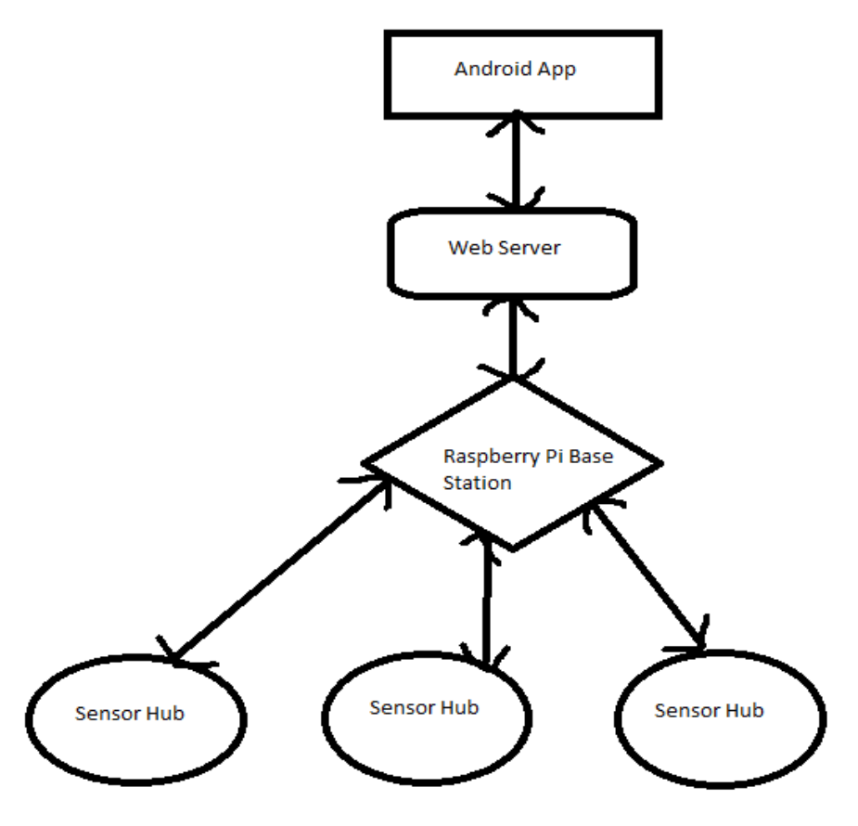

2.5 Project Overview

2.5.1 Bill of Materials

2.5.2 Time Commitment

2.5.3 Mechanical Assembly

2.5.4 PCB and Soldering

2.5.5 Power Up

2.5.6 Unit Testing

2.5.7 Production Testing

2.6 Problems Encountered

3. Progress Reports

3.1 Report 1

3.2 Report 2

3.3 Report 3

4. Conclusions

5. Recommendations

6. Technical References

7. Appendicies

7.1 Arduino Uno Sensor Setup

7.2 Arduino Xbee link

7.3 Database Code

7.4 Mobile Application

7.4.1 Main Activity

7.4.2 RoomActivity

7.4.3 RoomViewActivity

7.4.4 HomeActivity

7.4.5 Register Activity

