# CSIS 212-B04: Assignment 8

Kyle Stevens

## Program 1:

STUDENT

DOCTORAL

FRESHMAN

SOPHOMORE

JUNIOR

SENIOR

GRADUATE STUDENT

UNDERGRADUATE STUDENT

MASTERS

|  |
| --- |
| Superclass Student is a direct superclass of Undergraduate Student and Graduate Student. It might contain the common methods gpa(), firstName(), lastName(), degreeField(), fafsa(). All these superclass methods will be inherited and implemented by the subclasses of Student. This is referred to as an “is-a” relationship, where the subclass “is-a” subset of the superclass.  Subclasses Undergraduate Student and Graduate Student, both while Students, are distinct in their level of education, requirements for entry, types of degrees, etc. These distinctions will be noted in their unique implementations of their inherited methods, such as degreeField().  Subclasses Senior, Junior, Doctoral, Masters, etc. benefit the most from their superclass’s methods. For example, the superclass Student can be used by FAFSA for student loan applications across multiple universities. Each university, however, will implement their own systems for accessing FAFSA. |

## Program 2:

New classes can be added with little or no modification to the general portions of the program, as long as the new classes are part of the inheritance hierarchy that the program processes generically.

## Program 3:

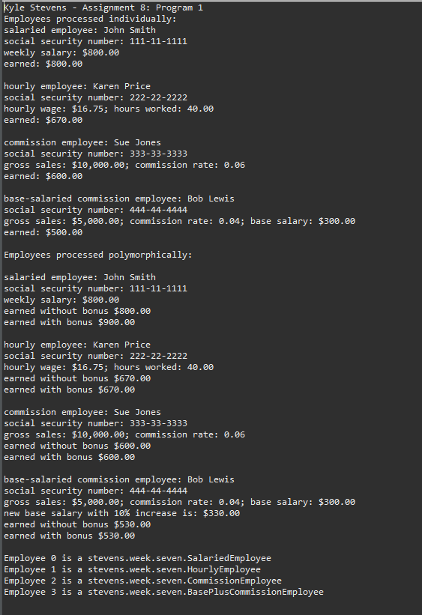

1. I have not shared the source code in my program with anyone other than my instructor’s approved human sources.
2. I have not used source code obtained from another student, or any other unauthorized source, either modified or unmodified.
3. If any source code or documentation used in my program was obtained from another source, such as a text book or course notes, that has been clearly noted with a proper citation in the comments of my program.
4. I have not knowingly designed this program in such a way as to defeat or interfere with the normal operation of any machine it is graded on or to produce apparently correct results when in fact it does not.