# CSIS 212-B04: Assignment 6

Kyle Stevens

## Program 1:

Output using Eclipse IDE instead of Bash window since I am calling multiple classes and when using Bash, the compiler could not find the Date class, even though it was called in the DateTest class.

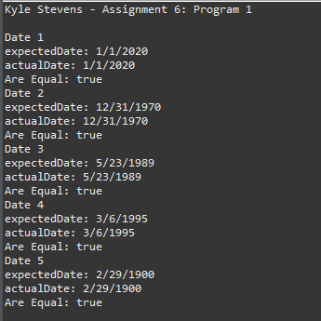

1. I have not shared the source code in my program with anyone other than my instructor’s approved human sources.
2. I have not used source code obtained from another student, or any other unauthorized source, either modified or unmodified.
3. If any source code or documentation used in my program was obtained from another source, such as a text book or course notes, that has been clearly noted with a proper citation in the comments of my program.
4. I have not knowingly designed this program in such a way as to defeat or interfere with the normal operation of any machine it is graded on or to produce apparently correct results when in fact it does not.