CSIS 330 – Lab 11: Packet Tracer

Network Representations (DNS and HTTP) Answer Template

**Screenshots:**

**Screenshot #1:**

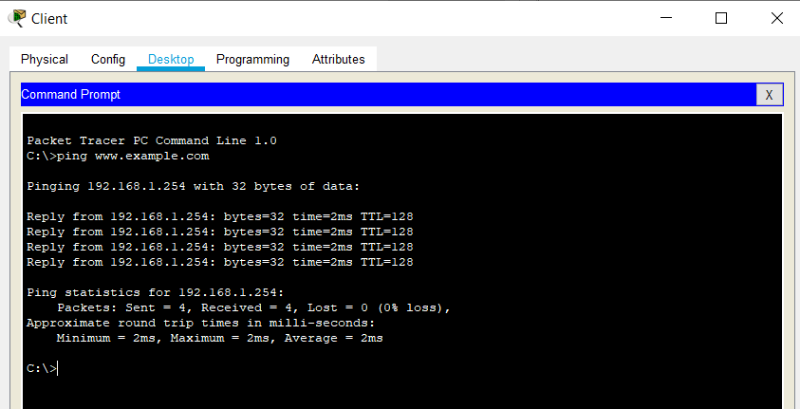

**Screenshot #2:**

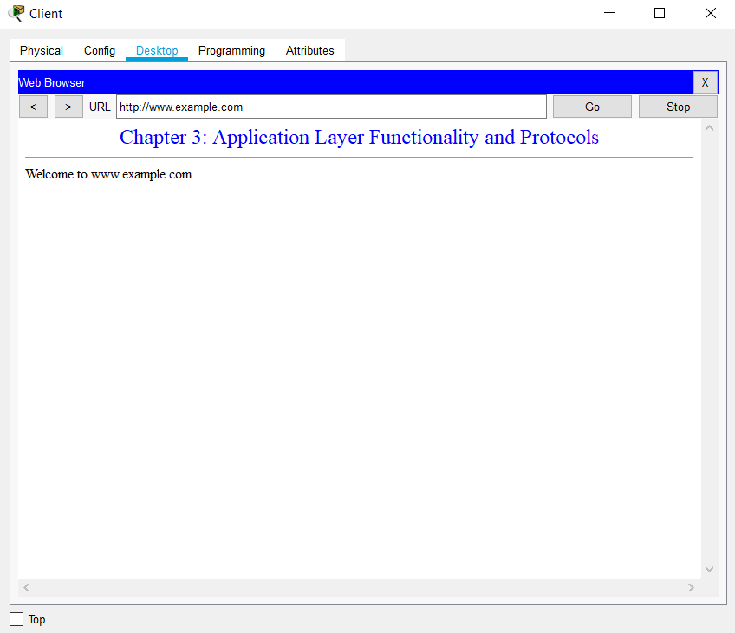

**Screenshot #3:**

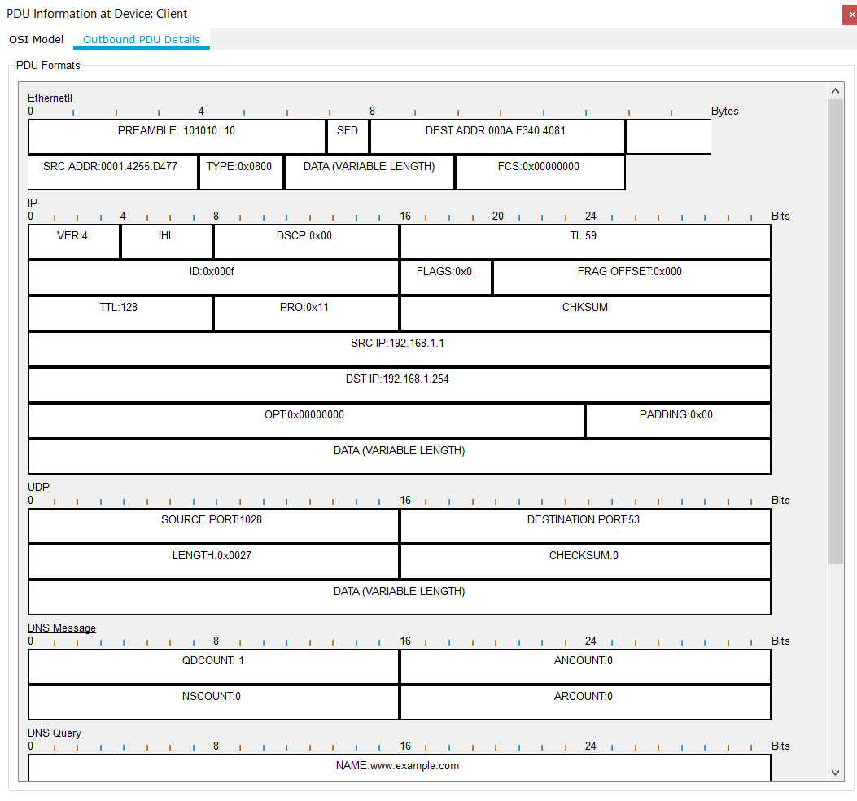

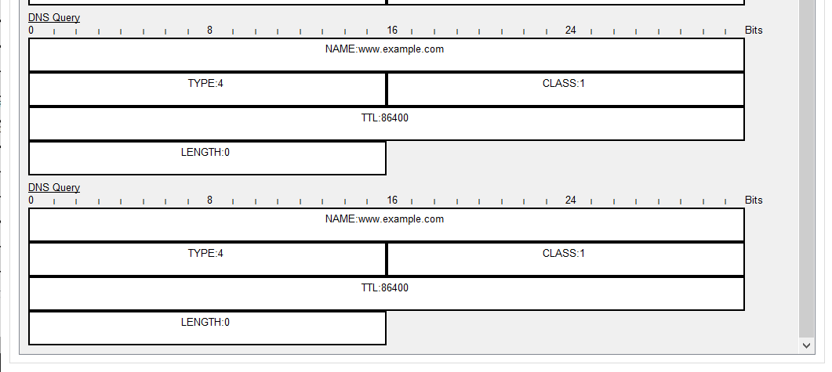

**Screenshot #4:**

