CSIS 330 – Lab 13: Packet Tracer

Web and Email Servers Answer Template

**Part 2:**     **Configure and Verify Email Services on Servers**

**Step 5:**

**Screenshot #1:**

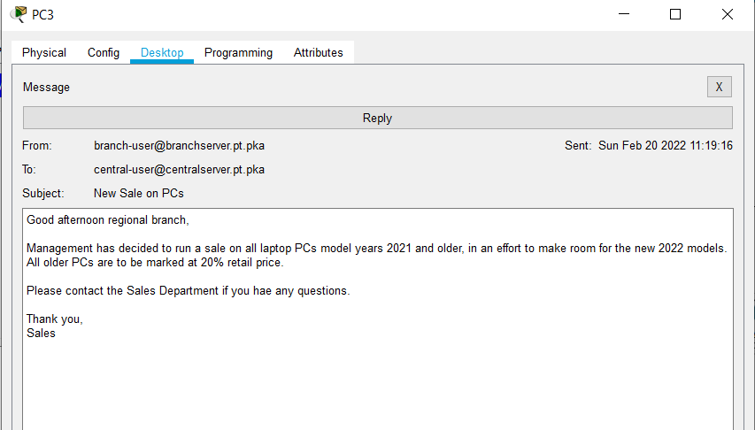

**Screenshot #2:**

