CSIS 330 – Lab 5: Packet Tracer Use of the TCP/IP Protocols and the OSI Model Answer Template

**Screenshot #1:**

**PDU Information – OSI Model Tab**

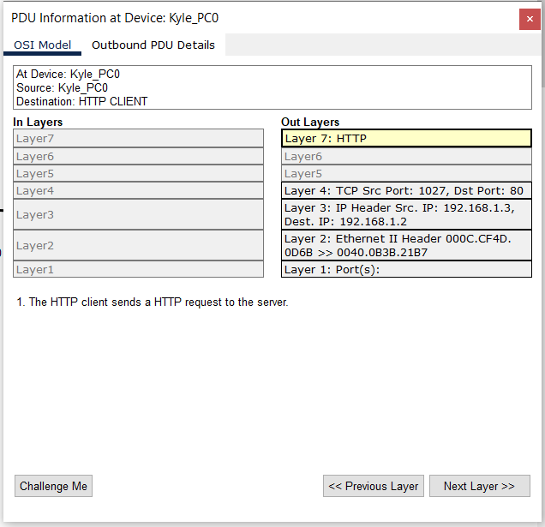

**Screenshot #2:**

**PDU Information – Outbound PDU Details tab**

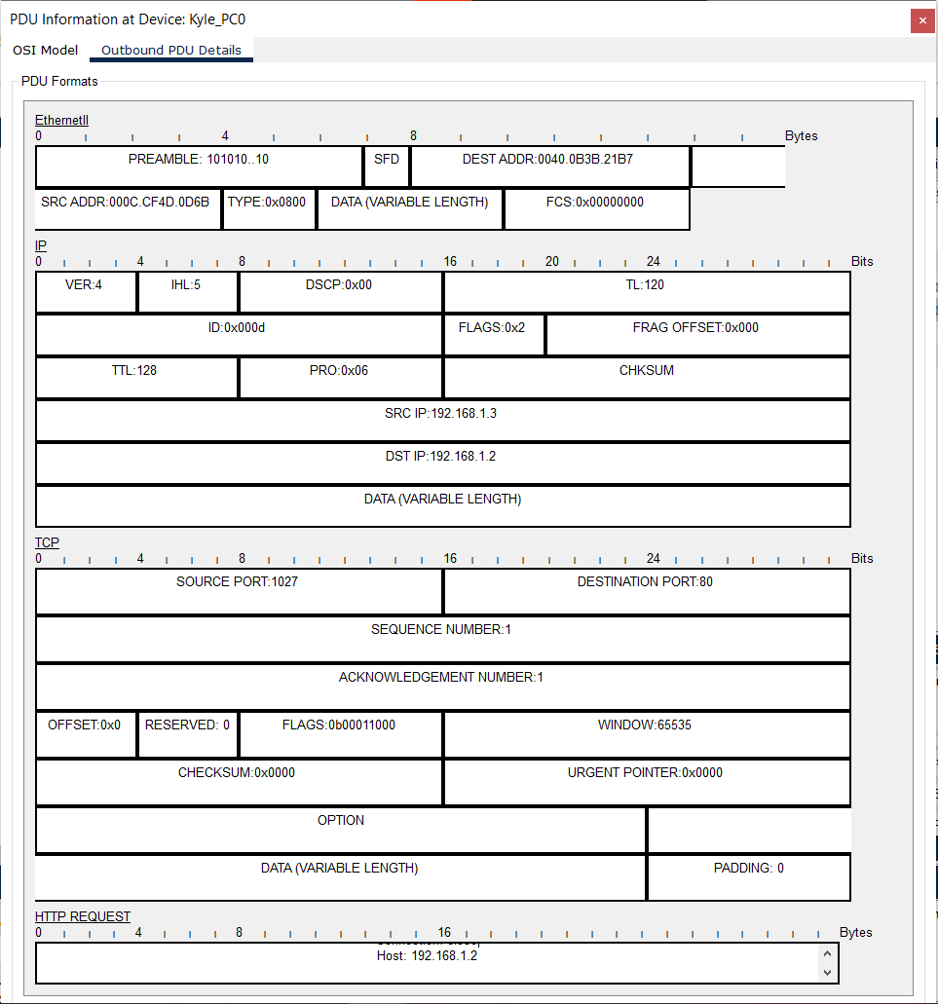

**Question a: _____Dst Port: 80__________**

**Question b: _____**

HTTP Data:Accept-Language: en-us  
Accept: */*  
Connection: close  
Host: 192.168.1.2

**____________________**

**Question c: ________32 Bits long_________________**