(https://carl-allen.github.io/nlp/2019/07/01/explaining-analogies-explained.html)
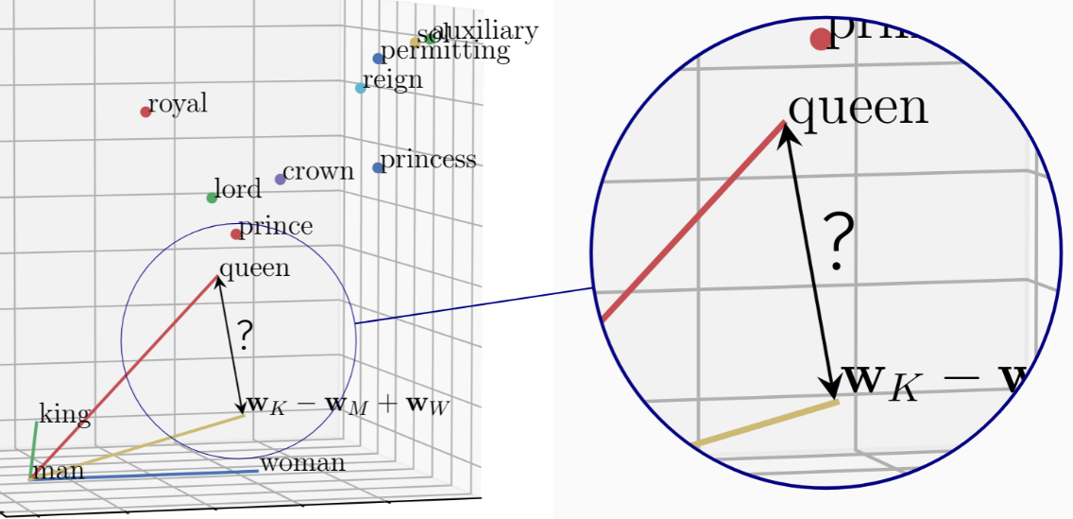

Assignment 1 Report

Name: 陳安楷
Institution (school): NTHU
Student ID: 111030034
Platform (Colab/Kaggle/Local): Local (lab server)
Python version: 3.12.11
Operating system: Ubuntu 20.04.6 LTS
CPU: Intel(R) Core(TM) i7-8700K CPU @ 3.70GHz
GPU requirement: NVIDIA GeForce GTX 1080 Ti

- Which embedding model do you use? What are the pre-processing steps? What are the hyperparameter settings? (5%)
Answer:
- Pre-processing steps:
  - Corpus Sampling: To manage computational resources and analyze the impact of data scale on performance, only a specific fraction (e.g., 5%, 10%, or 20%) of the original corpus was used for each training run.
  - English Vocabulary Filtering: This step was intended to remove noise, typos, or foreign words from the text. Each word in the sampled corpus was checked against the standard English word list provided by the NLTK library (nltk.corpus.words.words()). Any word not present in this reference vocabulary was discarded from the corpus.
  - Stop Word Removal: Common English stop words—words that occur with high frequency but typically carry little semantic weight (e.g., 'a', 'an', 'the', 'in', 'at', 'for')—were removed. This helps the model focus on more meaningful content words and allows the context window to capture relationships between more significant terms.
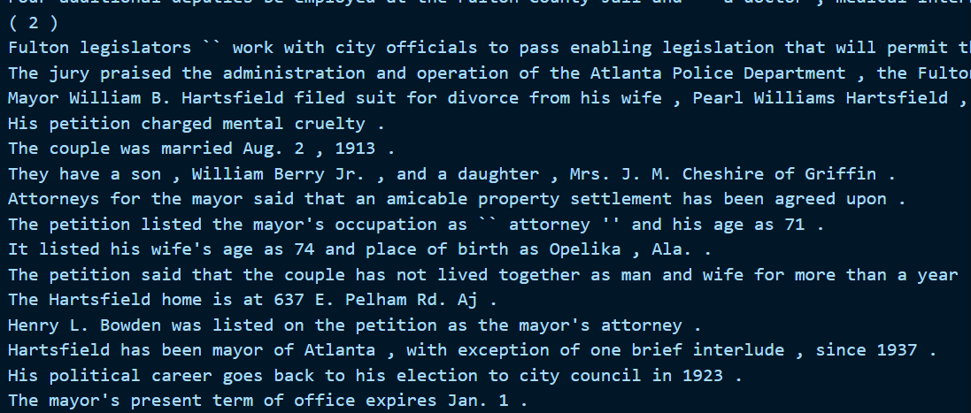
Figure1. Before preprocessing on Brown Dataset
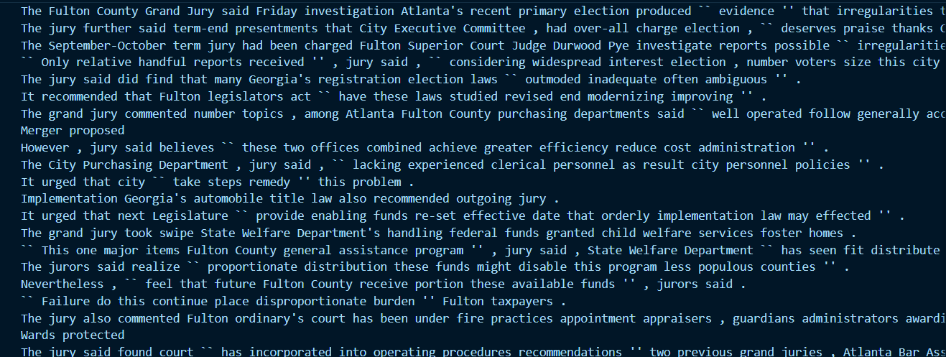
Figure 2. After preprocessing (removed stop words) on the Brown Dataset
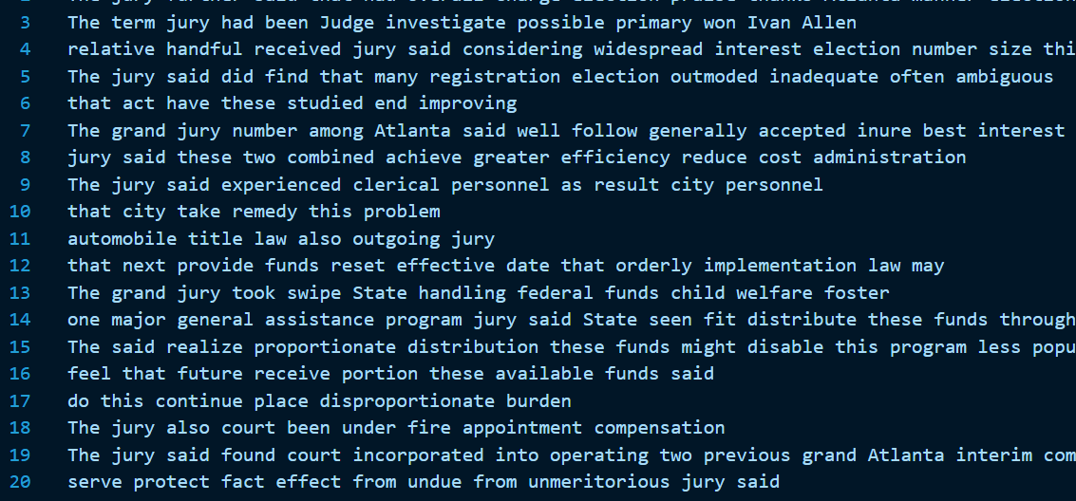
Figure 3. After preprocessing (removed stop words, and non english words) on the Brown Dataset
Foreshadowing the Impact of English Vocabulary Filtering
The drastic drop in performance observed in the second bar chart (titled "Preprocess: remove_non_english_and_stop_words") can be directly attributed to the English Vocabulary Filtering step (Step II). While intended as a cleaning measure, this approach is overly aggressive and fundamentally flawed for training language models, leading to a catastrophic loss of information for two primary reasons:
Elimination of Critical Semantic Content (Proper Nouns & Technical Terms): The nltk.corpus.words list is a generic dictionary. It does not contain most proper nouns, such as names of people (Einstein), places (Germany, Tokyo), or organizations (Google).
Removal of Grammatical Variations (Inflections): The NLTK word list is a fixed lexicon and often lacks inflected forms of words—such as plurals (computers), verb tenses (running, walked), or comparatives (bigger). For example, the list might contain computer but not computers. Removing these variations destroys the grammatical structure of the text.
- Hyperparameter settings
For the Wikipedia dataset 20% the best hyperparameter is: Window_size (ws) = 5, Vector_size (vs) = 300, lr = 0.025 yield same results, using CBOW (sg = 0)as embedding model.
For the Brown dataset, the best hyperparameter setup is, Window_size (ws) = 10, Vector_size (vs) = 100, Lr = 0.025, and also uses CBOW (sg = 0) as the embedding model.
- What will the performance be like if you sample 5%, 10% and 20% of wiki text in TODO4? (10%, 3% for each)
Answer:
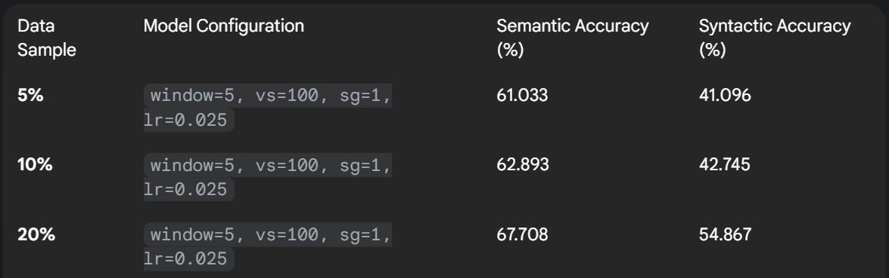
There is a clear and positive correlation between the amount of training data and the model's performance. As the percentage of the Wikipedia corpus used for training increases from 5% to 20%, both semantic and syntactic accuracy improve significantly. The largest performance jump occurs when moving from 10% to 20% of the data, especially for syntactic accuracy.
- What is the performance for different categories or sub-categories when trained on different corpora? (15%)
3.1 Present your results. (5%)
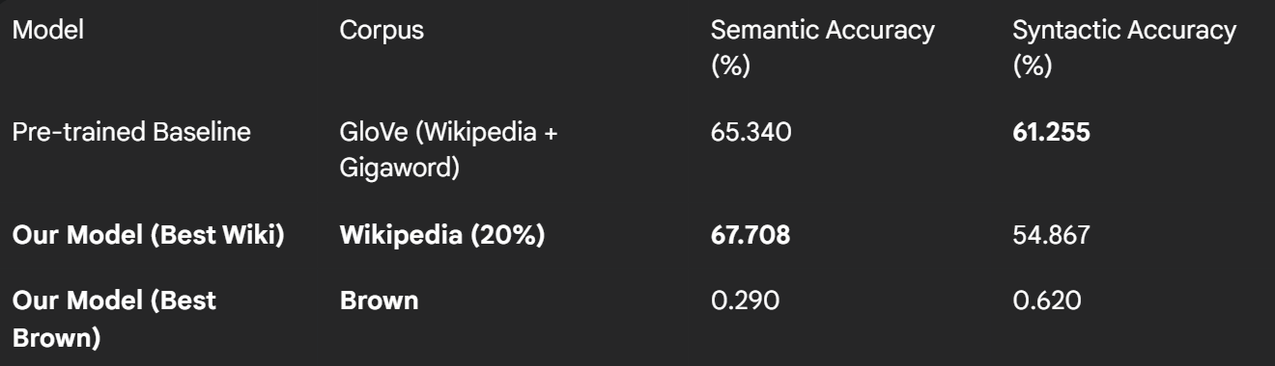
3.2 Introduce the corpus you selected and explain the differences between the Wikipedia corpus and your corpus. (including data size, topic difference, structural difference … ) (5%)
 | Wikipedia corpus | Brown corpus
Topic, genre diversity | Unbalanced & Single Genre: Overwhelmingly consists of encyclopedic articles. While topics are diverse, the style is consistently formal and informational. | Highly Balanced & Structured: Consists of exactly 500 samples (approx. 2,000 words each) carefully chosen to represent 15 distinct genres of American English prose published in 1961. Genres include Press Reportage, Religion, Learned/Academic, General Fiction, Romance, and Humor.
Structural Difference | Crowd-Sourced & Automatically Dumped | Manually Selected & Curated
3.3 Explain why the accuracy increases or decreases. (5%)
Answer:
Brown Corpus Performance: The updated scores for the Brown corpus model (0.290% Semantic, 0.620% Syntactic) are slightly better than near-zero, but they are still extremely low. It’s expected due to the small size of Brown corpus. Therefore the Word2Vec model can’t to learn meaningful and generalizable word representations, leading to a failure on the analogy task..
Our Wikipedia Model: Our model trained on 20% of Wikipedia still shows a stronger performance on semantic tasks (67.7% vs 65.3%) compared to the GloVe baseline. This suggests that the encyclopedic and fact-based nature of Wikipedia is highly effective for learning the specific types of semantic relationship‘‘‘s (like capital-country) that are heavily featured in the analogy test set.
- Select a few words and use their embeddings to retrieve the five most similar words and present the results. What do you observe? (10%)
To qualitatively assess the learned embeddings,
The best-performing model (wiki_word2vec_20%_..._sg=1_lr=0.025) was used to retrieve the five most similar words for a selection of test words. The results are presented below.
Test word | 5 most similar words
water | Groundwater, seawater, sewage, leachate, tapwater
taxi | 택시, taxicab, minibus, bus, chauffeur
Taiwan | China, Taipei, Hainan, Guangdong, fujian
tennis | Volleyball, badminton, pickleball, pxwomen, racquetball

The results from this model are highly coherent and demonstrate a robust understanding of semantic relationships. The model has successfully learned meaningful semantic relationships, capturing synonyms, categorical information, and geographical context. Here are some key findings:
Synonyms and Hyponyms: For water, the model correctly retrieves hyponyms (specific types of water) like groundwater, seawater, and tapwater. This shows it has learned the "is-a-type-of" relationship.
Categorical Similarity: For tennis, the model identifies other racquet sports (volleyball, badminton, racquetball), showing a clear grasp of categorical similarity.
Geographical Proximity: The model correctly places Taiwan in its geographical context by retrieving China, Taipei, and nearby provinces like Hainan and Guangdong.
Cross-Lingual Knowledge: An intriguing result is seen for taxi, where the model retrieves the Korean word 택시 (taek-si) alongside the English synonym taxicab and other modes of transport. This highlights the multilingual nature of the Wikipedia corpus and the model's powerful ability to learn cross-lingual synonyms from context.
Also, the worst-performing model (Brown Dataset) was used to retrieve the five most similar words for a selection of test words. The results are presented below.
Test word | 5 most similar words
water | Air, ground, hot surface, dust
taxi | Roaring, prostitution, ponies, flopped, flashed
Taiwan | Religions, Germanic, continuity, talents, beliefs
tennis | Tapered, Road, frail, wool
From the results, clearly there is one common story – The similar words are not that similar. The results for taxi and tennis are semantically incoherent. The retrieved words (prostitution, ponies, frail, wool) have no logical connection to the test words.
While the model can solve structured analogies (from TSNE plot we can see the relationships) to some extent, this qualitative analysis shows its limitations. The "similar" words are not truly similar but are artifacts of the contexts found within the Brown corpus. The model has not developed a robust understanding of meaning, but rather a map of which words tend to appear in similar sentences, leading to logical and often nonsensical results.
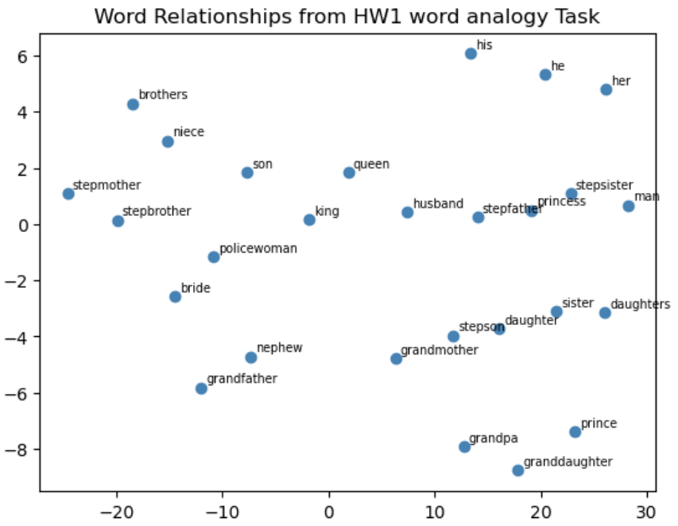
Figure 3. TSNE plot from the brown corpus (worst model)
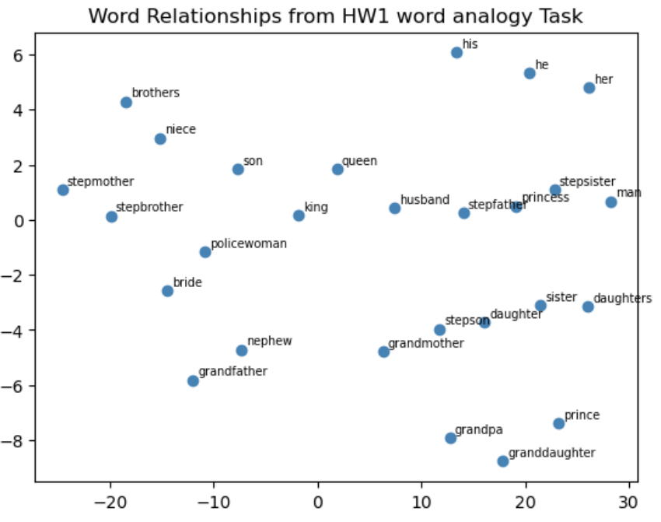
Figure 4. TSNE plot from one of the Best model (20%_only_removed_stop_window=5_vs=100_sg=1_lr=0.025.model)
Answer:
- Anything that can strengthen your report. (5%)
Answer:
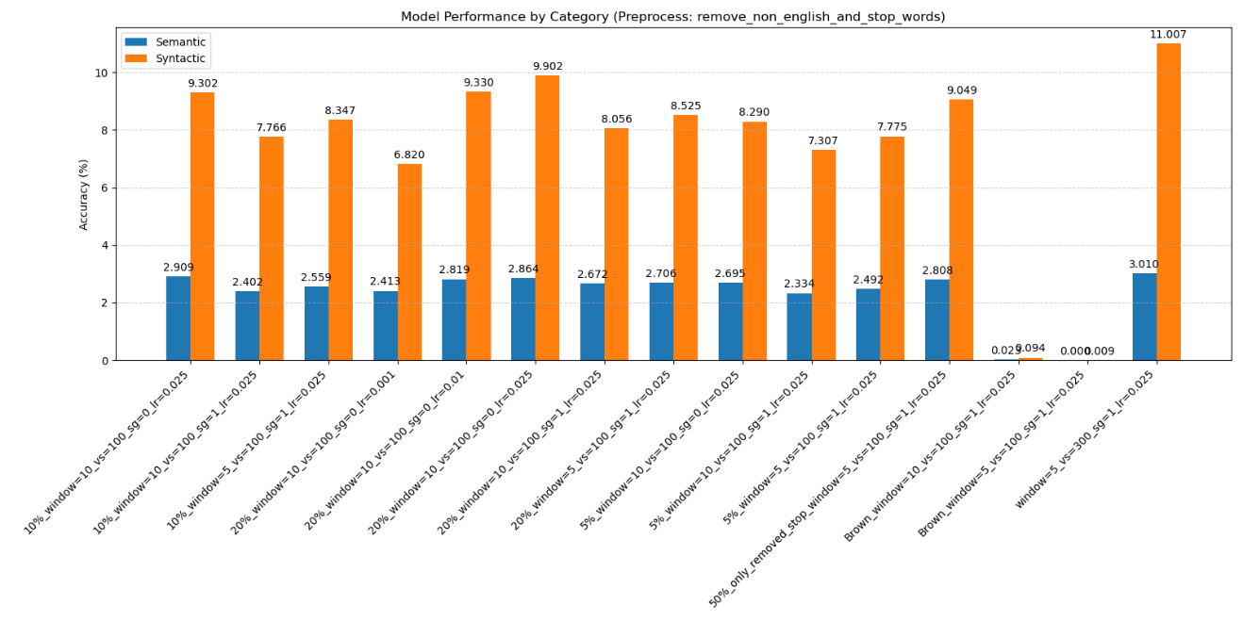
Figure 5. tested results on remove non english words and remove stop word preprocessing
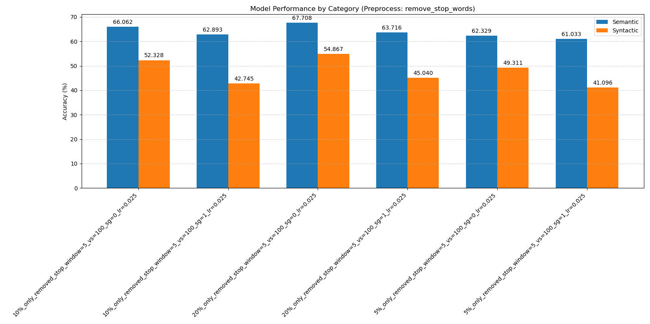
Figure 6. tested results on remove stop word preprocessing

Ablation Study:
1.Impact of Preprocessing Strategy: most significant factor influencing model performance was the choice of preprocessing. Ablation proves that the English vocabulary filtering step was fundamentally flawed. By removing all words not in a standard NLTK dictionary, it stripped the corpus of essential proper nouns (countries, names), inflected word forms, and technical terms.
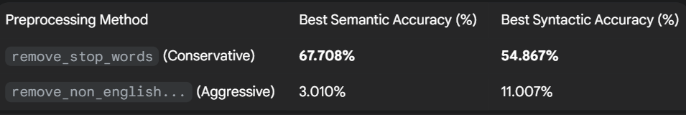

Ablation Study 2: Impact of Training Algorithm (CBOW vs. Skip-Gram)
Across all tested data scales, the CBOW (sg=0) algorithm consistently outperformed Skip-Gram (sg=1) on both semantic and syntactic analogy tasks. While Skip-Gram is often cited as being superior for semantic tasks, especially with smaller datasets, these results suggest the opposite for this specific task and corpus. CBOW, which learns to predict a target word from its context, proved more effective
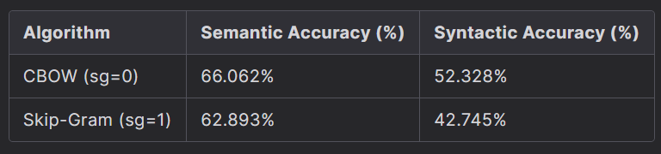
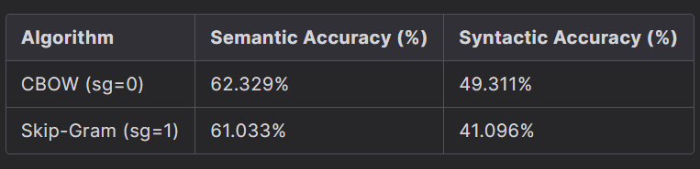
Overall Summary
This ablation study reveals a clear hierarchy of importance for the components of the Word2Vec pipeline:
- Preprocessing Strategy: An inappropriate cleaning step can single-handedly invalidate all other efforts, making it the most critical decision.
- Training Algorithm: The choice of algorithm (CBOW vs. Skip-Gram) has a noticeable impact, with CBOW proving superior in this specific context.
- Hyperparameter Tuning: While not detailed as a separate study here, variations in learning rate, window size, and vector size (as seen in the charts) provide smaller, incremental improvements on top of the foundation laid by the factors above.

