Case study: Reconstruction of infection dynamics during a pandemic using imperfect surveillance and serial serological survey data

Background:
During an emerging infectious disease outbreak, public health authorities often rely on multiple sources of information to monitor disease spread and evaluate the successfulness of intervention strategies. Reported case counts provide information on the number of detected infections, while serological surveys on the other hand are useful to provide information on the cumulative proportion of the population that has detectable antibodies related to infection in the past, thereby including undetected cases in the incidence data.
In this case study, participants will analyze simulated outbreak data from a pandemic occurring in a closed structured population. The simulation model incorporates infection transmission, vaccination, disease progression, and mortality. Next to the available demographic data, several other datasets are available representing different sources of information that may be collected during a real-world disease outbreak.
Model description:

The simulated data described below is based on the application of an individual-based microsimulation model (HERMES) tailored to serve as a tool to generate infectious disease transmission data to be used for in-depth analysis during the Lorentz Center workshop. More specifically, HERMES implements an individual-based infectious disease transmission model in a structured population comprising households, schools, workplaces, and the general community. Before starting the simulation of transmission events, HERMES constructs a synthetic population of individuals for which the demographic data are available. Next to measured age and gender-specific differences, individuals differ in their propensity to make contacts and in other unmeasured factors that potentially lead to individual-level variation.

In HERMES, transmission is simulated explicitly for each infected individual on each day. This implies that every infectious individual can generate new infections in their household, the community, school, and/or workplace. Transmission is governed by setting-specific effective contact probabilities that translate into transmission probabilities. The microsimulation model adopts an S(usceptible)I(nfected)R(ecovered)V(accinated)D(eath)-structure with individuals navigating between the different health states.

Course of the outbreak:

The outbreak starts at day 0 with the introduction of disease in the target population of size N = 1,000,000 individuals (see also demographic data). The first 20 days, there is unrestricted spread of the disease in the population after which a lockdown is imposed, leading to contact reductions at the workplace, in schools and in the general community. At day 35 an exit out of the lockdown is happening, leading to contact probabilities increasing to pre-lockdown values. At day 45, part of the population will start to get vaccinated with increasing vaccination coverage over three distinct cross-sectional time points, each 10 days apart, at which individuals are vaccinated irrespective of disease status.

Overview of the different datasets

- Demographic dataset (final_demographic_data)

As mentioned above, a synthetic population of size N = 1,000,000 individuals is constructed for the purpose of this case study. The demographic dataset contains individual-level information for all members of the synthetic population, with each row corresponding to a single individual. The following variables are recorded:

- ind_id: individual identification number
- age: age of the individual at the start of the outbreak (in years)
- sex: sex of the individual (male/female)
- hh_id: household identification number
- classroom_id: classroom identification number (if relevant)
- workplace_id: workplace identification number (if relevant)
- time: observation time (in days since start of study)

- Incidence data (final_incidence_data_day40)

Next to demographic data, the incidence of reported cases and hospitalizations is provided at day 40. More specifically, the dataset contains individual-level surveillance data on incident cases that were detected and confirmed, and subsequent hospitalizations (as a result of the infection) during the pandemic:

- ind_id: individual identification number
- time_of_symptom_onset: reported time of symptom onset (in days since start of study)
- time_of_reporting: time of reporting of a case (in days since start of study)
- time_of_hospitalization: time of hospitalization (if relevant)
- time: observation time (in days since start of study)

- Incidence data (final_incidence_data_reduced)

Next to the incidence data at day 40 in the pandemic, limited information about (symptomatic) cases at the end of the outbreak is provided as well.

- ind_id: individual identification number
- time_of_reporting: time of reporting of a case (in days since start of study)
- time: observation time (in days since start of study)

- Serological survey data (final_sero_data):

This dataset contains repeated cross-sectional serological survey data collected at three different instances during the outbreak (i.e., at day 10, 20, 30 and 40) on a random subset of the population with quantitative tests measuring IgG antibody titers (expressed as IU/ml on the original scale) subsequently transformed using a natural logarithmic transformation. No pre-specified cut-off has been supplied by the manufacturer of the serological test:

- ind_id: individual identification number
- log_igg: log-transformed antibody titer (in log(IU/mL) on the transformed scale)
- time_of_sampling: cross-sectional time point at which serum sample has been collected (i.e., day 10, 20, 30 and 40 following the introduction of the index case)

- Contact tracing data (final_contact_tracing_data):

This dataset contains information on a random subset (of transmission chains) of infector-infectee pairs generated between the start of the epidemic and day 30 of the outbreak. Next to information about the identified case and the reported contact, the probable time of the contact relevant for transmission has been reported by means of limits of the time window in which both persons have been in contact. The following information was recorded:

- time: observation time at the end of the contact tracing period (in days since start of study)
- ind_id: identifier of the identified case
- reported_contact: identifier of the reported contact
- ind_symptom_onset: symptom onset time of the identified case (days since start)
- reported_contact_symptom_onset: symptom onset time of the reported contact (days since start)
- time_of_contact_lower: lower limit of the time window for the probable time of contact (in days since start)
- time_of_contact_upper: upper limit of the time window for the probable time of contact (in days since start)

In contrast to real-world contact tracing data, the simulated dataset contains the true transmission links generated by the underlying epidemic model. Consequently, the true relationship is known for a selection of the transmission events, though the order is still unknown. For example, the reported contact and identified case are not necessarily infected in that order (although symptom onset times are larger for identified cases as compared to reported contacts).

- Mortality data (final_mortality_data):

This dataset contains the time of death of individuals. No indication about the reason of death has been supplied.

- ind_id: individual identification number
- time: observation time (in days since start of study)
- time_of_death: time of natural or disease-related death (in days since start of the outbreak) (if relevant)

- Vaccination data (final_vaccination_data):

This dataset contains the time of vaccination for individuals before the observation time of 90 days after the start of the outbreak.

- ind_id: individual identification number
- time: observation time (in days since start of study)
- time_of_vaccination: time of vaccination (in days) (if relevant)

Objectives
Participants may use one or more of the datasets to address one of the following tasks (one per group):
- Estimate key epidemiological parameters, including the basic/effective reproduction number, recovery time, incubation period, and reporting delay distribution.
- Derive the serial interval distribution based on the available contact tracing data.
- Estimate parameters related to the reporting-delay distribution and study underreporting in the incidence data through the use of serial serological survey data to estimate the proportion of underreporting.
- Estimate vaccine effectiveness using individual-level vaccination history and breakthrough infection data.
- Estimate excess mortality and its relation with infection and vaccination.

Instructions

Please approach your task in two steps:

- Step 1. Specify relevant estimands (population of interest, treatment conditions [or relevant analogon], endpoint, summary measure, handling of intercurrent events [when applicable]). Discuss possible models, their assumptions, which information is missing from the data and whether this could be (partially) retrieved from external data.

- Step 2. Implement one or more of the proposed models. Compare this to alternatives and consider sensitivity analyses.

Guidance for participants:

The following notes provide a possible starting point for statistical analyses of the available data sources. Multiple approaches may be valid and participants are encouraged to explore the use of alternative methods at the intersection between infectious disease modeling and survival analysis.

- Estimation of epidemiological parameters

The basic reproduction number $R_{0}$ is defined as the average number of secondary cases generated by a single typical infectious individual when introduced in a fully susceptible population.

A simple approach to estimate the basic reproduction number is to exploit its relation to the initial exponential growth phase of the epidemic. More specifically,

$$I^{*}\left(t\right)=I_{0}e^{rt}$$

where $I^{*}(t)$ denotes the number of new infections at time t, and r represents the epidemic (exponential) growth rate. The growth rate can be estimated from early incidence data (in final_incidence_data) and subsequently the basic reproduction number can be inferred using information on the generation-time distribution.

According to the Euler-Lotka equation, one can write

$$R_{0}=\frac{1}{\int_{0}^{∞}{e^{-rt}}w\left(t\right)dt}$$

with $w\left(t\right)$ representing the probability density function related to the generation-time distribution, to be estimated from a selection of sampled infector-infectee pairs (within the contact tracing window, implying truncation if the infector is infected outside the window).

After estimating the generation-time distribution parametrically assuming, for example, a Gamma distribution with shape and scale parameters $α$ and $β$, an estimate for $R_{0}$ becomes:

$${ {\hat{R}}_{0}= \left(1+\hat{β}r\right)}^{-\hat{α}}$$

which is directly obtained through the connection with the Laplace transform of a Gamma distributed random variable.

Needless to say, information on infection times are (typically) not directly available and the serial interval distribution is often used as an approximation of the generation-time distribution (see also serial interval distribution).
Next to the basic reproduction number $R_{0},$ the effective reproduction number $R_{t}$ representing the average number of secondary cases produced by a single typical infectious individual at time $t≥0$when introduced in a population with partial susceptibility as a result of ongoing transmission (or pre-existing natural or vaccine-induced immunity), is a key epidemiological parameter to assess the epidemiological situation in real-time. From a renewal equation point of view, the effective reproduction number can be expressed as

$$R_{t}=\frac{I^{*}\left(t\right)}{∫I^{*}\left(t-κ\right)w\left(κ\right)dκ}.$$

Again, information about the generation time (or serial) interval distribution is required.

- Serial interval distribution

The serial interval (SI) is the time between symptom onset in a primary case (the infector) and symptom onset in a secondary case (i.e., the infectee) (see Figure 1 below for a graphical representation). In contrast, the generation interval is the time between the infection of the infector and the infection of the infectee. While the generation interval more directly reflects the timing of transmission, infection times are rarely observed in practice. As a result, the serial interval is often used as a proxy because symptom onset dates are more readily available (as is the case here as well). Note that these two intervals are not identical, as the serial interval is influenced by the potentially different incubation periods of both the infector and the infectee.

In epidemiology, the serial interval is a fundamental parameter for several reasons:
- Quantifying the speed of spread. A short SI means that successive generations of cases follow one another rapidly, making the epidemic harder to contain. A long SI leaves more time to detect and isolate cases before they transmit further.
- Estimating the reproduction number (see estimation of epidemiological parameters). Both the basic reproduction number $R_{0}$ and the time-varying reproduction number $R_{t}$ are linked to the SI through the renewal equation: without an accurate SI estimate, any estimate of $R_{t}$ will be biased.
- Input in transmission models. Compartmental models (SIR, SEIR, etc.) and renewal equation models use the SI as a direct input to simulate epidemic dynamics and evaluate the impact of interventions.
- Designing control measures. The duration of quarantine, the contact-tracing window, and the timing of vaccination campaigns are all partly calibrated on the SI.

First of all, the contact tracing data provides information about the distribution of the serial interval. Therefore, one could come up with a nonparametric estimator of the serial interval distribution. Furthermore, for members of some of the infector-infectee pairs information on (likely) infection times is observed as well, either in an uncensored way, or with infection times (of the infectee) being interval-censored. This enables the translation from time of symptom onset to time of infection which is particularly relevant to study the generation time distribution and how it differs from the serial interval distribution (see also estimation of key epidemiological parameters).

.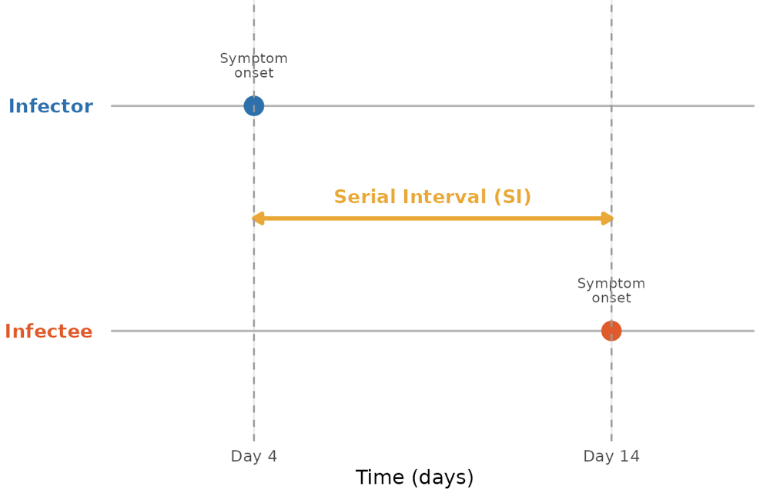
Figure 1. Definition of the serial interval (the time between symptom onset in an infector and infectee).

- Reporting delay distribution

The reporting delay is defined as the time between symptom onset and case reporting (in the absence of direct information on time of infection). Understanding reporting delays is important because observed case counts often lag behind actual transmission events. A possible starting point is to estimate the empirical reporting delay distribution based on the available incidence data. Is the reporting delay different in periods with high disease transmission or not?

Moreover, although no direct information on the time of infection is available, there is some information on the time between infection and symptom onset available from the contact tracing data. For each infector-infectee pair, information about the infection time of the infectee is either directly available (through the time of probable contact), or interval-censored.

- Serial serological data analysis

Repeated cross-sectional serological survey data can be used to estimate the underreporting in the observed data. Given the fact that serological data provides information on past infection, one can estimate the probability of past infection from the available serological data, which potentially depends on age, other demographic characteristics and the time of cross-sectional sampling.

A first crude approach would be based on classifying individuals into a seronegative and seropositive group based on a threshold value. In order to find the optimal threshold, a subset of individuals with known past infection status (in relation to the sampling time) could be considered based on which an optimal threshold is determined in view of maximizing both sensitivity and specificity (for example, through the calculation of a Youden’ index for different values of the threshold). Based on the selected threshold $τ$, the continuous (log-transformed) antibody titers $Y_{i}$ for individuals $i=1, …, N_{s}$ (with $N_{s}$ the sample size of the serological data) can be used to classify individuals as seronegative ($Y_{i}<τ$) or seropositive ($Y_{i}≥τ$). Let $Z_{i}=I(Y_{i}≥τ)$ represent the serostatus of individual $i$ based on the threshold $τ$, and ignoring dependence on covariates (such as age) for simplicity, then the time-dependent seroprevalence is defined as

$π_{s}\left(t\right)=P\left(Z=1 | T_{s}=t\right)=P\left(Z_{i}=1 \right| T_{s,i}=t)$,

with $Z_{i},$ $i=1, …, N_{s}$, a sample of the population with population random variable $Z$ denoting the serostatus for a random individual in that population, and $T_{s}$ the time of cross-sectional sampling. An ad-hoc adjustment for misclassification of individuals can be found in the work by Rogan and Gladen (1978). The Rogan and Gladen estimator is used to estimate the true prevalence in relation to the estimated seroprevalence, relying on sensitivity and specificity estimates (denoted hereunder as $ϕ$ and $ψ$, respectively) of the test used, i.e.,

$$π\left(t\right)= \frac{π_{s}\left(t\right)+ψ-1}{ϕ+ψ-1}.$$

This approach does not accommodate uncertainty with respect to the estimation of sensitivity and specificity values. However, an alternative method that does not require the specification of a threshold value (based on a random hold-out set as specified before) is mixture modelling in which a mixture distribution can be specified. More specifically, a seronegative and seropositive mixture distribution is weighted with weights being equal to $1-π\left(t\right)$ and $π\left(t\right)$, respectively. Note that direct modelling of the continuous antibody titer data is complicated by the presence of left censoring of (log-transformed) antibody concentrations with the limit of detection equal to $\ln\left(5\right)≈1.609$.

- Vaccine effectiveness estimation

Understanding vaccine-induced protection, or vaccine effectiveness (VE), is essential for defining effective vaccination programs. VE is an observable, population-level proxy of individual immunity from vaccination and describes the reduction in infection risk among vaccinated compared to unvaccinated individuals. VE is defined as

$$VE=1-RR$$

where RR is the relative risk of infection among vaccinated versus non-vaccinated individuals. Determining VE is hindered two interconnected challenges: (i) observational data makes it difficult to distinguish true VE from confounding factors (e.g., immunity acquired through natural infection, selective depletion of high-risk individuals) and (ii) standard statistical approaches can only approximate loss of protection over time and are known to produce biased estimates.

