Case study I: Reconstruction of infection dynamics during a pandemic using imperfect surveillance and serological survey data

Background:
During an emerging infectious disease outbreak, public health authorities often rely on multiple sources of information to monitor disease spread and evaluate the successfulness of intervention strategies. Reported case counts provide information on the number of detected infections, while serological surveys on the other hand are useful to provide information on the cumulative proportion of the population that has detectable antibodies related to infection in the past, thereby including undetected cases in the incidence data.
In this case study, participants will analyze simulated outbreak data from a pandemic occurring in a closed structured population. The simulation model incorporates infection transmission, vaccination, disease progression, and mortality. Next to the available demographic data, three datasets are available representing different sources of information that may be collected during a real-world disease outbreak.
One of the goals is to estimate key epidemiological quantities and assess the extent to which infection dynamics can be reconstructed from (imperfect) surveillance and serological data.

Model description:

The simulated data described below is based on the application of an individual-based microsimulation model (HERMES) tailored to serve as a tool to generate infectious disease transmission data to be used for in-depth analysis during the Lorentz Center workshop. More specifically, HERMES implements an individual-based infectious disease transmission model in a structured population comprising households, schools, workplaces, and the general community. Before starting the simulation of transmission events, HERMES constructs a synthetic population of individuals for which the demographic data are available.

In HERMES, transmission is simulated explicitly for each infected individual on each day. This implies that every infectious individual can generate new infections in their household, the community, school, and/or workplace. Transmission is governed by setting-specific effective contact probabilities that translate into transmission probabilities. The microsimulation model adopts an S(usceptible)I(nfected)R(ecovered)V(accinated)D(eath)-structure with individuals navigating between the different health states.

Demographic dataset (final_pop_data):

A synthetic population of N = 1,000,000 individuals is constructed for the purpose of this case study. The demographic dataset contains individual-level information for all members of the synthetic population, with each row corresponding to a single individual. The following variables are recorded:

- ind_id: individual identification number
- age: age of the individual at the start of the outbreak (in years)
- sex: sex of the individual (male/female)
- hh_id: household identification number
- classroom_id: classroom identification number (if relevant)
- workplace_id: workplace identification number (if relevant)
- time_of_hospitalization: time of hospitalization (if relevant)
- time_of_death: time of natural or disease-related death (in days) (if relevant)
- time_of_vaccination: time of vaccination (in days) (if relevant)

Incidence data (final_incidence_data):

Incidence of cases and deaths are obtained from the microsimulation model over time. More specifically, the dataset contains individual-level surveillance data on incident cases during the pandemic:

- ind_id: individual identification number
- age: age of the individual (in years)
- sex: sex of the individual (male/female)
- time_of_symptom_onset: reported time of symptom onset (in days)
- time_of_reporting: time of reporting (in days)

Serological survey data (final_sero_data):

This dataset contains repeated cross-sectional serological survey data collected at three different instances during the outbreak (i.e., at day 10, 20 and 30).

- ind_id: individual identification number
- age: age of the individual (in years)
- age_group: 10-year age group
- time_since_symptom_onset: time since symptom onset (in days) (if relevant)
- sero_status: serostatus of the individual at time of sampling indicating the presence or absence of (IgG) antibodies (1: seropositive; 0: seronegative)
- log_gg: log-transformed antibody titer (in IU/mL)
- time_of_sampling: cross-sectional time point at which serum sample has been collected (i.e., day 10, 20 and 30 following the introduction of the index case)

Contact tracing data (final_contact_tracing_data):

This dataset contains information on infector-infectee pairs generated between day 10 and day 20 of the outbreak. The following information was recorded:

- infector_id: identifier of the presumed infector
- infectee_id: identifier of the presumed infectee
- infector_symptom_onset: symptom onset time of the infector (days since start)
- infectee_symptom_onset: symptom onset time of the infectee (days since start)
- infector_age: age of the infector (in years)
- infectee_age: age of the infectee (in years)

In contrast to real-world contact tracing data, the simulated dataset contains the true transmission links generated by the underlying epidemic model. Consequently, the true infector–infectee relationship is known for a selection of the transmission events.

Objectives
Participants may use one or more of the datasets to address the following questions:
- Estimate key epidemiological parameters, including the basic/effective reproduction number, recovery time, incubation period, and reporting delay distribution.
- Derive the serial interval distribution based on the contact tracing data.
- Estimate parameters related to the reporting-delay distribution and infer underreporting in the available incidence data.
- Estimate vaccine effectiveness using individual-level vaccination history and breakthrough infection data.

Guidance for participants:

The following notes provide a possible starting point for statistical analyses of the available data sources. Multiple approaches may be valid and participants are encouraged to explore the use of alternative methods at the intersection between infectious disease modeling and survival analysis.

- Estimation of epidemiological parameters

The basic reproduction number $R_{0}$ is defined as the average number of secondary cases generated by a single typical infectious individual when introduced in a fully susceptible population.

A simple approach to estimate the basic reproduction number is to exploit its relation to the initial exponential growth phase of the epidemic. More specifically,

$$I^{*}\left(t\right)=I_{0}e^{rt}$$

where $I^{*}(t)$ denotes the number of new infections at time t, and r represents the epidemic (exponential) growth rate. The growth rate can be estimated from early incidence data (in final_incidence_data) and subsequently the basic reproduction number can be inferred using information on the generation-time distribution.

According to the Euler-Lotka equation, one can write

$$R_{0}=\frac{1}{\int_{0}^{∞}{e^{-rt}}w\left(t\right)dt}$$

with $w\left(t\right)$ representing the probability density function related to the generation-time distribution, to be estimated from a selection of sampled infector-infectee pairs (within the contact tracing window, implying truncation if the infector is infected outside the window).

After estimating the generation-time distribution parametrically assuming, for example, a Gamma distribution with shape and scale parameters $α$ and $β$, an estimate for $R_{0}$ becomes:

$${ {\hat{R}}_{0}= \left(1+\hat{β}r\right)}^{-\hat{α}}$$

which is directly obtained through the connection with the Laplace transform of a Gamma distributed random variable.

Needless to say, information on infection times are (typically) not directly available and the serial interval distribution is often used as an approximation of the generation-time distribution.

- Serial interval distribution
The serial interval (SI) is defined as the time elapsed between symptom onset in a primary case (the infector) and symptom onset in a secondary case (the infectee). In epidemiology, the serial interval is a fundamental parameter for several reasons:
- Quantifying the speed of spread. A short SI means that successive generations of cases follow one another rapidly, making the epidemic harder to contain. A long SI leaves more time to detect and isolate cases before they transmit further.
- Estimating the reproduction number. Both the basic reproduction number $R_0$ and the time-varying reproduction number $R_t$ are linked to the SI through the renewal equation: without an accurate SI estimate, any estimate of $R_t$ will be biased.
- Input in transmission models. Compartmental models (SIR, SEIR, etc.) and renewal equation models use the SI as a direct input to simulate epidemic dynamics and evaluate the impact of interventions.
- Designing control measures. The duration of quarantine, the contact-tracing window, and the timing of vaccination campaigns are all partly calibrated on the SI.

In practice, the SI is a proxy for the generation interval (the time between infection of the primary case and infection of the secondary case) which is typically unobservable.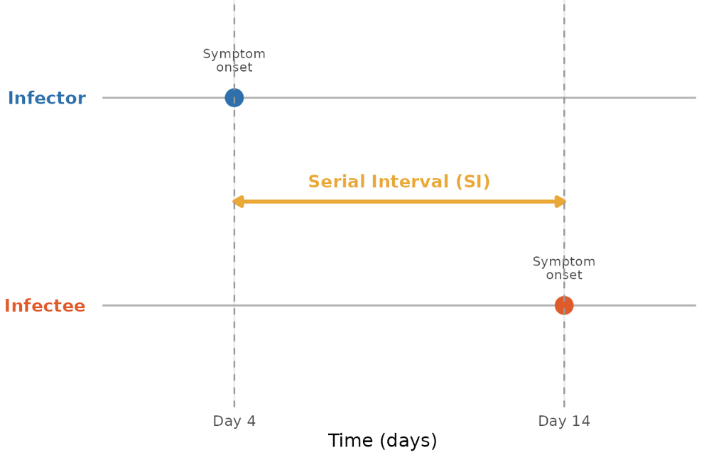
Figure 1. Definition of the serial interval (the time between symptom onset in an infector and infectee).

- Reporting delay distribution

The reporting delay is defined as the time between symptom onset and case reporting (in the absence of information on time of infection). Understanding reporting delays is important because observed case counts often lag behind actual transmission events. A possible starting point is to estimate the empirical reporting delay distribution based on the available incidence data. Is the reporting delay different in periods with high disease transmission or not?

- Vaccine effectiveness estimation

Understanding vaccine-induced protection, or vaccine effectiveness (VE), is essential for defining effective vaccination programs. VE is an observable, population-level proxy of individual immunity from vaccination and describes the reduction in infection risk among vaccinated compared to unvaccinated individuals. Vaccine effectiveness is defined as

$$VE=1-RR$$

where RR is the relative risk of infection among vaccinated versus non-vaccinated individuals. Determining VE is hindered two interconnected challenges: (i) observational data makes it difficult to distinguish true VE from confounding factors (e.g., immunity aquired through natural infection, selective depletion of high-risk individuals) and (ii) standard statistical approaches can only approximate loss of protection over time and are known to produce biased estimates.

$$VE=1-RR$$

A particularly important source of bias arises from susceptible depletion. As an epidemic progresses, unvaccinated individuals who are most susceptible to infection are preferentially infected and leave the at-risk population. This progressively changes the composition of the unvaccinated comparator group, generating an apparent decline in measured VE even when true, individual-level protection has not changed. Distinguishing this artefact from genuine immunological waning is one of the central methodological challenges in VE estimation.

In this workshop, participants will estimate VE over time from simulated epidemic data in which true protection does not wane. The goal is to characterise how and when susceptible depletion produces spurious signals of waning, and to evaluate the performance of different analytical approaches in the presence of this artefact.

