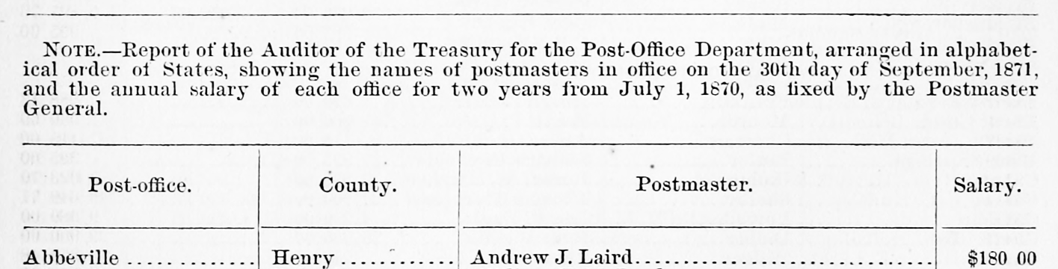

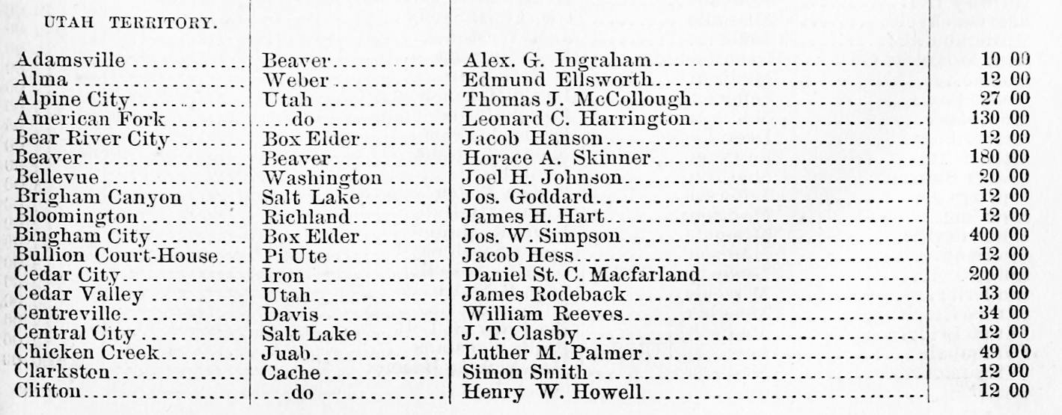

**Source: Official Register of the United States, 1871**