**Software Requirements Specification**

**for**

Builder’s Block

**Version 1.0 approved**

**Prepared by Kenny Lema, William J. Dolley, Kylie Marbury-Savage, Addam Shover, Owen Leavitt**

**Bears Den Burrito Bowl**

**2/26/2025**

**Table of Contents**

**Table of Contents ii**

**Revision History ii**

**1. Introduction 1**

1.1 Purpose 1

1.2 Document Conventions 1

1.3 Intended Audience and Reading Suggestions 1

1.4 Product Scope 1

1.5 References 1

**2. Overall Description 2**

2.1 Product Perspective 2

2.2 Product Functions 2

2.3 User Classes and Characteristics 2

2.4 Operating Environment 2

2.5 Design and Implementation Constraints 2

2.6 User Documentation 2

2.7 Assumptions and Dependencies 3

**3. External Interface Requirements 3**

3.1 User Interfaces 3

3.2 Hardware Interfaces 3

3.3 Software Interfaces 3

3.4 Communications Interfaces 3

**4. System Features 4**

4.1 System Feature 1 4

4.2 System Feature 2 (and so on) 4

**5. Other Nonfunctional Requirements 4**

5.1 Performance Requirements 4

5.2 Safety Requirements 5

5.3 Security Requirements 5

5.4 Software Quality Attributes 5

5.5 Business Rules 5

**6. Other Requirements 5**

**Appendix A: Glossary 5**

**Appendix B: Analysis Models 5**

**Appendix C: To Be Determined List 6**

**Revision History**

| **Name** | **Date** | **Reason For Changes** | **Version** |
| --- | --- | --- | --- |
| Initial Version | 03/05/2024 | Initial | 0.0.1 |
| Updated Doc | 03/12/2025 | Instructor feedback from deliverable 0  -updating functional and non-functional requirements  - | 0.0.2 |
| Updated Doc | 4/13/2025 | Updated UI elements | 0.0.3 |
| Updated Doc | 5/8/2025 | -Instructor feedback from previous deliverables  -Final revisions update  -Updated UI pics | 0.0.4 |

# **Introduction**

## **Purpose**

*Builder’s Block v0.01*

*Developed by Bears Den Burrito Bowl*

The software will provide users with the ability to generate color palettes using **MC** blocks to inspire builds.

This SRS outlines the requirements for the entire Builder’s Block system, including palettes and other tools.

## **Document Conventions**

Bold size 18 Times - Section heading

Bold size 14 Times - Subsection headings

Bold size 11 Arial - Important words

Italics size 11 Arial - To do

Arial size 11 Arial - Body text

Highlighted size 11 Arial - Super important items

Blue size 11 Arial - Names for subsystems

hyperlinked size 11 Arial - Important links

## **Intended Audience and Reading Suggestions**

**Developers** will use this document to understand the functional and non-functional requirements that guide system design and implementation. **Project managers** will refer to the SRS to define project scope, timelines, priorities, and resource allocation. **Marketing staff** may use the SRS to align the product's features with market needs and user expectations. **Users** or their representatives will use the document to ensure the product meets their needs. **Documentation writers** will use the SRS to create user manuals, FAQs, and other documentation. They should focus on user requirements and any interface specifications.

This is suggested to be read top to bottom, so they understand how everything works.

## **Product Scope**

The specified software is a **Minecraft Block Palette Assistant**, designed to simplify the process of selecting and organizing block combinations for players building in **MC**. It’s purpose is to assist users in creating visually cohesive and aesthetically pleasing designs by leveraging color theory and theme based recommendations. Some benefits of our product include time and effort spent experimenting with block choices, enhancing creativity, and improving overall quality of builds.

## **References**

None, as of right now

# **Overall Description**

## **Product Perspective**

There are other systems that do similar things to Builder’s Block (eg. [Block Palettes](https://www.blockpalettes.com/), [Minecraft Wiki](https://minecraft.wiki/)), but they lack certain features that Builder’s Block will not. Builder’s Block will serve as an alternative to them.

## **Product Functions**

* Generate color palettes using **MC** blocks based on filters provided by the user
* Filters will consist of block(s) to be included, preset tags, and general colors.
* Circle generator tool
* Accounts

## **User Classes and Characteristics**

Novice **MC** builders:

Novice builders are mainly who the website is aimed to assist. They have a hard time coming up with designs and palettes that look good. They will find the website useful in all aspects as it will majorly assist in their ability to create good looking builds. They can parse the website and find out what they like. It will also help them to realize their design preferences and eventually stop needing the website.

Expert **MC** builders:

Expert builders will also find use for BB. Everyone runs out of ideas at some point, even the experts. They won’t need it often, but when they eventually can’t come up with a good palette, BB will give them the burst of inspiration they need to get going again.

## **Operating Environment**

Builder’s Block is a website. It should function on any operating system that can run a browser. It should be able to coexist with any application.

## **Design and Implementation Constraints**

The software must be operational in a standard web browser.

Will not have access to a large scale database.

## **User Documentation**

There is currently no User Documentation associated with this document.

## **Assumptions and Dependencies**

It is assumed that a reliable and up-to-date source for **MC** block data will be available for integration. If such a source is unavailable or becomes inaccessible, development could be delayed. Dependencies on frameworks and libraries are critical for development. Issues such as discontinued support, licensing changes, or compatibility problems could impact the project timeline. The project assumes sufficient time to complete the planned features. Any reduction in the timeline due to unforeseen circumstances could result in feature delays or scope reductions. Inaccurate or outdated block data would undermine the software’s core functionality, requiring additional resources to build and maintain a custom database.

# **External Interface Requirements**

## **User Interfaces**

Rows of pages at the top that link to each page.

* circle generator
* random palette from color
* logo for home page

a circle in the top left that has login and profile controls

* logout/login
* favorited palettes
* profile settings

## **Hardware Interfaces**

The only supported system will be desktop/mobile browser

## **Software Interfaces**

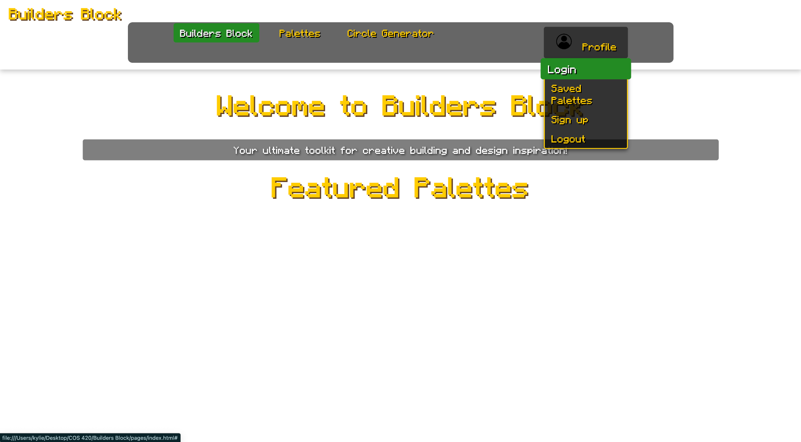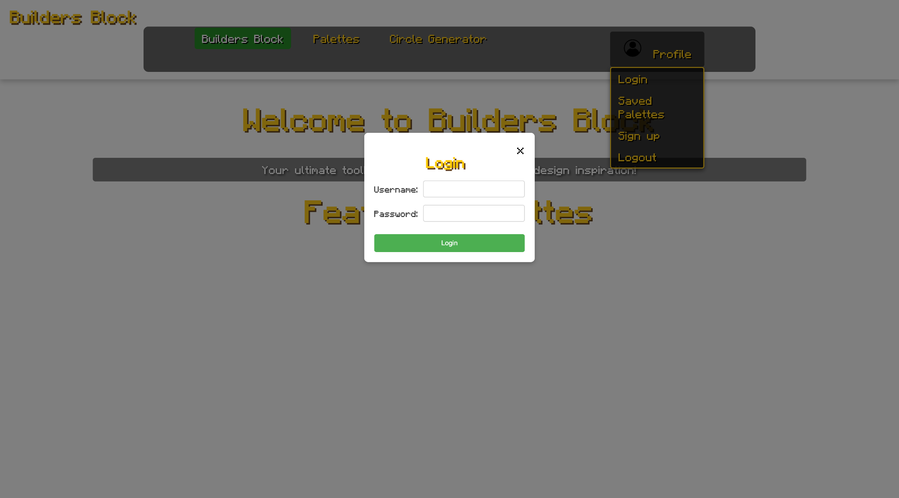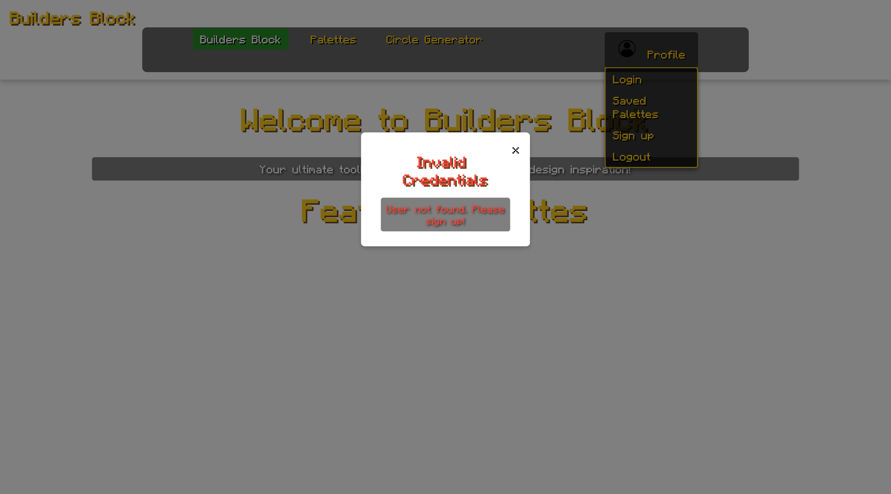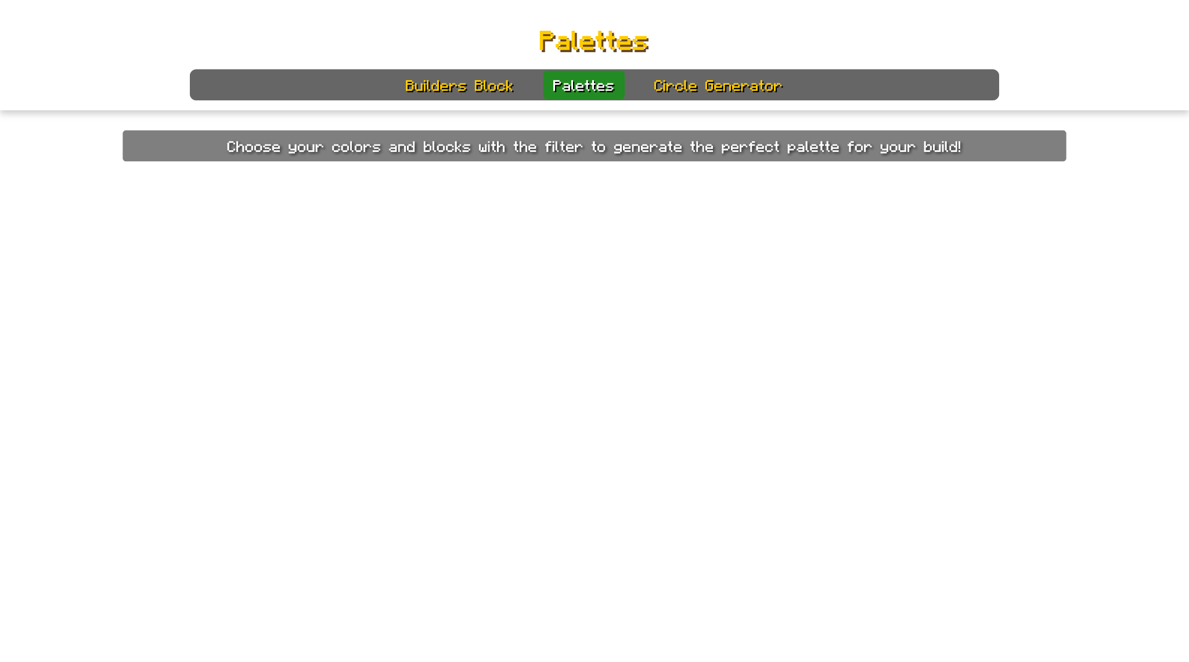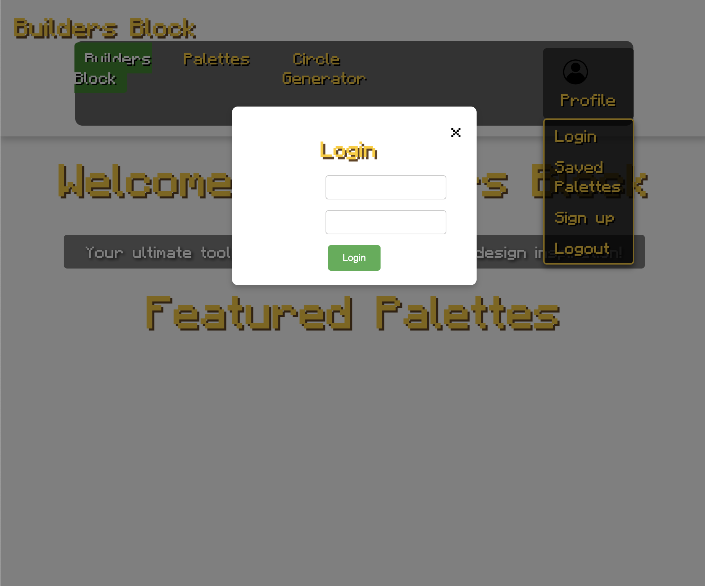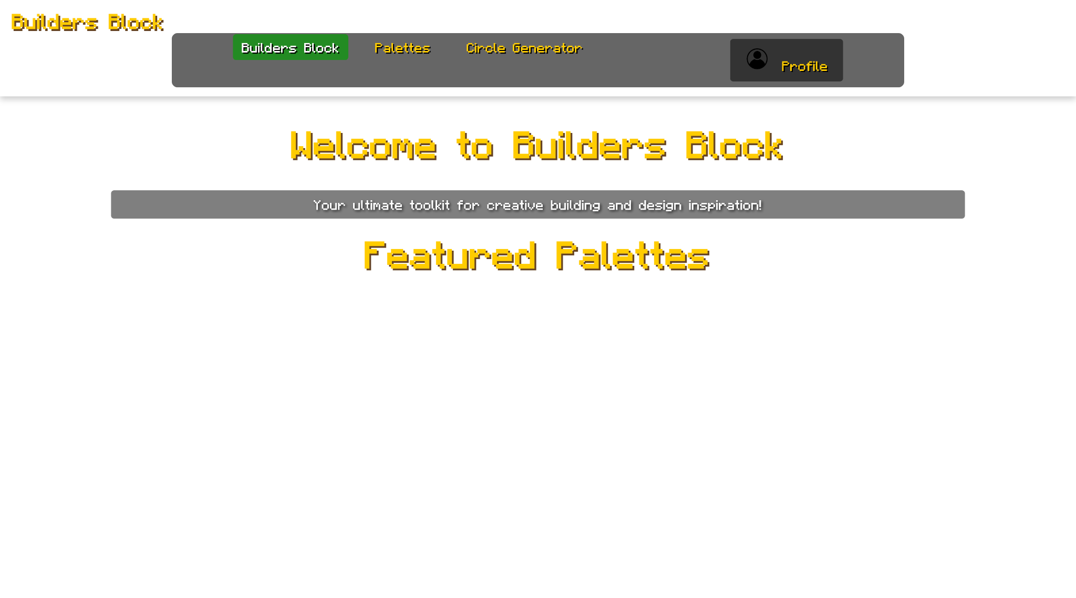

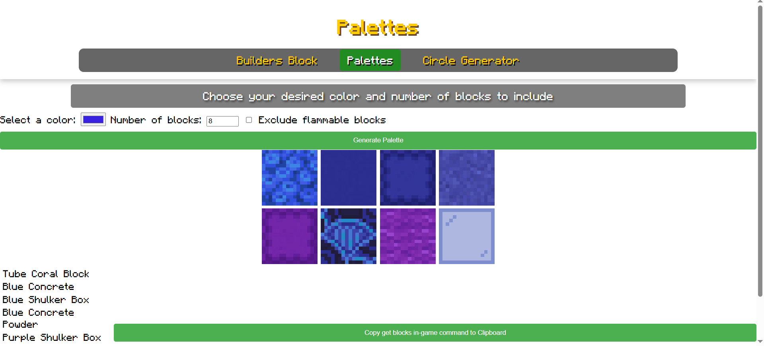

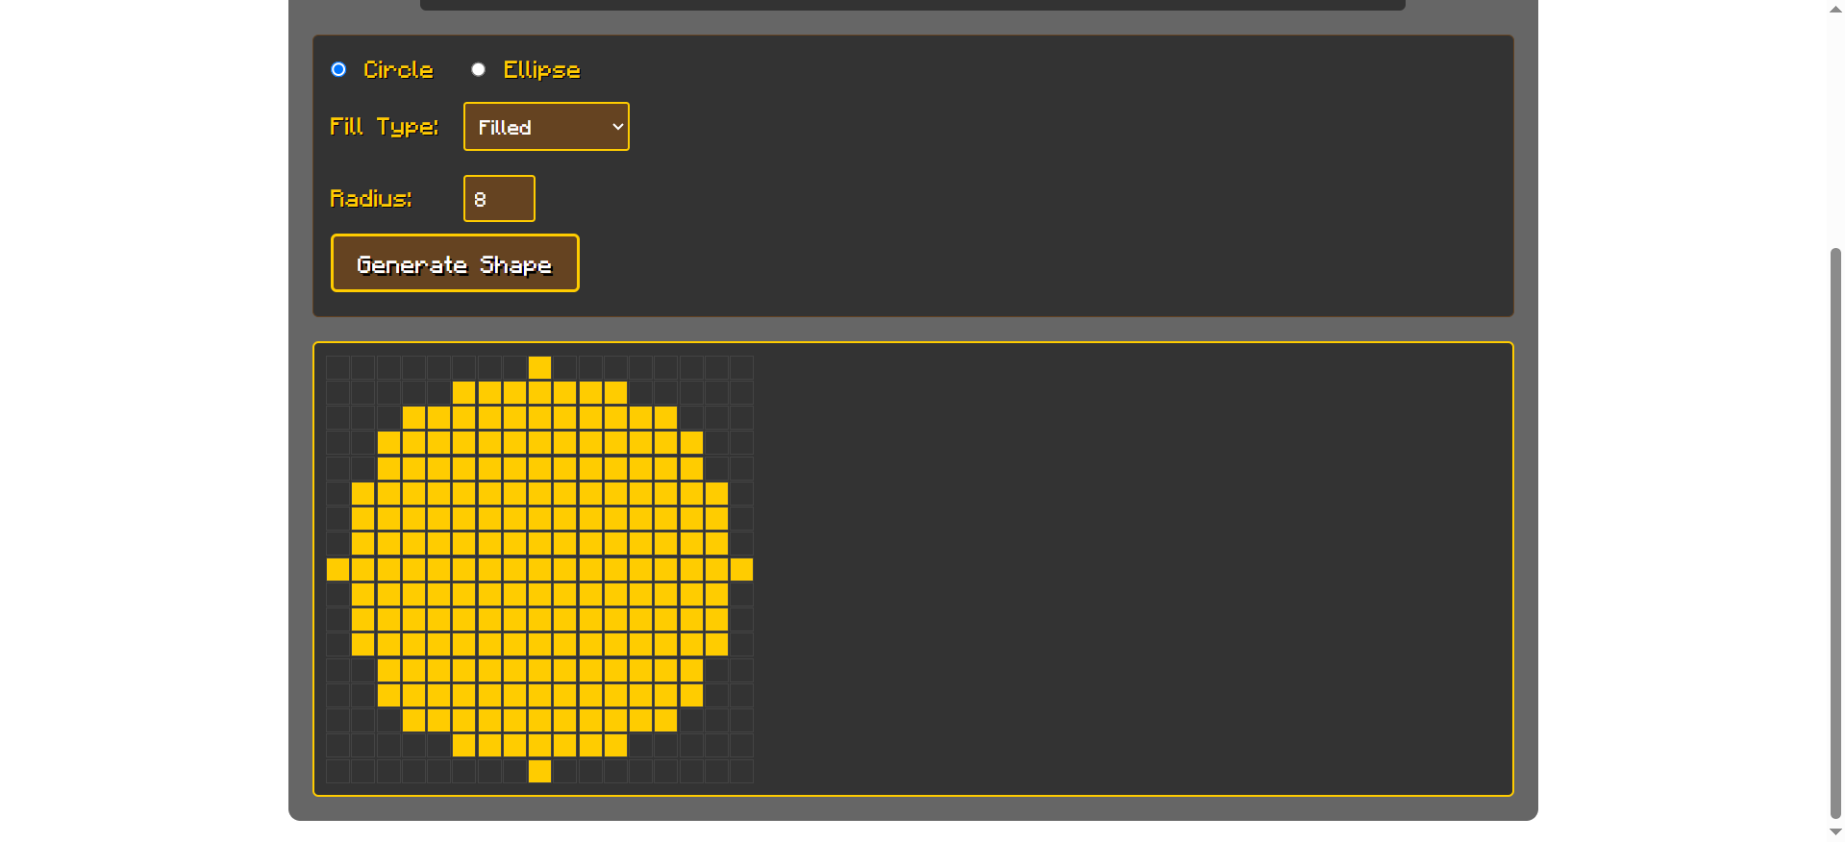

The system needs to interface with a database of password and username pairs.

The system needs to interface with a database of favorite palettes per account.

## **Communications Interfaces**

The product must be accessible via modern web browsers using HTTP/HTTPS protocols. The web interface will serve as the primary platform for users to access features like palette generation and block data browsing. HTTP/HTTPS for web communication.

# **System Features**

## Palette Generator

**4.1.1 Description and Priority**

Priority: High

-This feature allows users to input a **MC** block, and the system will generate a matching color palette based on the block’s colors. The generated palette can be used for design purposes, ensuring aesthetic consistency in **MC** builds or related creative projects.

Benefit**:** 9 (Enhances user experience by providing useful color recommendations)

Cost**:** 5 (Moderate development effort required for color extraction and matching)

**4.1.2 Stimulus/Response Sequences**

User Action: The user enters the website and sees a search bar or selection menu for **MC** blocks.

System Response: The system loads the interface and displays a list of available blocks or a text input for the user to specify a block.

User Action: The user selects or types the name of a **MC** block or specific color and submits the request.

System Response: The system retrieves the block’s texture data or predefined color palette and begins processing the color extraction/matching.

User Action: The user waits while the system processes the request.

System Response: The system analyzes the block’s colors and displays a visually appealing palette

User Action: The user views and interacts with the colored palettes

System Response: The system allows the user to copy colors, save the palette, or download it in a preferred format.

**4.1.3 Functional Requirements**

REQ-1: The system shall enable users to search for specific blocks when creating a palette.

REQ-2: The system shall provide sorting tools for blocks (e.g., flammability, color)

REQ-3: The system shall provide a search bar or selection menu for users to input or choose a **MC** block.

REQ-4: The system shall enable users to create and save custom patterns.

REQ-5: The system shall allow users to download a palette as a text file or png.

REQ-6: The system shall handle errors by displaying an error message if the block cannot be processed or if an unexpected error occurs.

REQ-7: The system shall allow users to reset or generate a new color palette without requiring a page refresh.

REQ-8: The system shall include a gallery showcasing most popular designs for inspiration.

REQ-9: The system shall provide information on each block that is presented in a palette.

REQ-10: The system shall enable users to create and save block palettes for projects.

REQ-11: The system shall enable users to share their filters directly via a link.

REQ-27: The system will generate a minecraft command that will give a

shulker box of the items present in the palette.

## Circle Generator

**4.2.1 Description and Priority**

Priority: Medium

-This feature will allow the user to create circles in **MC**, with any height and radius provided. -This feature will make the process of calculating how to make **MC** circular builds much more efficient.

Benefit**:** 8 ( It makes creating circles in **MC** much easier and user-friendly)

Cost**:** 5 ( Moderate development effort required for a quick formula to output dimensions to create circles)

**4.2.2 Stimulus/Response Sequences**

User Action: The user navigates to the website and selects the "Circle Generator" feature.

System Response: The system loads the interface with input fields for height and radius selection.

User Action: The user enters the desired height and radius values for the circle.

System Response: The system validates the input to ensure it is within acceptable limits. If the input is invalid, an error message is displayed.

User Action: The user submits the request to generate the circle.

System Response: The system calculates the block placements required to create a circular structure in **MC** and generates a visual representation of the circle

User Action: The user views the generated circle

System Response: The system allows the user to download it as an image, or tweak the height/radius to regenerate the structure.

**4.2.3 Functional Requirements**

REQ-12: The system shall provide input spaces for users to specify the desired height and radius of the circle.

REQ-13: The system shall validate the user’s input to ensure that the height and radius are positive integers within a reasonable range. If invalid, an error message will be displayed.

REQ-14: The system shall calculate the block placements needed to create a circular shape based on the provided dimensions.

REQ-15: The system shall generate a visual representation or text-based blueprint that guides the user in building the circle in Minecraft.

REQ-16: The system shall present the generated blueprint in a clear format.

REQ-17: The system shall allow users to download circle blueprints as a PNG.

REQ-18: The system shall support quick modifications, enabling users to adjust the height and radius without needing to restart the process.

REQ-19: The system shall ensure that the generated circle maintains accuracy by following Minecraft block placement logic.

REQ-20: The system shall handle errors, displaying appropriate messages if an issue occurs during processing.

REQ-21: The system shall provide clear error messages for users in case of failure (e.g., server downtime or invalid input).

## General System

**4.3.3 Functional Requirements**

REQ-22: The system shall provide support for English.

REQ-23: The system shall allow users to create accounts and log in to save their preferences and designs.

REQ-24: They system shall ensure ADA compliance, including proper use of semantic HTML, alt text for images, and keyboard navigation.

REQ-25: The system shall ensure the website works seamlessly on desktop, tablet, and mobile devices.

REQ-26: The system shall allow users to switch between light and dark modes.

# **Other Nonfunctional Requirements**

## **Performance Requirements**

NON-REQ 1- The system will allow the user to use the website within 2 seconds of login in.

NON-REQ 2 - The website must load all pages and tools within 3 seconds under 1,000 concurrent users.

NON-REQ-3: - The system will handle up to 10,000 concurrent users without significant performance degradation.

NON-REQ-4: - The platform will maintain 99% uptime annually.

NON-REQ-5: - The system will return search results within 3 seconds.

NON-REQ-6: - This website shall create a circle within 2 milliseconds of user input.

NON-REQ-7: - The platform will support the addition of new resources (e.g., patterns, tutorials) only requiring 2 hours of downtime.

NON-REQ-8 - The system will deliver accurate results for tools like the circle generator and pattern creator 95% of the time.

NON-REQ 16 - Non-functional Requirements: The system will generate commands that work 99% of the time.

## **Safety Requirements**

NON-REQ-9: - The system will prevent data leaks of passwords and account information by making sure that the password users give meet requirements. These requirements include; being a minimum of 8 charters, one special charter and at least 2 numbers.

## **Se**c**urity Requirements**

NON-REQ-10: - All user data must be encrypted during transmission via HTTPS and stored.

## **Software Quality Attributes**

NON-REQ-11: - The website will accurately fit the size of 16:9, 8:6, and 20:9 screens.

NON-REQ-12: - The site must work across Chrome, Firefox, Safari, Opera GX, and Microsoft Edge.

NON-REQ-13: - The website will have consistent formatting through each tab, including titles, subtitles and body of paragraphs

## **Business Rules**

This platforms main selling point will be it’s automatic generation of palettes, allowing for never before seen palettes

**Appendix A: Glossary**

**mBDBB** - Bear’s Den Burrito Bowl

**BB** - Builder’s Block

**MC** - Minecraft

**Appendix B: Analysis Models**

N/A

**Appendix C: To Be Determined List**

1. <https://minecraft.wiki/>
2. <https://www.blockpalettes.com/palettes?block=spruce_planks>