* Requirements (2)
  + Use Case Model
  + Actor Details
  + Use Case Details
* Technology Plan (1)
* Risk Analysis (1)
* Effort Estimate (2)
  + Nominal Effort Calculation
  + Effort Estimate
* Initial Architecture

Requirements

Use Case Model

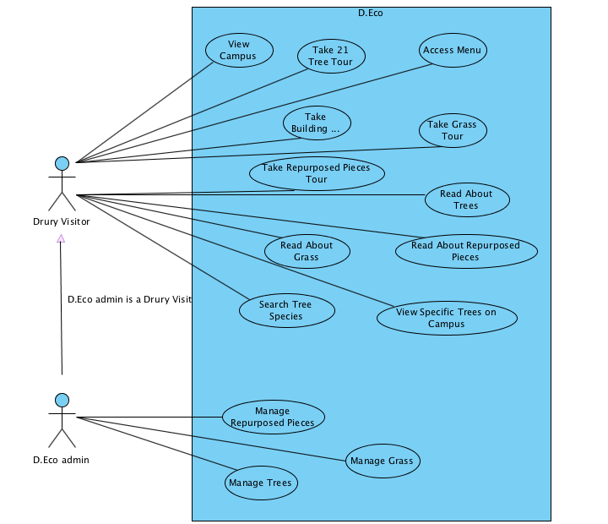

Actor Details

|  |  |
| --- | --- |
| Actor | Description |
| Drury Visitor | A Drury visitor is a person who uses the app to explore Drury’s buildings, grasses, and trees |
| D.Eco Admin | A D.Eco admin is a person who can manage (add, delete) the building, grass, and tree information |

Use Case Details

|  |  |
| --- | --- |
| Use Case | Description |
| View Campus | A *Drury Visitor* looks at the campus map, which contains options to look at trees, buildings, or repurposes pieces, or grass. In addition, they can see their current location. |
| Take 21 Tree Tour | A *Drury Visitor* views trees on map and is able to see their current location. In addition, they can click on specific trees. |
| Access Menu | A *Drury Visitor* can select which tour they want to take (tree, repurposed pieces, grass or building) |
| Take Building Tour | Drury Visitor views buildings on the campus map and is able to see their name and information about the building. |
| Take Grass Tour | A *Drury Visitor* looks at different species located on campus and is able to see information about the species. |
| Take Repurposed Pieces Tour | A *Drury Visitor* looks at the different pieces on campus and can click on more information about the pieces. |
| Read About Trees | A *Drury Visitor* reads detailed information (species, paragraph about, in honor of person, and pictures) about the specific tree clicked. |
| Read About Repurposed Pieces | A *Drury Visitor* reads detailed information about specific repurposed piece clicked. |
| Read About Grass | A *Drury Visitor* reads detailed information about specific grass clicked. |
| View Specific Trees on Campus | A *Drury Visitor* can see the unique species mapped on the campus. |
| Search Trees Species | A *Drury Visitor* uses a search bar to look for specific species on Drury’s campus |
| Manage Repurposed Pieces | A *D.Eco Admin* adds, deletes, or edit information about repurposed places. |
| Manage Grass | A *D.Eco Admin* adds, deletes, or edit information about grasses. |
| Manage Trees | A *D.Eco Admin* adds, deletes, or edit information about trees. |

Technology Plan

|  |  |
| --- | --- |
| Technology | Experience Rating |
| Phone App Technologies | |
| iOS |  |
| Android |  |
| Cordova |  |
| Windows 10 Phone |  |
| Map Technologies | |
| Google Maps |  |
| Microsoft Bing maps |  |
| OpenLayers |  |
| OpenStreetMap |  |
| Application & Web Development | |
| Java |  |
| Swift |  |
| HTML 5 |  |
| Javascript |  |
| JQuery Mobile |  |
| BootStrap Framework |  |
| Ionic Framework |  |
| Web Server Scripting | |
| PHP |  |
| Microsoft ASP .NET |  |

Risk Analysis

Effort Estimate

|  |  |  |  |
| --- | --- | --- | --- |
| Screen/Report | Complexity | Obj Points | Notes |
| View Campus | 1 | 1 | Screen will be constructed by reading Drury location from data source |
| Subscreen | | | |
| Access Menu | 1 | 1 | Simple drop down with text tabs |
|  | | | |
| Take 21 Tree Tour | 2 | 2 | Screen will be constructed by Drury’s location and individual location from data source |
| Subscreen | | | |
| Read About Trees | 1 | 1 | Simple text with some images on screen |
| Search Tree Species | 1 | 1 | Simple search bar that access data source |
| View Specific Trees on campus | 2 | 2 | Filter specified tree requested from search bar, and access data source |
|  | | | |
| Take Building Tour | 2 | 2 | Screen will be constructed by Dury’s location and individual location from data source |
| Subscreen | | | |
| Read About Repurposed Pieces | 1 | 1 | Simple text with some images on screen (from database?) |
|  | | | |
| Take Grass Tour | 2 | 2 | Screen will be constructed by Drury’s location and individual location from data source with grass location |
| Subscreen | | | |
| Read about Grasses | 1 | 1 | Simple text with some images on screen (access database?) |
|  | | | |
| Take Repurposed Pieces Tour | 2 | 2 | Screen will be constructed by Duryr’s location and individual location from data source with repurposed pieces location |
| Subscreen | | | |
| Read about repurposed pieces | 1 | 1 | Simple text with some images on screen (access databse?) |
|  | | | |
| Manage Repurposed pieces | 1 | 1 | Simple screen and access to database |
| Manage grass | 1 | 1 | Simple screen and access to database |
| Manage trees | 1 | 1 | Simple screen and access to database |
| Screen Total |  | 20 | Total object points for screen |
| 3GL Modules | | | |
| Map Modules | 5@10 | 50 | Module requiring scripting against a map API |
| GPS Tour | 5@10 | 50 | Module to find individual location with GPS |
| Server Modules | 4@10 | 40 | Data server for all 4 Map Modules |
| 3GL Total |  | 140 | Total object points for 3GL Module |
| Total Object Points |  | 160 | Total object points for the project |

Effort Estimate Assumptions

Initial Architecture