About our company:

Our company is here to help you design a website to make you look like a web design wiz without needing the experience to do so. With an extensive variety of expertise, we are able to work with a wide range of clients. From company websites to cooking websites to personal blogs we can do it all! There is no challenge that Wizard Web Design can’t handle.

Mission statement:

Get the first steps started in making your idea a reality by working with Wizard Web Design.

Services:

We make website as small or big as you need! We make websites from 1 page to 5 pages. We have a flat fee of 10 dollars per page and 12 per hour spent working on your website. We can guarantee that you will get the best quality website that we can provide you.

Portfolio:

coffee shop website: 3 pages

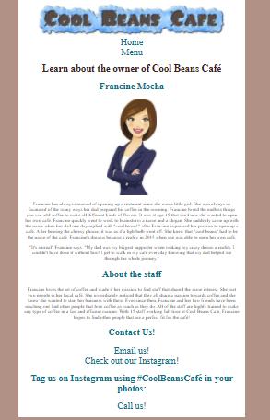pg. 1 main index pg 2 menu pg 3 more info about coffee shop owner

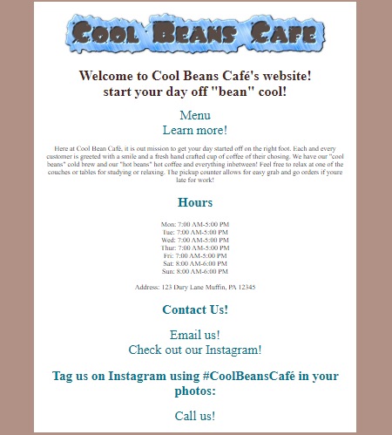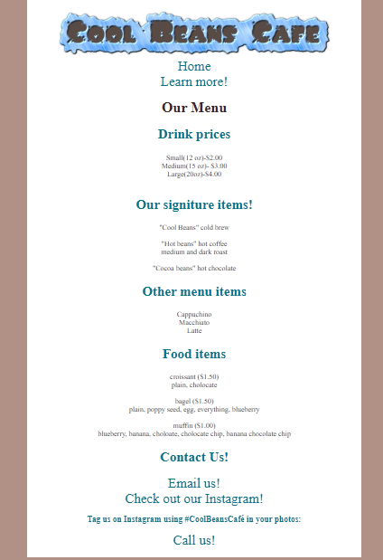

Holiday website

