**Personal Portfolio Template**

Group 21

Kylie Stride – n5413796

<https://github.com/kyliestride/IFB299-Portfolio>

# **Artefact 1**: BRUM Database

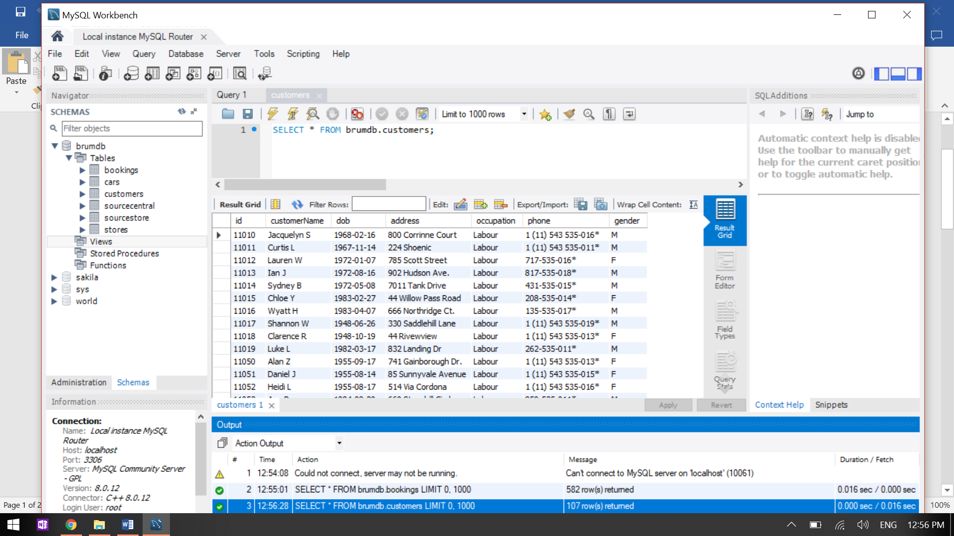

I converted the sample spreadsheets to .csv files, which I then imported as tables into MySQL. I then wrote the SQL to build and populate a database with the data in those imported tables. The data is organised and formatted in such a way that it is easily understood by users of the website.

The database is to be used to provide the data for the website prototype. The SQL is written in such a way that it will read any amount of data imported, assuming that the data organisation and formatting will be consistent for both the central and store databases. It will be linked to the website using Django.

# **Artefact 2**: BRUM Database UML Diagram

Prior to building the SQL for the database, I created a model in MySQL. This model was based on the above UML diagram. The diagram shows the relationships between the tables in the database. It has been used as a constant reference point for the building of the database, and it was the basis for the group’s understanding of how classes might be built. It has helped in keeping a clear picture of the data and how it should be handled.

# **Artefact 3**: UI Design: Account Overview: Users

# 

I created a series of UI mockups for the Account Overview page for customers. There are five images total in the series, each of which illustrates a design for a tab in the account options panel. “Profile” allows users to change their data in the Customers table (excluding the user ID). “Bookings” allows users to browse current bookings, while “History” displays past bookings. “Security” allows users to change their passwords and “Account” allows them to delete their account.

This series of UI mockups provided a jumping-off point for the developers of the front-end website code (HTML, CSS, etc.) when creating the Account Overview page.

# **Artefact 4**: UI Design: Individual User Lookup: Staff View

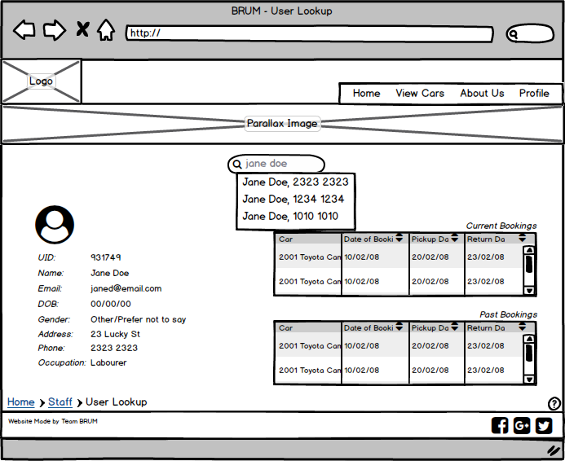

I created this UI design for the page staff use to look up Brum’s users. The search bar in the middle-top of the page dynamically searches by name and phone number to allow staff to view users one at a time. The left column includes all the information in the user’s entry in the Customers table in the database. On the right, two tables list all the current and previous bookings linked with the user’s ID.

This UI mockup provided a jumping-off point for the developers of the front-end website code (HTML, CSS, etc.) when creating the User Lookup page.

# **Artefact 5**: Agenda and Minutes

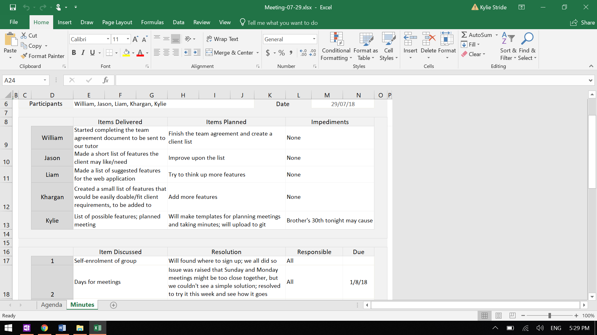

In the beginning of the semester, I created an Excel template for the keeping of meeting records. There are two parts to the template: the agenda and the minutes. The agenda has fields for the date, time, and location of the planned meeting, items carried from the previous meeting, and additional items to be discussed. The minutes has fields for the date, who attended, each attendee’s input for the stand-up meeting, each item discussed in the meeting, and any additional notes.

Over the course of the semester, I used this template for every meeting. I planned ahead in the agenda, listing items to be addressed in the coming meeting according to previous discussion and my own understanding of what we needed to do. At the beginning of each meeting, I initiated a quick stand-up meeting and noted down everyone’s input. During each meeting, I used the agenda to keep the discussion on track and to ensure that everything was covered that needed to be covered. I then made sure to ask if anyone had any more points to discuss before we wrapped up.

These templates were extremely useful for me. In my position as scrum master, having the agenda prepared ahead of time helped me to be sure that we were on track as much as possible. The minutes also helped as a reference to remind myself of what everyone was doing and helped to give me a broader picture of how everyone was going, meaning I could reach out privately to particular team members who I thought might be struggling. I also endeavoured to put the agenda and minutes up where the others could access them, and so I hope that they made good use of them. I had hoped (and suggested) that others would contribute to the agenda ahead of time, but this did not happen.