Project 2
Kylin Sun
2025-11-17

Plot 1: Monthly Average CO and O3 (2018–2020)
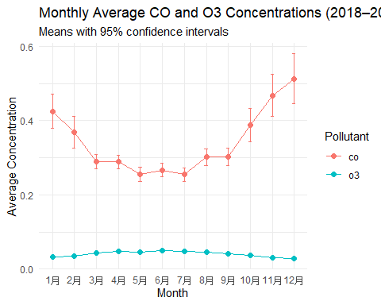
Plot 1 shows the monthly average concentrations of CO and O3 across all three years combined. O3 displays a clear seasonal pattern, with higher levels in the summer months and lower levels during winter. CO shows the opposite pattern, with higher concentrations in winter and lower concentrations in summer. The 95% confidence intervals are relatively narrow, suggesting that the monthly averages are estimated with good precision.

Plot 2: Monthly Average PM2.5 by Year
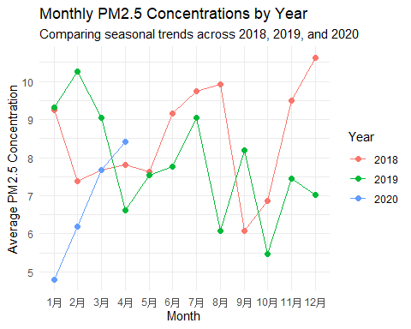 Plot 2 compares the monthly average PM2.5 concentrations for 2018, 2019, and 2020. The monthly patterns for 2018 and 2019 are relatively similar, although 2019 appears slightly lower in several months. The 2020 values only cover January through April, so the line is shorter and cannot be directly compared across all months. Overall, PM2.5 shows noticeable month-to-month variability, but no consistent seasonal pattern across all three years.

