九十學年度「全國大專電腦軟體設計競賽」
大學甲組試題
Notes for Contestants
- There are 7 problems for the contest. You may work on the problems in any order.
2. You may use any algorithm/method to solve the problems. However, the execution
time of your program for each problem must not exceed 60 seconds, otherwise the
program will be considered run-time exceeded.
3. Input files for the problems are preinstalled in the system for automatic judging. The input files are named according to the problem ID, where “UXin.txt” is the input file for Problem X. The input and output formats of your program must be designed according to the input and output formats described in each problem.
4. Since Visual Basic does not support console mode applications, VB programs should print output to the file “output.txt” instead of the standard output.
Problem 1

Harmonic Coherence Problem

Let T=(V, E) be a directed tree where V is the vertices set and E is the directed edge set. Two trees T₁=(V₁, E₁) and T₂=(V₂, E₂) are said to be equivalent, denoted by T₁≡T₂, if V₁=V₂ and E₁=E₂. Also let S_{T}(r) be a spanning tree derived based upon T by taking vertex r as the root. We say two directed trees T₁ and T₂ can harmonically cohere, denoted by T₁∼T₂, if every v∈V₁∩V₂, S_{T1}(v) ≡ S_{T2}(v). Take the following trees for example. T₁∼T₂, because S_{T1}(v) ≡ S_{T2}(v) when v=4, 5, 7 and 8. T₁ and T₃ are not harmonically coherent, because S_{T2}(v) ≠ S_{T3}(v) when v=1, 2 and 3. Note that T₂∼T₃, because V₂∩V₃=∅ satisfies the harmonic coherence condition.

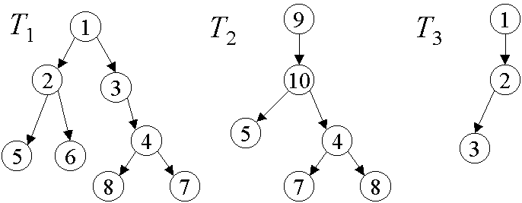

Given a tree set E, we define the harmonic degree of it, denoted by h(E), as the number of tree pairs (T_{i}, T_{j}), where T_{i} and T_{j} ∈E, such that T_{i}∼T_{j}. In the above example, h({T₁, T₂, T₃})=2.

Given a tree set E, please write a program to find h(E). We assume (1) there are at most 500 vertices, numbered in the range from 1 to 500, (2) each vertex has at most 2 outgoing degrees and (3) the number of trees in E is no more than 10. Note that a tree with n vertices may have a vertex whose number is greater than n (See the above tree T₂).

Input format: The input data contains several test sets. Each test set ends with a “/”. However, the last test set ends with double slashes ‘//’. Within each set, several trees are given. Each tree is described in terms of a sequence of vertex-id triples (n, l, r), where n is the vertex id, l and r are the vertex id of vertex n’s two children. In the absence of any child, null id “0” is used. At the end of the sequence, a null triple (0,0,0) will be followed.

Output format: For each test set, output the value of h(E) in a line according to the sequence of test sets, where E is a set of input trees. Note that each line contains only one h(E).

Sample input:
1 2 3
2 0 4
0 0 0
1 0 2
2 3 4
0 0 0
/
1 2 3
2 5 6
3 0 4
4 8 7
5 0 0
6 0 0
7 0 0
8 0 0
0 0 0
9 10 0
10 5 4
4 7 8
5 0 0
7 0 0
8 0 0
0 0 0
1 2 0
2 3 0
3 0 0
0 0 0
//
Sample output:
0
2

Problem 2
Tree Comparison

Given a set of n organisms, V ={ v₁,v₂ …, v_{n}}, their evolutionary relation ordinarily can be represented by a so-called phylogenic tree of n leaves labeled with v₁,v₂ …, v_{n} . The removal of any edge in a phylogenic tree of V forms two subtrees and thus induces a partition of V into two subsets. Intuitively, two organisms are closer in evolutionary relation than the other two, if less edges are removed such that the formers are in different parties.
In practice, one does not know the real phylogenic tree of V. However, one can produce a phylogenic tree according to certain closeness measure of organisms. Different measures may produce different phylogenic trees. For two phylogenic trees, one would like to compare them to get more information about the real phylogenic tree. One of the comparison models is to compute the number of good edges as described in the following. The more good edges the higher similarity of the two phylogenic trees.

Given two phylogenic trees T₁ and T₂ of V. An edge e in T₁ is called a good edge if there exists an edge e’ in T₂ such that they induce the same partition of V in T₁ and T₂ respectively; otherwise it is called a bad edge.
The problem is: Given two phylogenic trees T₁ and T₂ of V, count the numbers of good edges in T₁.
Example:
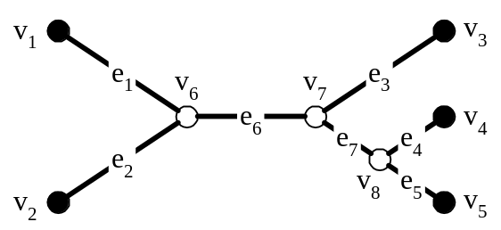
Figure 1: Tree 1.
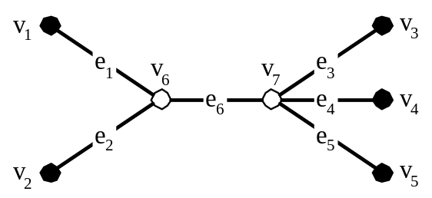
Figure 2: Tree 2.

Tree 1 and Tree 2 depicted in Figure 1 and 2 respectively are of leaves with the same set of labels {v₁, v₂, v₃, v₄, v₅}, but with different tree structures. In Tree 1, if we remove edge e₆, the leaves are partitioned into two parties: {v₁, v₂} and {v₃, v₄, v₅}. In Tree 2, if we remove the edge e₆, we will obtain the same partition. Thus e₆ in Tree 1 is a good edge, also e₆ in Tree 2 is a good edge. In contrast, if we remove e₇ in Tree 1, we obtain a partition: {v₁, v₂, v₃}, {v₄, v₅}, while we cannot find any edge in Tree 2 to induce this partition. Thus, e₇ is a bad edge in Tree 1.

 | v1 | v2 | v3 | v4 | v5 | v6 | v7 | v8 |  |  | v1 | v2 | v3 | v4 | v5 | v6 | v7
v1 | 0 | 0 | 0 | 0 | 0 | 1 | 0 | 0 |  | v1 | 0 | 0 | 0 | 0 | 0 | 1 | 0
v2 | 0 | 0 | 0 | 0 | 0 | 1 | 0 | 0 |  | v2 | 0 | 0 | 0 | 0 | 0 | 1 | 0
v3 | 0 | 0 | 0 | 0 | 0 | 0 | 1 | 0 |  | v3 | 0 | 0 | 0 | 0 | 0 | 0 | 1
v4 | 0 | 0 | 0 | 0 | 0 | 0 | 0 | 1 |  | v4 | 0 | 0 | 0 | 0 | 0 | 0 | 1
v5 | 0 | 0 | 0 | 0 | 0 | 0 | 0 | 1 |  | v5 | 0 | 0 | 0 | 0 | 0 | 0 | 1
v6 | 1 | 1 | 0 | 0 | 0 | 0 | 1 | 0 |  | v6 | 1 | 1 | 0 | 0 | 0 | 0 | 1
v7 | 0 | 0 | 1 | 0 | 0 | 1 | 0 | 1 |  | v7 | 0 | 0 | 1 | 1 | 1 | 1 | 0
v8 | 0 | 0 | 0 | 1 | 1 | 0 | 1 | 0
Table 1. Adjacency matrix of Tree 1 Table 2. Adjacency matrix of Tree 2

The matrices shown in Tables 1 and 2 are the adjacency matrices of Tree 1 and Tree 2 respectively. In the input format, we follow the convention that the leaf nodes are listed in front of non-leaf nodes as the matrices in Tables 1 and 2. Furthermore, the i-th leaf node of a tree is of the same label with the i-th leaf node of the other tree.

Input format:
The input data contains several test sets. Within each set, the first line contains three numbers n, m, and l, where n (2 ≤ n ≤ 50) and m (n ≤ m, l ≤ 100). The number n is the number of leaf nodes of two trees, and m and l are the numbers of nodes of the two trees respectively. After first line, there are an m × m matrix, A and then an l × l matrix, B. The matrices A and B as adjacency matrices denote two trees Tree 1 and Tree 2, respectively. As the order of nodes in the adjacency matrix, the first n nodes in Tree 1 and in Tree 2 are the leaf nodes. The ith node of Tree 1 and the ith node of Tree 2 are of the same label for 1 ≤ i ≤ n.
The end of input is signified by n = m = l = 0 (zero).

Output format:
For each test set of the input, calculate the number of good edges in Tree 1 and output it in a line.

Sample input:
5 8 7
0 0 0 0 0 1 0 0
0 0 0 0 0 1 0 0
0 0 0 0 0 0 1 0
0 0 0 0 0 0 0 1
0 0 0 0 0 0 0 1
1 1 0 0 0 0 1 0
0 0 1 0 0 1 0 1
0 0 0 1 1 0 1 0
0 0 0 0 0 1 0
0 0 0 0 0 1 0
0 0 0 0 0 0 1
0 0 0 0 0 0 1
0 0 0 0 0 0 1
1 1 0 0 0 0 1
0 0 1 1 1 1 0
4 6 6
0 0 0 0 1 0
0 0 0 0 1 0
0 0 0 0 0 1
0 0 0 0 0 1
1 1 0 0 0 1
0 0 1 1 1 0
0 0 0 0 1 0
0 0 0 0 0 1
0 0 0 0 1 0
0 0 0 0 0 1
1 0 1 0 0 1
0 1 0 1 1 0
0 0 0

Sample output:
6
4

Problem 3
An Address Learning and Lookup Scheme

A speedy address learning and lookup scheme is needed to support low-delay cut-through transmission for a high speed Ethernet switch. To achieve this, one way is to construct a learning table that has 2⁴⁸ entries of memory, which can be addressed directly using the 48-bit Ethernet address. However, this is obviously not a cost-effective approach because too many entries will be wasted. The following architecture manages to reduce the lookup delay time and yet uses only the entries required by the MAC (media access control) address database the switch plans to support. Instead of using a CAM-based (CAM, content addressable memory) approach that compares the DA (destination address) of the received packet with all recorded source addresses, the approach used requires only a memory bus cycle to find out the destination port from the address-learning table.
To avoid CAM operation, the port number of a received packet is recorded in a table directly addressed by a hashed source address of the packet. We use a simple XOR-folding operation to achieve this. For the learning process, the SA (source address) of a received packet is first hashed into an n-bit binary from 48 bits. A typical implementation requires storing about 8K MAC addresses for a Class C subnet. In this case, the hashed value is 13-bit in length. The hashing process is as follows (See Figure 1 for an illustration):

Procedure Xor-folding(SA, HSA₁₃ )
/* SA: Source address.
HSA₁₃: 13-bit hashed SA.*/
{
Step 1 unpacks 48 bits into two 26-bit binaries with the last and beginning 4 bits overlapped.
Step 2 xors 26 bits.
Step 3 xors 13 bits. The result is a 13-bit binary, which is then used directly to address the learning table.
}

Conceptually, we unpack the 48-bit Ethernet address into two 26-bit binaries and then perform bit-wise XOR operation. The resultant 26-bit value is folded and XORed again to obtain a 13-bit binary. The final hashed value is used as an address that points directly to an entry of the address-learning table.

In this way, the hashed value can be computed directly using exclusive-or operation and the delay time for this hashing function will be trivial. Using the hashed value as an address, the switch simply sets a bit in the addressed entry to indicate the input port number of the packet. That is, the bit position corresponds to the port number of the received packet. Figure 2 illustrates the organization of the address learning and lookup architecture.
In this design with no CAM operation, the learning table can be updated easily and quickly for insertion and deletion of entries without comparisons. The address table has 8K entries if we hash the addresses into a 13-bit binary. For a low cost switch, this is a typical system requirement for the MAC address database. More MAC addresses can be stored by increasing the number of bits of the hashed value through the XOR-folding process. The learning table is dynamically shared by all of the ports. An aging function can be used to invalidate the entries periodically for re-learning.
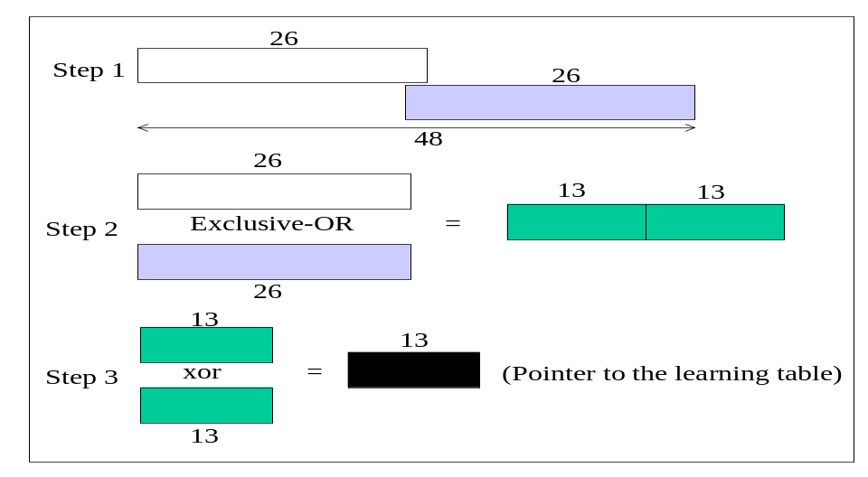

Figure 1. Hashing function based on XOR-folding to obtain a 13-bit address pointer.
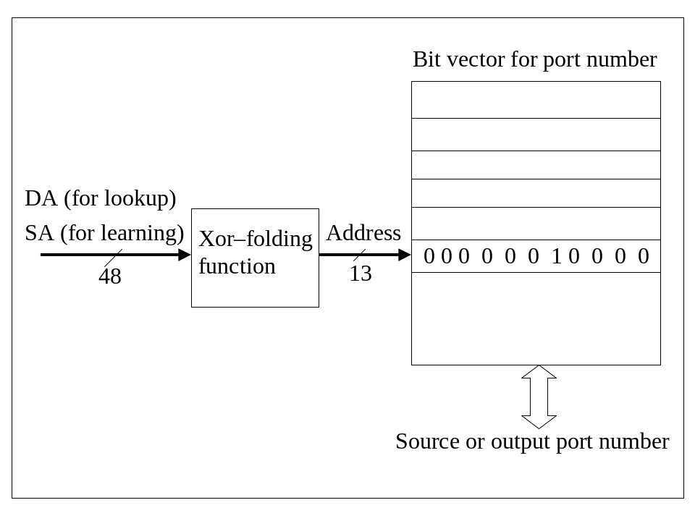Figure 2. Address learning and lookup architecture.

Specifically, the learning algorithm is shown in Figure 3.

Procedure: Learning (SA, SP[N:1])

/* SP[N:1]: Current source port ID. Corresponding bit indicates the input port number of the incoming packet.
SA: Source address.
HSA_{n}: n-bit hashed SA.
M(HSA_{n})[N:1]: Destination port bit vector in the memory. */

{
HSA_{n} = Xor-folding (SA); /* Hash 48 bits to an n-bit binary. */
TEMP[N:1] = M(HSA_{n})[N:1]; /* Read current input port status at address HSA_{n} */
M(HSA_{n})[N:1] = SP[N:1] OR TEMP[N:1]; /* Add new port ID bit to the original port bit vector. */
}
Figure 3. Addressing learning algorithm.

The OR operation in the learning algorithm adds the current port identifier bit to the existing status. This is done to resolve the case of possible occurrences of hashing collision. Hashing collision occurs when two different source addresses or more are hashed into the same location. To find out the destination port number of a received packet, the first step is to extract the destination address bits from the packet, as the data are available. Then the destination address is hashed into a 13-bit binary value using the same hashing algorithm in address learning. The 13-bit binary value is simply used to read the bit vector from the address table. Through the direct mapping between the hashed SA and the hashed DA, the time of finding out the destination port requires only a bus read cycle. In the lookup process, this approach has eliminated the need for explicit comparison between the destination address of the incoming packet and the source addresses of those packets that were received previously. And in this way, we are able to achieve the lowest possible delay time in a single memory read cycle without using full 48-bit address space in constructing the MAC address table. The lookup operation is illustrated in Figure 4.

Procedure: Lookup (DA, SP[N:1])

/* DP[N:1]: Destination port bit vector.
DA: Destination address.
HDA_{n}: Hashed n-bit DA. */

{
HDA_{n} = Xor-folding (DA); /* Hash 48-bit DA into n-bit binary */
If M(HDA_{n})[N:1] == 0)
DP[N:1] = NOT SP[N:1]
/* A zero bit vector indicates that the output port has not been learnt and the received frame must be broadcast. In this case, all ports are selected as the destination except the receiving one. */
else
DP[N:1] = M(HDA_{n})[N:1];
/* The destination port(s) is (are) selected for packet output. */
}
Figure 4. Output port lookup scheme.

Since we use hashed addresses, it is possible that a hashing collision may occur. To resolve this issue, packets with different SAs that are hashed to the same entry but have a different port number from the stored one will also result in their port number bits to be set in the addressed entry. Doing this way guarantees that packets that collide the source addresses in the learning table are always delivered to their destination ports.

In this problem, ignore the broadcast address or multicast addresses specified by the Ethernet protocol.

Input format: Up to 8192 lines of the triple of (SA, DA, input port number) can be specified. The first triple represents the first packet to enter the switch, and so on. The file ends at the line with the word END. SA and DA are given in hexadecimal digit while input port number is given in decimal. The ports are numbered from 0 to 11.

Output format: The first line reports the number of hashing collisions. The second line reports the number of uni-casts (that is, the destination port of the incoming packet is found and the packet is only delivered to this port.) The third line reports the number of multicasts (including broadcasts). The fourth line reports the port number of the first unicast.

Sample input:

(DD5047733C2C, 6B2FC9397CAF, 11)
(D4028DDFA969, DD5047733C2C, 6)
(D4B9ECC83131, D4028DDFA969, 0)
(77B916BDE240, 64E7D76AE17C, 8)
END

Sample output:
1
2
2
11

Problem 4
Symbol Reference Problem

In assembly programs, we usually use symbols to define address of memory locations. An assembler has to translate those symbols into address and assemble them as part of the object code.
Suppose that we have an incomplete assembler, which has most of the functions of a complete assembler except for the part of symbol reference. The assembler assembles programs into partial object code, as shown in figure 1. In the figure, all the address of symbols are missing and represented by hyphens, “-“. Write a program to solve symbol reference problem for assembly programs.
Hint: You DON’T have to know how to assemble an assemly program. Your program just needs to construct a symbol table. For those incomplete object code, your program looks up the operands from the symbol table, and replaces the hyphens with the address for the symbol. And, it is done.

Input format:

Each line consists of five fields:
- Symbol (optional)
- Mnemonic operation (or OP code; required)
- Operands (Two or more operands are separated with a comma and a space. When Mnemonic operation is HLT, NOP, RET, or WAIT, there is no operand.)
- Starting address (required, except for the last line)
- Partially assembled object code (optional)

Fields are separated with one or more <tab> characters. When a line starts with a <tab> character, the line has an empty symbol field.

Output format:

The complete object code, each line of which corresponds to a line in the source program accordingly. For example, if there is a line in the source program for which no object code is generated, the corresponding line in the output is an empty line.

Sample input:
See Figure 2.

Sample output:
See Figure 3.

Line Symbol OP code Operands Address Object code
1. GCD START 1000
2. FIRST MOV AX, #15 1000 A307000F
3. MOV LOC1, AX 1004 A106----
4. MOV AX, #9 1008 A3070009
5. MOV LOC2, AX 100C A106----
6. L1 MOV AX, LOC1 1010 A306----
7. CMP AX, LOC2 1014 3B06----
8. JEQ L2 1018 7400----
9. JGT L3 101C 7800----
10. MOV LOC3, AX 1020 A106----
11. MOV AX, LOC2 1024 A306----
12. MOV LOC1, AX 1028 A106----
13. MOV AX, LOC3 102C A306----
14. MOV LOC2, AX 1030 A106----
15. JMP L1 1034 7000----
16. L3 MOV AX, LOC1 1038 A306----
17. SUB AX, LOC2 103C 2B06----
18. MOV LOC1, AX 1040 A106----
19. JMP L1 1044 7000----
20. L2 MOV LOC3, AX 1048 A106----
21. HLT 104C F400
22. LOC1 RESW 1 104E
23. LOC2 RESW 1 1052
24. LOC3 RESW 1 1056
25. END FIRST

Figure 1: A partially assembled program and object code

GCD START 1000
FIRST MOV AX, #15 1000 A307000F
MOV LOC1, AX 1004 A106----
MOV AX, #9 1008 A3070009
MOV LOC2, AX 100C A106----
L1 MOV AX, LOC1 1010 A306----
CMP AX, LOC2 1014 3B06----
JEQ L2 1018 7400----
JGT L3 101C 7800----
MOV LOC3, AX 1020 A106----
MOV AX, LOC2 1024 A306----
MOV LOC1, AX 1028 A106----
MOV AX, LOC3 102C A306----
MOV LOC2, AX 1030 A106----
JMP L1 1034 7000----
L3 MOV AX, LOC1 1038 A306----
SUB AX, LOC2 103C 2B06----
MOV LOC1, AX 1040 A106----
JMP L1 1044 7000----
L2 MOV LOC3, AX 1048 A106----
HLT 104C F400
LOC1 RESW 1 104E
LOC2 RESW 1 1052
LOC3 RESW 1 1056
END FIRST

Figure 2: Sample Input

A307000F
A106104E
A3070009
A1061052
A306104E
3B061052
74001048
78001038
A1061056
A3061052
A106104E
A3061056
A1061052
70001010
A306104E
2B061052
A106104E
70001010
A1061056
F400

Figure 3: Sample Output

Problem 5

The Machine Gun Problem

Some policemen are practicing shooting with a special machine gun in a shooting range. Their machine guns can be set to launch a fixed number of bullets each second after the trigger is pulled. For example, if one sets his machine gun to launch three bullets and he pulls the trigger at 12:00’00, then the machine gun will launch three bullets at 12:00’00, 12:00’01 and 12:00’02 respectively.

Now, assume we have two policemen John and Peter who are practicing shooting with their machine guns. John sets his machine gun to launch three bullets for each shooting. Also, he pulls the trigger every four seconds. The first time he pulls the trigger is one second after a particular time t. Then, his machine gun will launch bullets at t+1, t+2, t+3, t+5, t+6, t+7, t+9, t+10, t+11, t+13, t+14, t+15,.., etc. Peter sets his machine gun to launch two bullets for each shooting. He pulls the trigger every three seconds. And, the first time he pulls the trigger is two seconds after t. Then, Peter’s machine gun will launch bullets ate t+2, t+3, t+5, t+6, t+8, t+9, t+11, t+12, t+14, t+15, .., etc. We can easily find out their machine guns launch bullets simultaneously at t+2, t+3, t+5, t+6, t+9, t+11, t+14, t+15, …., etc. Also, we can conclude that their machine guns launch bullets simultaneously at t+2, t+3, t+5, t+6, t+9, t+11, t+2+12, t+3+12, t+5+12, t+6+12, t+9+12, t+11+12, t+2+12*2, t+3+12*2, t+5+12*2, t+6+12*2, t+9+12*2, t+11+12*2, …., etc. That is, their machine guns launch bullets simultaneously at t+2+12*i, t+3+12*i, t+5+12*i, t+6+12*i, t+9+12*i, t+11+12*i, where i ≥ 0. We call the number “12” the cycle number in this example.

Please design a program to list the cycle number and the times which the machine guns of three policemen launch bullets simultaneously.

Input format:
There are three lines. Each line describes the shooting detail of a policeman. The first integer is the seconds that the policeman first pulls the trigger after a particular time t. The second integer is the number of bullets which his machine gun is set to launch after the trigger is pulled. The third integer is x if the policeman pulls the trigger every x seconds. (Note that the third integer is not less than the second integer.)

Output format:
The output is just one line with a serial of integers. It begins with a sequence of integers which represent the times that the machine guns of the three policemen launch bullets simultaneously after t. Note that these should include all the possible integers smaller than the cycle number. The end of the line should be the cycle number.

Sample input:
1 3 4
2 2 3
3 5 6

Sample output:
3 5 6 9 11 12

Problem 6

Cellular Networks

Cellular networks are widely used in telecommunication systems. For instance, in GSM (Global System for Mobile Communications), base stations are arranged in a cellular structure, as shown in the following figure. Each cell is a hexagon. In each cell, the base station is located at the center of the cell to serve the mobile phones covered by the hexagon. The radius R of a cell is the distance from the base station to the farthest point. In this problem, we always assume R = 5 km.
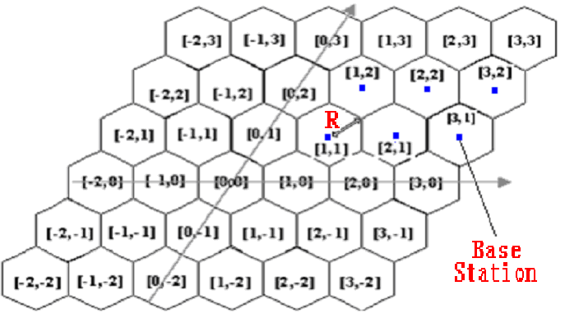
Next, we need to assign an ID to each cell. Each cell is denoted by [i, j]. The cell which covers the origin is denoted by [0, 0]. The cell in the east of [0, 0] is denoted by [1, 0]. The cell in the west of [0, 0] is denoted by [-1, 0]. The cell in the northeast of [0, 0] is denoted by [0, 1]. The cell in the southwest of [0, 0] is denoted by [0, -1]. This notation can be easily generalized, as shown in the above figure.

Now the question is as follows. You are given a mobile phone currently located at cell [a, b]. Then the mobile phone may make a sequence of moves and reach certain cell, say [a’, b’]. And you need to compute the distance from the base station of [a’, b’] to the base station of [0, 0] (i.e., the origin). Note that you need to translate [a’, b’] into the Euclidean coordinate (i.e., on an x-y plane), and then compute the distance. For instance, the base station of [-1, 1] is at [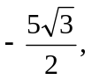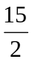] under the Euclidean coordinate. So its distance to the origin is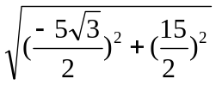=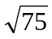=8.66.

The direction in which the mobile phone may move is represented by an integer. From any cell [x, y], moving toward the cell on the east is represented by a “1”, moving toward the cell on the northeast is represented by a “2”, moving toward the cell on the northwest is represented by a “3”, moving toward the cell on the west is represented by a “4”, moving toward the cell on the southwest is represented by a “5”, and moving toward the cell on the southeast is represented by a “6”. This notation is illustrated in the following figure.
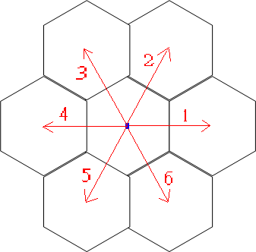
How the mobile phone moves is represented by a sequence of numbers. For example, if starting from cell [2, 1], the mobile phone makes a sequence of moves [1, 2, 4, 4, 4, 4, 5], it will enter cell [-1, 1], as shown in the following figure. Then you need to calculate the distance from the base station of cell [-1, 1] to the base station of cell [0, 0], which is 8.66.
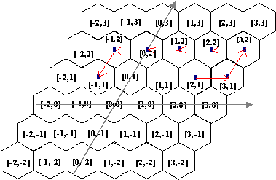
To summarize, you are given a cell [a, b] followed by a sequence of legal moves [m₁, m₂, ...,m_{k}]. You need to determine the destination cell, say [a’, b’], that the mobile phone will arrive at. Then, compute the distance between the base stations of cells [a’, b’] and [0, 0]. The input and output formats are as follows.
- input: [a, b], [m₁, m₂, ...,m_{k}]. In your program, only cells [x, y] such that -100<x<100 and -100<y<100 need to be considered. Remember that the cell radius is R = 5 km.
- output: a real number which represents the distance (in km). Since truncation/rounding error may occur, we only request a precision up to two decimal points.

Input format:
a list of 5 moves, one in each line

Output format:
a list of 5 real numbers with a precision up to two decimal points, one for each input line

Sample input:
[0,0],[1, 3, 5]
[2,1],[1,2,4,4,4,4,5]
[1,1],[1,2,3,4,5,6]
[0,-1],[1,1,5,4,4]
[-1,-2],[1,1,2,2,4]

Sample output:
0.00
8.66
15.00
17.32
0.00

Problem 7
The C + G-richest region of a DNA sequence

The main aim of the Human Genome Project is to determine the roughly three billion nucleotides of the human genome, which encodes all the information of a human, by the year 2003. This DNA sequence data, essentially a gigantic string of the four letters A, C, G, and T, can help us understand and eventually treat many of the more than 4000 genetic diseases that afflict mankind. However, the data will be useless unless proper methods are developed to interpret the information that it encodes.
Computer analysis of newly determined DNA sequences usually includes a task to identify C + G-rich regions. One reasonable scheme to measure the C + G richness of a region is the scoring expression 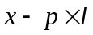, where x is the C + G count of the region, l is the length of the region, and p is a positive ratio constant. Given a ratio 0 < p <1, a length cutoff L, and a DNA sequence, i.e. a string of the four letters A, C, G, and T, write a program to report the score of the region of length at least L, which maximizes the expression .
For example, if p = 0.6, L = 5, and the given DNA sequence is GACGTCCCAGCAACAAA, the C + G-richest region of length at least L under this measurement is the region from position 3 to position 11, i.e., CGTCCCAGC. This region contains 5 C’s and 2 G’s, thus the C + G count is 7. Its score is 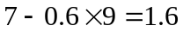. This is the highest score of any region of length at least 5.

Input format:
p (a real number between 0 and 1)
L (an integer between 1 and 10000)
The DNA sequence is of length at most 50000.
The input file is terminated by a line with the number 0.

Output format:
Report the score of the region of length at least L, which maximizes the expression .

Sample input:
0.6
5
GACGTC
CCAGCAACAAA
0

Sample output
The highest score is 1.6.

