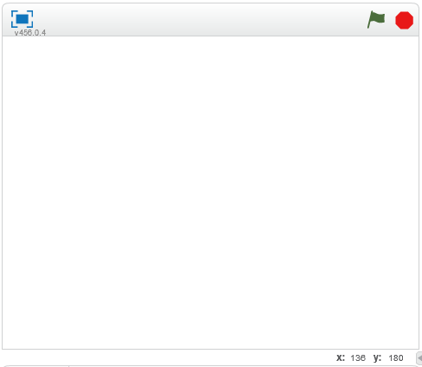1)

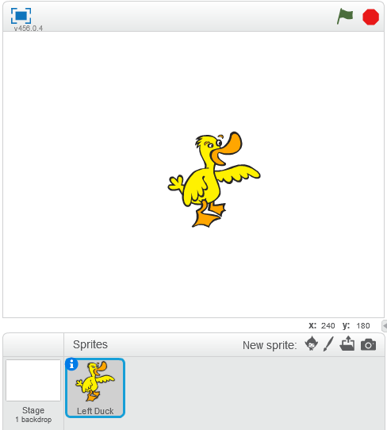

2)

No

Left Duck Glides, in one second, to the Center of the stage

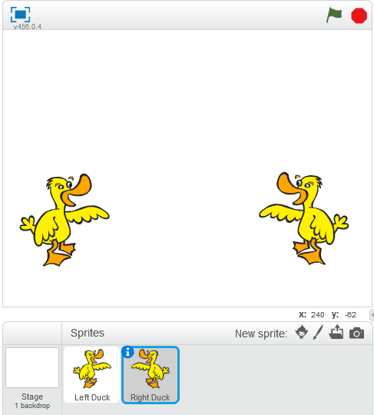

3)

Left Duck glides, in one second, to the Left edge of the stage.

4) Click and drag the block you want to snap in, towards the opening in the middle of the “forever” loop structure. You will see a highlighted “predictor” showing where it will snap. Let the block go.

5) Click on the block you want to separate, drag it away from the “forever” loop, it will pull away, and you can drop it somewhere else on the scripts area.

6)

Move Left Duck to Left Edge of Stage

Yes

Go Flag Clicked?

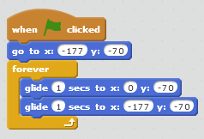7)

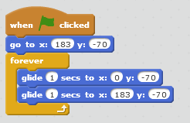8)

9) Click and drag the question towards condition hexagon, it will highlight, let go and the question will snap into the hex.

10) Click and drag the question away from the if block, it will pop out and you can drop it anywhere in the scripts area.

11)

Repeat:

If Left Duck is touching Right Duck

Say Quack for one second

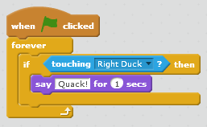12)

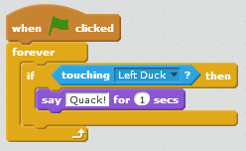13)

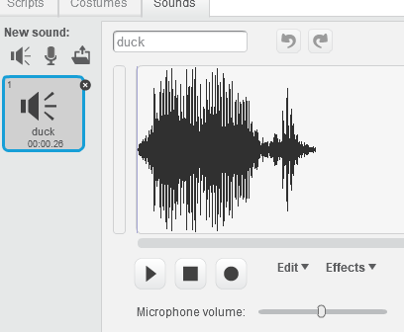14)

15) 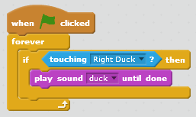

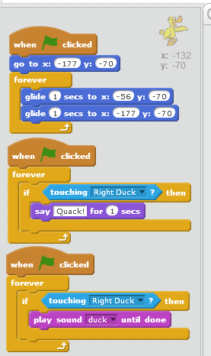16) Left Duck:

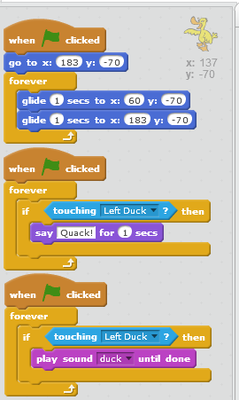Right Duck:

17) Pass this Course

18) Exit Conditional

19) No

Hey professor, I mentioned to you a simple java program I wrote to help me learn that was funny. You said as long as it doesn’t print out “Professor Walsh is an a-hole” on the screen, you wouldn’t be offended. ☺

**import** java.util.Scanner;

**public** **class** myfirstJava {

**public** **static** **void** main(String args[]) {

System.***out***.print("Are you a boy, or girl? ");

Scanner answer = **new** Scanner(System.***in***);

String strAnswer = answer.nextLine();

**switch**(strAnswer) {

**case**("boy"):

System.***out***.println("Congratulations! You have a penis! Go into the world and "

+ "be privalaged and get higher paying jobs automagically!");

**break**;

**case**("girl"):

System.***out***.println("I'm so sorry you were born the OTHER sex.");

System.***out***.println("Your day will be crap, not because "

+ "you made bad decisions, but because society hates you.");

**break**;

**default**:

System.***out***.println("I'm a republican, and your answer wasn't 'boy' or 'girl',"

+ " I will assume you're just a perverted goth kid with"

+ " daddy issues.");

System.***out***.println("GET A JOB, AND GET SOME JESUS!");

**break**;

}

}

}