Name: ___Casey Sorrells___ worksheet07A

Create a portion of a flowchart that asks the question do you have 40 or more dollars. If the answer is yes, then withdraw $40. If the answer is no, then display a message that says “insufficient funds.”

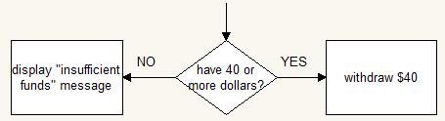

Create a portion of a flowchart that asks the question does the sign say walk. If the answer is yes, then cross the street. If the answer is no, then stop.

YES

NO

Sign Says “Walk”?

CROSS THE STREET

STOP

Create a portion of a flowchart that asks do you have a flashlight. If the answer is yes, then turn on the flashlight. If the answer is no, then turn on a cellphone.

TURN ON FLASHLIGHT

Do you have a flashlight?

YES

NO

TURN ON CELLPHONE

Create a portion of a flowchart that asks is there milk in the refrigerator. If the answer is yes, then eat a bowl of cereal. If the answer is no, then buy milk.

MILK IN REFRIGERATOR?

BUY MILK

EAT BOWL OF CEREAL

NO

YES