Name: _________________________________ worksheet07B

Here is an example of a flowchart with a loop.

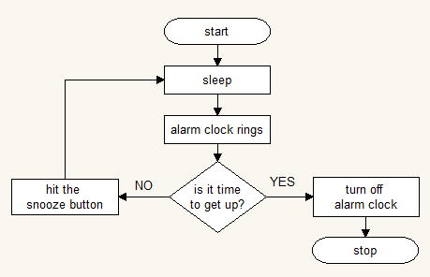

Write a flowchart for calling someone on the phone.  
Use these steps:  
dial a phone number  
say something  
listen to other person talking  
is conversation over?  
if no then reloop   
if yes then hang up