1)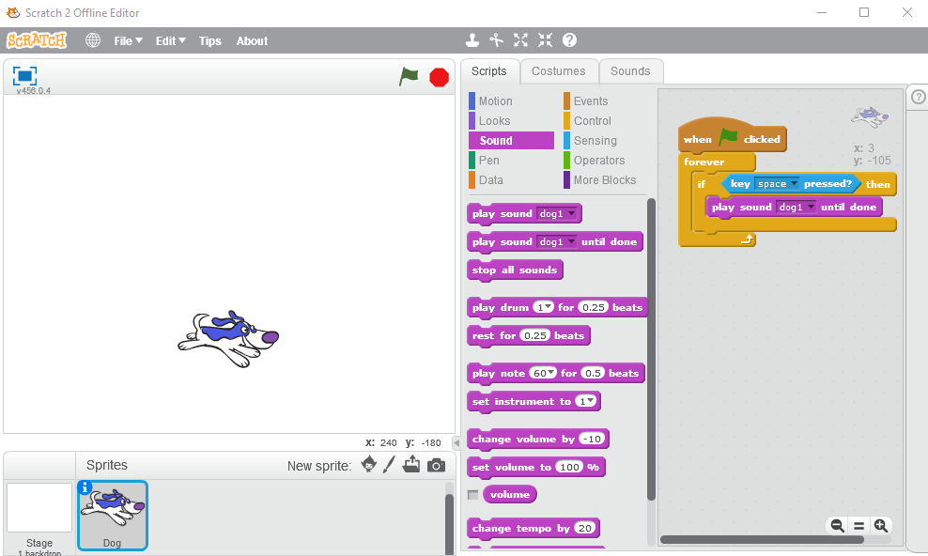

2) 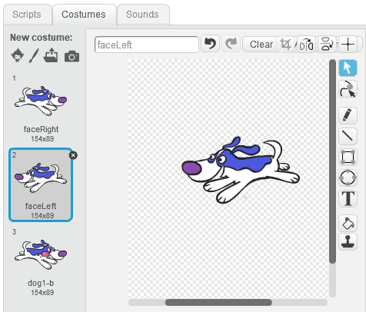

3) 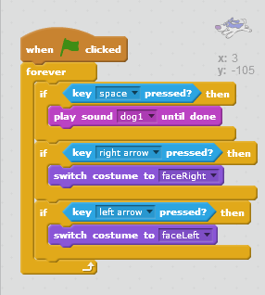

4) 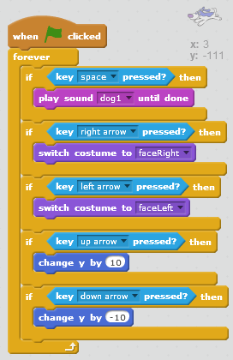

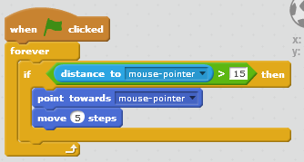

5)

6) 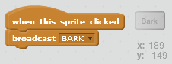

7) 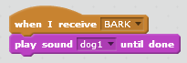

8) 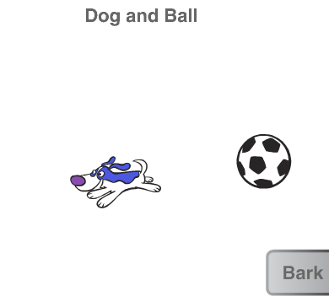

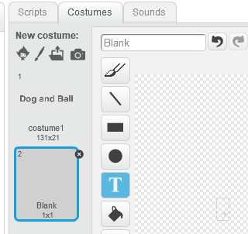

9)

10) 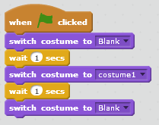

11)

When the green go button is clicked

Repeat forever

If the space key is pressed

Play ‘meow’ sound until done

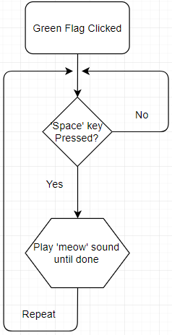12)

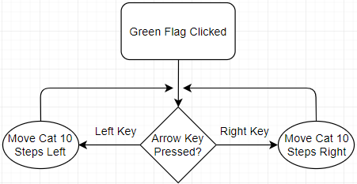13)

14)

Set a Timer for 10 Seconds

Repeat forever

If the Timer is at 0, then End the Game

If the Timer is not at 0, subtract 1 from the Timer

Wait 1 second