Using tutorials for C++, I made this program, which generates the first 41 Fibonacci Numbers.

Here's the code:

// IntroToComputerProgrammingLAB1A.cpp
//

#include "stdafx.h"
#include <iostream>

int main()
{
// first setting up some variables to work with
long firstNumber = 0;
long secondNumber = 1;
long thirdNumber = 0;
int i = 0;

// use a do loop to iterate through the
// fibonacci numbers, and print them on the screen
do
{
std::cout << secondNumber << "\n";

thirdNumber = firstNumber + secondNumber;
firstNumber = secondNumber;
secondNumber = thirdNumber;

i++;

} while (i <= 40);

// return 0, because that's what you do apparently...
return 0;
}

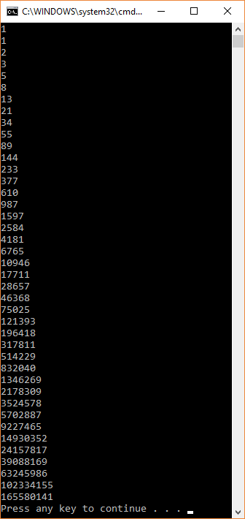
Here is the output:

