MOBILE APPLICATION
AUTOMATION TESTING REPORT
CAPS Mobile Application Verification
Date: March 21, 2026
Appium Server v3.2.2 | AndroidUiAutomator2Driver v7.0.0

Physical Android Device  Target Device | Android 16 / API 36  OS Level | 2 Resolved / 1 Open  Bug Status | UI Inspection  Primary Goal

1. Executive Summary
This report details the automated testing session for the com.caps.mobile Android application. The session focused on establishing a stable connection between the Appium Server and the physical device, inspecting the UI hierarchy of a hybrid application, and validating user interaction flows.

While the session achieved its primary goal of UI inspection, several critical configuration roadblocks were identified and resolved during the initialization phase. One runtime issue (BUG-003) remains open and will require remediation in future test scripts.

Session ID: f0d15835-0818-490b-9303-3932738b9cc0

2. Technical Environment & Configuration

2.1 Testing Stack
Component | Detail
Automation Framework | Appium v3.2.2 with AndroidUiAutomator2Driver v7.0.0
Hardware under Test (HuT) | Physical Android Device (UDID: R8YY40FSTWF)
OS Level | Android 16 (Pre-release / API 36)
ADB Communication | TCP Port 5037 and 8200
Appium Home Path | C:\Users\Lejanie Embrado\.appium
Node.js Environment | Healthy (confirmed post-session)

2.2 Desired Capabilities
The following parameters were utilized to establish the Appium session:

Capability | Value
platformName | Android
appium:automationName | UiAutomator2
appium:deviceName | Android Device
appium:ensureWebviewsHavePages | True
appium:nativeWebScreenshot | True

3. Execution Timeline & Analysis
The session was conducted across three distinct phases spanning approximately 21 minutes, from 15:52 to 16:13.

3.1 Phase I: Initialization & Debugging (15:52 – 15:57)
The session initially failed due to two distinct environment issues that required resolution before automation could proceed:

Error | Type | Description | Resolution
BUG-001 | 404 Not Found | Client attempted to access /wd/hub — a legacy Appium 2.x path not valid in Appium 3.x. | Updated client to use the standardized Appium 3.x root path.
BUG-002 | 500 Internal Error | Server could not locate the APK file at the path specified in the session capabilities. | APK path was verified and updated to the correct local directory.

Both blockers were resolved within this phase, allowing the session to proceed to active inspection.

3.2 Phase II: UI Inspection & Navigation (15:58 – 16:10)
Once the session was established, Appium Inspector was used to map the application's UI hierarchy. Key findings from this phase include:

- Hybrid Content: The application successfully rendered WebViews (WEBVIEW_15772), requiring context switching for full inspection of embedded web content.
- Navigation Mapping: Elements for Quizzes, Users, and Home were identified within the native navigation bar. High-reliability locators using Accessibility IDs were successfully extracted.
- Input Testing: A 400 Bad Request was recorded at 16:07:28 during a value-setting command (BUG-003). This indicates a synchronization gap between the automation script and the application's input state — the element was targeted before it became interactable.

3.3 Phase III: Teardown (16:13)
The session concluded with a clean and complete exit. The following teardown actions were confirmed:
- The driver force-stopped the com.caps.mobile application.
- Port forwarding was removed and ADB connections were closed.
- The device's hidden_api_policy was successfully restored to its default system value.

4. Comprehensive Bug Report
Bug ID | Severity | Category | Description | Status
BUG-001 | Blocker | Configuration | Handshake Failure: Server returned 404 for /wd/hub/session. Caused by legacy pathing in client settings. | Resolved
BUG-002 | Blocker | Environment | Installation Failure: APK path not found. System could not locate the debug build at the specified string path. | Resolved
BUG-003 | Medium | Runtime | Input Exception (400): Attempt to send keys to a focused element failed. Likely caused by a race condition — element was not yet interactable. | Open

BUG-001 and BUG-002 were environment configuration issues resolved during the initialization phase and do not require action in future sessions, provided the same environment is used. BUG-003 is an active runtime defect that requires implementation of explicit wait conditions before further input-related test cases are executed.

5. UI Observations & Screenshots
The following screenshots were captured during the live Appium session and manual inspection of the CAPS application. Each image is annotated with observations relevant to the automation testing effort and UI quality assessment.

5.1 Home Screen — Dark Mode (15:59)
The Home screen was captured during the active Appium session. The screen displays a Student-role user interface with a bottom navigation bar containing Classes, Home, Sessions, and Leaderboard tabs. The Home tab is active, indicated by the orange highlight and dot indicator.

The dashboard shows a card with 24 items to review alongside a carousel indicator. Below this, the Available Subjects section renders the message No subjects available, suggesting the test account has no enrolled subjects or the backend returned an empty dataset at the time of capture.

UI Issue Observed: The application renders in dark mode with a near-black background. Several text elements — particularly in the lower navigation overlay — appear in colors that closely match the background, reducing contrast and legibility. This is a UI/UX concern that should be flagged for accessibility review.

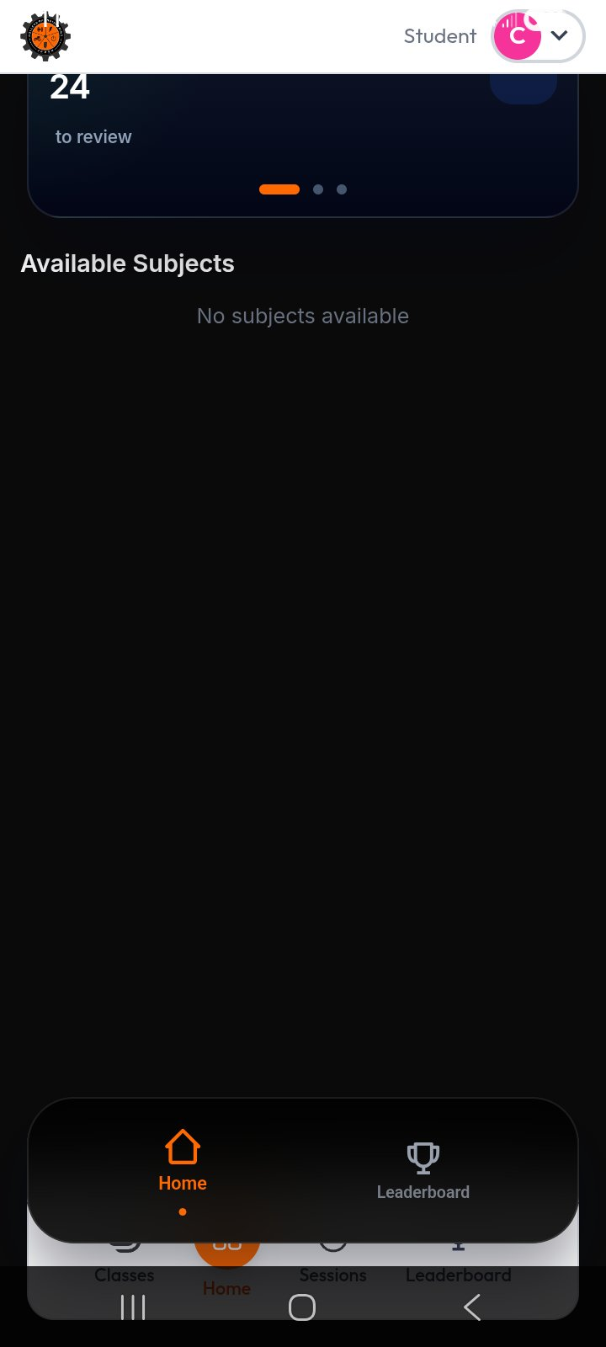
Figure 1 — Home Screen (Dark Mode): Student dashboard showing 24 items to review and empty Available Subjects section.

5.2 Register Account Screen — Dropdown Overlap Bug (16:12)
This screenshot captures the Register Account screen of the CAPS (Comprehensive Assessment and Preparation System) application, version v2.0.0, developed by Team CAPS. The screen presents fields for Select Campus, Select Position, and additional credential inputs.

UI Bug Observed: A critical rendering defect is visible. When the Select Campus dropdown is activated (indicated by the orange border highlight), its expanded option list overlaps the input fields positioned below it, obscuring them entirely. The dropdown panel is rendered above the form fields rather than being contained within a scrollable region, constituting a z-index or overlay layering bug that prevents the user from seeing or interacting with the fields behind the open dropdown.

Additionally, some input field placeholder text appears in a color that blends with the field background — white or near-white text on a white/light background — making field labels indiscernible without focus. This is the font-color-matching-background issue observed during the session.

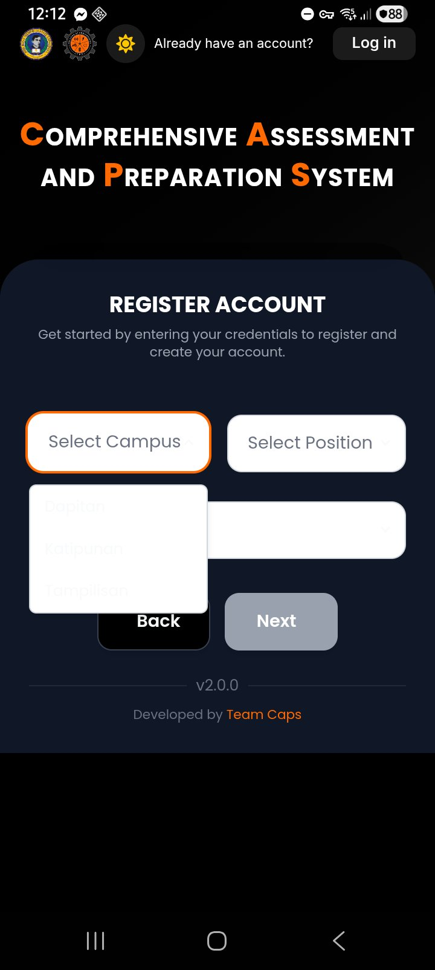
Figure 2 — Register Account Screen: Dropdown overlap bug where the campus selection list covers underlying form fields. Note also the low-contrast placeholder text.

5.3 Leaderboard Screen — User Profile Menu (16:01)
This screenshot shows the Leaderboard screen with the user profile dropdown menu expanded. The active user is identified as CPE Student with the email cpe.student@university.edu, a test credential used for the session. The menu exposes Settings, Server Config, Dark Mode, Support, and Log out options.

The Leaderboard content area displays No leaderboard data available yet with a prompt to complete practice exams — expected behavior for a freshly created test account with no completed assessments.

Automation Relevance: The user profile menu elements are key targets for test coverage. The Log out action is a necessary teardown step in end-to-end scripts. The Server Config option is particularly noteworthy — its presence in the production-accessible UI suggests that server endpoint configuration is exposed to regular users, which is both a security and UX concern warranting a formal flag.

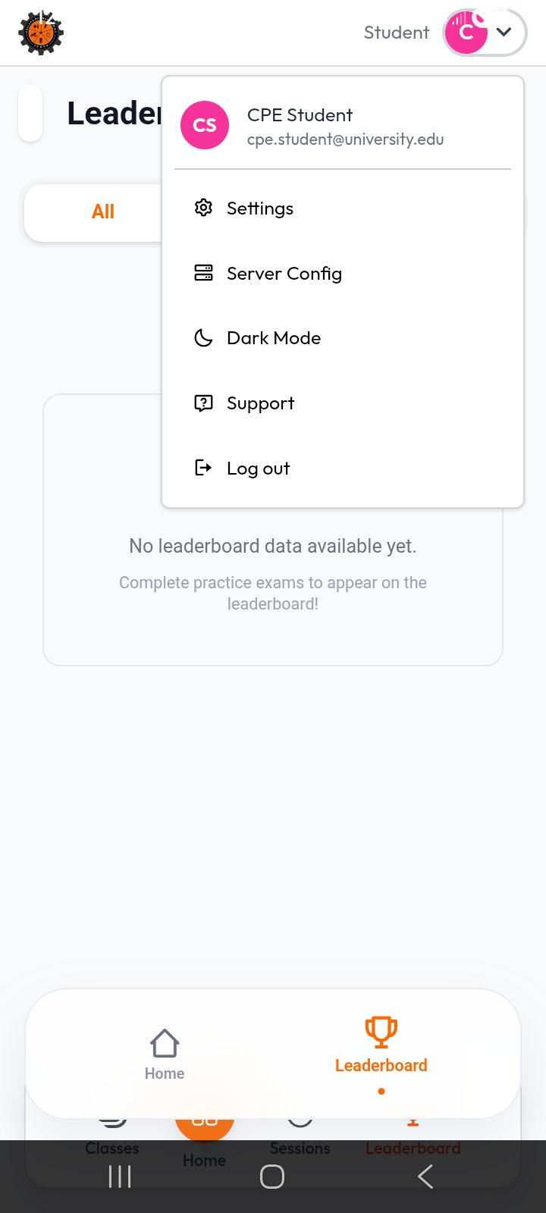
Figure 3 — Leaderboard Screen with User Menu: Test account identity, available menu actions, and empty leaderboard state.

5.4 Appium Inspector — XML Source & Element Selection
This screenshot captures the Appium Inspector v2025.7.1 interface during an active inspection session. The left panel displays the live device mirror showing a Basic Information dialog — a modal for creating a new quiz, with fields for Quiz Name and Description.

The center panel shows the parsed XML source tree of the UI hierarchy. Key elements include:
- android.widget.FrameLayout and LinearLayout as top-level containers.
- android.webkit.WebView confirmed active, identified as CAPS JRMSU - Comprehensive Assessment and Preparation System, confirming the hybrid app context.
- android.view.View nodes nested within the WebView representing the web content layer.
- android.widget.Image with content-desc College Logo and android.widget.TextView with text Dean visible in the native layer.

The right panel shows the Selected Element attributes for the highlighted EditText field (Quiz Name input):

Attribute | Value
elementId | 00000000-0000-062f-0000-00e400000007
index | 1
package | com.caps.mobile
class | android.widget.EditText
text | (empty — field focused but unpopulated)
checkable | false
-android uiautomator | new UiSelector().className("android.widget.EditText").instance(0)
xpath | //android.view.View[@resource-id="quiz-create-form"]/android.view.View[2]/...

This element corresponds directly to BUG-003: the 400 Bad Request error occurred when the automation script sent keys to this EditText before it reached a fully interactable state. The UiAutomator selector and XPath locator captured here will be used in the remediated test script with explicit wait conditions applied before any input action.

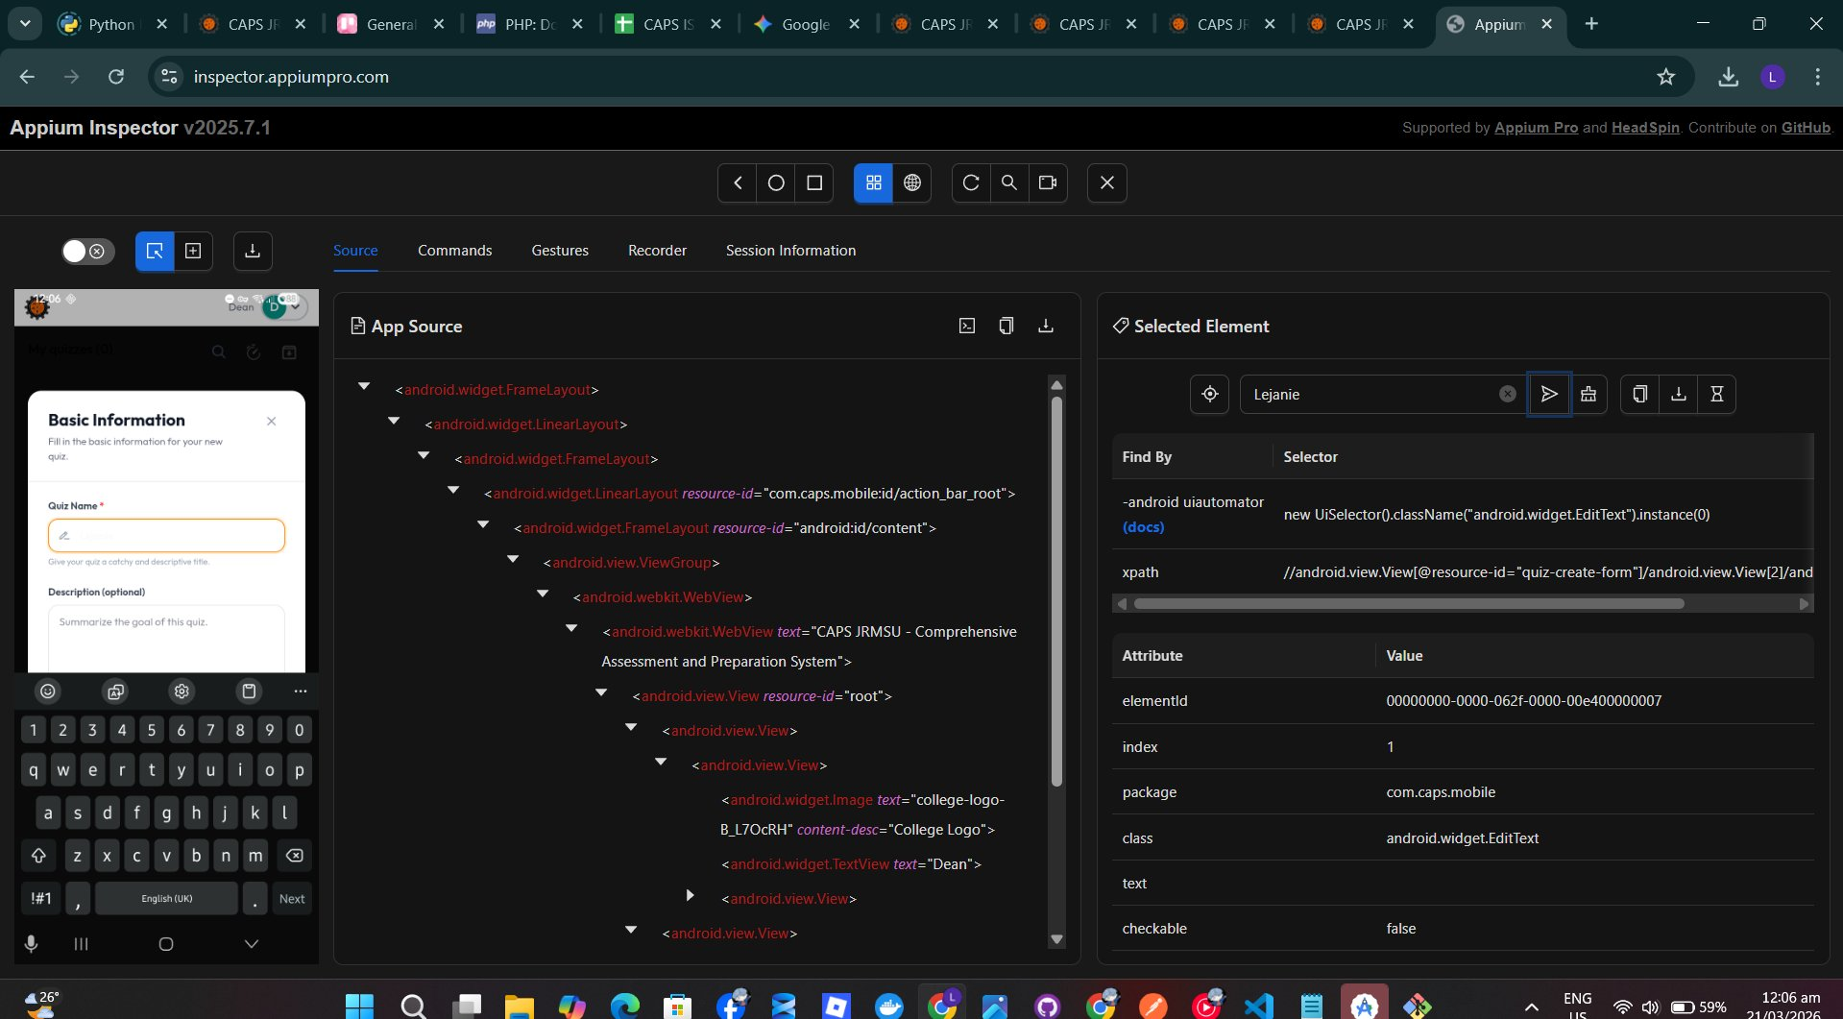
Figure 4 — Appium Inspector: Active session showing XML source hierarchy, WebView context, and selected EditText element attributes for the Quiz Name field.

6. Conclusion

6.1 Summary of Results
The testing session was a success regarding environment validation and UI inspection. The team successfully bypassed Android 16 security policies, established a stable ADB connection, and completed a full UI hierarchy inspection of the com.caps.mobile application. The app demonstrates a standard XML-based Android layout with integrated WebViews, making it a suitable and ready candidate for further automated regression testing.

6.2 Technical Stability
The UiAutomator2 driver proved stable on the physical Android device running Android 16 (API 36). The resolution of the 404 and 500 errors during Phase I confirms that the local Appium environment is correctly configured and that the Node.js runtime is healthy. No driver crashes or unexpected session terminations were observed after the initialization phase.

6.3 Recommendations
- Implementation of Explicit Waits: To resolve BUG-003, all future scripts must implement Explicit Waits using Expected Conditions to confirm elements are in an interactable state before sending input actions.
- Locator Strategy: Continue using Accessibility IDs as the primary locator strategy, as they proved the most stable and reliable during this session's inspection.
- Context Management: Given the presence of WebViews, future test scripts must include logic to switch between NATIVE_APP and WEBVIEW contexts to interact with embedded web content correctly.

This report was generated based on Appium session logs, Inspector data, and bug tracking records captured during the March 21, 2026 testing session. Findings should be reviewed by the QA lead before test case implementation proceeds.

