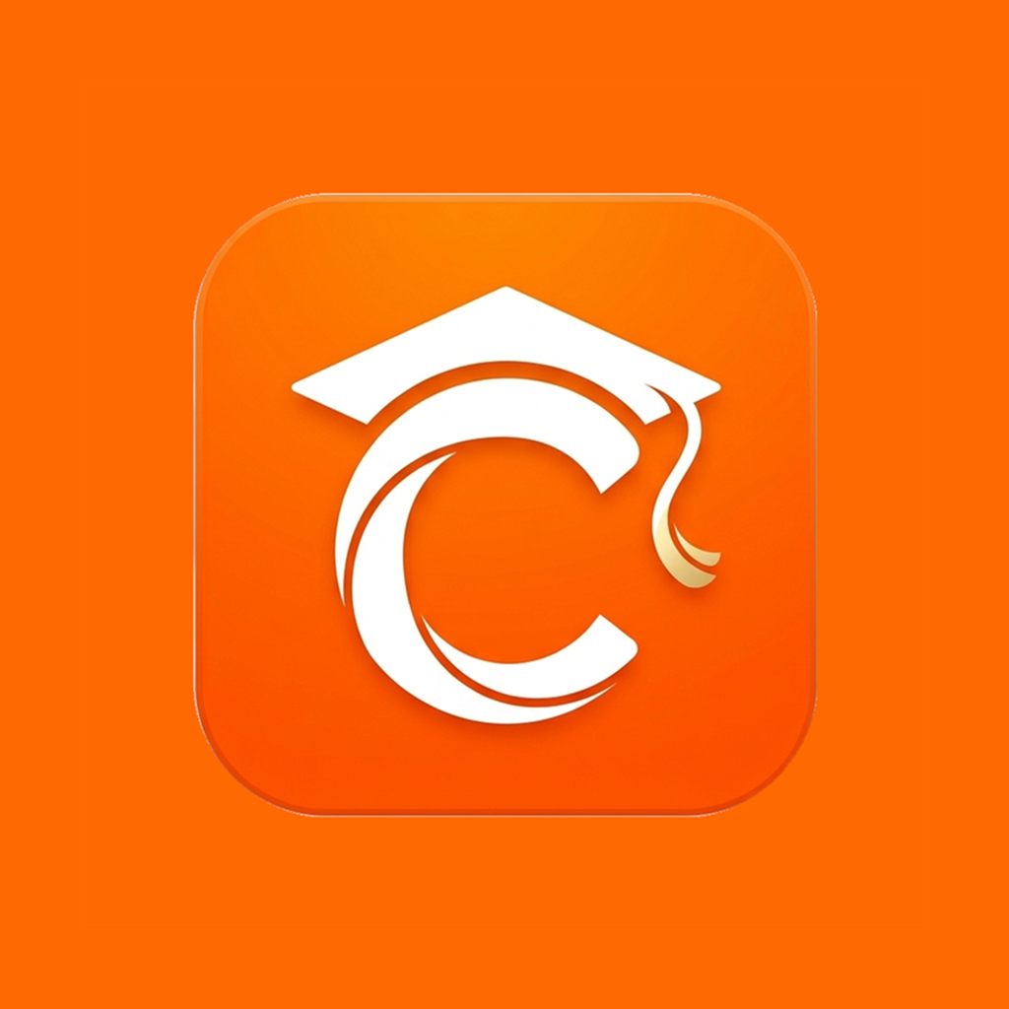

CAPS Mobile Application
User Manual
Version 2.0.13
Prepared by:
Team CAPS

1. Introduction

1.1 Purpose of the Manual
This manual explains how to use the CAPS Mobile Application. It helps students, faculty members, program chairs, deans, and associate deans understand the main parts of the app.

1.2 Scope of the Manual
This manual covers installation, Log In, common features, role-based features, system flow diagrams, troubleshooting, FAQs, and support information.

1.3 Intended Users
This manual is for:
- Students
- Faculty Members
- Program Chairs
- Deans
- Associate Deans
- System administrators and support staff

1.4 Objectives
This manual aims to:
- Guide users in installing and opening CAPS Mobile.
- Explain how users can log in and manage their accounts.
- Show the main features available for each role.
- Help users solve common problems.
- Provide support details when users need help.

2. System Overview

2.1 What CAPS Is
CAPS (Comprehensive Assessment and Preparation System) is an application that helps users access school-related tools and information in one place. It provides a convenient way to manage academic tasks, view grades, take practice exams, and stay connected with your school community.

2.2 Main Features
CAPS Mobile includes:
- Account Log In and account registration
- Role-based dashboards
- Practice exams and quizzes
- Subject and class management
- Student performance tracking
- Notifications and announcements
- Reports and analytics
- Profile and password management

2.3 User Roles
Role | Main Use
Student | Takes practice exams, joins classes, views results, and checks progress
Faculty | Manages subjects, classes, quizzes, reports, and announcements
Program Chair | Monitors users, subjects, classes, reports, and announcements
Dean | Reviews users, subjects, classes, reports, analytics, and enhancement data
Associate Dean | Reviews academic data, users, subjects, classes, reports, and announcements

3. System Requirements

3.1 Android Version
Use an Android phone that supports APK installation. Android 8.0 or higher is recommended.

3.2 Internet Connection
An internet connection is required to:
- Log in
- Load dashboards
- Submit or take quizzes
- View notifications
- Update records
- Sync reports and analytics

3.3 Storage Requirement
Make sure the phone has enough free storage before installing the APK. At least 200 MB of free storage is recommended.

3.4 Other Requirements
The user must have:
- A valid CAPS account
- A correct ID code or student number
- A password
- Access to the registered email address for password reset

4. Installation Guide

Downloading the APK
- Get the CAPS.apk file from the official source provided by the development team or system administrator.
- Save the file on the Android phone.

4.2 Installing the Application
1. Open the downloaded APK file.
2. Tap Install.
3. Wait until the installation is finished.

Allowing Permissions
- If the phone asks for permission to install from unknown sources, tap Settings.
- Allow installation from the selected file manager or browser.
- Return to the APK file and install again.

Launching the Application
- After installation, tap Open.
- Wait for the CAPS Mobile Log In screen to appear.

Updating the Application
- If the app shows an update notice, tap Download & Install Update.
- Allow the update if the phone asks for permission.
- Open the app again after the update.

5. User Log In and Account Access

Log In
- Open CAPS Mobile.
- Enter the Instructor Code or Student ID Number.
- Enter the Password.
- Tap Log In.
- The app will open the correct dashboard based on the user's role.

5.2 Remember Me
- On the Log In screen, check Remember me.
- Log in normally.
- The app will remember the account on the same device.

5.3 Forgot Password
1. On the Log In screen, tap Forgot your password?
2. Enter the registered email address.
3. Tap Send Reset Link.
4. Open the email and follow the reset link.

5.4 Reset Password
1. Open the reset password link from the email.
2. Enter the new password.
3. Confirm the new password.
4. Tap Reset Password.
5. Return to the Log In screen and log in again.

5.5 Log Out
- Tap Profile.
- Tap Sign Out or Log Out.
- Confirm the action if the app asks for confirmation.

6. Common Features

6.1 Dashboard Overview
The dashboard is the first screen after Log In. It shows important information based on the user's role.

6.2 Navigation
Users can move around the app using the bottom navigation bar. Common tabs include:
- Home
- Subjects
- Classes
- Insights
- Leaderboard
- Profile

6.3 Notifications
- Tap the bell icon.
- Select a notification.
- Read the notification details.
- Close the notification after reading.

6.4 Profile Management
- Tap Profile.
- Tap Edit Profile.
- Update the name, email, or password if needed.
- Save the changes.

6.5 Settings and Theme
- Tap the moon or theme icon.
- The app changes between light and dark mode.

6.6 Help Center and Support
- Tap the help icon or open Help Center from the Profile screen.
- Read the available help topics or FAQs.
- If the user is a student, submit a support request when needed.
- If the user is a staff user, use the support area to view support-related concerns.

6.7 Account Registration
New users can create an account if account registration is enabled.
- On the Log In screen, tap Sign up.
- Enter the first name and last name.
- Tap Next.
- Enter the user code and email address.
- Tap Next.
- Select the position, campus, and program.
- Tap Next.
- Enter and confirm the password.
- Tap Create your account.
- Wait for account approval if approval is required.

6.8 Search, Filters, and Lists
Several screens use search bars and filters. These help users find records faster.
- Tap the search bar.
- Type the subject, class, user, or keyword.
- Use the filter buttons if available.
- Tap the result to open the selected record.

6.9 Admin Tools Button
Staff roles may see the Admin Tools floating button. It gives fast access to role-based tools.
- Tap Admin Tools.
- Select the needed action, such as Users, Reports, Analytics, Classes, Subjects, or Create Announcement.
- The selected screen will open.

7. Student Module

7.1 Student Dashboard
- Log in using a student account.
- The app opens the Student dashboard.
- View recent exam score, featured review items, and available subjects.

7.2 Viewing Grades and Results
- Tap Profile or open the result screen after taking a quiz.
- Review scores, average score, best score, and attempts.
- Tap a result item to see more details if available.

7.3 Viewing Notifications
- Tap the bell icon on the dashboard.
- Tap the notification to open details.
- Read the message.

7.4 Taking Class Quizzes
- Tap Classes.
- Select a class.
- Open the Quizzes tab.
- Tap Start Quiz.
- Answer the questions and submit the quiz.

7.5 Updating Profile
- Tap Profile.
- Tap the edit or settings button.
- Update the needed information.
- Save the changes.

7.6 Searching Practice Subjects
- From the Student dashboard, tap Search Subjects.
- Type the subject name or subject code.
- Use filters such as All, Program, or General if available.
- Tap the subject to open the practice exam information screen.

7.7 Starting a Practice Exam
- Select a subject from the dashboard or search screen.
- Read the practice exam information.
- Check the number of items, total points, and timer if shown.
- Tap Start Exam.

7.8 Answering Practice Exam Questions
- Read the question carefully.
- Select the correct answer.
- Tap Next to move to the next question.
- Tap the bookmark icon if the question must be reviewed later.
- Use the question list if the app shows question navigation.
- Tap Submit after answering.

7.9 Viewing Practice Exam Results
- After submitting the exam, wait for the result screen.
- Review the score, total items, and performance summary.
- Check correct and wrong answers if available.
- Return to the dashboard or take another exam.

7.10 Viewing Practice History
- Open Profile.
- Tap Recent Performance or Practice History.
- Review previous exams and scores.
- Tap an item to view more details if available.

7.11 Viewing Frequent Mistakes
- Open Profile.
- Tap Frequent Mistakes.
- Review topics or questions that were often answered incorrectly.
- Use the information to review weak areas.

7.12 Viewing Strong Areas, Weak Areas, and Time per Topic
- Open Profile.
- Tap Strong Areas, Weak Areas, or Time per Topic.
- Review the subjects or topics shown.
- Use the results to plan study time.

7.13 Using Bookmarks
- While answering a practice exam, tap the bookmark icon on a question.
- Open My Bookmarks from the profile or insight screen.
- Review bookmarked questions.
- Remove a bookmark if the question no longer needs review.

7.14 Viewing Leaderboard
- Tap Leaderboard from the bottom navigation bar.
- Choose Weekly or All Time if available.
- Review the top students and the current user's rank.
- Share the achievement if the share option is available.

7.15 Joining, Viewing, and Leaving Classes
- Tap Classes.
- View joined classes or available class records.
- Tap a class to open class details.
- Open Quizzes to see assigned quizzes.
- Tap Leave Class only when the student needs to leave the class.

8. Faculty Module

8.1 Faculty Dashboard
- Log in using a faculty account.
- The app opens the Faculty dashboard.
- Review available quick actions and management options.

8.2 Managing Subjects
- Tap Subjects.
- View the subject list.
- Select a subject to view or manage its questions.
- Use the available action buttons for the subject.

8.3 Managing Classes
- Tap Classes.
- Select a class.
- View students, quizzes, or results.
- Use the class action buttons as needed.

8.4 Assigning Quizzes
- Open a class.
- Tap the Quizzes tab.
- Tap Assign Quiz.
- Select the quiz and set details.
- Save the assignment.

8.5 Sending Announcements
- Open the announcement or admin tools option.
- Enter the announcement title.
- Select the target users.
- Write the message.
- Tap Post Announcement.

8.6 Updating Profile
- Tap Profile.
- Tap Edit Profile.
- Update name, email, or password.
- Save the changes.

8.7 Creating and Managing Practice Questions
- Tap Subjects.
- Select a subject.
- Tap the add question or create quiz option.
- Enter the question details.
- Add the answer choices.
- Mark the correct answer.
- Save the question.

8.8 Editing, Duplicating, and Deleting Questions
- Open the subject question list.
- Tap the menu or action button beside the question.
- Choose Edit, Duplicate, or Delete.
- Confirm the action if the app asks for confirmation.

8.9 Viewing Class Students
- Tap Classes.
- Open a class.
- Tap Students.
- Review the list of enrolled students.
- Remove a student only when needed and allowed.

8.10 Viewing Class Quiz Results
- Open a class.
- Tap Results.
- Select a quiz or student result.
- Review score, attempts, and accuracy.

8.11 Archived Classes
- Open Archived Classes from Admin Tools or the class screen.
- Review archived class records.
- Restore or delete an archived class if the action is allowed.

8.12 Reports Hub
- Open Reports.
- Review recent takers, leaderboard data, and user reports.
- Open a report ticket to see details.
- Use export or print options if available.

9. Program Chair Module

9.1 Program Chair Dashboard
- Log in using a Program Chair account.
- The app opens the Program Chair dashboard.
- Review dashboard counts, quick actions, and available tools.

9.2 Managing Subjects
- Tap Subjects.
- Search or filter the subject list.
- Open a subject to view details.
- Manage questions or subject settings if allowed.

9.3 Monitoring Classes
- Tap Classes.
- Select a class.
- View students, quizzes, and results.
- Monitor class progress.

9.4 Monitoring Reports
- Open Reports from the available tools.
- Review the report list.
- Open a report to see details.

9.5 Managing Approvals
- Open User Management.
- Review pending users.
- Tap the approve button to activate a user.
- Tap the disapprove button if the user should not be activated.

9.6 Updating Profile
- Tap Profile.
- Tap Edit Profile.
- Update the needed information.
- Save the changes.

9.7 Reviewing Users by Role and Status
- Open User Management.
- Use the role filters to view admins or students.
- Use the status filters to view pending, active, inactive, or disapproved users.
- Tap a user to view more details.

9.8 Viewing Insights
- Open Insights from Admin Tools.
- Review the available shortcut cards.
- Open reports, classes, subjects, or export options from the insights hub.

9.9 Creating Quizzes
- Open Create Quiz or the subject quiz option.
- Enter the quiz title.
- Select the related subject.
- Save and add questions.

10. Dean Module

10.1 Dean Dashboard
- Log in using a Dean account.
- The app opens the Dean dashboard.
- View question, user, and subject counts.
- Use quick actions such as Analytics, Support, Classes, and Create quiz.

10.2 Viewing Department Reports
- Open Reports.
- Select a report.
- Review the report details.
- Use the information for monitoring and decision-making

10.3 Approval Monitoring
- Open User Management.
- Use the filters for All, Pending, Active, Inactive, and Disapproved.
- Approve or disapprove users when needed.

10.4 Reviewing Enhancement and Analytics
- Tap Enhancement.
- Review the overview, students, and analytics tabs.
- Check pass rate, average score, improvement, top subjects, and weak topics.

10.5 Updating Profile
- Tap Profile.
- Tap Edit Profile.
- Update the needed information.
- Save the changes.

10.6 Managing Users
- Tap Admin Tools.
- Select User Management.
- Search for a user by name, email, or user code.
- Use status filters to check pending, active, inactive, or disapproved accounts.
- Approve, disapprove, activate, or deactivate accounts when allowed.

10.7 Managing Subjects
- Tap Subjects.
- Use program and year filters.
- Open a subject to review its questions or settings.
- Use subject action buttons when needed.

10.8 Managing Classes
- Tap Classes.
- Open a class.
- Review students, quizzes, and results.
- Use archive, edit, or quiz actions if allowed.

10.9 Viewing Analytics Details
- Open Enhancement or Analytics.
- Tap Overview, Students, or Analytics.
- Review pass rate, average score, improvement, top subjects, weak topics, and student lists.

10.10 Support Ticket
- Open Support from the dashboard or Admin Tools.
- Review support tickets.
- Open a ticket to read the issue.
- Update the status if the action is allowed.

11. Associate Dean Module

11.1 Associate Dean Dashboard
- Log in using an Associate Dean account.
- The app opens the Associate Dean dashboard.
- Review dashboard counts, subjects, classes, enhancement, and profile tools.

11.2 Viewing Department Reports
- Open Reports.
- Select a report.
- Review the report details.

11.3 Approval Monitoring
- Open User Management.
- Review pending, active, inactive, and disapproved users.
- Approve or disapprove users if allowed.

11.4 Reviewing Enhancement and Analytics
- Tap Enhancement.
- Review performance data.
- Check top subjects and weakest topics.

11.5 Updating Profile
- Tap Profile.
- Tap Edit Profile.
- Update the needed information.
- Save the changes.

11.6 Managing Users
- Open User Management.
- Search or filter users.
- Review the user's role, status, campus, and program.
- Use account action buttons if allowed by the role.

11.7 Managing Subjects and Classes
- Tap Subjects to review subject records.
- Use filters to find the needed subject.
- Tap Classes to review class records.
- Open a class to view students, quizzes, and results.

11.8 Creating Announcements
- Open Create Announcement from Profile or Admin Tools.
- Enter the announcement title.
- Choose the target users.
- Enter the message.
- Tap Post Announcement.

11.9 Reports, Insights, and Export
- Open Reports or Insights.
- Review recent takers, leaderboard information, support reports, and report tickets.
- Use export or print options if available.

12. System Flow Diagrams
This section contains one process flowchart per user role.

12.1 Student Process Flow

Figure 12.1. Student process flow

12.2 Faculty Process Flow

Figure 12.2. Faculty process flow

12.3 Program Chair Process Flow

Figure 12.3. Program Chair process flow

12.4 Dean Process Flow

Figure 12.4. Dean process flow

12.5 Associate Dean Process Flow

Figure 12.5. Associate Dean process flow

13. Troubleshooting Guide
Problem | Possible Cause | Solution
App cannot be installed | Unknown source installation is blocked | Allow installation from the file manager or browser, then install again
App does not open | App version is outdated | Install the latest APK version
Update required message appears | The installed version is older than the required version | Tap Download & Install Update
Cannot log in | Wrong ID code or password | Check the ID code and password, then try again
Forgot password link not received | Wrong email or slow email delivery | Check the email address, spam folder, and internet connection
Dashboard does not load | Weak or no internet connection | Connect to a stable network and refresh the app
Notifications do not appear | Internet issue or notification permission is disabled | Check internet connection and app notification settings
Quiz does not submit | Internet connection was lost | Reconnect to the internet and try again
App is slow | Low storage or weak connection | Free phone storage, close other apps, and use a better connection
Profile update fails | Missing required field or weak connection | Complete all required fields and try again

14. Frequently Asked Questions

14.1 How do I log in?
Enter your Instructor Code or Student ID Number, enter your password, and tap Log In.

14.2 How do I reset my password?
Tap Forgot your password? on the Log In screen, enter your registered email address, and follow the reset link sent to your email.

14.3 How do I view notifications?
Tap the bell icon on the top part of the screen, then tap a notification to view its details.

14.4 How do students take quizzes?
Students tap Classes, select a class, open the quiz, tap Start Quiz, answer the questions, and submit.

14.5 How do I update my profile?
Tap Profile, select Edit Profile, update the information, and save the changes.

14.6 How do faculty members assign quizzes?
Faculty members open a class, tap Quizzes, tap Assign Quiz, choose the quiz, and save.

14.7 How do administrators monitor users?
Program Chairs, Deans, and Associate Deans can open User Management to view users by status and approve or disapprove accounts if allowed.

