Program Chair Bug Root Cause Analysis
Bug: Program chair can’t view all questions in General Subjects within their campus. They only see questions with the same roleId within their campus .
Expected Behavior: Program chair should view all questions in General Subjects within their campus, regardless of roleId.
- Why can’t the program chair view all questions? → Because the query filters questions by roleId.
- Why is the query filtering by roleId? → Because the access logic ties visibility to the user’s roleId.
- Why is visibility tied to roleId instead of campus scope? → Because the requirement was misinterpreted. Developers assumed role-based filtering was sufficient.
- Why was the requirement misinterpreted? → Documentation or acceptance criteria didn’t clearly specify that program chairs should see all campus questions.
- Why wasn’t this caught earlier? → Lack of test cases covering cross-role visibility within the same campus.
Root Cause
- Misinterpretation of requirements: Visibility was implemented as role-based instead of campus-based.
- Gap in QA coverage: No test cases validated cross-role visibility for program chairs.
Resolution / Fix
- Action Taken: Modified the query in the indexing function of questions for a subject to filter by campus scope instead of roleId.
- Result: Program chairs can now view all questions in General Subjects within their campus, regardless of roleId.
Corrective & Preventive Actions
- Update requirements: Clarify documentation to explicitly state campus-based visibility rules.
- Enhance test coverage: Add QA test cases for cross-role visibility scenarios.
- Regression testing: Run regression tests on all visibility queries to prevent similar issues.

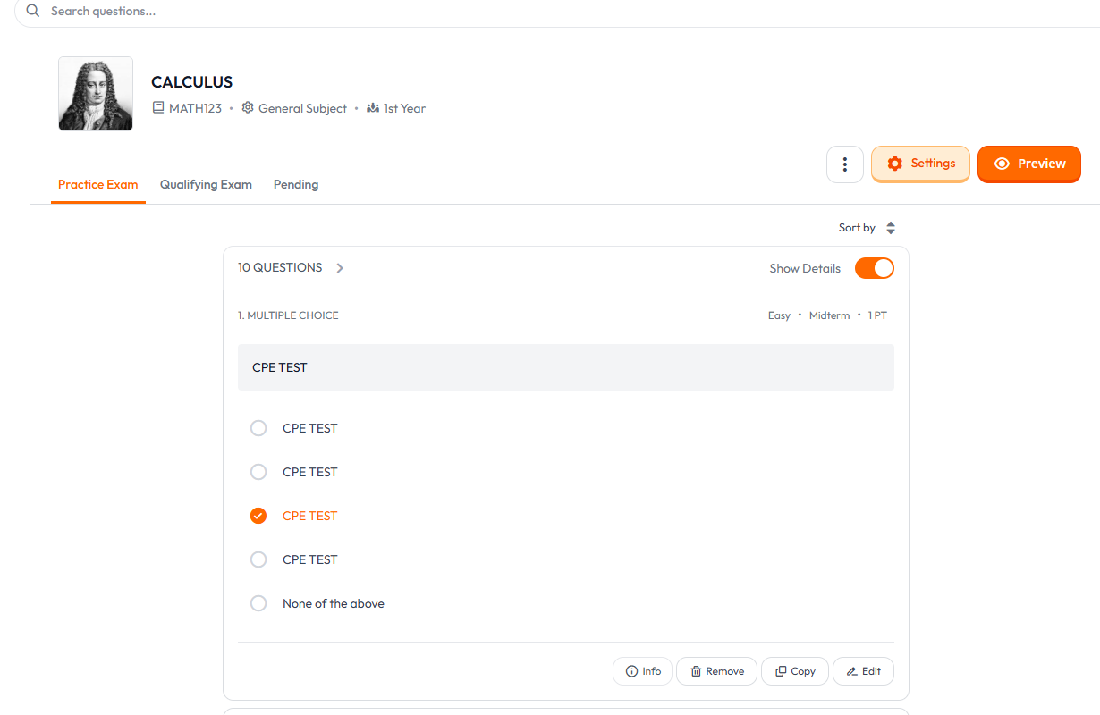
TESTING BEHAVIOR BEFORE FIX:

TEST CASE 1: VIEWING ALL QUESTIONS USING DEAN ACCOUNT
EXPECTED BEHAVIOR: CAN VIEW ALL QUESTIONS
ACTUAL BEHAVIOR: CAN VIEW ALL QUESTIONS

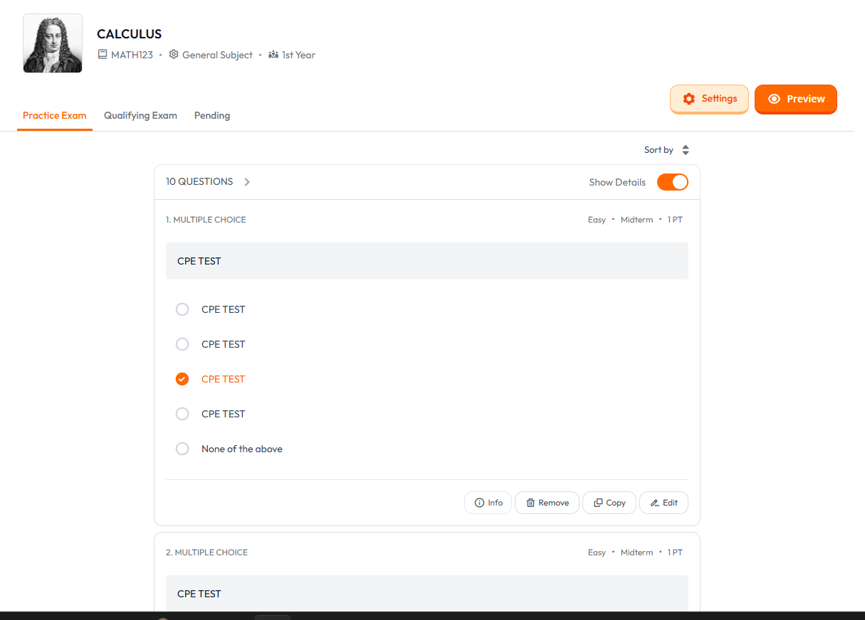

TEST CASE 2: VIEWING ALL QUESTIONS USING CPE PROGRAM CHAIR ACCOUNT
EXPECTED BEHAVIOR: CAN VIEW ALL QUESTIONS
ACTUAL BEHAVIOR: CAN VIEW ALL QUESTIONS

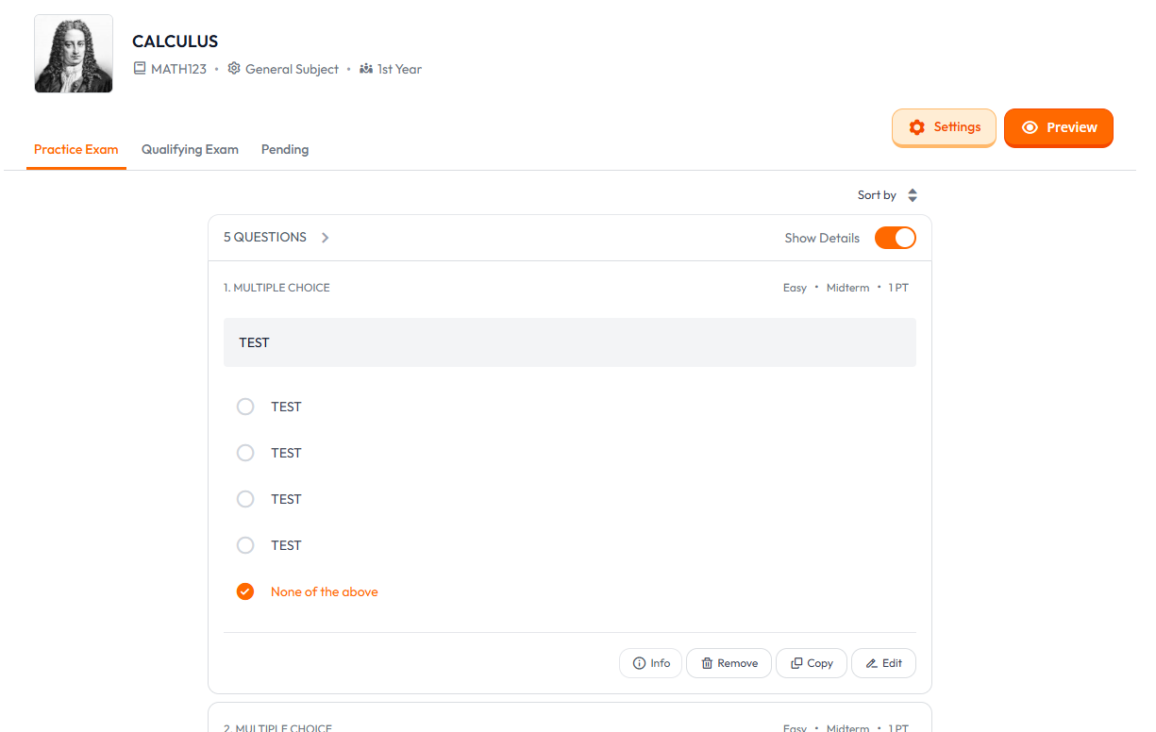

TEST CASE 3: VIEWING ALL QUESTIONS USING CE PROGRAM CHAIR ACCOUNT
EXPECTED BEHAVIOR: CAN VIEW ALL QUESTIONS
ACTUAL BEHAVIOR: CAN’T VIEW ALL QUESTIONS BECAUSE THE ADDED QUESTIONS ARE FROM CPE PROGRAM CHAIR AND FACULTY

TESTING BEHAVIOR AFTER FIX:


TEST CASE 1: VIEWING ALL QUESTIONS USING DEAN ACCOUNT
EXPECTED BEHAVIOR: CAN VIEW ALL QUESTIONS
ACTUAL BEHAVIOR: CAN VIEW ALL QUESTIONS



TEST CASE 2: VIEWING ALL QUESTIONS USING CPE PROGRAM CHAIR ACCOUNT
EXPECTED BEHAVIOR: CAN VIEW ALL QUESTIONS
ACTUAL BEHAVIOR: CAN VIEW ALL QUESTIONS

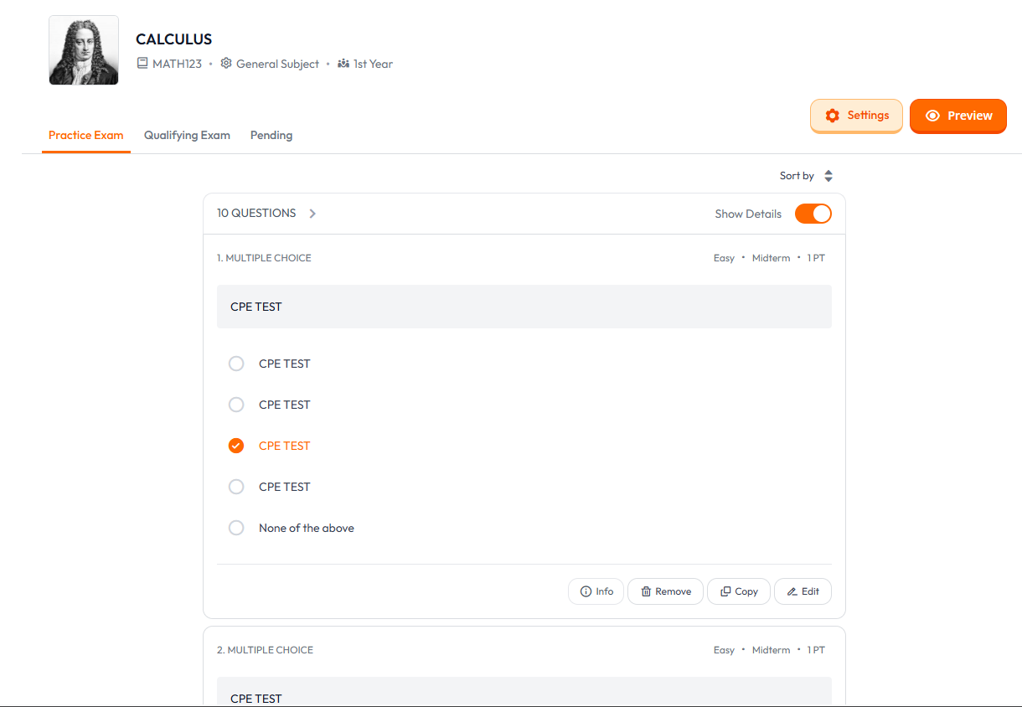

TEST CASE 3: VIEWING ALL QUESTIONS USING CE PROGRAM CHAIR ACCOUNT
EXPECTED BEHAVIOR: CAN VIEW ALL QUESTIONS
ACTUAL BEHAVIOR: CAN VIEW ALL QUESTIONS
Code Before Fix:
For all subjects, a Program Chair could only view:

Questions created by users in the same program.
Questions created by the Dean (roleID = 4).

// Apply program-based filtering for Program Chairs, but also include questions added by the Dean (roleID 4)
if ($isProgramChair) {
$query->where(function($q) use ($user) {
$q->whereHas('user', function($q2) use ($user) {
$q2->where('programID', $user->programID);
})
->orWhereHas('user', function($q2) {
$q2->where('roleID', 4); // Dean
});
});
}

Code After Fix:
The logic now checks whether the subject is a General Subject (programID = 6).
If the subject is a General Subject, the program chair can view all the questions that are inside in that subject.

// Apply role-based filtering for Program Chairs
if ($isProgramChair) {
if ($subject->programID === 6) {
// General subject: show all questions from the same campus, regardless of program
$query->whereHas('user', function ($q) use ($user) {
$q->where('campusID', $user->campusID);
});
} else {
// Program-specific subject: filter by program, but also include questions added by the Dean (roleID 4)
$query->where(function ($q) use ($user) {
$q->whereHas('user', function ($q2) use ($user) {
$q2->where('programID', $user->programID);
})
->orWhereHas('user', function ($q2) {
$q2->where('roleID', 4); // Dean
});
});
}

