Part-1: Write a function to compute Euclidian Distance between each individual value in each matrix.

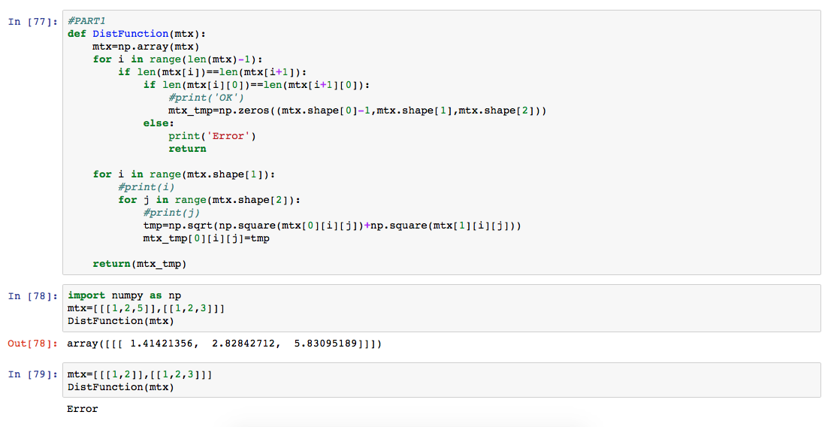

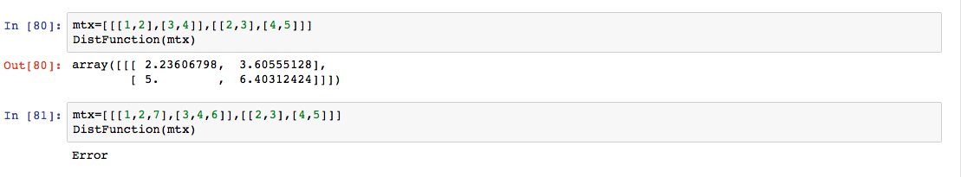

Part2-a: Create Table (9 Attributes) and Load into sqlite

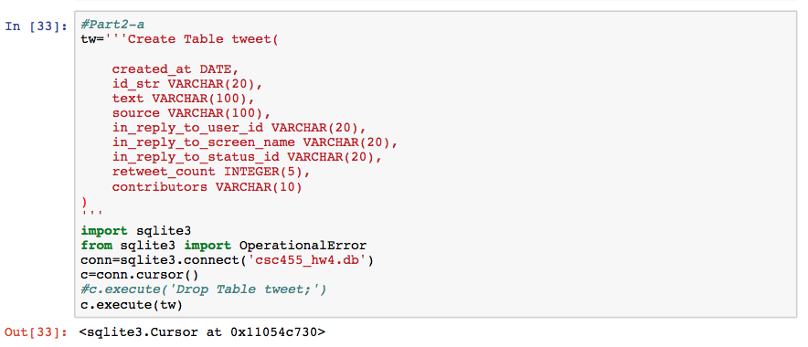

Part2-b: Write python code to read through the Assignment4.txt file and populate table from part2-a including NULLs (i.e. None)

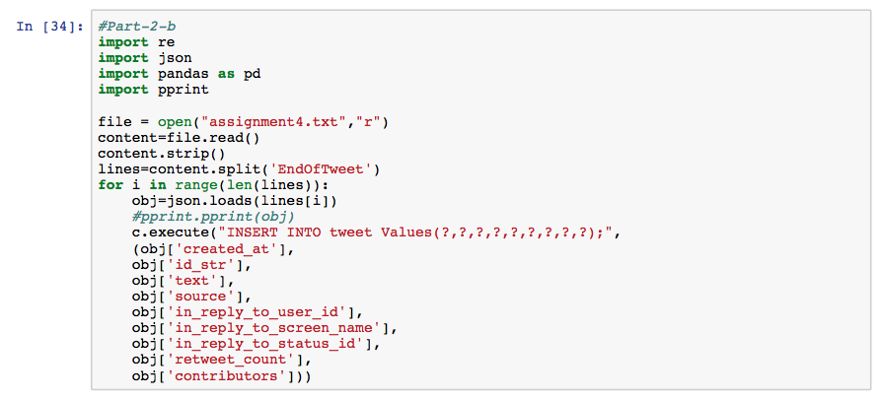

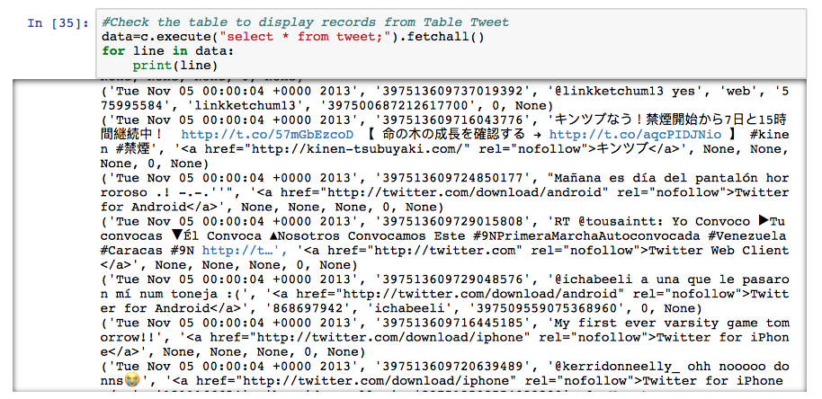

#Part3-a: The table name ‘tweet’ is assigned on part2-a

c.execute("select count(source) from tweet where source LIKE '%iPhone%';").fetchall()

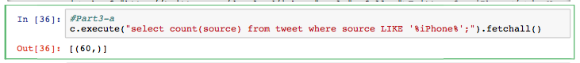

#Part3-b

c.execute("Create View notreply as select * from tweet where 'in_reply_to_user_id is NULL'").fetchall()



#Part3-c: The View is assigned as 'notreply' on Part3-b

c.execute("select * from notreply where retweet_count > (select avg(retweet_count) from tweet);").fetchall()



#Part3-d: The name of View is assigned as ‘retweet5’

c.execute("Create View retweet5 AS select id_str,text, source from tweet where retweet_count>=5").fetchall()

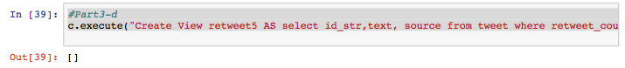

#Part3-e: View is named as retweet5 from Part3-d which is already filter out retweet_count>=5

c.execute("select count(*) from retweet5").fetchall()

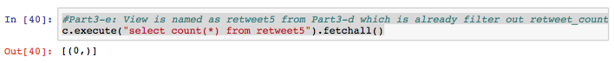

Part3-f: Write Python script to find out the number of tweet with retweet_count>=5

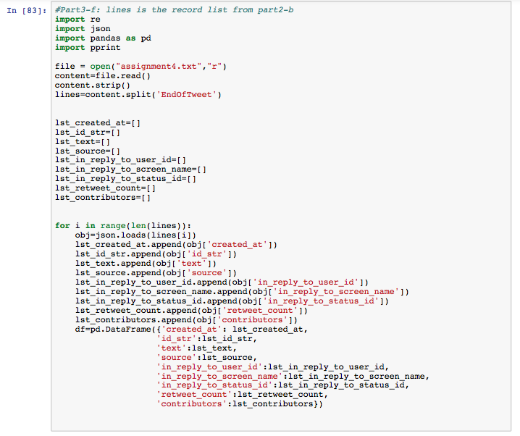

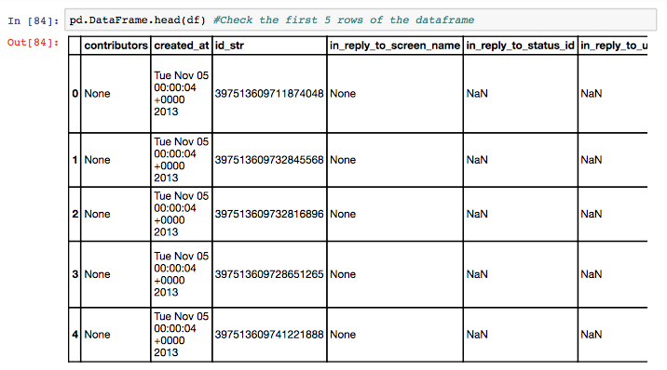

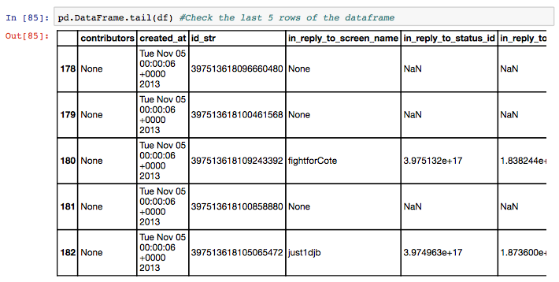

#***The number of tweet_count >= 5 equals to ZERO

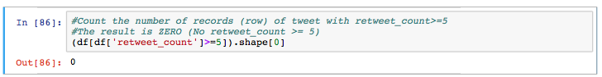

Part-4: Write python function with Table Name as parameter to output INSERT statement to a file. In this case, I named the file as “file.txt”.

