**CSC 555: Mining Big Data**

Project, Phase 1

In this part of the project, you will 1) Set up a 3-node cluster and 2) perform data warehousing and transformation queries using Hive, Pig and Hadoop streaming. The modified Hive-style schema is still available at:

http://rasinsrv07.cstcis.cti.depaul.edu/CSC555/SSBM1/SSBM_schema_hive.sql

It is based on SSBM benchmark (derived from industry standard TPCH benchmark). I modified it from SQL to HiveQL. This is Scale1, or the smallest unit – lineorder is the largest table at about 0.6GB. You can use wget to download the following links. Keep in mind that data is |-separated (not csv).

<http://rasinsrv07.cstcis.cti.depaul.edu/CSC555/SSBM1/dwdate.tbl>

<http://rasinsrv07.cstcis.cti.depaul.edu/CSC555/SSBM1/lineorder.tbl>

<http://rasinsrv07.cstcis.cti.depaul.edu/CSC555/SSBM1/part.tbl>

<http://rasinsrv07.cstcis.cti.depaul.edu/CSC555/SSBM1/supplier.tbl>

<http://rasinsrv07.cstcis.cti.depaul.edu/CSC555/SSBM1/customer.tbl>

Please be sure to submit all code (pig and python).

# Part 1: Multi-node cluster

1. Your first step is to setup a multi-node cluster and re-run a simple wordcount. For this part, you will create a 3-node cluster (with a total of 1 master + 2 worker nodes). Include your master node in the “slaves” file, to make sure all 3 nodes are working.

You need to perform the following steps:

1. Create a new node of a medium size. It is possible, but I do not recommend trying to reconfigure your existing Hadoop into this new cluster (it is much easier to make 3 new nodes for a total of 4 in your AWS account).
   1. When creating a node I recommend changing the default 8G hard drive to 30G so that you do not run out of space easily.
   2. Change your security group setting to open firewall access. Rather than figure out all individual port, you can set 0-64000 range opening up all ports (not the

most secure setting in the long term, but fine for us)

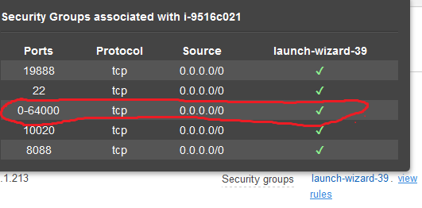

* 1. Step by step instructions on how to make the change to open up the ports:

Click on security group (launch-wizard-x)

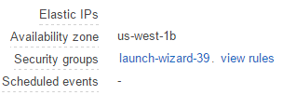

Right click on the security group and choose Edit inbound rules

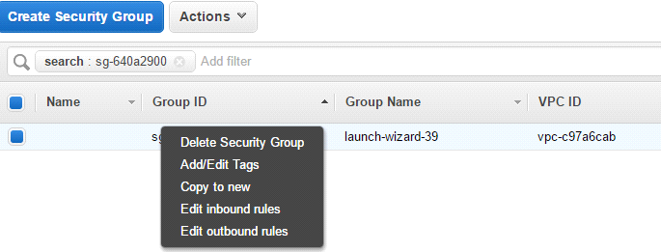

Add a new rule and put in the ports 0-64000 and “Anywhere” and click save.

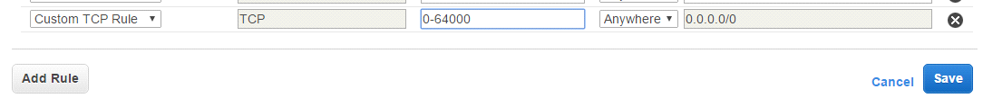

This will open the firewall completely for all ports.

* 1. Finally, right click on the Master node and choose “create more like this” to create 2 more nodes with same settings. If you configure the network settings on master first, security group information will be copied.

NOTE: Hard drive size will not be copied and default to 8G unless you change it.

1. Connect to the master and set up Hadoop similarly to what you did previously. Do not attempt to repeat these steps on workers yet – you will only need to set up Hadoop once.
   1. Configure core-site.xml, adding the **PrivateIP** (do not use public IP) of the master. 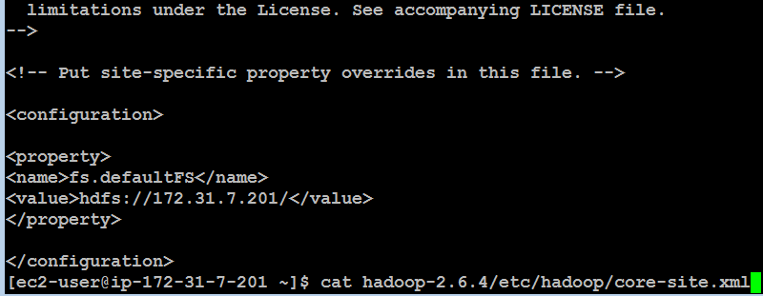
   2. Configure hdfs-site and set replication factor to 2.

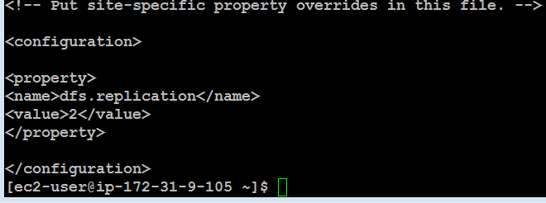

* 1. cp hadoop-2.6.4/etc/hadoop/mapred-site.xml.template hadoop-2.6.4/etc/hadoop/mapred-site.xml and then configure mapred-site.xml

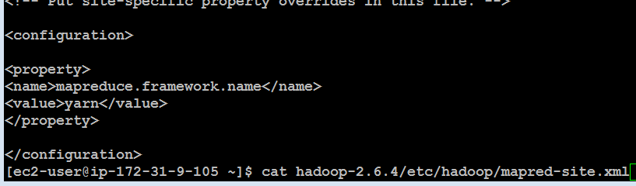

* 1. Configure yarn-site.xml (once again, use PrivateIP of the master)

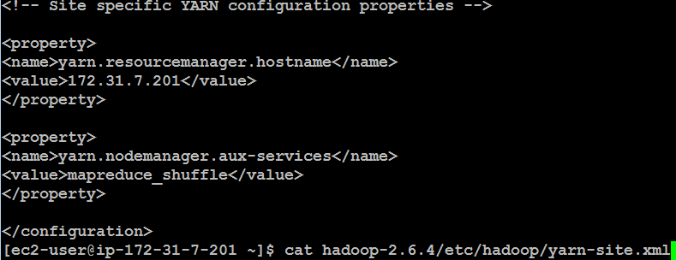

Finally, edit the slaves file and list your 3 nodes (master and 2 workers) using Private IPs

[ec2-user@ip-172-31-7-201 ~]$ cat hadoop-2.6.4/etc/hadoop/slaves

172.31.7.201

172.31.5.246

172.31.11.50

Make sure that you use private IP (private DNS is also ok) for your configuration files (such as conf/masters and conf/slaves or the other 3 config files). The advantage of the Private IP is that it does not change after your instance is stopped (if you use the Public IP, the cluster would need to be reconfigured every time it is stopped). The downside of the Private IP is that it is only meaningful within the Amazon EC2 network. So all nodes in EC2 can talk to each other using Private IP, but you cannot connect to your instance from the outside (e.g., from your laptop) because Private IP has no meaning for your laptop (since your laptop is not part of the Amazon EC2 network).

Now, we will pack up and move Hadoop to the workers. All you need to do is to generate and then copy the public key to the worker nodes to achieve passwordless access across your cluster.

1. Run ssh-keygen -t rsa (and enter empty values for the passphrase) on the master node. That will generate .ssh/id_rsa and .ssh/id_rsa.pub (private and public key). You now need to manually copy the .ssh/id_rsa.pub and append it to ~/.ssh/authorized_keys **on each worker.**

Keep in mind that this is a single-line public key and accidentally introducing a line break would break it. For example:

Note that this is NOT the master, but one of the workers (ip-172-31-5-246). The first public key is the .pem Amazon half and the 2nd public key is the master’s public key copied in as one line.

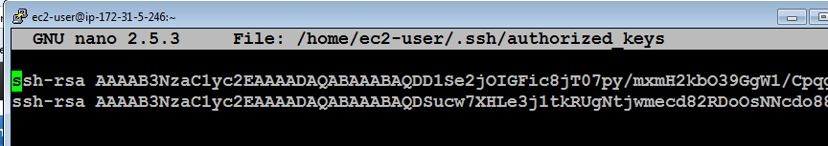

You can add the public key of the master to the master by running this command:

cat ~/.ssh/id_rsa.pub >> ~/.ssh/authorized_keys

Make sure that you can ssh to all of the nodes from the master node (by running ssh 54.186.221.92, where the IP address is your worker node) from the master and ensuring that you were able to login. You can exit after successful ssh connection by typing exit (the command prompt will tell you which machine you are connected to, e.g., ec2-user@ip-172-31-37-113). Here’s me ssh-ing from master to worker.

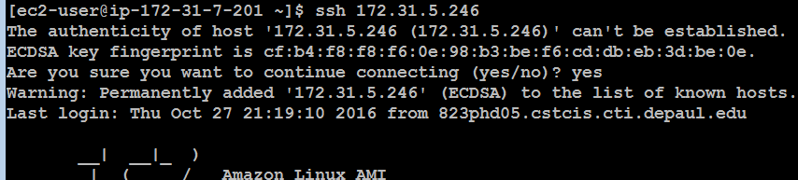

Once you are have verified that you can ssh from the master node to every cluster member including the master itself (ssh localhost), you are going to return to the master node (exit until your prompt shows the IP address of the master node) and pack up the contents of the hadoop directory there. Make sure your Hadoop installation is configured correctly (because from now on, you will have 3 copies of the Hadoop directory and all changes may need to be applied in 3 places).

cd (go to root home directory, i.e. /home/ec2-user/)

(pack up the entire Hadoop directory into a single file for transfer. You can optionally compress the file with gzip)

tar cvf myHadoop.tar hadoop-2.6.4

ls -al myHadoop.tar (to verify that the .tar file had been created)

Now, you need to copy the myHadoop.tar file to every non-master node in the cluster. If you had successfully setup public-private key access in the previous step, this command (for each worker node) will do that:

(copies the myHadoop.tar file from the current node to a remote node into a file called myHadoopWorker.tar. Don’t forget to replace the IP address with that your worker nodes. By the way, since you are on the Amazon EC2 network, either Public or Private IP will work just fine.)

scp myHadoop.tar ec2-user@54.187.63.189:/home/ec2-user/myHadoopWorker.tar



Once the tar file containing your Hadoop installation from master node has been copied to each worker node, you need to login to each non-master node and unpack the .tar file.

Run the following command (on each worker node, not on the master) to untar the hadoop file. We are purposely using a different tar archive name (i.e., myHadoopWorker.tar), so if you get “file not found” error, that means you are running this command on the master node or have not successfully copied myHadoopWorker.tar file.

tar xvf myHadoopWorker.tar

Once you are done, run this on the master (nothing needs to be done on the workers to format the cluster unless you are re-formatting, in which case you’ll need to delete the dfs directory).

hadoop namenode -format

Once you have successfully completed the previous steps, you should be able to start and use your new cluster by going to the master node and running the start-dfs.sh and start-yarn.sh scripts (you do not need to explicitly start anything on worker nodes – the master will do that for you).

You should verify that the cluster is running by pointing your browser to the link below.

http://[insert-the-public-ip-of-master]:50070/

Make sure that the cluster is operational (you can see the 3 nodes under Datanodes tab).

Submit a screenshot of your cluster status view.

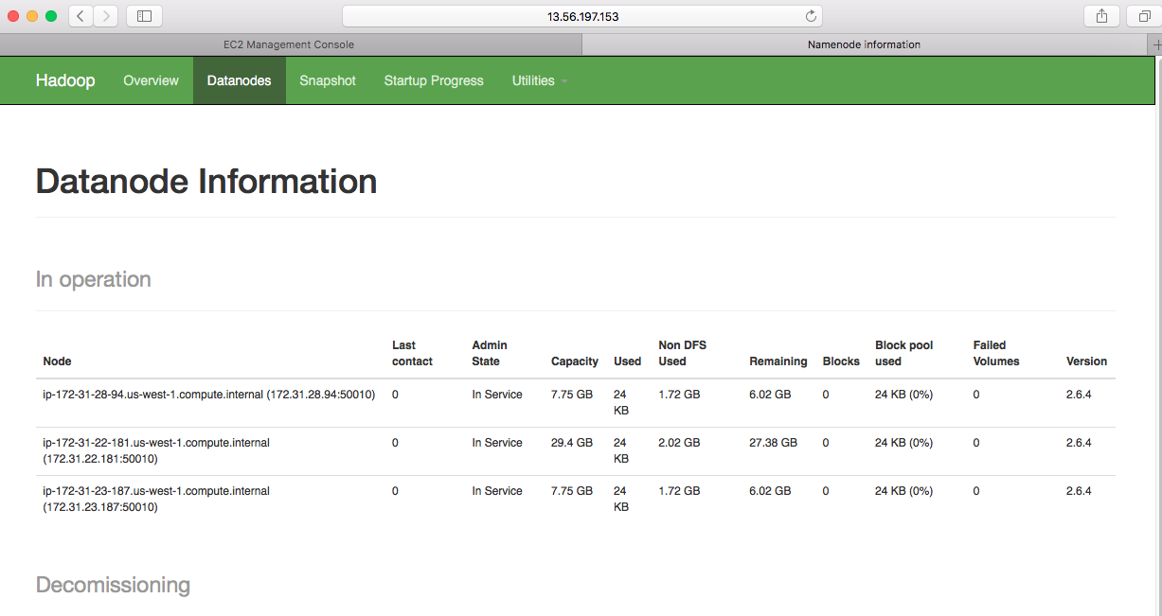

Repeat the steps for wordcount using bioproject.xml from Assignment 1 and submit screenshots of running it.

hadoop fs -put bioproject.xml /data/

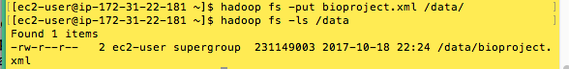

Report the time:

time hadoop jar hadoop-2.6.4/share/hadoop/mapreduce/hadoop-mapreduce-examples-2.6.4.jar wordcount /data/bioproject.xml /data/wordcount1

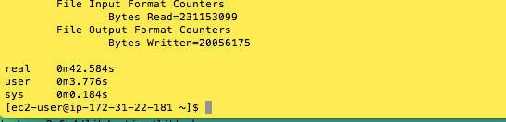

Report the size of the wordcount file

hadoop fs -du /data/wordcount1/

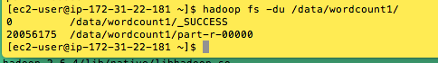

Report the count of grep the word “subarctic”

hadoop fs -cat /data/wordcount1/part-r-00000 | grep subarctic

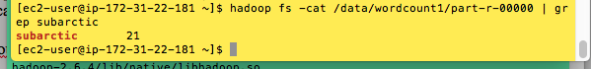

# Part 2: Hive

Run the following five (1.1, 1.2, 1.3 and 2.1, 2.2) queries in Hive and record the time they take to execute: <http://rasinsrv07.cstcis.cti.depaul.edu/CSC555/SSBM1/SSBM_queries.sql>

<http://rasinsrv07.cstcis.cti.depaul.edu/CSC555/SSBM1/dwdate.tbl>

<http://rasinsrv07.cstcis.cti.depaul.edu/CSC555/SSBM1/lineorder.tbl>

<http://rasinsrv07.cstcis.cti.depaul.edu/CSC555/SSBM1/part.tbl>

<http://rasinsrv07.cstcis.cti.depaul.edu/CSC555/SSBM1/supplier.tbl>

<http://rasinsrv07.cstcis.cti.depaul.edu/CSC555/SSBM1/customer.tbl>

create table dwdate (

d_datekey int,

d_date varchar(19),

d_dayofweek varchar(10),

d_month varchar(10),

d_year int,

d_yearmonthnum int,

d_yearmonth varchar(8),

d_daynuminweek int,

d_daynuminmonth int,

d_daynuminyear int,

d_monthnuminyear int,

d_weeknuminyear int,

d_sellingseason varchar(13),

d_lastdayinweekfl varchar(1),

d_lastdayinmonthfl varchar(1),

d_holidayfl varchar(1),

d_weekdayfl varchar(1)

) ROW FORMAT DELIMITED FIELDS TERMINATED BY '|';

LOAD DATA LOCAL INPATH '/home/ec2-user/dwdate.tbl' OVERWRITE INTO TABLE dwdate;

create table lineorder (

lo_orderkey int,

lo_linenumber int,

lo_custkey int,

lo_partkey int,

lo_suppkey int,

lo_orderdate int,

lo_orderpriority varchar(15),

lo_shippriority varchar(1),

lo_quantity int,

lo_extendedprice int,

lo_ordertotalprice int,

lo_discount int,

lo_revenue int,

lo_supplycost int,

lo_tax int,

lo_commitdate int,

lo_shipmode varchar(10)

) ROW FORMAT DELIMITED FIELDS TERMINATED BY '|';

LOAD DATA LOCAL INPATH '/home/ec2-user/lineorder.tbl' OVERWRITE INTO TABLE lineorder;

create table part (

p_partkey int,

p_name varchar(22),

p_mfgr varchar(6),

p_category varchar(7),

p_brand1 varchar(9),

p_color varchar(11),

p_type varchar(25),

p_size int,

p_container varchar(10)

) ROW FORMAT DELIMITED FIELDS TERMINATED BY '|';

LOAD DATA LOCAL INPATH '/home/ec2-user/part.tbl' OVERWRITE INTO TABLE part;

create table supplier (

s_suppkey int,

s_name varchar(25),

s_address varchar(25),

s_city varchar(10),

s_nation varchar(15),

s_region varchar(12),

s_phone varchar(15)

) ROW FORMAT DELIMITED FIELDS TERMINATED BY '|';

LOAD DATA LOCAL INPATH '/home/ec2-user/supplier.tbl' OVERWRITE INTO TABLE supplier;

1.1)

select lo_orderdate, sum(lo_extendedprice) as revenue

from lineorder, dwdate

where lo_orderdate = d_datekey

and d_year = 1994

and lo_discount between 1 and 3

and lo_quantity < 25

GROUP BY lo_orderdate;

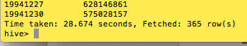

Ans: 28.674 sec.

1.2)

select sum(lo_extendedprice) as revenue

from lineorder, dwdate

where lo_orderdate = d_datekey

and d_yearmonth = 'Jan1993'

and lo_discount between 5 and 6

and lo_quantity between 25 and 35;

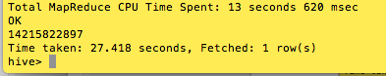

Ans: 27.418 sec.

1.3)

select sum(lo_extendedprice) as revenue

from lineorder, dwdate

where lo_orderdate = d_datekey

and d_weeknuminyear = 6 and d_year = 1994

and lo_discount between 5 and 8

and lo_quantity between 36 and 41;

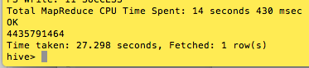

Ans: 27.298 sec.

2.1)

select sum(lo_revenue), d_year, p_brand1

from lineorder, dwdate, part, supplier

where lo_orderdate = d_datekey

and lo_partkey = p_partkey

and lo_suppkey = s_suppkey

and p_category = 'MFGR#12'

and s_region = 'AMERICA'

group by d_year, p_brand1

order by d_year, p_brand1;

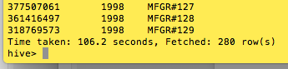

Ans: 106.2 sec.

2.2)

select sum(lo_revenue), d_year, p_brand1

from lineorder, dwdate, part, supplier

where lo_orderdate = d_datekey

and lo_partkey = p_partkey

and lo_suppkey = s_suppkey

and p_brand1 between 'MFGR#2221'

and 'MFGR#2238'

and s_region = 'ASIA'

group by d_year, p_brand1

order by d_year, p_brand1;

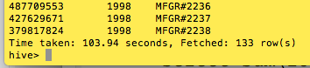

Ans: 103.94 sec.

# Part 3: Pig

Convert and load the data into Pig, implementing queries 0.1, 0.2, 0.3. You only need to do all of the queries for Pig. Check disk storage, if your disk usage is over 90% Pig may hang without an error or a warning.

One easy way to time Pig is as follows: put your sequence of pig commands into a text file and then run, from command line in pig directory (e.g., [ec2-user@ip-172-31-6-39 pig-0.15.0]$), bin/pig -f pig_script.pig (which will inform you how long the pig script took to run).

--Q0.1

SELECT AVG(lo_revenue)

FROM lineorder;

Parse the followings on the script and then execute in the PIG directory

lod = LOAD '/user/ec2-user/lineorder.tbl' USING PigStorage('|')

AS (lo_orderkey :float,

lo_linenumber :float,

lo_custkey :float,

lo_partkey :float,

lo_suppkey :float,

lo_orderdate :float,

lo_orderpriority :chararray,

lo_shippriority : chararray,

lo_quantity :float,

lo_extendedprice :float,

lo_ordertotalprice :float,

lo_discount :float,

lo_revenue :float,

lo_supplycost :float,

lo_tax :float,

lo_commitdate :float,

lo_shipmode : chararray);

by_all= group lod ALL;

all_avg = FOREACH by_all GENERATE AVG( lod.lo_revenue);

Dump all_avg;

STORE all_avg INTO '/result0.1' USING PigStorage ('\t');

Output:

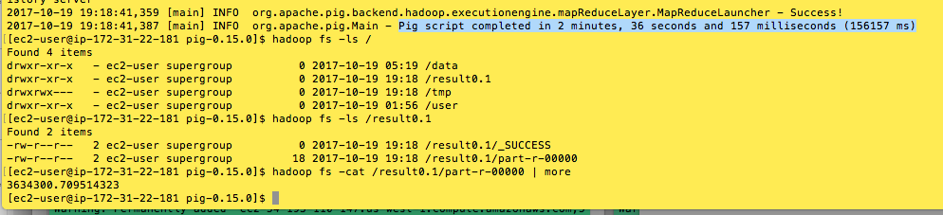

Ans: 2min 36sec 157 ms was taken

--Q0.2

SELECT lo_discount, COUNT(lo_extendedprice)

FROM lineorder

GROUP BY lo_discount;

Parse the followings on the script and then execute in the PIG directory

lod = LOAD '/user/ec2-user/lineorder.tbl' USING PigStorage('|')

AS (lo_orderkey :float,

lo_linenumber :float,

lo_custkey :float,

lo_partkey :float,

lo_suppkey :float,

lo_orderdate :float,

lo_orderpriority :chararray,

lo_shippriority : chararray,

lo_quantity :float,

lo_extendedprice :float,

lo_ordertotalprice :float,

lo_discount :float,

lo_revenue :float,

lo_supplycost :float,

lo_tax :float,

lo_commitdate :float,

lo_shipmode : chararray);

by_discount = group lod by lo_discount;

discount_count = FOREACH by_discount GENERATE group as lo_discount, COUNT(lod);

dump discount_count;

store discount_count into '/result0.2' using PigStorage('\t');

Output:

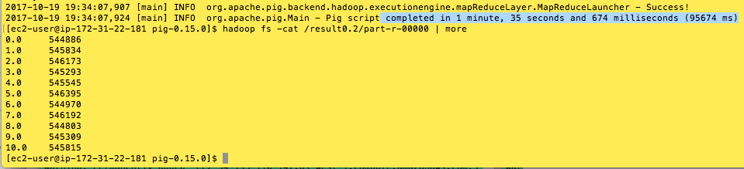

Ans: 1min 35sec 674ms

--Q0.3 Added simple test query

SELECT lo_quantity, SUM(lo_revenue)

FROM lineorder

WHERE lo_discount < 3

GROUP BY lo_quantity;

Parse the followings on the script and then execute in the PIG directory

lod = LOAD '/user/ec2-user/lineorder.tbl' USING PigStorage('|')

AS (lo_orderkey :float,

lo_linenumber :float,

lo_custkey :float,

lo_partkey :float,

lo_suppkey :float,

lo_orderdate :float,

lo_orderpriority :chararray,

lo_shippriority : chararray,

lo_quantity : chararray,

lo_extendedprice :float,

lo_ordertotalprice :float,

lo_discount :float,

lo_revenue :float,

lo_supplycost :float,

lo_tax :float,

lo_commitdate :float,

lo_shipmode : chararray);

LowDis = filter lod by lo_discount < 3;

lod = foreach lod generate lo_quantity as qua, lo_revenue as rev;

by_lo_quantity = group lod by qua;

sumTab = FOREACH by_lo_quantity GENERATE group as qua, SUM(lod.rev);

dump sumTab;

store sumTab into '/result0.3' using PigStorage('\t');

Output:

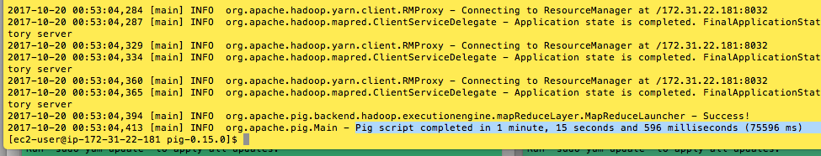

Ans: 1min 15sec 596ms was taken

# Part 4: Hadoop Streaming

Implement query **0.3** using Hadoop streaming with python (you may implement this part in Java if you prefer).

SELECT lo_quantity, SUM(lo_revenue)

FROM lineorder

WHERE lo_discount < 3

GROUP BY lo_quantity;

Ans:

Python Code (Mapper): col8: lo_quantity, col12: lo_revenue, col11: lo_discount

#!/usr/bin/python

import sys

for line in sys.stdin:

    words=line.strip()

    words=words.split('|')

    print '%s\t%s\t%s' % (words[8], words[12], words[11])

Python Code (Reducer): col0: lo_quantity, col1: lo_revenue, col2: lo_discount

#!/usr/bin/env python

import sys

qua=None #Preset the quantity is None

rev=None #Preset the revenue is None

for line in sys.stdin:

    words=line.strip()

    words=words.split('\t')

    if float(words[2]) < 3 :

        if qua == None:

            qua = words[0]

            rev = float(words[1])

        elif words[0] != qua :

            print '%s\t%s' % (qua, rev)

    qua = words[0]

    rev = float(words[1])

elif words[0] == qua:

    rev += float(words[1])

print '%s\t%s' % (qua, rev)

Testing in Terminal

[ec2-user@ip-172-31-22-181 ~]$ cat lineorder.tbl | python project_mapper1.py | sort -n | python project_reducer1.py

Hadoop streaming Code

hadoop jar /home/ec2-user/hadoop-2.6.4/share/hadoop/tools/lib/hadoop-streaming-2.6.4.jar -D mapred.output.key.comparator.class=org.apache.hadoop.mapred.lib.KeyFieldBasedComparator -D mapred.text.key.comparator.options=-n -input /projectData -output /data/output -mapper project_mapper1.py -reducer project_reducer1.py -file project_reducer1.py -file project_mapper1.py

Output:

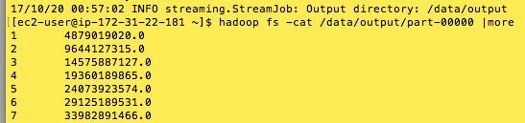

Submit a single document containing your written answers. Be sure that this document contains your name and “CSC 555 Project Phase 1” at the top.