|  |  |  |  |  |
| --- | --- | --- | --- | --- |
| Star war site | | | | |
|  |  | | |  |
| Database structure | | | | |
|  | | by Vicky Schorborch |  | |

TABLE OF CONTENTS

1. Executive summary 3

2. Star Wars Database Structure 4

PhpMyAdmin Configuration 4

Raw Data testing 7

# 1. Executive summary

In this report will be describe the preliminary design of the Star War database who will be connected with the web site, this database design in essential to store the information of our site and then we can use to display the record into the site as the client required

# 2. Star Wars Database Structure

To store all the information that will be processed by the Star Wars website is important define the database structure according to the client requirements.

Furthermore, to define the Structure of the database we should define the normalization to avoid duplicate data.

For our database design and develop we will create tables following the the 3rd normal form, for this goal we are using phpMyAdmin software to make all the configuration of our database.

The tables that will be create are:

* **User**
* **Movies**
* **Characters**
* **Ships**
* **Planets**
* **The force (Jedi, Sith)**
* **Alien Races**
* **User forums.**

## PhpMyAdmin Configuration

Database user details

**Username**: mri

**Host** **name**: localhost

**Password**: password

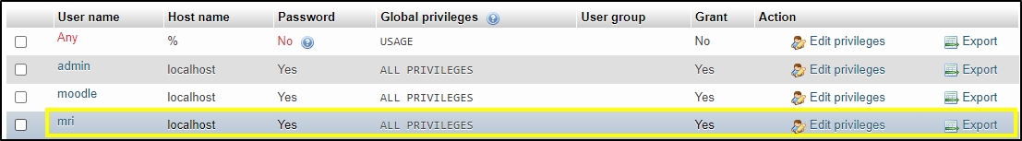

**Database** **name**: star_war

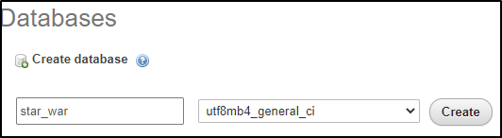

**Create a Table user**

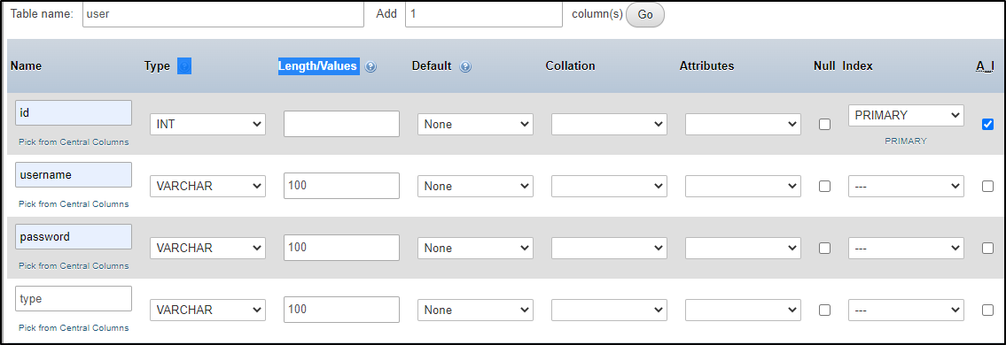



**Create a Table Movies**

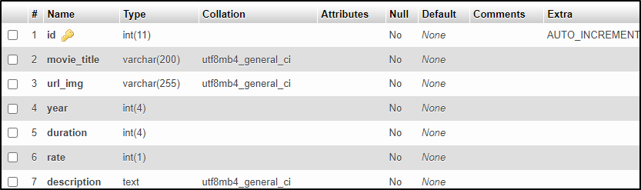

**Create a Table Characters**

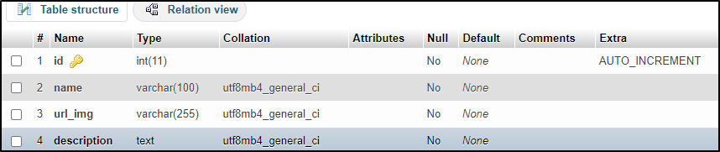

**Create a Table Ships**

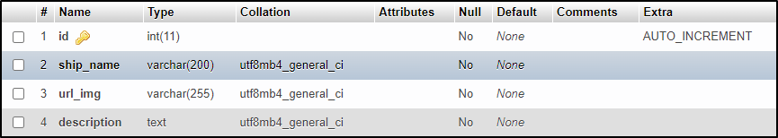

**Create a Table Planets**

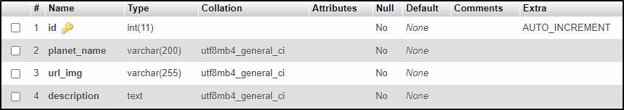

**Create a Table Alien Races**

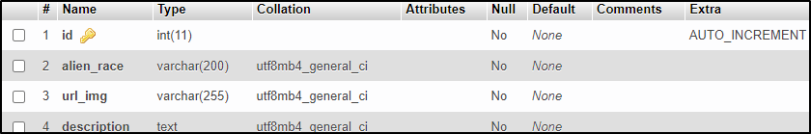

**Create a Table the Force**

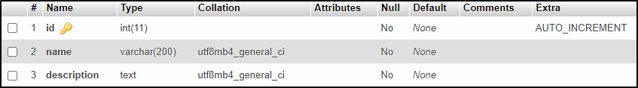

**Create a Table Forums**

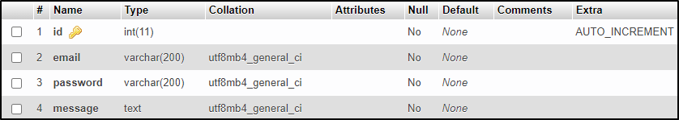

## Raw Data testing

**User - Table**



**Movies - Table**



**Characters - Table**



**Planets - Table**



**Ships - Table**



**Forums - Table**



**Alien_race – Table**



**The force (Jedi, Sith)**

