Astana IT University
School of Information Technology

Customer Churn Prediction

Educational Practice Mini-Project Report

Project Track: Machine Learning
Team Name: StarTrio
Academic Group: ______________________
Instructor Collaborator: @bakhtiyar-k

Team Members:
Kymbat Uagap
Zhansaya Yerkenova
Saltanat Tlegen

2025

1. Team Members and Contributions

Full Name | Role | Contributions
Kymbat Uagap | Team Leader /  Machine Learning Engineer | Organized the project workflow and GitHub repository, performed data preprocessing, handled missing values and feature encoding, trained and evaluated machine learning models, conducted feature importance analysis, selected the final model, saved churn_model.pkl, prepared machine learning screenshots and results for the report, and coordinated team activities.
Zhansaya Yerkenova | Data Analyst | Collected and prepared the dataset, performed exploratory data analysis, analyzed customer churn patterns, created visualizations and charts, interpreted dataset characteristics, and provided screenshots and findings for the report.
Saltanat Tlegen | Documentation &  Project Integration | Organized project documentation, compiled and formatted the final report, prepared the contribution table, coordinated final submission materials, assisted with GitHub repository maintenance, and collected screenshots.

2. Project Overview
This project is a machine learning mini-project for predicting customer churn. The system uses a customer churn dataset, performs preprocessing and exploratory data analysis, compares several machine learning algorithms, saves the best model, and deploys it in a Streamlit application.
The application allows a user to enter customer information and returns a churn prediction, a probability score, a risk level, and a summary of the values used for prediction.

3. Problem Statement
Customer churn is an important business problem because losing customers reduces revenue and increases the cost of acquiring new users. The goal of this project is to predict whether a customer is likely to leave the service based on customer profile, usage, support, payment, subscription, and interaction data.
The target variable is Churn:
• 1 — customer left the service
• 0 — customer remained with the service

4. Methodology / Tools and Technologies Used
Tools and technologies used in this project:
- Python — main programming language
- Pandas — data loading and preprocessing
- NumPy — numerical operations
- Scikit-learn — machine learning models and evaluation
- Matplotlib / Seaborn — data visualization
- Jupyter Notebook — exploratory analysis
- Streamlit — web application deployment
- GitHub — version control and collaboration
- Pytest — automated testing

Data preprocessing steps:
- Loaded the customer churn dataset (440,833 records).
- Removed rows with missing values.
- Removed the CustomerID column as it is only an identifier.
- Applied one-hot encoding to categorical variables (Gender, Subscription Type, Contract Length).
- Split the dataset into training and testing subsets.

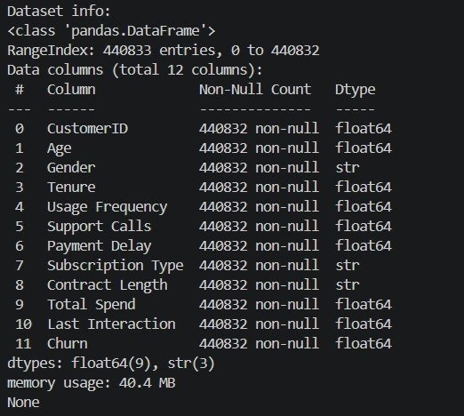
Figure 1. Dataset structure and feature information.
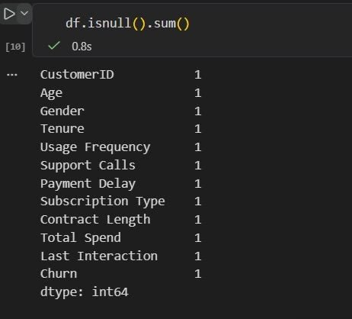 | 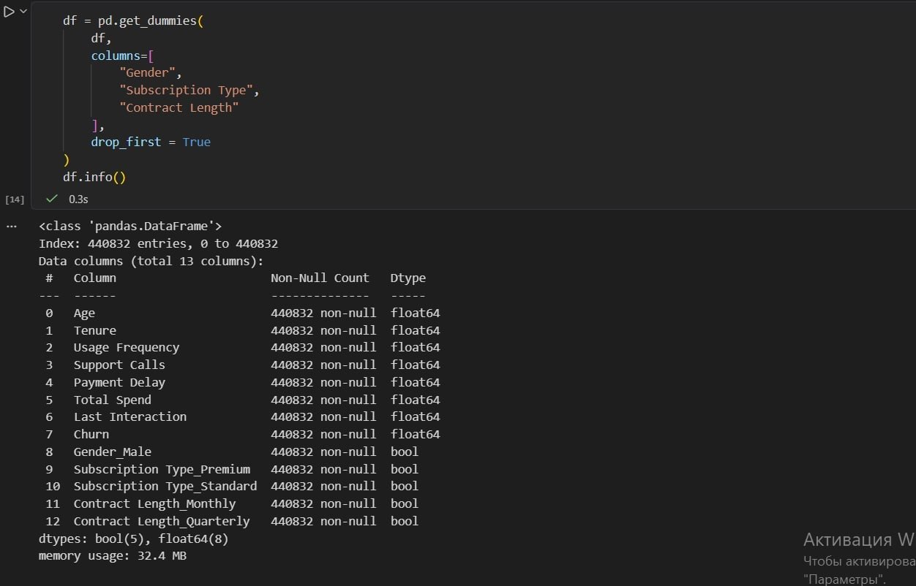
Figure 2. Missing value analysis. | Figure 3. Dataset after encoding.

5. Main Features / Model Description
Three machine learning algorithms were trained and compared:
- Logistic Regression
- Decision Tree Classifier
- Random Forest Classifier

Input features: Age, Gender, Tenure, Usage Frequency, Support Calls, Payment Delay, Subscription Type, Contract Length, Total Spend, Last Interaction.

The Streamlit application accepts the following inputs:
Required: Age, Monthly Charges, Contract Length, Support Calls
Optional: Tenure Months, Usage Frequency, Payment Delay, Last Interaction, Gender, Subscription Type

Application output:
- Churn prediction
- Probability score
- Risk level
- Input summary table

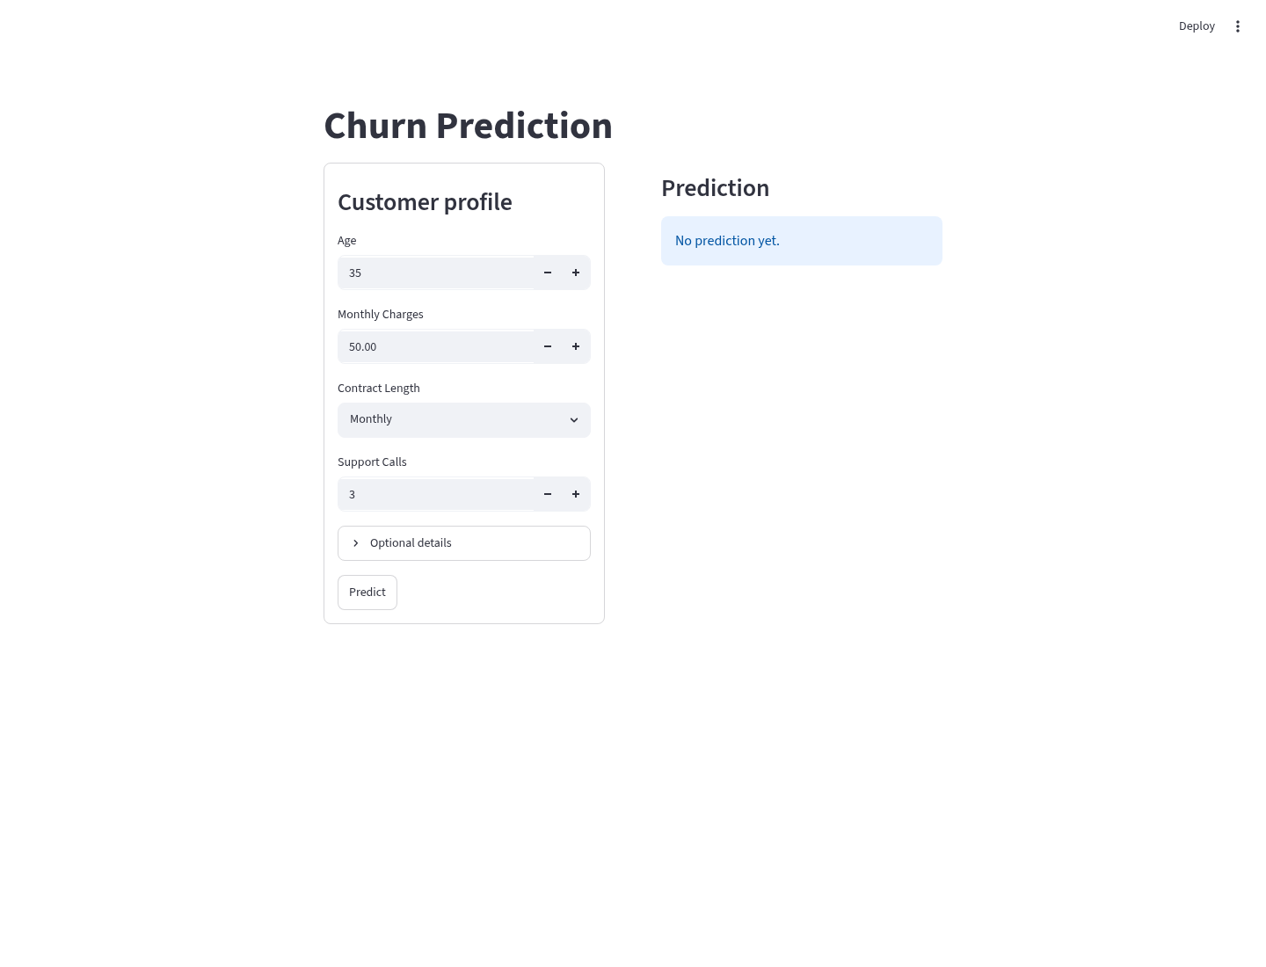
Figure 4. Streamlit application input form.

6. Implementation Explanation
The implementation follows these steps:
- Load the dataset from data/customer_churn_dataset-training-master.csv.
- Remove rows with missing values.
- Remove the CustomerID column.
- Apply one-hot encoding to categorical variables.
- Split data into training (80%) and testing (20%) subsets.
- Train Logistic Regression, Decision Tree, and Random Forest models.
- Evaluate each model using accuracy and classification metrics.
- Save the selected Decision Tree model as models/churn_model.pkl.
- Load the saved model in src/main.py.
- Convert Streamlit user inputs into the exact model feature schema (using training dataset medians/modes for missing optional features).
- Display prediction, probability score, risk level, and input summary to the user.

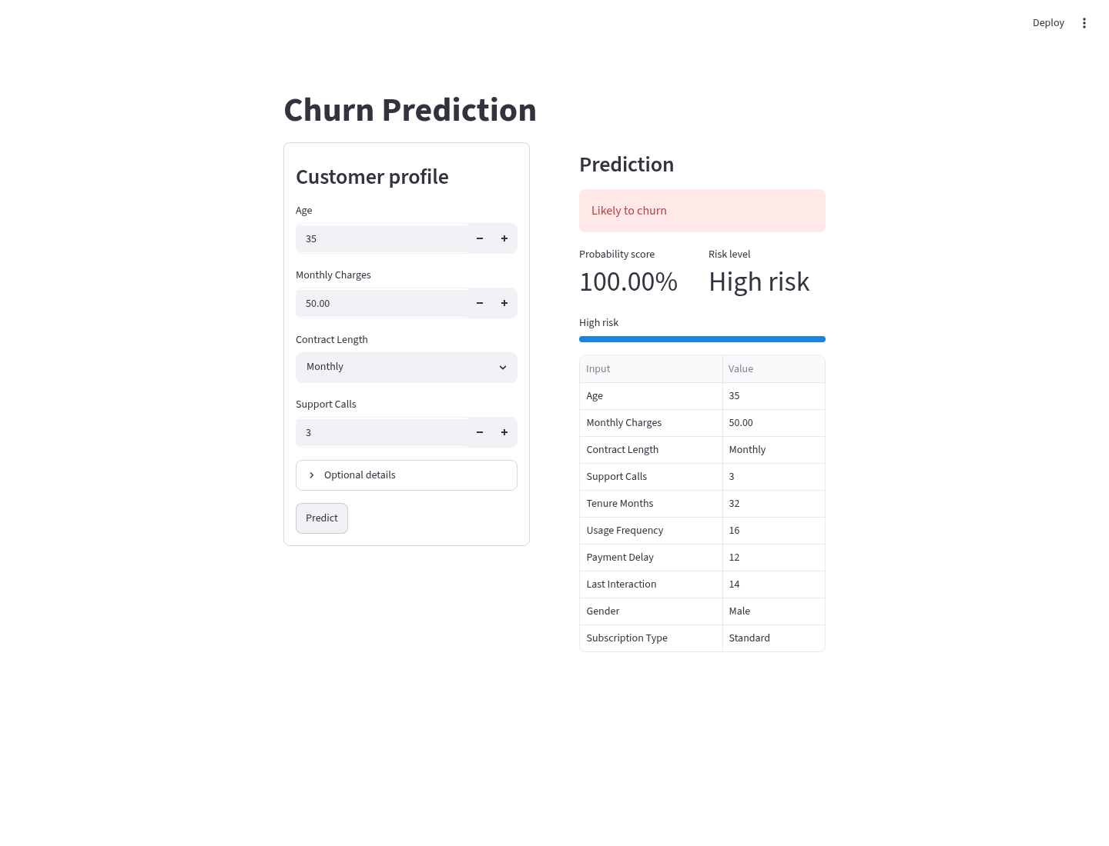
Figure 5. Streamlit prediction output.

7. Screenshots
Exploratory Data Analysis:

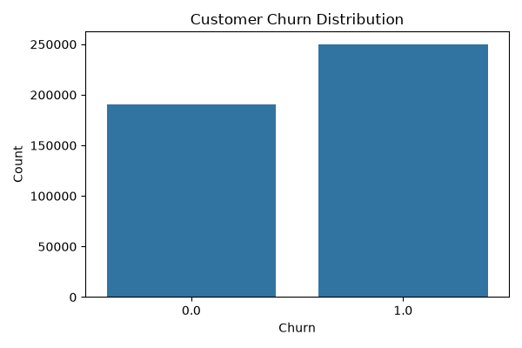 | 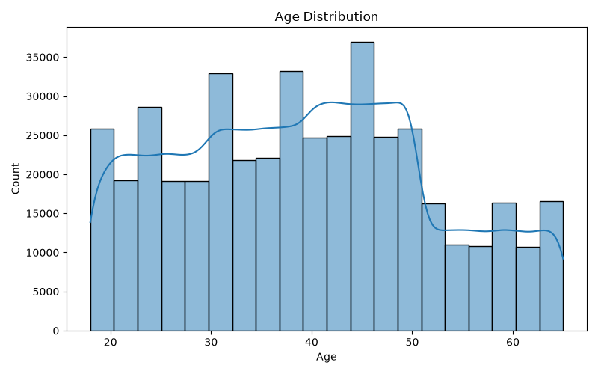
Figure 6. Churn distribution. | Figure 7. Age distribution.

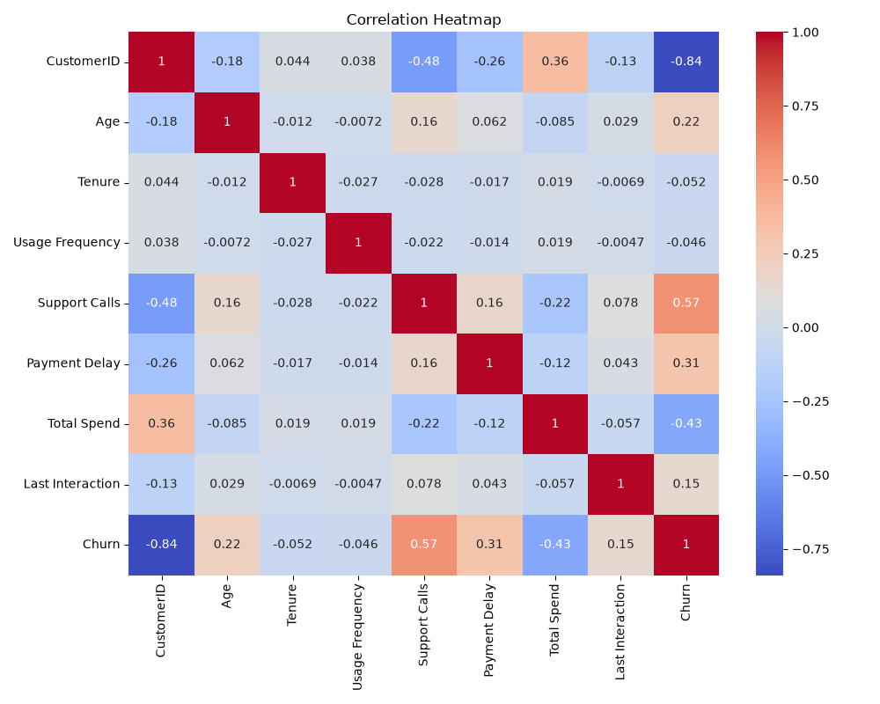
Figure 8. Correlation heatmap of numerical features.

Model Training and Evaluation:

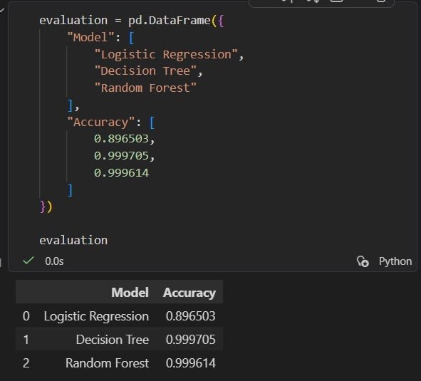 | 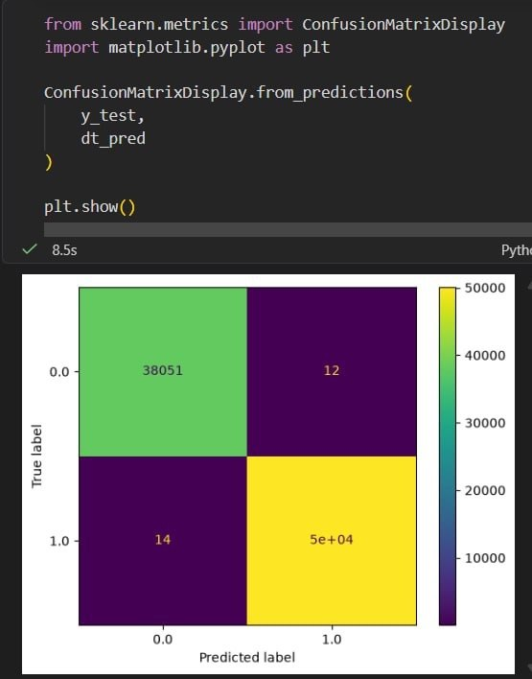
Figure 9. Model accuracy comparison. | Figure 10. Confusion matrix.

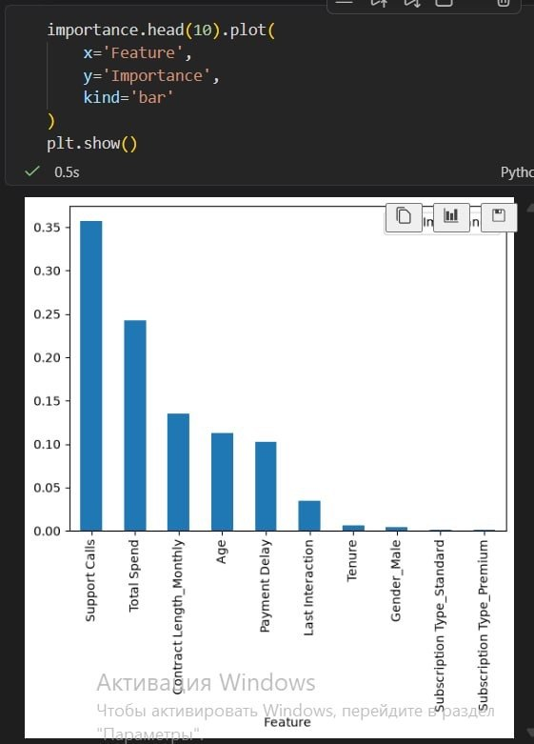
Figure 11. Feature importance visualization.

8. Testing and Evaluation Results
Model accuracy comparison:

Model | Accuracy
Logistic Regression | 89.65%
Decision Tree Classifier (selected) | 99.97%
Random Forest Classifier | 99.96%

The Decision Tree Classifier achieved the highest accuracy (99.97%) and was selected as the final model for deployment.
The most important features identified by the model were: Support Calls, Total Spend, Contract Length, Age, and Payment Delay.

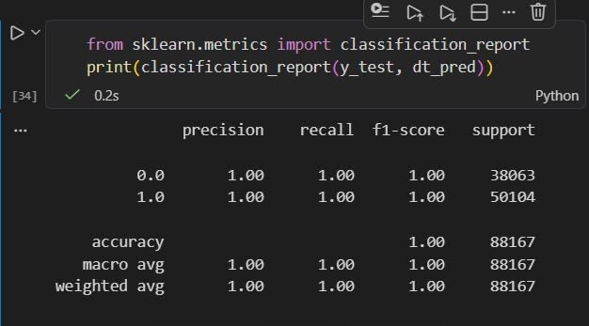
Figure 12. Classification report of the selected model.

Automated Testing:
The project was tested using Pytest. Tests verify that required project files exist, src/main.py runs successfully, the prediction input matches the model schema, and the prediction output is a valid binary label with a probability between 0 and 1.

9. Difficulties and Solutions
Difficulty 1: The dataset contained categorical features that could not be directly processed by machine learning algorithms.
Solution: One-hot encoding was applied to transform categorical values (Gender, Subscription Type, Contract Length) into numerical model inputs.

Difficulty 2: Several machine learning models had to be compared to identify the best performer.
Solution: Logistic Regression, Decision Tree, and Random Forest models were all trained and evaluated on the same train/test split. The highest-performing model was selected for deployment.

Difficulty 3: The saved model was trained with more features than the minimal application input requirements.
Solution: Optional inputs were added to the Streamlit application. Missing model features are filled with training dataset medians for numeric columns and modes for categorical columns, keeping the UI simple while preserving the trained model's feature schema.

10. Conclusion
The team successfully developed a machine learning project for customer churn prediction. The project includes data preprocessing, exploratory data analysis, model training, model evaluation, feature importance analysis, saved model deployment, a Streamlit web interface, automated tests, screenshots, and report materials.
The Decision Tree Classifier achieved the best accuracy (99.97%) and was integrated into the application. The Streamlit application can predict churn from customer profile and behavior inputs and displays the result in a clear format for the user.

11. Links
GitHub Repository: https://github.com/aitu-educational-practice-2026/educational-practice-project-startrio
Instructor Collaborator: @bakhtiyar-k (added as collaborator to the private GitHub repository)

