Specification: Student Management System
Version 1.1

Mai Văn Kỳ - 062206006846
Nguyễn Minh Huy - 079206010447
Nguyễn Võ Phương Uyên - 058306001251
Phạm Hữu Phước - 060206013186
Rcom Chiến - 064205002320

Student Management System | Version 1.1
System specification | Date : 25/12/2025

DOCUMENT REVISION HISTORY
Date | Version | Describe | Authur
25/12/2025 | 1.0 | Document construction
30/12/2025 | 1.1 | Update system usecase
03/01/2026 | 1.2 | Update requirements

Student Management System | Version 1.1
System specification | Date : 25/12/2025
- Student Management System
1. INTRODUCTION
1.1. Purpose
This document details the functional and non-functional requirements for the Student Management System (SMS). The system is built on a Web platform to digitize manual training management processes, thereby improving the efficiency of managing student data, credit registration processes, and grade management at the University.
2. LIST OF ACTORS
2.1. Administrator (Admin)
- The system administrator, responsible for managing platform data (students, lecturers, courses) and system configuration.
2.2. Lecturer
- The teaching staff, responsible for entering grades, managing class sections, and providing course materials.
2.3. Student
- The learner, uses the system to register for credits, view timetables, and look up academic results.
3. FUNCTIONAL REQUIREMENTS
3.1. System & Authentication
- FR-01: Login
The system allows users to log in using an ID (or Email) and Password.
The system automatically redirects users to the Dashboard corresponding to their role (Admin/Lecturer/Student).
- FR-02: Password Recovery
If a user forgets their password, the system allows a request for a new password via the registered Email.
- FR-03: Change Password

Student Management System | Version 1.1
System specification | Date : 25/12/2025

Users have the right to change their password after successfully logging in to secure their account.
3.2. Administrator Features
- FR-04: Manage Students
Admin has the right to Add, Edit, Delete, and View student profiles.
Data includes: Student ID (Unique), Full Name, Date of Birth, Gender, Administrative Class, Major, Status (Studying/Reserved/Graduated/Dropped out).
- FR-05: Manage Lecturers
Admin manages lecturer profiles including: Lecturer ID, Full Name, Faculty/Department, Email, Phone Number.
- FR-06: Manage Courses & Classes
Manage Course Catalog: Course ID, Course Name, Number of Credits.
Open Class Sections: Create classes for each semester and assign lecturers.
- FR-07: Configuration
Admin sets time parameters: Semester start/end dates, credit registration periods, grade submission deadlines.
3.3. Lecturer Features
- FR-08: View Schedule
Lecturers can view the list of assigned class sections for the semester.
View the list of students in each class section.
- FR-09: Grade Management
Enter and update component grades (Attendance, Midterm, Final) for students.
Constraint: Lecturers are only allowed to edit grades within the permitted timeframe configured by the Admin. After the deadline, the grade sheet will be locked.
- FR-10: Manage Materials
Upload course outlines, lecture materials, or announcements for the classes they are in charge of.
3.4. Student Features
- FR-11: View Profile
Student Management System | Version 1.1
System specification | Date : 25/12/2025

View personal information and academic records. Students can update contact information (Phone, Email) but cannot edit academic information (Student ID, Major, Class).
- FR-12: Course Registration
Students search for and register for class sections open during the registration period.
Constraint: The system automatically checks for schedule conflicts and maximum credit limits before recording the registration.
- FR-13: View Timetable
The system automatically displays the weekly timetable based on the credit registration results.
- FR-14: View Grades
Students view detailed grade sheets for courses and Cumulative GPA. This data is in Read-only mode.
3.5. Academic support and registration
- FR-15: Prerequisite Check
The system automatically validates registration eligibility based on two criteria:
- Prerequisite Status: The student must have passed the required prerequisite subjects.
- Schedule Conflict: The selected course section must not overlap with the student's existing timetable.
- FR-16: Registration for Retakes and Improvements Students may register for retakes or improvement courses according to the training regulations.
4. NON-FUNCTIONAL REQUIREMENTS
4.1. Performance
- The system must support a minimum of 1,000 concurrent users (especially during credit registration periods).
- Response time for common operations must not exceed 3 seconds.

Student Management System | Version 1.1
System specification | Date : 25/12/2025

- Storage capacity: Manage data for 25,000+ students and over 3,000,000 grade records.
4.2. Security
- User passwords must be encrypted (Hashing) in the database.
- Audit log : All critical actions (grade changes, account updates, data deletions) must be recorded in an audit log for traceability.
- Strict adherence to Role-Based Access Control (RBAC): Students only view their own data; Lecturers only operate on assigned classes.
- The system has mechanisms to prevent common web security vulnerabilities (SQL Injection, XSS).
4.3. Reliability & Availability
- The system operates 24/7 with Uptime > 99.5%.
- Data must be automatically backed up daily.

4.4. Usability
- User-friendly interface, supports Vietnamese/English.
- Responsive design on both computers and mobile devices.
- New users should be able to complete basic tasks (login, view timetable, view grades) without external assistance after a short onboarding period.

4.5. Design Constraints
- Development Platform: Web Application.
- Programming language: Python

Student Management System | Version 1.1
System specification | Date : 25/12/2025

II . Use case diagram
- Overview Diagram
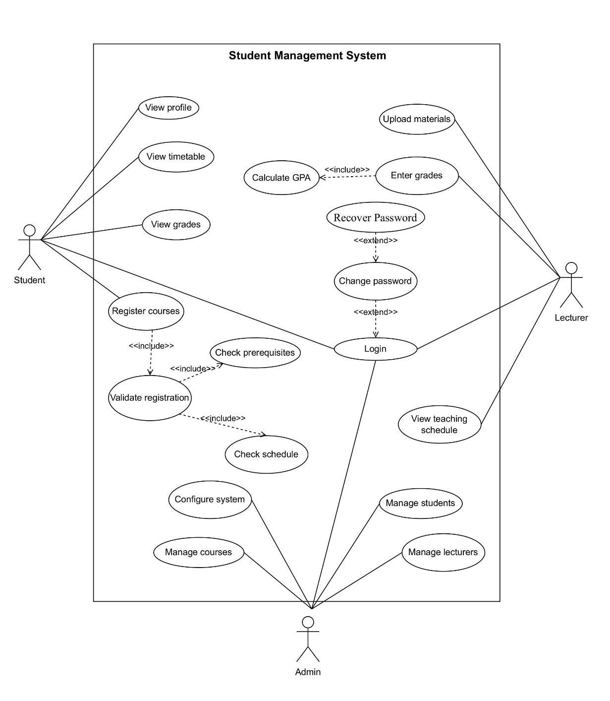

  - List of actors
No. | Actor | Description
1 | Student | A user who uses the system to register for courses, view schedules, and check academic results.
2 | Lecturer | A user who uses the system to manage classes, enter grades, and upload learning materials.
3 | Admin | A user who manages system data, configures the system, and maintains system operations.
  - List of usecase
No. | Use Case | Description
1 | Login | Authenticate user into the system
2 | Change Password | Change account password
3 | View Profile | View personal information
4 | View Timetable | View study timetable
5 | Register Courses | Register for available courses
6 | Validate Registration | Validate course registration
7 | Check Prerequisites | Check prerequisite courses
8 | Check Schedule | Check schedule conflicts
9 | View Grades | View grade report
10 | Calculate GPA | Calculate grade point average
11 | Enter Grades | Enter student grades
12 | Upload Materials | Upload learning materials
13 | View Teaching Schedule | View teaching timetable
14 | Manage Students | Manage student information
15 | Manage Lecturers | Manage lecturer information
16 | Manage Courses | Manage course information
17 | Configure System | Configure system settings
18 | Recover Password | Recover account password

Student Management System | Version 1.1
System specification | Date : 25/12/2025

- Use case Login
  - Summary
This use case allows a user (Student, Lecturer, or Admin) to log in to the Student Management System using their account credentials.
  - Flow of Events
    - Main Flow
- The system displays the login form.
- The user enters username/email and password.
- The system validates the credentials.
- If valid, the system grants access and displays the appropriate dashboard.
    - Alternative Flow
Invalid credentials: If the user enters incorrect login information, the system displays an error message and allows retry.
  - Special Requirements
None.
  - Preconditions
The user is not logged in.
  - Postconditions
- Success: User is logged in.
- Failure: System state remains unchanged.
  - Extensions
Change password.
- Use case Register Courses
  - Summary
This use case allows a student to register for available courses in the current semester.
  - Flow of Events
Student Management System | Version 1.1
System specification | Date : 25/12/2025
    - Main Flow
- The student selects the course registration function.
- The system displays the list of available courses.
- The student selects desired courses.
- The system executes Validate Registration.
- If valid, the system saves the registration.
- The system confirms successful registration.
    - Alternative Flow
If registration is invalid (missing prerequisites, schedule conflict, credit limit exceeded), the system displays an error message and does not save.
  - Special Requirements
None.
  - Preconditions
The student is logged in and within the registration period.
  - Postconditions
- Success: Course registration is saved.
- Failure: No changes are made.
  - Extensions
Validate Registration
- Use case Validate Registration
  - Summary
This use case validates whether a student's course registration is acceptable.
  - Flow of Events
- The system checks prerequisites (Check Prerequisites).
- The system checks schedule conflicts (Check Schedule).
- The system checks credit limits.
- If all conditions are met, registration is approved.
  - Preconditions
The student has selected courses.
  - Postconditions
The system returns a validation result to Register Courses.
Student Management System | Version 1.1
System specification | Date : 25/12/2025
- Use case View Grades
5.1. Summary
This use case allows students to view their grade report and GPA.
5.2. Flow of Events
- The student selects the view grades function.
- The system executes Calculate GPA.
- The system displays course grades and GPA.
  - Preconditions
The student is logged in.
  - Postconditions
No system state is changed.
- Use case Enter grades
  - Summary
This use case allows lecturers to enter and update grades for students in their courses.
  - Main Flow
- The lecturer selects a course.
- The system displays enrolled students.
- The lecturer enters or updates grades.
- The system saves grades and executes Calculate GPA.
- The system confirms completion.
7. Use case Change password
7.1 Summary
Allows users to change their account password.
7.2 Main Flow
- User selects Change Password.
- System asks for current password and new password.
- User enters required information.
- System validates current password and updates to new one.
7.3 Preconditions
User is logged in.
Student Management System | Version 1.1
System specification | Date : 25/12/2025

7.4 Postconditions
Password is updated.
8. Use case View Profile
8.1 Summary
Allows students to view their personal profile information.
8.2 Main Flow
- Student selects View Profile.
- System displays personal and academic information.
8.3 Preconditions
Student is logged in.
8.4 Postconditions
No data is modified.
9. Use case View Timetable
9.1 Summary
Allows students to view their weekly class timetable.
9.2 Main Flow
- Student selects View Timetable.
- System retrieves registered classes.
- System displays timetable.
9.3 Preconditions
Student is logged in.
9.4 Postconditions
No data is modified.
10. Use case Check Prerequisites
10.1 Summary
Checks whether a student has passed required prerequisite courses.
10.2 Main Flow
- System retrieves prerequisite requirements.
- System compares with student's completed courses.
- System returns validation result.
10.3 Preconditions
Student Management System | Version 1.1
System specification | Date : 25/12/2025
Courses are selected.
10.4 Postconditions
Validation result is returned.
11. Use case Check Schedule
11.1 Summary
Checks whether selected courses conflict with existing timetable.
11.2 Main Flow
- System retrieves class schedules.
- System compares time slots.
- System returns conflict status.
11.3 Preconditions
Courses are selected.
11.4 Postconditions
Validation result is returned.
12. Use case Calculate GPA
12.1 Summary
Automatically calculates student's cumulative GPA.
12.2 Main Flow
- System retrieves grade records.
- System applies GPA formula.
- System updates GPA value.
12.3 Preconditions
Grades exist.
12.4 Postconditions
GPA is updated.
13. Use case Upload Materials
13.1 Summary
Allows lecturers to upload teaching materials.
13.2 Main Flow
- Lecturer selects Upload Materials.
- Lecturer selects a class and uploads files.
Student Management System | Version 1.1
System specification | Date : 25/12/2025
- System stores files and confirms success.
13.3 Preconditions
Lecturer is logged in.
13.4 Postconditions
Materials are stored.
14. Use Case: View Teaching Schedule
14.1 Summary
Allows lecturers to view their teaching schedule.
14.2 Main Flow
- Lecturer selects View Teaching Schedule.
- System displays assigned classes.
14.3 Preconditions
Lecturer is logged in.
14.4 Postconditions
No data is modified.
15. Use case Manage Students
15.1 Summary
Allows admin to manage student information.
15.2 Main Flow
- Admin selects Manage Students.
- Admin adds/edits/deletes student records.
- System saves changes.
15.3 Preconditions
Admin is logged in.
15.4 Postconditions
Student records are updated.
16. Use case Manage Lecturers
16.1 Summary
Student Management System | Version 1.1
System specification | Date : 25/12/2025

Allows admin to manage lecturer information.
16.2 Main Flow
- Admin selects Manage Lecturers.
- Admin adds/edits/deletes lecturer records.
- System saves changes.
16.3 Preconditions
Admin is logged in.
16.4 Postconditions
Lecturer records are updated.
17. Use case Manage Courses
17.1 Summary
Allows admin to manage course and class information.
17.2 Main Flow
- Admin selects Manage Courses.
- Admin adds/edits/deletes courses and class sections.
- System saves changes.
17.3 Preconditions
Admin is logged in.
17.4 Postconditions
Course data is updated.
18. Use case Configure System
18.1 Summary
Allows admin to configure system parameters.
18.2 Main Flow
- Admin selects Configure System.
- Admin sets semester dates, deadlines, and limits.
- System saves configuration.
18.3 Preconditions
Admin is logged in.
18.4 Postconditions
Student Management System | Version 1.1
System specification | Date : 25/12/2025

System settings are updated.
19. Use case Recover password
19.1 Summary
This use-case allows users (including Students, Lecturers, and Administrators) to request a new password via their registered Email address if they have forgotten their login credentials.
19.2 Main Flow
- The system displays a form requiring the user to enter their registered Email address.
- The user enters the Email and clicks the submit button.
- The system validates the format and verifies the existence of the Email in the database.
- If the Email is valid and exists, the system automatically generates a new random password.
- The system updates the new password (hashed) into the database for the corresponding account.
- The system sends the new password information to the user's Email.
- The system notifies "Request successful, please check your Email" and redirects the user to the Login screen
19.3 Preconditions
Admin is logged in.
19.4 Postconditions
System settings are updated.

Student Management System | Version 1.1
System specification | Date : 25/12/2025
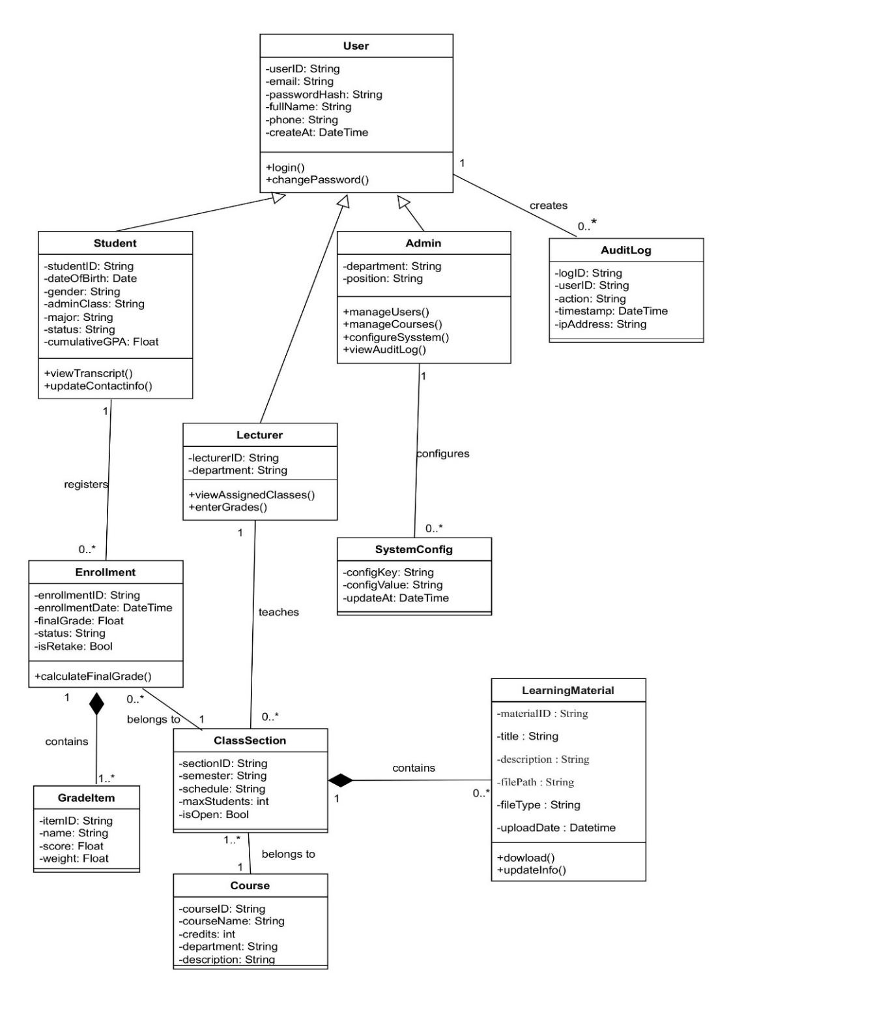
III .Class diagram

Student Management System | Version 1.1
System specification | Date : 25/12/2025
IV. Data Flow Diagram
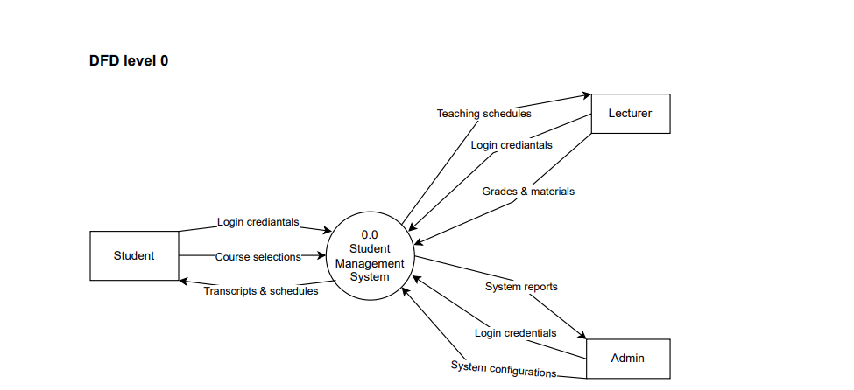

Student Management System | Version 1.1
System specification | Date : 25/12/2025
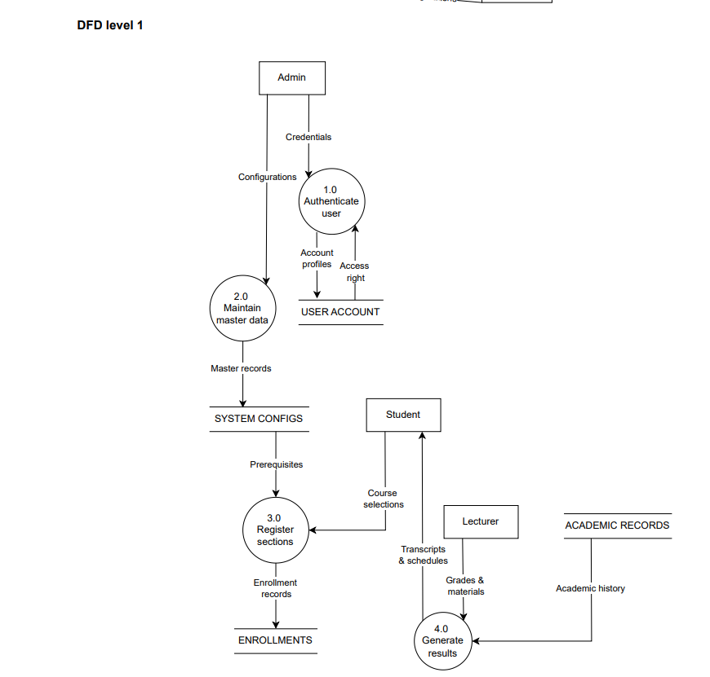

Student Management System | Version 1.1
System specification | Date : 25/12/2025
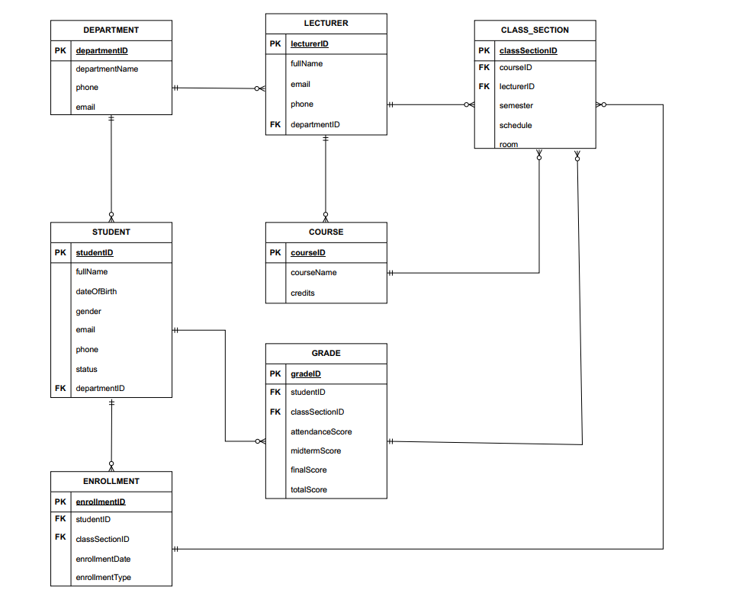
V. Data Model Diagram

Student Management System | Version 1.1
System specification | Date : 25/12/2025

VI . INTERFACE DESIGN DESCRIPTION (IDD)

1. User Interface Overview
1.1. Design Principles
The system is designed as a Console Application where users interact entirely via the keyboard. The interface adheres to the following principles to ensure usability:
- Menu-Driven Navigation: Users navigate by entering numeric options (e.g., 1, 2, 3) to select functions.

- Consistency: All screens feature a clear Header and a consistent "Back/Exit" option.

- System Feedback: Confirmation messages are always displayed after critical actions (Save, Delete, Update).

- Input Validation: User input is validated immediately to prevent errors.

1.2. User Roles & Access Control
The system supports three distinct user groups with dedicated menus :

- Admin: Manages platform data, user accounts, and system configuration.
- Lecturer: Manages class sections, teaching schedules, and grading.
- Student: Registers for course credits and tracks academic progress.

2. INTERFACES AND FUNCTIONS
2.1. Login Interface
This is the initial screen displayed upon launching the application

STUDENT MANAGEMENT SYSTEM
System Login
- Login Account (UserID): ________
- Password: ________
- Forgot Password ?
- Exit

Student Management System | Version 1.1
System specification | Date : 25/12/2025

- Input: Users enter their UserID and Password. The password is masked with * characters for security.

- Processing: The system validates credentials against the Users table.

- Success: Automatically redirects the user to the corresponding Dashboard (Admin, Lecturer, or Student).
- Failure: Displays "Invalid username or password" and allows the user to retry.

2.2 Admin Interface
Greeting: [FullName]
1. Manage Departments
2. Manage Course Catalog
3. Open New Class Sections
4. Configure Semesters & Registration Status
5. Manage User Accounts
6. Logout
Your choice: _
2.2.1 Function Descriptions
The Admin is responsible for initializing and maintaining the system.
- Function 1: Manage Departments
  - When selected: Displays the list of existing department codes and names.
  - Action: Enter a new department code (e.g., IT) and department name (Information Technology).
  - Result: Displays “Department added successfully” and saves the record to the Departments table.
- Function 2: Manage Courses
  - When selected: Displays the course catalog with credit values.
  - Action: Enter courseID, courseName, and credits.
  - Result: Updates the Courses table.
Student Management System | Version 1.1
System specification | Date : 25/12/2025

- Function 3: Open Class Sections
  - When selected: Displays the input screen for class creation.
  - Action: Select a course ID, a lecturer ID, and a semester ID.
  - Result: Generates a class section ID and stores it in the Classes table.
- Function 4: Configure Semesters & Status
  - When selected: Displays the current registration status (Open/Closed).
  - Action: Select "Open" to allow students to register or "Closed" to end the registration period.
  - Result: Controls student access to the registration function.
- Function 5: Manage User Accounts
  - When selected: Displays the list of users and their roles (Student/Lecturer/Admin).
  - Action: Create a new userID, assign a default password, and assign a department.

2.3 Lecturer Interface
Greeting: [FullName]
1. View Teaching Schedule
2. View Student List by Class
3. Enter / Update Grades
4. Manage Learning Materials
5. Change Password
6. Logout
Your choice: _
• 1. View Teaching Schedule: Lists assigned class sections for the current semester (Class Code, Course Name, Room, Time) .
• 2. View Student List: Requires entering a Class Code -> Displays the list of enrolled students (Student ID, Full Name) .
Student Management System | Version 1.1
System specification | Date : 25/12/2025

• 3. Enter Grades:
- System displays the student list for the selected class.
- Lecturer enters grades for each component (Attendance, Midterm, Final).
- System automatically calculates the Final Grade and saves it to the Grades table .
- Constraint: Grading is only allowed when the Admin has opened the grading portal.

2.4 Student Interface
Greeting: [FullName]
1. View Personal Profile & Administrative Class
2. Register for Courses
3. View Registered Timetable
4. View Grades
5. Logout
Your choice: _
• 1. Personal Information: Displays Read-only data (Student ID, Name, Department, Class) .
• 2. Register for Courses (Critical):
- Accessible only when the system status is "Open".
- Displays a list of available classes (Class Code, Course Name, Schedule, Capacity).
- Student enters the Class Code to register.
- Validation: System automatically checks for Schedule Conflicts and Prerequisites. If valid -> Displays "Registration Successful".
• 3. View Timetable: Lists classes successfully registered in the Enrollments table .
• 4. View Grades: Displays a detailed transcript of studied courses and the Cumulative GPA .

Student Management System | Version 1.1
System specification | Date : 25/12/2025

2.5 Common System Functions
- Change Password: Prompts for Old Password -> New Password -> Confirm New Password. Updates the database upon success.
- Password Recovery: Prompts for UserID and Email. The system verifies the record and sends a new password (or OTP) via Email.
- Confirmation Dialogs: For critical actions (e.g., Delete User, Drop Course), the system asks: "Are you sure you want to proceed? (Y/N)".
- Error Handling: If input format is invalid or logic is violated (e.g., schedule conflict), the system displays a clear error message and prompts for re-entry, ensuring the application does not crash.

