Specification: Student Management System
Version 1.2

TT | Name - MSSV | Task List | Assessment
1 | Phạm Hữu Phước -060206013186 | Software Requirements Specification | complete
2 | Nguyễn Võ Phương Uyên - 058306001251 | Class diagram + Datamodel Diagram | complete
3 | Rcom Chiến -064205002320 | Use case diagram | complete
4 | Nguyễn Minh Huy - 079206010447 | Data Flow Diagram | complete
5 | Mai Văn Kỳ -062206006846 | Interface design description | complete
Student Management System | Version 1.2
System specification | Date : 08/01/2026

Division of Labor

Student Management System | Version 1.2
System specification | Date : 08/01/2026
DOCUMENT REVISION HISTORY
Date | Version | Describe | Authur
25/12/2025 | 1.0 | Document construction
30/12/2025 | 1.1 | Update system usecase
03/01/2026 | 1.2 | Update requirements

- Student Management System
1. INTRODUCTION
1.1. Purpose
This document details the functional and non-functional requirements for the Student Management System (SMS). The system is built on a Web platform to digitize manual training management processes, thereby improving the efficiency of managing student data, credit registration processes, and grade management at the University.
2. LIST OF ACTORS
2.1. Administrator (Admin)
- The system administrator, responsible for managing platform data (students, lecturers, courses) and system configuration.
2.2. Lecturer
- The teaching staff, responsible for entering grades, managing class sections, and providing course materials.
2.3. Student
- The learner, uses the system to register for credits, view timetables, and look up academic results.
3. FUNCTIONAL REQUIREMENTS
3.1. System & Authentication
- FR-01: Login
The system allows users to log in using an ID (or Email) and Password.
The system automatically redirects users to the Dashboard corresponding to their role (Admin/Lecturer/Student).
- FR-02: Password Recovery
If a user forgets their password, the system allows a request for a new password via the registered Email.
3.2. Administrator Features
- FR-03: Manage Students
Admin has the right to Add, Edit, Delete, and View student profiles.
Data includes: Student ID (Unique), Full Name, Date of Birth, Gender, Administrative Class, Major, Status (Studying/Reserved/Graduated/Dropped out).
- FR-04: Manage Lecturers

Student Management System | Version 1.2
System specification | Date : 08/01/2026
Admin manages lecturer profiles including: Lecturer ID, Full Name, Faculty/Department, Email, Phone Number.
- FR-05: Manage Courses & Classes
Manage Course Catalog: Course ID, Course Name, Number of Credits.
Open Class Sections: Create classes for each semester and assign lecturers.
- FR-06: Assign Lecturer to Class
Based on the existing courses, the Admin assigns specific lecturers to class sections.
The system records the teaching assignment for the semester.
- FR-07: Add Student to Class
The Admin directly adds students to specific class sections.
Allows searching for students and enrolling them in classes without requiring student self-registration.
- FR-08: Configuration
Admin sets time parameters: Semester start/end dates, credit registration periods, grade submission deadlines.
3.3. Lecturer Features
- FR-09: View Schedule
Lecturers can view the list of assigned class sections for the semester.
View the list of students in each class section.
- FR-10: Grade Management
Enter and update component grades (Attendance, Midterm, Final) for students.
Constraint: Lecturers are only allowed to edit grades within the permitted timeframe configured by the Admin. After the deadline, the grade sheet will be locked.
3.4. Student Features
- FR-11: View Profile
View personal information and academic records. Students can update contact information (Phone, Email) but cannot edit academic information (Student ID, Major, Class).
- FR-12: View Timetable
The system automatically displays the weekly timetable based on the credit registration results.
- FR-13: View Grades
Students view detailed grade sheets for courses and Cumulative GPA. This data is in Read-only mode.
4. NON-FUNCTIONAL REQUIREMENTS
4.1. Performance
- The system must support a minimum of 1,000 concurrent users (especially during credit registration periods).
Student Management System | Version 1.2
System specification | Date : 08/01/2026
- Response time for common operations must not exceed 3 seconds.
- Storage capacity: Manage data for 25,000+ students and over 3,000,000 grade records.
4.2. Security
- User passwords must be encrypted (Hashing) in the database.
- Audit log : All critical actions (grade changes, account updates, data deletions) must be recorded in an audit log for traceability.
- Strict adherence to Role-Based Access Control (RBAC): Students only view their own data; Lecturers only operate on assigned classes.
- The system has mechanisms to prevent common web security vulnerabilities (SQL Injection, XSS).
4.3. Reliability & Availability
- The system operates 24/7 with Uptime > 99.5%.
- Data must be automatically backed up daily.
4.4. Usability
- User-friendly interface, supports Vietnamese/English.
- Responsive design on both computers and mobile devices.
- New users should be able to complete basic tasks (login, view timetable, view grades) without external assistance after a short onboarding period.
4.5. Design Constraints
- Programming language: Python

Student Management System | Version 1.2
System specification | Date : 08/01/2026

II . Use case diagram
- Overview Diagram
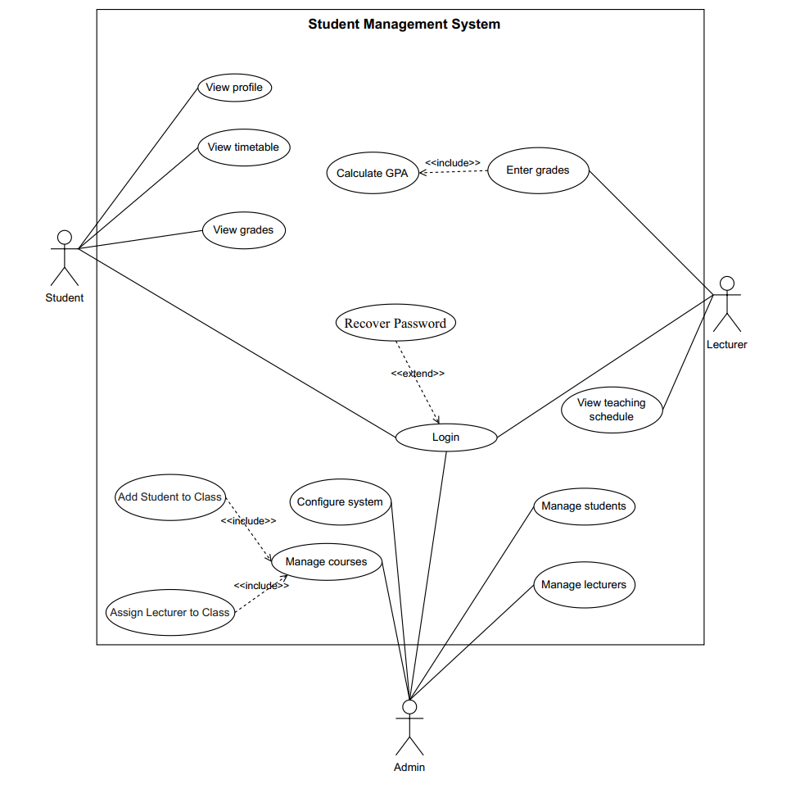

Student Management System | Version 1.2
System specification | Date : 08/01/2026
  - List of actors
No. | Actor | Description
1 | Student | A user who uses the system to register for courses, view schedules, and check academic results.
2 | Lecturer | A user who uses the system to manage classes, enter grades, and upload learning materials.
3 | Admin | A user who manages system data, configures the system, and maintains system operations.
  - List of usecase
No. | Use Case | Description
1 | Login | Authenticate user into the system
2 | View Profile | View personal information
3 | View Timetable | View study timetable
4 | View Grades | View grade report
5 | Calculate GPA | Calculate grade point average
6 | Enter Grades | Enter student grades
7 | View Teaching Schedule | View teaching timetable
8 | Manage Students | Manage student information
9 | Manage Lecturers | Manage lecturer information
10 | Assign Lecturer to Class | Assign lecturer information
11 | Add Student to Class | Add student information
12 | Manage Courses | Manage course information
13 | Configure System | Configure system settings
14 | Recover Password | Recover account password
- Use case Login
  - Summary
This use case allows a user (Student, Lecturer, or Admin) to log in to the Student Management System using their account credentials.
  - Flow of Events
    - Main Flow
- The system displays the login form.
- The user enters username/email and password.
- The system validates the credentials.
- If valid, the system grants access and displays the appropriate dashboard.
    - Alternative Flow
Student Management System | Version 1.2
System specification | Date : 08/01/2026
Invalid credentials: If the user enters incorrect login information, the system displays an error message and allows retry.
  - Special Requirements
None.
  - Preconditions
The user is not logged in.
  - Postconditions
- Success: User is logged in.
- Failure: System state remains unchanged.
  - Extensions
Change password.
- Use case View Grades
3.1 Summary
This use case allows students to view their grade report and GPA.
3.2 Flow of Events
- The student selects the view grades function.
- The system executes Calculate GPA.
- The system displays course grades and GPA.
  - Preconditions
The student is logged in.
  - Postconditions
No system state is changed.
4 . Use case Enter grades
  - Summary
This use case allows lecturers to enter and update grades for students in their courses.
  - Main Flow
- The lecturer selects a course.
- The system displays enrolled students.
- The lecturer enters or updates grades.
- The system saves grades and executes Calculate GPA.
- The system confirms completion.
5. Use case View Profile
5.1 Summary
Allows students to view their personal profile information.
5.2 Main Flow
- Student selects View Profile.
- System displays personal and academic information.
5.3 Preconditions
Student is logged in.
Student Management System | Version 1.2
System specification | Date : 08/01/2026
5.4 Postconditions
No data is modified.
6. Use case View Timetable
6.1 Summary
Allows students to view their weekly class timetable.
6.2 Main Flow
- Student selects View Timetable.
- System retrieves registered classes.
- System displays timetable.
6.3 Preconditions
Student is logged in.
6.4 Postconditions
No data is modified.
7. Use case Calculate GPA
7.1 Summary
Automatically calculates student's cumulative GPA.
7.2 Main Flow
- System retrieves grade records.
- System applies GPA formula.
- System updates GPA value.
7.3 Preconditions
Grades exist.
7.4 Postconditions
GPA is updated.
8. Use Case: View Teaching Schedule
8.1 Summary
Allows lecturers to view their teaching schedule.
8.2 Main Flow
- Lecturer selects View Teaching Schedule.
- System displays assigned classes.
8.3 Preconditions
Lecturer is logged in.
8.4 Postconditions
No data is modified.
9. Use case Manage Students
9.1 Summary
Allows admin to manage student information.
9.2 Main Flow
- Admin selects Manage Students.
- Admin adds/edits/deletes student records.
Student Management System | Version 1.2
System specification | Date : 08/01/2026
- System saves changes.
9.3 Preconditions
Admin is logged in.
9.4 Postconditions
Student records are updated.
10. Use case Manage Lecturers
10.1 Summary
Allows admin to manage lecturer information.
10.2 Main Flow
- Admin selects Manage Lecturers.
- Admin adds/edits/deletes lecturer records.
- System saves changes.
10.3 Preconditions
Admin is logged in.
10.4 Postconditions
Lecturer records are updated.
11. Use case Manage Courses
11.1 Summary
Allows admin to manage course and class information.
11.2 Main Flow
- Admin selects Manage Courses.
- Admin adds/edits/deletes courses and class sections.
- System saves changes.
11.3 Preconditions
Admin is logged in.
11.4 Postconditions
Course data is updated.
12. Use case Configure System
12.1 Summary
Allows admin to configure system parameters.
12.2 Main Flow
- Admin selects Configure System.
- Admin sets semester dates, deadlines, and limits.
- System saves configuration.
12.3 Preconditions
Admin is logged in.
12.4 Postconditions
System settings are updated.
13. Use case Recover password
13.1 Summary
Student Management System | Version 1.2
System specification | Date : 08/01/2025
This use-case allows users (including Students, Lecturers, and Administrators) to reset their forgotten password by providing their unique identification code (ID).
13.2 Main Flow
- The user selects the "Recover Password" option from the interface.
- The system displays a form requesting the user's ID (Student ID or Lecturer ID or Administrator ID).
- The user enters their ID and clicks the "Recover" button.
- The system verifies the existence of the ID in the User Accounts table.
- If the ID is valid, the system automatically resets the account password to a system default value.
- The system displays a notification: "Password has been reset to default. Please log in again".
- The system redirects the user back to the Login screen.
13.3 Preconditions
Admin is logged in.
13.4 Postconditions
System settings are updated.
14. Use case Add Student to Class
14.1 Summary
The Admin enters a studentID to directly enroll a specific student into a course section (class).
14.2 Main Flow:
- On the Class List interface, the Admin clicks the "Add Student" button for a specific class.
- The system displays a Popup/Form requesting the "Student ID".
- The Admin enters the studentID and clicks "Save".
- The system validates the input data.
- If valid, the system saves the record to the Assignments table in database and displays a success message.
- The student list for that class is automatically reloaded.
14.3 Validation & Exceptions:
- Duplicate Enrollment: If the Student ID is already enrolled in this specific class, the system displays an error: "This student is already a member of this class".
- Class Capacity Limit: If the class has reached its maxCapacity (configured in Function 4), the system displays a warning: "Class is full. Cannot add more students". The Admin can choose to Cancel or go to Function 4 to increase the capacity.

Student Management System | Version 1.2
System specification | Date : 08/01/2025
- Class Capacity Limit: If the class has reached its maxCapacity (configured in Function 4), the system displays a warning: "Class is full. Cannot add more students". The Admin can choose to Cancel or go to Function 4 to increase the capacity.
- Invalid Student ID: If the Student ID does not exist in the User Accounts table, the system displays: "Student ID not found".
15. Usecase Assign Lecturer to Class
15.1 Summary
The Admin assigns a specific Lecturer to a course section (class) to be responsible for teaching and grading.
15.2 Main Flow:
- On the Class List interface, the Admin clicks the "Assign Lecturer" button for a specific class.
- The system displays a Popup/Form requesting the "Lecturer ID".
- The Admin enters the Lecturer ID and clicks "Save".
- The system validates the input data.
- If validthe system updates the Classes table in the Database and displays a success message.
- The class information is updated to show the assigned lecturer's name.
15.3 Validation & Exceptions:
- Error 1 (Not Found): The Lecturer ID entered does not exist in the system (Lecturer Table). -> Message: "Lecturer ID does not exist."
- Error 2 (Replacement Warning): The class is already assigned to another Lecturer. Message: "This class is currently assigned to [Current Lecturer Name]. Do you want to replace them?". If "Yes", the system updates the new lecturer. If "No", the operation is cancelled.
- Error 3 (Empty): The Admin clicked Save without entering a Lecturer ID.-> Message: "Please enter a Lecturer ID."

Student Management System | Version 1.2
System specification | Date : 08/01/2025

III .Class diagram
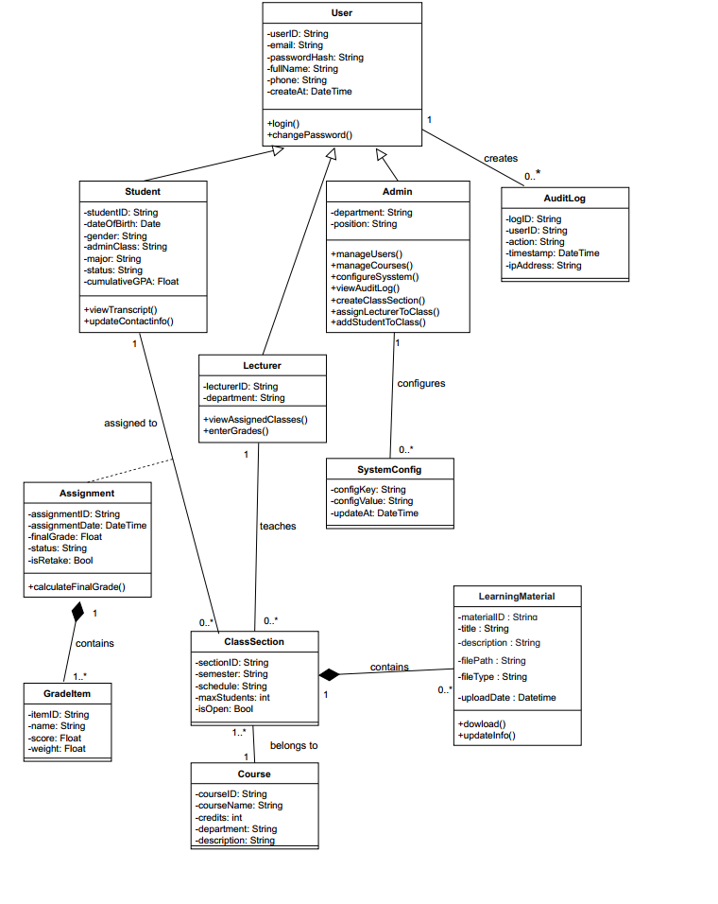

Student Management System | Version 1.2
System specification | Date : 08/01/2025
IV. Data Flow Diagram

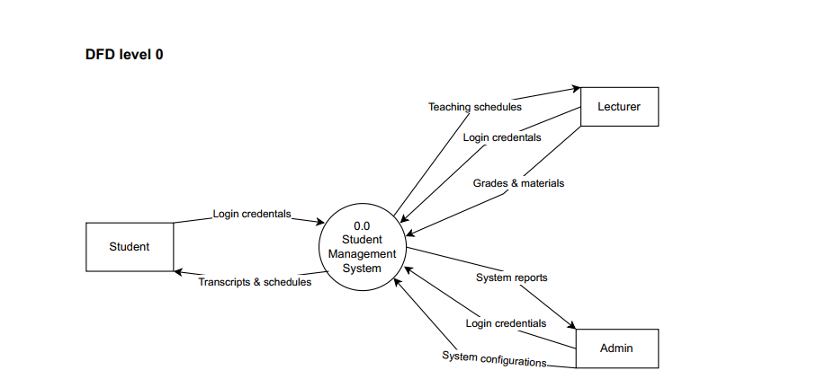

Student Management System | Version 1.2
System specification | Date : 08/01/2025

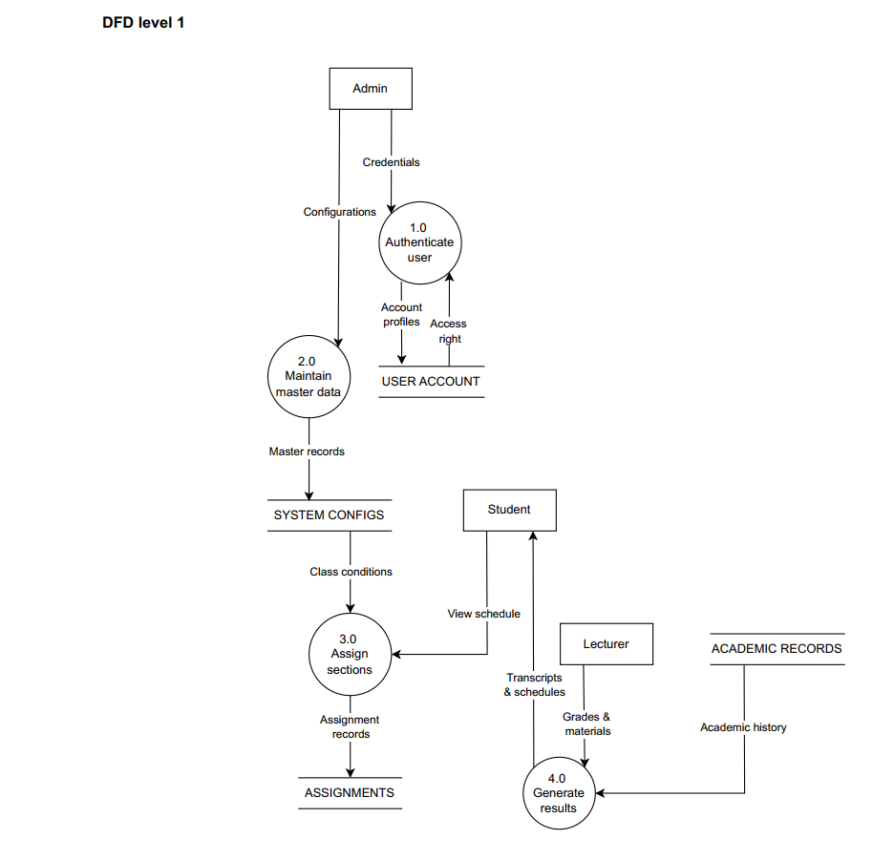

Student Management System | Version 1.2
System specification | Date : 08/01/2025
V. Data Model Diagram

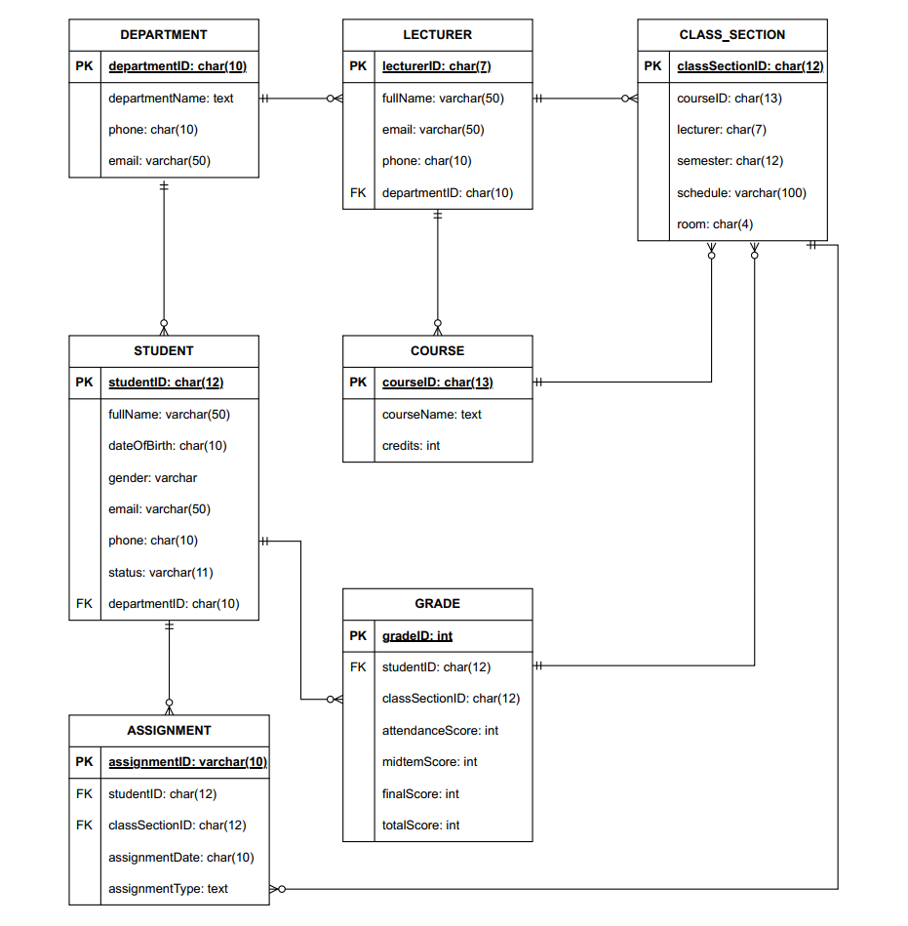

Student Management System | Version 1.2
System specification | Date : 08/01/2025

VI . INTERFACE DESIGN DESCRIPTION (IDD)

1. User Interface Overview
1.1. Design Principles
The system is designed as a Console Application where users interact entirely via the keyboard. The interface adheres to the following principles to ensure usability:
- Menu-Driven Navigation: Users navigate by entering numeric options (e.g., 1, 2, 3) to select functions.
- Consistency: All screens feature a clear Header and a consistent "Back/Exit" option.
- System Feedback: Confirmation messages are always displayed after critical actions (Save, Delete, Update).
- Input Validation: User input is validated immediately to prevent errors.
1.2. User Roles & Access Control
The system supports three distinct user groups with dedicated menus :
- Admin: Manages platform data, user accounts, and system configuration.
- Lecturer: Manages class sections, teaching schedules, and grading.
- Student: Registers for course credits and tracks academic progress.
2. INTERFACES AND FUNCTIONS
2.1. Login Interface
This is the initial screen displayed upon launching the application

STUDENT MANAGEMENT SYSTEM
System Login
- Login Account (UserID): ________
- Password: ________
- Forgot Password ?
- Exit
- Input: Users enter their UserID and Password. The password is masked with * characters for security.
- Processing: The system validates credentials against the Users table.
- Success: Automatically redirects the user to the corresponding Dashboard (Admin, Lecturer, or Student).
- Failure: Displays "Invalid username or password" and allows the user to retry.
2.2 Admin Interface
Student Management System | Version 1.2
System specification | Date : 08/01/2025
Greeting: [FullName]
1. Manage Departments
2. Manage Course Catalog
3. Open & Assign Class Sections
4. Configure Semesters & Class Condition
5. Manage User Accounts
6. Logout
Your choice: _
- Function 1: Manage Departments
  - When selected: Displays the list of existing department codes and names.
  - Action: Enter a new department code (e.g., IT) and department name (Information Technology).
  - Result: Displays “Department added successfully” and saves the record to the Departments table.
- Function 2: Manage Courses
  - When selected: Displays the course catalog with credit values.
  - Action: Enter courseID, courseName, and credits.
  - Result: Updates the Courses table.
- Function 3: Open & Assign Class Sections
  - When selected: Displays the input screen for creating and assigning new class sections.
  - Action: Select a course ID, a lecturer ID, and a semester ID. Enter the list of studentID to directly assign them to the class section.
- Result: Automatically generates a classSectionID and stores the data in the ClassesSection and Assignments tables.
- Function 4: Configure Semesters & Class Conditions

Student Management System | Version 1.2
System specification | Date : 08/01/2025
  - When selected: Displays the current semester status and class configuration settings.
  - Action: Update the active semester and set the maxCapacity (maximum students) for each class section. Select "Open" to allow the schedule to be visible to students or "Closed" to end the assignment period.
- Result: Saves the configurations to the SYSTEM CONFIGS table to validate class capacity and visibility.
- Function 5: Manage User Accounts
  - When selected: Displays the list of users and their roles (Student/Lecturer/Admin).
  - Action: Create a new userID, assign a default password, and assign a department.
- Function 6: Logout
- When selected: The system terminates the user's current active session.
- Action: The user clicks on the "Logout" option from the interface menu.
- Result: The system clears temporary authentication data and automatically redirects the user back to the Login Interface.
2.3 Lecturer Interface
Greeting: [FullName]
1. View Teaching Schedule.
2. View Student List by Class.
3. Enter / Update Grades.
4. Logout.
Your choice: _
- Funtion 1: View teaching schedule
- When selected: Displays the list of class sections assigned to the lecturer for the current semester.
- Action: The system retrieves teaching assignment data from the database.
- Result: Displays specific teaching times and locations for each assigned class.
- Function 2: View student list by class
- When selected: Displays the list of students currently enrolled in a specific class section.
Student Management System | Version 1.2
System specification | Date : 08/01/2025
- Action: Select a specific class section currently being taught to view details.
- Result: Displays a list including studentID and fullName for all students in that class.
- Function 3: Enter/ Update Grades
- When selected: Opens the grade management interface for a selected class section.
- Action: Enter numerical grades into the corresponding columns and click the save button.
- Result: Displays "Grades updated successfully" and saves the data to the grade table.
- Function 4: Logout
- When selected: The system terminates the user's current active session.
- Action: The user clicks on the "Logout" option from the interface menu.
- Result: The system clears temporary authentication data and automatically redirects the user back to the Login Interface.
2.4 Student Interface
Greeting: [FullName]
1. View Personal Profile & Administrative Class
2. View Class Schedule
3. View Academic Result
4. Logout
Your choice: _
- Function 1: View Personal Profile & Administrative Class
- When selected: Displays the student's personal information and their assigned administrative class.
- Action: None (Read-only access).
- Result: Shows details such as studentID, fullName, dateOfBirth, and classID.
- Function 2: View Class Schedule
- When selected: Displays the list of all class sections that the student has been assigned to for the current semester.
- Action: The system automatically retrieves data from the Assignments and ClasseSection tables based on the logged-in studentID.
Student Management System | Version 1.2
System specification | Date : 08/01/2025
- Result: Displays a timetable including courseName, lecturerName and room.
- Function 3: View Academic Results
- When selected: Displays the student's grade reports and transcripts.
- Action: Select a specific semester to view grades.
- Result: Shows a summary of grades for each course and the calculated GPA.
- Function 4: Logout
- When selected: The system terminates the user's current active session.
- Action: The user clicks on the "Logout" option from the interface menu.
- Result: The system clears temporary authentication data and automatically redirects the user back to the Login Interface.
2.5 Common System Functions
- Password Recovery: Prompts for UserID. The system verifies the record and automatically resets the password to the system default.
- Confirmation Dialogs: For critical actions (e.g., Delete User, Drop Course), the system asks: "Are you sure you want to proceed? (Y/N)".
- Error Handling: If input format is invalid or logic is violated (e.g., schedule conflict), the system displays a clear error message and prompts for re-entry, ensuring the application does not crash.

