
MINISTRY OF EDUCATION, CULTURE AND RESEARCH
OF THE REPUBLIC OF MOLDOVA
Technical University of Moldova
Faculty of Computers, Informatics and Microelectronics
Department of Software Engineering and Automation

Vasile Brînză, FAF-242

Report
Laboratory Work No. 1
Cryptography and Security

Checked by:
Zaica Maia, university assistant

Chișinău 2026
Table of Contents
1 INTRODUCTION 3
1.1 Classical substitution ciphers 3
1.2 Purpose of the laboratory work 3
2 THEORETICAL BACKGROUND 4
2.1 The Caesar cipher 4
2.2 The Caesar cipher with a permutation 4
2.3 Encoding of the Romanian alphabet 4
3 IMPLEMENTATION 5
3.1 Tools and program structure 5
3.2 Letter encoding 5
3.3 Encryption and decryption (Task 1.1) 5
3.4 Text normalization and validation 6
3.5 Key and operation validation 6
3.6 Building the permuted alphabet (Task 1.2) 6
3.7 Encryption and decryption with two keys (Task 1.2) 7
3.8 Keyword validation (Task 1.2) 7
4 RESULTS 8
4.1 Task 1.1 – Caesar cipher 8
4.2 Task 1.2 – Caesar cipher with a permutation 9
CONCLUSION 11
SOURCE CODE 11
REFERENCES 11

1 INTRODUCTION

1.1 Classical substitution ciphers
Cryptography is the study of methods that allow two parties to communicate securely in the presence of an adversary. Before the computer era, the most common way to hide the meaning of a message was a substitution cipher: every letter of the plaintext is replaced by another letter according to a secret rule. The best-known example is the Caesar cipher, named after Julius Caesar, who is said to have used it with a shift of three positions to communicate with his generals.
Although substitution ciphers have no practical security today, they remain an essential starting point in the study of cryptography. They introduce the basic vocabulary of the field (plaintext, ciphertext, key, key space, encryption and decryption functions) and show, in a very concrete way, the two classical attacks against weak ciphers: exhaustive key search (brute force) and frequency analysis.

1.2 Purpose of the laboratory work
The objectives of this laboratory work are:
• to understand how the Caesar cipher works and to implement it for the Romanian alphabet (n = 31);
• to see why its very small key space makes it insecure;
• to strengthen the cipher with a second key, a keyword that permutes the alphabet;
• to implement both versions with full validation of the user input.
Both tasks were implemented in Python 3. The programs run in a terminal; the user chooses the operation (encryption or decryption), enters the text and the key(s), and receives the result.

2 THEORETICAL BACKGROUND

2.1 The Caesar cipher
In the Caesar cipher every letter of the plaintext is replaced by the letter found a fixed number of positions further along the alphabet. Each letter is first replaced by its numeric code (its position in the alphabet, starting from 0). The secret key k is the size of the shift and is the same for encryption and decryption. For an alphabet of n letters the encryption and decryption functions are:
c = e_k(x) = (x + k) mod n, m = d_k(y) = (y − k) mod n,
where x is the code of a plaintext letter and y the code of a ciphertext letter. The modulo operation makes the alphabet "wrap around": after the last letter the count continues from the first one. When y − k is negative, n has to be added to bring the result back into the range 0 … n − 1.
Key space. The key can take the values k ∈ {1, 2, …, n − 1}; k = 0 is excluded because it leaves the text unchanged. For the Romanian alphabet (n = 31) there are therefore only 30 possible keys. An attacker who intercepts a ciphertext can simply try all 30 shifts, and exactly one of them will produce readable Romanian text. This is why the Caesar cipher is considered extremely weak.

2.2 The Caesar cipher with a permutation
To enlarge the key space, a second key is introduced: a keyword k2 (any sequence of letters, meaningful or not). The keyword is used to build a permuted alphabet: first its letters are written in order, keeping only the first occurrence of each repeated letter, and then the remaining letters of the alphabet are appended in their natural order. The Caesar shift k1 is then applied over this new ordering, i.e. the code of a letter is its position in the permuted alphabet:
c = π[(π⁻¹(x) + k1) mod n], m = π[(π⁻¹(y) − k1) mod n],
where π is the permuted alphabet and π⁻¹(x) the position of letter x in it.
Key space. Theoretically the alphabet can be ordered in n! ways, so the number of key pairs (k1, k2) is n! × (n − 1). For n = 31 this gives 31! × 30 = 246 685 159 625 337 684 531 766 886 400 000 000 (≈ 2.47 × 10³⁵), far too many to try one by one. However, the cipher is still monoalphabetic: every plaintext letter is always replaced by the same ciphertext letter, so the letter frequencies of the language remain visible in the ciphertext and the cipher can be broken by frequency analysis.

2.3 Encoding of the Romanian alphabet
Both tasks use the Romanian alphabet of n = 31 letters with the fixed encoding from Table 2.1 (A = 0, Ă = 1, …, Z = 30). Built-in character encodings (ASCII, Unicode code points) are not used to compute the shift.
Table 2.1: Letter encoding of the Romanian alphabet (part 1)
Letter | A | Ă | Â | B | C | D | E | F | G | H | I | Î | J | K | L | M
Code | 0 | 1 | 2 | 3 | 4 | 5 | 6 | 7 | 8 | 9 | 10 | 11 | 12 | 13 | 14 | 15

Table 2.1 (continued): Letter encoding of the Romanian alphabet (part 2)
Letter | N | O | P | Q | R | S | Ș | T | Ț | U | V | W | X | Y | Z
Code | 16 | 17 | 18 | 19 | 20 | 21 | 22 | 23 | 24 | 25 | 26 | 27 | 28 | 29 | 30

3 IMPLEMENTATION

3.1 Tools and program structure
The programs were written in Python 3 and are executed from the terminal. Each program consists of the cipher function(s) and a main() function that reads and validates the input in three loops: the operation, the text (and keyword, for Task 1.2) and the numeric key. Every loop repeats until a valid value is entered, so the program never stops on a typing mistake.

3.2 Letter encoding
alphabet = "AĂÂBCDEFGHIÎJKLMNOPQRSȘTȚUVWXYZ"
# print(len(alphabet)) = 31

The alphabet is stored as a single string whose order is exactly the encoding from Table 2.1. The code of a letter is its index in this string (alphabet.index(char)), and the letter with code i is alphabet[i]. In this way the shift is computed only from the Romanian alphabet, without using ASCII or Unicode values (ord() and chr() are never called).

3.3 Encryption and decryption (Task 1.1)
def encrypt(text, alphabet, key):
encrypted_text = ""
for char in text:
position = alphabet.index(char)
new_position = (position + key) % len(alphabet)
encrypted_text += alphabet[new_position]
return encrypted_text

def decrypt(text, alphabet, key):
decrypted_text = ""
for char in text:
position = alphabet.index(char)
new_position = (position - key) % len(alphabet)
decrypted_text += alphabet[new_position]
return decrypted_text

Both functions translate the formulas from Section 2.1 directly: each letter is converted to its code, the key is added (or subtracted) and the result is reduced modulo n = len(alphabet) = 31. In Python the % operator always returns a non-negative result for a positive divisor (for example (1 − 3) % 31 = 29), so the case of a negative difference during decryption is handled correctly without any extra check.

3.4 Text normalization and validation
user_text = input("Enter a text: ")
user_text = user_text.upper() # conversion to uppercase
user_text = user_text.replace(" ", "") # remove spaces
user_text = user_text.replace("Ş", "Ș").replace("Ţ", "Ț") # cedilla edge case

valid = True
for char in user_text:
if char not in alphabet:
valid = False
print(f"Invalid character '{char}' in the text. Please use only "
f"characters from the alphabet '{alphabet}'.")
break

Before encryption the text is converted to uppercase and all spaces are removed, as the task requires. The letters Ș and Ț are sometimes typed with a cedilla (Ş, Ţ) instead of a comma below, depending on the keyboard; these variants are replaced with the correct letters so that the text is accepted. Every remaining character is then checked against the alphabet. If a character is not allowed, the program shows which character was rejected, lists the allowed letters and asks for the text again.

3.5 Key and operation validation
while True:
try:
key = int(input("Enter a key (integer): "))
if key < 1 or key > 30:
print("Invalid key. Please enter a key between 1 and 30.")
else:
break
except ValueError:
print("Invalid input. Please enter an integer.")

The key is read with int(); if the input is not a number, the ValueError exception is caught and the user is told that an integer is expected. If the number is outside the range 1 … 30, the message states the allowed range. The operation is validated in the same way: only "e" (encryption) or "d" (decryption) is accepted, in upper or lower case.

3.6 Building the permuted alphabet (Task 1.2)
def cipher(text, alphabet, key, keyword, operation):
permuted_alphabet = ""
for char in keyword:
if char not in permuted_alphabet:
permuted_alphabet += char
for char in alphabet:
if char not in permuted_alphabet:
permuted_alphabet += char
print("Permuted alphabet:", permuted_alphabet)

The permuted alphabet is built in two passes. The first loop copies the letters of the keyword, skipping any letter that is already present, so only the first occurrence of a repeated letter is kept. The second loop appends the remaining letters of the Romanian alphabet in their natural order. The result always contains all 31 letters exactly once, and it is printed so that the result can be checked by hand.

3.7 Encryption and decryption with two keys (Task 1.2)
output = ""
for char in text:
position = permuted_alphabet.index(char)
if operation == 'd':
new_position = (position - key) % len(permuted_alphabet)
else:
new_position = (position + key) % len(permuted_alphabet)
output += permuted_alphabet[new_position]
return output

The shift is the same as in Task 1.1, but positions are now taken from the permuted alphabet instead of the standard one. A single function handles both operations; the sign of the shift depends on the chosen operation.

3.8 Keyword validation (Task 1.2)
keyword = input("Enter a keyword (string): ")
keyword = keyword.upper()
keyword = keyword.replace(" ", "")
keyword = keyword.replace("Ş", "Ș").replace("Ţ", "Ț")

if len(keyword) < 7:
print("Invalid keyword. Please enter a keyword with "
"at least 7 characters.")
continue

for char in keyword:
if char not in alphabet:
print(f"Invalid character '{char}' in the keyword. ...")
break

The keyword is normalized exactly like the text (uppercase, no spaces, cedilla variants replaced). It is then checked for the minimum length of 7 characters and for characters outside the Romanian alphabet. In both cases a clear message is shown and the keyword is requested again. The numeric key (key 1) is validated with the same loop as in Task 1.1.

4 RESULTS

4.1 Task 1.1: Caesar cipher
The plaintext "cifrul cezar" was encrypted with k = 3. After converting to uppercase and removing the space we get CIFRULCEZAR.
The program produces the same ciphertext, and decrypting it with the same key returns the original text (Figure 4.1). A second example with a longer message containing the letter Ț is shown in Figure 4.2.
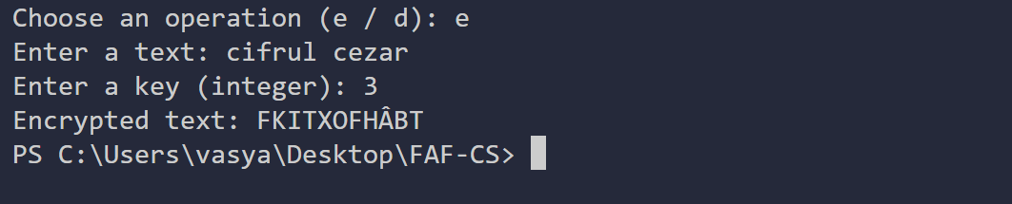
Figure 4.1: Task 1.1: encryption and decryption of "cifrul cezar", k = 3
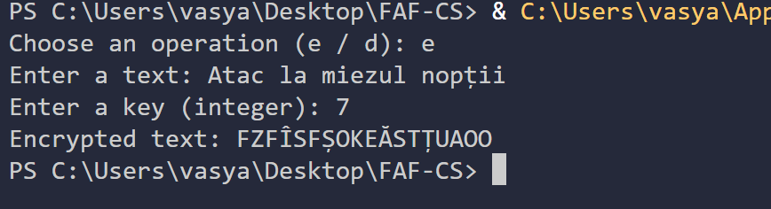
Figure 4.2: Task 1.1: encryption and decryption of "Atac la miezul nopții", k = 7
Figure 4.3 shows the program's reaction to invalid input: an unknown operation, a text containing digits, a key equal to 0, a non-numeric key and a key greater than 30. In each case a message is displayed and the value is requested again.
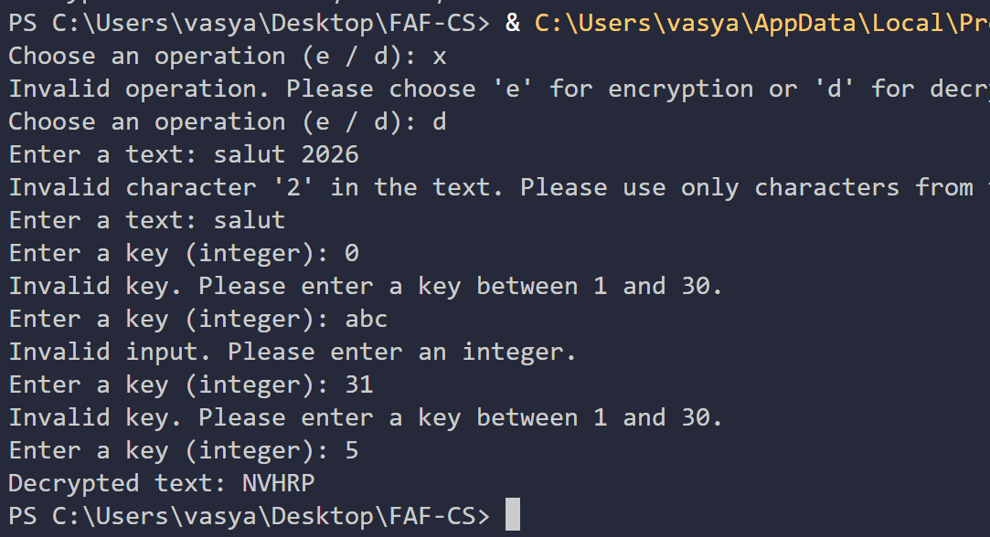
Figure 4.3: Task 1.1: messages for invalid operation, character and key

4.2 Task 1.2: Caesar cipher with a permutation
For the keyword k2 = "criptografie" the distinct letters C, R, I, P, T, O, G, A, F, E are written first (the second R and I are dropped), followed by the rest of the alphabet in natural order. With k1 = 3 the plaintext CIFRULCEZAR becomes POÂTXQPBIĂT, whereas the plain Caesar cipher with the same k gave FKITXOFHÂBT. Table 4.2 shows the permuted alphabet and the shifted alphabet, which can be used to check the result by hand (e.g. C has position 0 and becomes the letter at position 3, P).
Table 4.2: Permuted alphabet for k2 = criptografie and shift k1 = 3 (part 1)
a | 0 | 1 | 2 | 3 | 4 | 5 | 6 | 7 | 8 | 9 | 10 | 11 | 12 | 13 | 14 | 15
b | C | R | I | P | T | O | G | A | F | E | Ă | Â | B | D | H | Î
+3 | P | T | O | G | A | F | E | Ă | Â | B | D | H | Î | J | K | L

Table 4.2 (continued): Permuted alphabet for k2 = criptografie and shift k1 = 3 (part 2)
a | 16 | 17 | 18 | 19 | 20 | 21 | 22 | 23 | 24 | 25 | 26 | 27 | 28 | 29 | 30
b | J | K | L | M | N | Q | S | Ș | Ț | U | V | W | X | Y | Z
+3 | M | N | Q | S | Ș | Ț | U | V | W | X | Y | Z | C | R | I

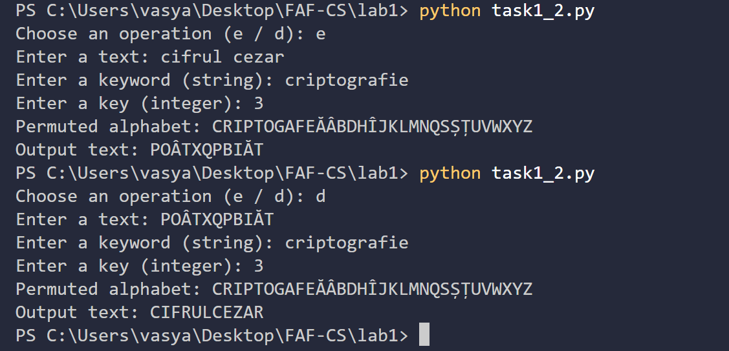
Figure 4.4: Task 1.2: encryption and decryption, k1 = 3, k2 = criptografie
Figure 4.5 shows the validation in Task 1.2: invalid operation, a text with a punctuation mark, a keyword that is too short ("cheie", 5 letters), a keyword that contains digits, a key greater than 30 and an empty key.
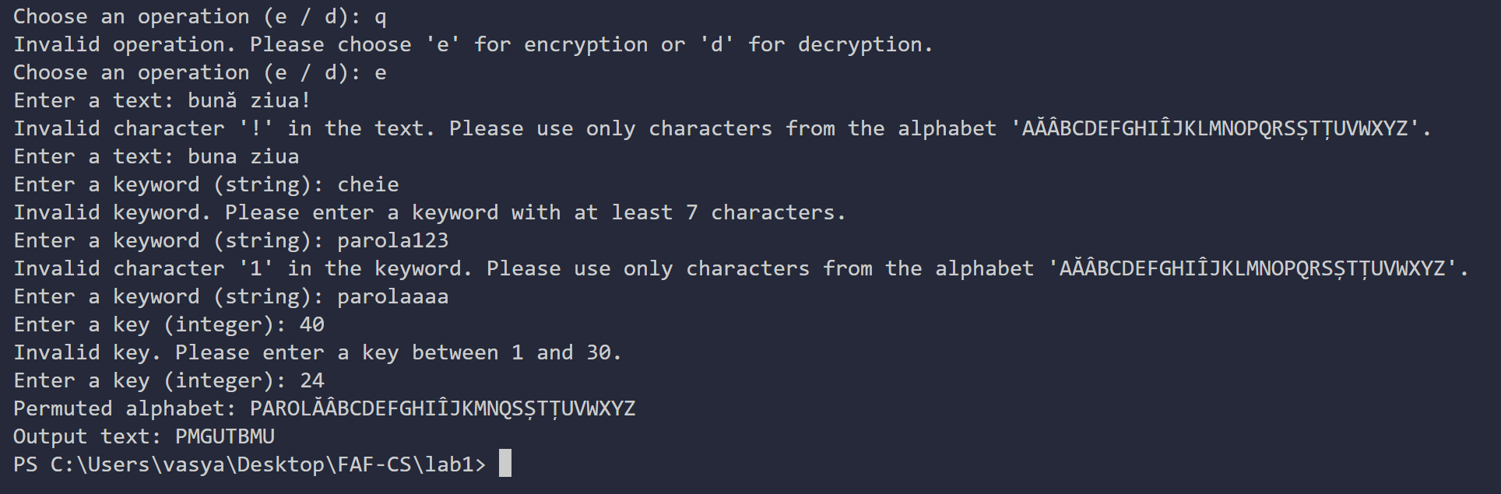
Figure 4.5: Task 1.2: messages for invalid text, keyword and key

CONCLUSION
In this laboratory work the Caesar cipher and its two-key variant with a keyword-based permutation were implemented for the Romanian alphabet of 31 letters. Both programs use only the encoding of Table 2.1, accept upper and lowercase letters, remove spaces, handle the cedilla variants of Ș and Ț, and repeat the request with a clear message whenever the operation, text, keyword or key is invalid. All test cases were verified by hand and decryption always returned the original plaintext.
The classic Caesar cipher is not secure. With only 30 possible keys for the Romanian alphabet, a brute-force attack takes a fraction of a second even by hand, and the correct key is immediately recognizable because it is the only one that produces readable text.
The keyword permutation increases the theoretical key space to 31! × 30 ≈ 2.47 × 10³⁵, which makes exhaustive search impractical. In practice, however, the real number of keys is much smaller, because the keyword is usually a word and the letters after it stay in alphabetical order (in the example above the tail …U V W X Y Z is unchanged). More importantly, the cipher remains monoalphabetic: each letter is always replaced by the same letter, so frequency analysis of a sufficiently long ciphertext reveals the substitution.
The main lesson of this work is that a large key space is a necessary but not a sufficient condition for security: a cipher must also hide the statistical structure of the language. The work also showed the importance of careful input handling (letter encoding, normalization of special Romanian characters and correct modular arithmetic for negative values) when implementing even the simplest cryptographic algorithm.

REFERENCES
1. Source Code. [Online]. Available:
https://github.com/kynexi/FAF-CS
2. Wikipedia, "Caesar cipher," Wikipedia.org. [Online]. Available: https://en.wikipedia.org/wiki/Caesar_cipher
3. Wikipedia, "Keyword cipher," Wikipedia.org. [Online]. Available: https://en.wikipedia.org/wiki/Keyword_cipher
4. Wikipedia, "Frequency analysis," Wikipedia.org. [Online]. Available: https://en.wikipedia.org/wiki/Frequency_analysis

