
MINISTRY OF EDUCATION, CULTURE AND RESEARCH
OF THE REPUBLIC OF MOLDOVA
Technical University of Moldova
Faculty of Computers, Informatics and Microelectronics
Department of Software Engineering and Automation

Report
on laboratory work no. 3
Operating Systems
Topic: The Command Line: Shell, Pipes and Text Filters

Done by:
st. gr. FAF-242, Vasile Brînză

Checked by:
Reițman Patricia, university assistant

Chișinău 2026
Table of Contents
PURPOSE OF THE WORK 3
1 MOVE FAST, FIND HELP 4
1.1 Tab completion and history search 4
1.2 Built-in and external commands, PATH and exit codes 4
1.3 Finding help without a browser 5
1.4 Answers to the Observe questions 5
2 WHAT THE SHELL DOES TO YOUR LINE 6
2.1 Test directory 6
2.2 Predictions and real outputs 6
2.3 Answers to the Observe questions 7
3 REDIRECTION, CHAINING AND JOBS 8
3.1 Separate files for stdout and stderr 8
3.2 The order of redirections 8
3.3 Appending, input redirection and chaining 9
3.4 Background jobs 9
3.5 Answers to the Observe questions 10
4 ANSWER QUESTIONS WITH ONE-LINERS 10
4.1 Q1 – Number of failed requests 10
4.2 Q2 – Different pages 11
4.3 Q3 – Requests per page 11
4.4 Q4 – Users with the most failed requests 11
4.5 Q5 – Requests of user3 11
4.6 Q6 – Last 3 failed requests 12
4.7 Q7 – Login shells in /etc/passwd 12
4.8 Q8 – ls /etc | wc -l versus ls -l /etc | wc -l 12
4.9 Full run of oneliners.sh 12
4.10 Bonus – failed requests at minutes ending in 0 13
5 YOUR FIRST SCRIPT 13
5.1 The script report.sh 13
5.2 Running the script 14
5.3 Answers to the Observe questions 14
CONCLUSIONS 16
REFERENCES 17

PURPOSE OF THE WORK
The purpose of this laboratory work is to learn to work efficiently in the Linux command line (bash). By the end of the work the goals are:
• to move fast in the terminal using Tab completion, the command history and the built-in help (man, --help, help);
• to predict what the shell does to a command line before it runs: globbing, quoting, variable, arithmetic, command and brace expansion;
• to redirect standard output and standard error, to chain commands with ; && || and to control background jobs;
• to answer real questions about a data set (an artificial web access log of 500 lines) with one-line pipelines of small filters: grep, cut, sort, uniq, wc, head, tail, tr;
• to turn the best one-liners into a first bash script with argument checking and exit codes.
The work was done on a Lenovo laptop running Linux Mint, in bash, inside the course repository folder ~/os-2026-VasileBrinza/lab3 (used instead of ~/os-lab3). The data set was generated with the script from the task; wc -l access.log printed 500 access.log, as required. Each line has the form date time user result page, for example 2026-10-05 10:01 user1 OK /page1.

1 MOVE FAST, FIND HELP

1.1 Tab completion and history search
Tab completion. Typing ls /usr/sh and pressing Tab once completed the name to /usr/share/, because it is the only entry in /usr that starts with "sh". Pressing Tab a second time did not complete anything more: there are many entries inside /usr/share, so bash asked "Display all 329 possibilities? (y or n)" and then listed them (Figure 1.1). Typing cd /et and pressing Tab once completed immediately to cd /etc/, since only one name matches.
Reverse history search (Ctrl+R). After running a few commands (cd kynex…, cd lab3, …), pressing Ctrl+R and typing the first letters of an earlier command found the most recent matching command in the history; pressing Enter executed it again. Typing only cd matched the most recent command that contained it (cd lab3), so the search always returns the newest match first.
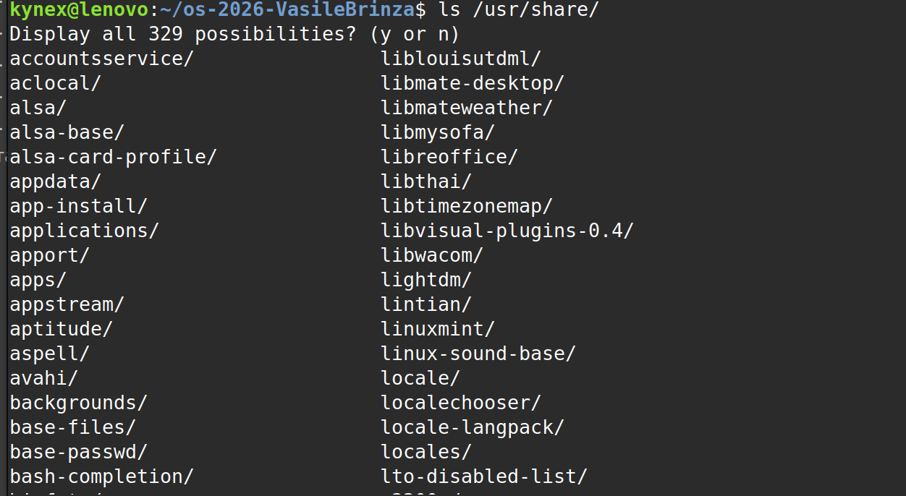
Figure 1.1 – Tab completion

1.2 Built-in and external commands, PATH and exit codes
type cd ; type ls ; type echo ; which ls
echo $PATH
echo $PATH | tr ':' '\n'
nosuchprog ; echo "exit code: $?"
type shows how the shell will interpret a name. cd and echo are reported as shell builtins; ls is an external program (on Linux Mint it is also an alias for ls --color=auto), and which ls shows its location in the file system. $PATH is the list of directories, separated by ":", that the shell searches, in order, for external commands; tr ':' '\n' replaces each ":" with a new line so that every directory appears on its own line.
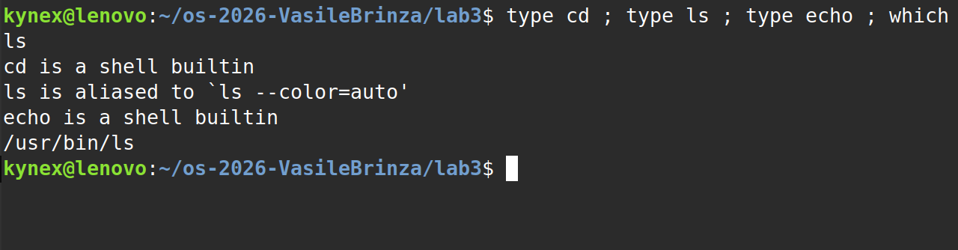
Figure 1.2 – Output of type and which
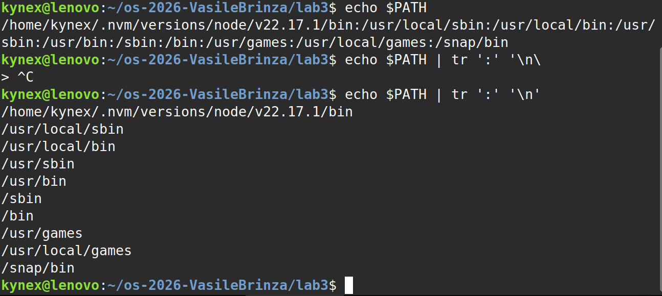
Figure 1.3 – The directories in PATH
Figure 1.4 – Exit code of a missing command

1.3 Finding help without a browser
man ls opens the manual page (inside it, /sort searches for the word "sort", n jumps to the next match and q quits). ls --help | head prints the first lines of the short built-in help of the program. man -k "list directory" searches the descriptions of all manual pages and returns the commands related to listing directories (ls, dir, vdir). help cd shows the help of a bash builtin; builtins have no separate program, so their help is inside bash.

1.4 Answers to the Observe questions
1. Which of cd, ls, echo are built-ins, and why MUST cd be one?
cd and echo are built into bash; ls is an external program. cd must be a builtin because the current working directory is a property of each process. An external program runs in a separate child process: it could change only its own directory and then exit, and the shell (the parent process) would stay where it was. Only the shell itself can change the shell's directory.
2. How many directories are in your PATH, and in which one is ls?
ls is found in /usr/bin – which ls prints /usr/bin/ls (Figure 1.2).
3. What exit code does a command that is not found return?
The shell prints "nosuchprog: command not found" and the exit code $? is 127. (126 would mean that the file exists but cannot be executed.)
4. Which option of ls sorts by modification time?
ls -t – sorts by modification time, newest first (found in man ls by searching for "sort"). ls -ltr gives the reverse order, with the newest files at the bottom.

2 WHAT THE SHELL DOES TO YOUR LINE

2.1 Test directory
mkdir -p ~/os-2026-VasileBrinza/lab3/play && cd ~/os-2026-VasileBrinza/lab3/play
touch a.c b.c file1.txt file2.txt notes.txt "alfa beta.txt"
ls
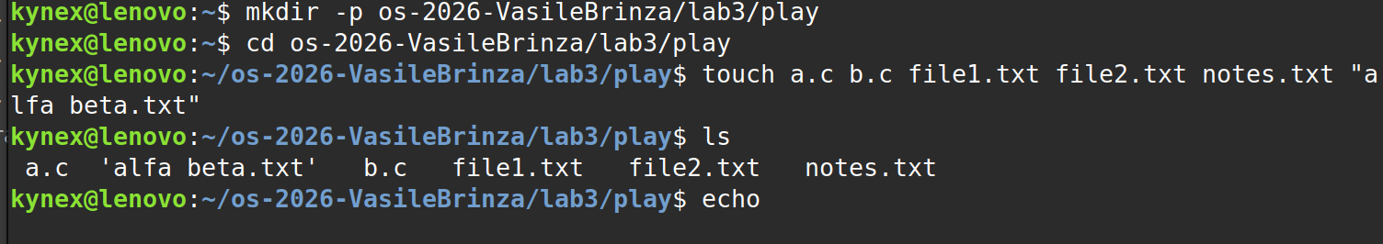
Figure 2.1 – Files created in the play directory

2.2 Predictions and real outputs
For every line, the prediction was written before pressing Enter. Table 2.1 compares the predictions with the real outputs (Figures 2.2–2.4).
Table 2.1 – Predictions and real outputs
Command | My prediction | Real output | Explanation (if different)
echo *.c | All files ending in .c | a.c b.c | As predicted: * matches any sequence of characters.
echo file?.txt | file1.txt file2.txt | file1.txt file2.txt | As predicted: ? matches exactly one character.
echo [a-b]* | All files that contain a or b | a.c alfa beta.txt b.c | [a-b] matches only ONE character, and here it is the first one: the pattern means "names that start with a or b", not names that contain them.
echo *.xyz | *.xyz | *.xyz | As predicted: when no file matches, bash leaves the pattern unchanged.
ls alfa beta.txt | The file alfa beta.txt | ls: cannot access 'alfa'…  ls: cannot access 'beta.txt'… | The unquoted space splits the line into two words, so ls receives two arguments, alfa and beta.txt, and neither exists.
ls "alfa beta.txt" | 'alfa beta.txt' | 'alfa beta.txt' | As predicted: the quotes keep the name as one argument.
echo '$HOME' "$HOME" \$HOME | $HOME /home/kynex /home/kynex | $HOME /home/kynex $HOME | The backslash escapes the $, so the third word is printed literally, the same as with single quotes.
echo {1..5} ; echo $((7 * 6)) | 1 2 3 4 5  42 | 1 2 3 4 5  42 | As predicted: {1..5} is brace expansion, $(( )) is arithmetic expansion.
echo "today is $(date +%A), I am $(whoami)" | today is Monday, I am kynex | today is Monday, I am kynex | As predicted: $( ) runs the command and inserts its output (command substitution), also inside double quotes.
touch log{1..3}.txt && ls log* | log1.txt log2.txt log3.txt | log1.txt log2.txt log3.txt | As predicted: the brace creates three names, then the glob log* lists them.

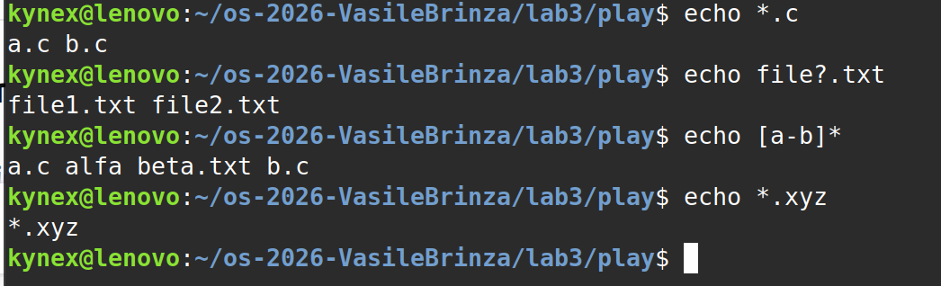
Figure 2.2 – Globbing results
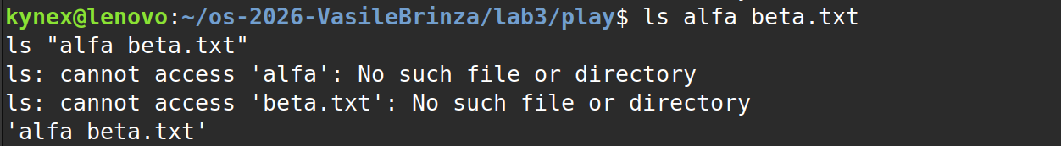
Figure 2.3 – The ls error on a name with a space, and the fix
Figure 2.4 – Single quotes, double quotes and backslash

2.3 Answers to the Observe questions
1. Prediction, real output and explanation for each line
See Table 2.1.
2. echo knows nothing about files, yet echo *.c printed file names. Who produced them?
The shell. Before running any command, bash performs filename expansion (globbing): it replaces *.c with the list of matching names, a.c b.c. echo is then started with these two arguments and simply prints them; it never sees the *.
3. Why did ls alfa beta.txt fail? Give two different ways to fix it.
Bash splits the command line into words at unquoted spaces, so ls received two separate arguments, alfa and beta.txt, and neither file exists. Fixes: put the name in quotes – ls "alfa beta.txt" (or single quotes) – or escape the space with a backslash – ls alfa\ beta.txt. Tab completion inserts the backslash automatically.
4. What is the difference between single and double quotes?
Inside single quotes everything is literal: no expansion at all, so '$HOME' prints $HOME. Inside double quotes the text is still one word (no splitting, no globbing), but $variables, $(commands) and $((arithmetic)) are expanded, so "$HOME" prints /home/kynex.
Why ls shows 'alfa beta.txt' in quotes. When its output goes to a terminal, GNU ls quotes names that contain spaces or other special characters (quoting style "shell-escape"). This shows clearly that the space belongs to one file name, and the printed name can be copied and pasted back into a command as it is. When the output goes into a pipe or a file, ls prints the plain name.

3 REDIRECTION, CHAINING AND JOBS

3.1 Separate files for stdout and stderr
ls /etc /nope > out.txt 2> err.txt
wc -l out.txt ; cat err.txt
> sends standard output (stream 1) to out.txt and 2> sends standard error (stream 2) to err.txt. Nothing appeared on the screen during the first command. out.txt has 259 lines: the header line "/etc:" (ls prints it because it received two arguments) followed by the 258 entries of /etc (compare with Figure 4.8, where ls /etc | wc -l gives 258). err.txt contains the single line "ls: cannot access '/nope': No such file or directory".
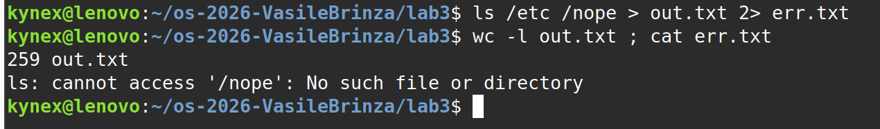
Figure 3.1 – stdout and stderr in separate files

3.2 The order of redirections
ls /etc /nope > all.txt 2>&1 ; tail -2 all.txt
ls /etc /nope 2>&1 > all.txt
With > all.txt 2>&1 the screen stayed empty and tail -2 all.txt showed the last two entries of /etc (zsh, zsh_command_not_found): both the listing and the error went into the file. With 2>&1 > all.txt the error message appeared on the terminal (Figure 3.2) and only the listing was saved.
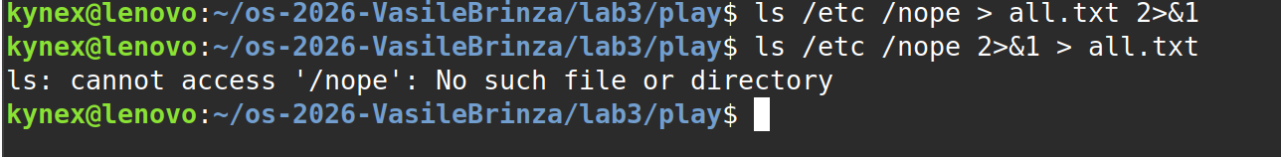
Figure 3.2 – Comparing the order of redirections

3.3 Appending, input redirection and chaining
echo first > notes.md ; echo second >> notes.md ; cat notes.md
wc -l < access.log
ls /nope 2> /dev/null || echo "failed with code $?"
mkdir -p tmp && cd tmp && echo "I am in $(pwd)" ; cd ~/os-2026-VasileBrinza/lab3
> creates or overwrites a file and >> appends to it, so notes.md contains "first" and "second" on two lines. wc -l < access.log printed only 500.
Figure 3.3 shows a useful mistake: in the first line | was typed instead of ||, and in the second line & instead of &&. With |, the two commands run at the same time in a pipeline, and $? is expanded before ls has finished, so it printed "failed with code0" – the status of the previous command, not of ls. With the correct ||, echo runs only because ls failed, and the message is "failed with code 2" (ls returns 2 when an argument cannot be accessed). With a single &, mkdir -p tmp && cd tmp was sent to the background as job [1] (PID 23737) and ran in a subshell, so the shell itself did not move, and echo printed "I am in …/lab3/play". With && the result is "I am in …/lab3/tmp", and the final cd returns to the lab3 folder.
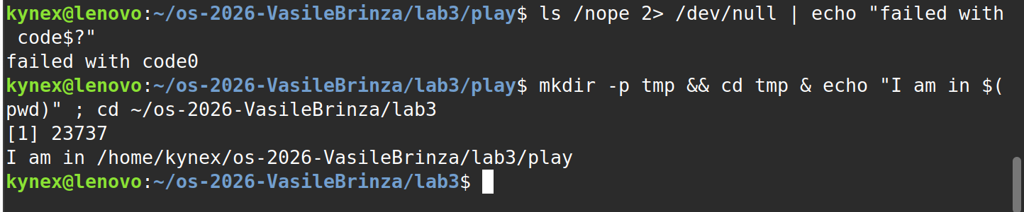
Figure 3.3 – The ; && || operators

3.4 Background jobs
sleep 100 &
jobs ; kill %1 ; jobs
& starts sleep in the background and the shell immediately returns the prompt, printing the job number and the PID. jobs lists the jobs of the current shell. In this run the sleep received job number [2] (number [1] was still taken by the background command from Figure 3.3), so kill %1 answered "no such job" and kill %2 was needed. Right after kill, jobs still showed the job as Terminated; bash reports the change of status once and then removes the job, so the last jobs printed nothing. If kill is repeated after that, it fails because the job no longer exists.
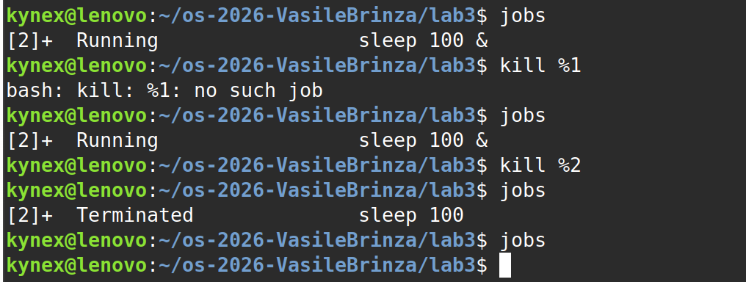
Figure 3.4 – Running a background job and stopping it

3.5 Answers to the Observe questions
1. Which file got the error message, and which got the listing?
err.txt got the error message (standard error, stream 2) and out.txt got the listing of /etc (standard output, stream 1).
2. What is the difference between > all.txt 2>&1 and 2>&1 > all.txt?
Redirections are processed from left to right, and 2>&1 means "make stderr point to wherever stdout points right now". In > all.txt 2>&1, stdout is first sent to all.txt, then stderr is copied from it, so both streams go into the file. In 2>&1 > all.txt, stderr is first copied from stdout while stdout is still the terminal, and only then stdout is moved to the file; therefore the error still appears on the screen and only the listing is saved.
3. Why does wc -l < access.log print only a number, while wc -l access.log also prints the file name?
With < the shell opens the file and connects it to the standard input of wc; wc only reads a stream of data and does not know any file name. With wc -l access.log, the name is given as an argument, wc opens the file itself and prints the name next to the count.
4. Explain each operator in one sentence: ; && ||
A ; B runs B after A finishes, whatever the result of A. A && B runs B only if A succeeded (exit code 0). A || B runs B only if A failed (exit code different from 0).

4 ANSWER QUESTIONS WITH ONE-LINERS
All answers are saved in oneliners.sh, one command line per question with the question as a comment above it. The fields of access.log are separated by spaces: 1 = date, 2 = time, 3 = user, 4 = result, 5 = page.

4.1 Q1 – Number of failed requests
grep -c FAIL access.log
grep -c counts the lines that contain FAIL. Answer: 100 requests failed (every fifth request).
Figure 4.1 – Number of failed requests

4.2 Q2 – Different pages
cut -d' ' -f5 access.log | sort -u
cut -d' ' -f5 keeps only the 5th field (the page); sort -u sorts and removes duplicates. Answer: 4 different pages – /page0, /page1, /page2, /page3.

Figure 4.2 – The different pages requested

4.3 Q3 – Requests per page
cut -d' ' -f5 access.log | sort | uniq -c
sort puts identical pages next to each other, because uniq -c only counts adjacent identical lines. Answer: 125 requests for each page. Check: 4 × 125 = 500, the number of lines in the log.

Figure 4.3 – Number of requests per page

4.4 Q4 – Users with the most failed requests
grep FAIL access.log | cut -d' ' -f3 | sort | uniq -c | sort -rn \
| awk 'NR==1{m=$1} $1==m{print $2, $1}'
grep keeps the failed requests, cut extracts the user, sort | uniq -c counts the failures per user and sort -rn orders the counts from largest to smallest. Because the maximum can be shared, awk remembers the first (largest) count and prints every user with that count. Answer: user3 and user5, with 15 failed requests each. Check: the per-user counts are 14, 14, 14, 15, 14, 15, 14 (users 0–6), and their sum is 100, equal to Q1.

Figure 4.4 – Users with the most failed requests

4.5 Q5 – Requests of user3
printf "Total: "; grep -c ' user3 ' access.log; printf "Failed: "; grep FAIL access.log | grep -c ' user3 '
The spaces around user3 make the match exact, so the word cannot match inside another field. Answer: user3 made 72 requests, and 15 of them failed.

Figure 4.5 – Requests and failures of user3

4.6 Q6 – Last 3 failed requests
grep FAIL access.log | tail -3 | cut -d' ' -f2,3
tail -3 keeps the last three failed lines; cut -f2,3 shows only the time and the user. Answer: 10:10 user0, 10:15 user5, 10:20 user3.

Figure 4.6 – The last 3 failed requests

4.7 Q7 – Login shells in /etc/passwd
cut -d: -f7 /etc/passwd | sort | uniq -c | sort -rn
In /etc/passwd the fields are separated by ":" and field 7 is the login shell of the account. Answer (on this laptop): /usr/sbin/nologin – 40 accounts, /bin/false – 5, /bin/bash – 2, /bin/sync – 1. Most accounts are system accounts for services and use nologin or false, which refuse an interactive login; only 2 accounts can log in with bash. These numbers depend on the computer.
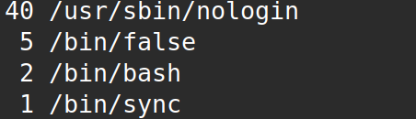
Figure 4.7 – Login shells and the number of accounts using each

4.8 Q8 – ls /etc | wc -l versus ls -l /etc | wc -l
ls /etc | wc -l
ls -l /etc | wc -l
Prediction: the second number is bigger by one because of the "total" line. Result: 258 and 259, as predicted. When its output goes into a pipe, ls prints one name per line, so wc counts 258 entries. ls -l prints the same 258 entries, one per line, plus a first line "total N" (the disk blocks used by the listed files), so wc counts one line more.
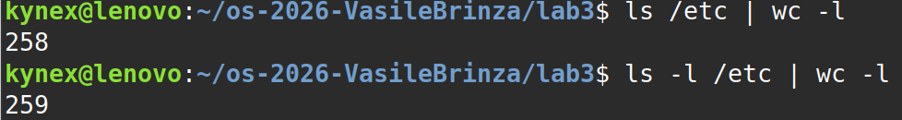
Figure 4.8 – Comparing ls and ls -l piped to wc -l

4.9 Full run of oneliners.sh
The whole file runs with bash oneliners.sh in the lab3 folder and prints the answers to Q1–Q7 in order (Q8 is only a comment with the explanation).
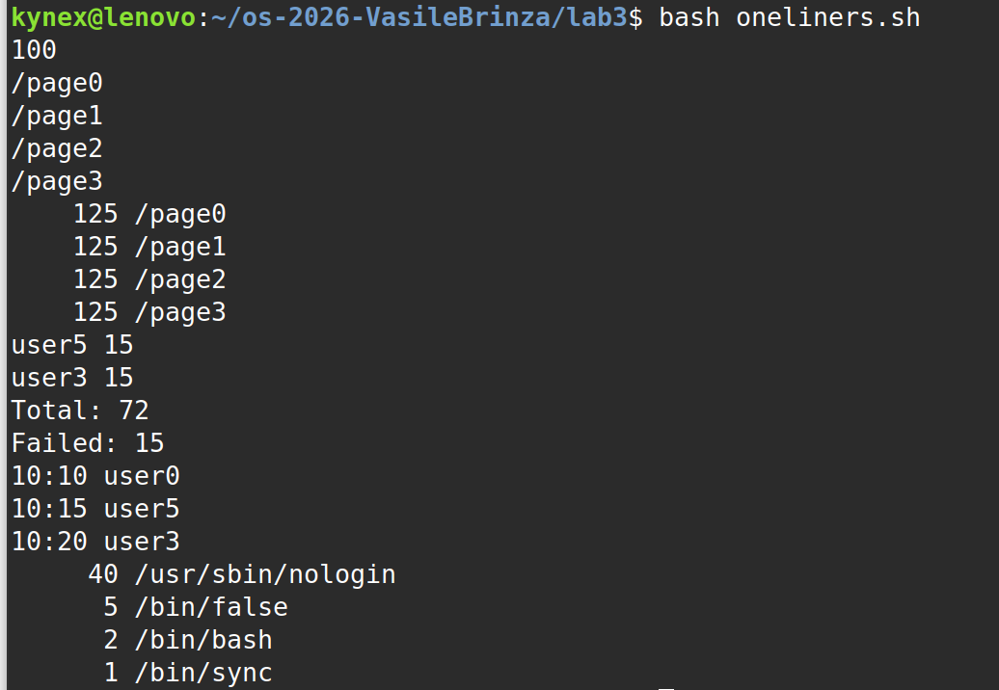
Figure 4.9 – Full run of oneliners.sh

4.10 Bonus – failed requests at minutes ending in 0
grep -Ec ' 10:[0-5]0 .* FAIL ' access.log
-E enables extended regular expressions; 10:[0-5]0 matches the minutes 00, 10, 20, 30, 40, 50, .* skips the user, and FAIL requires the failed result; -c counts the lines. Answer: 50 lines. This is also visible from how the log is generated: the minute is i mod 60 and a request fails when i is divisible by 5. A minute ending in 0 means i is divisible by 10, so every such request is also a failed one: 500 / 10 = 50.

5 YOUR FIRST SCRIPT

5.1 The script report.sh
The TODO was completed with a for loop over the users 0 to 6. For each user, the failed lines are filtered with grep and the lines of that user are counted with grep -c:
for i in {0..6}; do
count=$(grep FAIL "$log" | grep -c "user$i")
echo "user$i: $count failures"
done
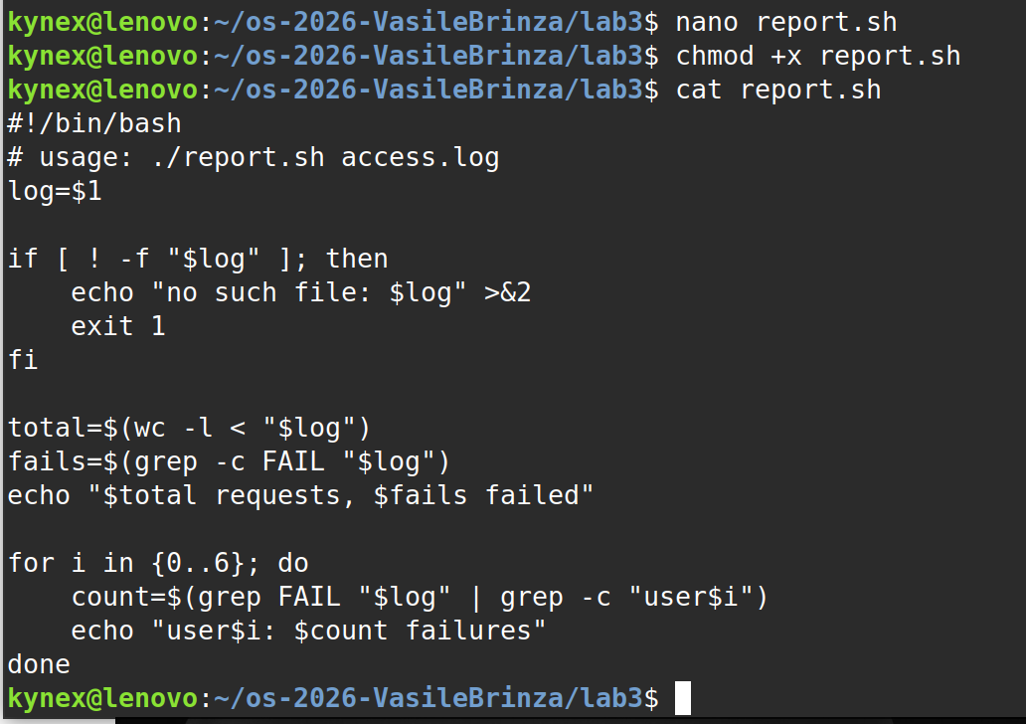
Figure 5.1 – Contents of report.sh

5.2 Running the script
chmod +x report.sh
./report.sh access.log
./report.sh nope.log ; echo "exit code: $?"
On access.log the script prints "500 requests, 100 failed" and the failures of each user (14 for users 0, 1, 2, 4, 6 and 15 for users 3 and 5) – the same results as Q1 and Q4, and the sum is again 100. On a missing file it prints "no such file: nope.log" and the exit code is 1.
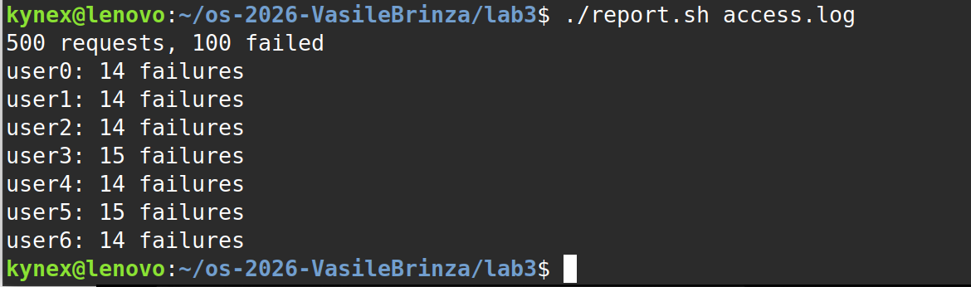
Figure 5.2 – Running the script on access.log
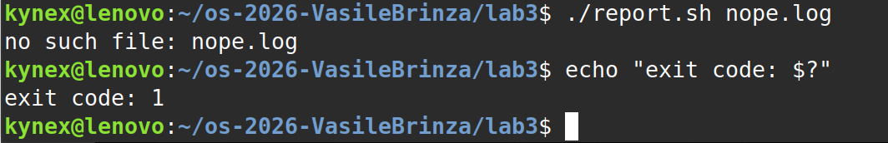
Figure 5.3 – Error handling for a missing file

5.3 Answers to the Observe questions
1. What does the first line #!/bin/bash do, and what happens if you run ./report.sh before chmod +x?
The first line is the "shebang". When the file is executed, the kernel reads #! and starts the program written after it, /bin/bash, giving it the script as an argument; so the script is always run by bash, whatever shell the user is in. A new file does not have the execute permission, so ./report.sh before chmod +x fails with "bash: ./report.sh: Permission denied". (bash report.sh would still work, because then bash only reads the file.)
2. Why must you type ./report.sh and not just report.sh?
A name without "/" is searched only in the directories listed in PATH, and the current directory is not in PATH (this is a safety measure, so a file in the current folder cannot replace a system command such as ls). ./report.sh is a path – "the file report.sh in the current directory" – so no PATH search is done.
3. Why does the script write the error with >&2 and end with exit 1?
>&2 sends the message to standard error, so it is still seen on the screen when the normal output is redirected to a file or a pipe, and it does not mix with the real results. exit 1 stops the script and returns a non-zero exit code, so the user, another script or && / || can detect that it failed (Figure 5.3 shows exit code 1).

CONCLUSIONS
In this laboratory work I learned to work faster in bash with Tab completion, Ctrl+R history search and the built-in help (man, --help, man -k, help). I saw the difference between builtins and external programs and why cd must be a builtin: the current directory belongs to the shell process, and a child process cannot change it.
The most important idea of the work is that the shell transforms the command line before the command runs. Globs, braces, variables, $( ) and $(( )) are all expanded by bash, and the program receives only the final list of arguments. Most of my wrong predictions came from this: [a-b]* matches the first character only, an unquoted space splits a file name in two, and a backslash protects $ just like single quotes.
Redirection showed that every process has separate stdout and stderr streams, that redirections are applied from left to right, and that small typing mistakes such as | instead of || or & instead of && completely change the meaning of a line (a pipeline instead of a condition, a background job instead of a sequence).
In Part 4 every question about the 500-line log was answered with one pipeline of small filters. The self-checks of the task confirmed the results: the per-page counts add up to 500 and the per-user failures add up to the 100 failed requests. Finally, the one-liners became a reusable script that checks its argument, writes errors to stderr and returns a meaningful exit code.

REFERENCES
1. The Open Group, "Shell Command Language," The Open Group Base Specifications (POSIX.1-2017). [Online]. Available: https://pubs.opengroup.org/onlinepubs/9699919799/utilities/V3_chap02.html
2. M. Kerrisk, "passwd(5) – Linux manual page," The Linux man-pages project. [Online]. Available: https://man7.org/linux/man-pages/man5/passwd.5.html
3. W. Shotts, The Linux Command Line, 2nd ed. San Francisco, CA, USA: No Starch Press, 2019. [Online]. Available: https://linuxcommand.org/tlcl.php
4. V. Brînză, "os-2026-VasileBrinza," GitHub repository, lab3 folder (report.sh, oneliners.sh). [Online]. Available: https://github.com/kynexi/os-2026-VasileBrinza/tree/lab3/lab3

