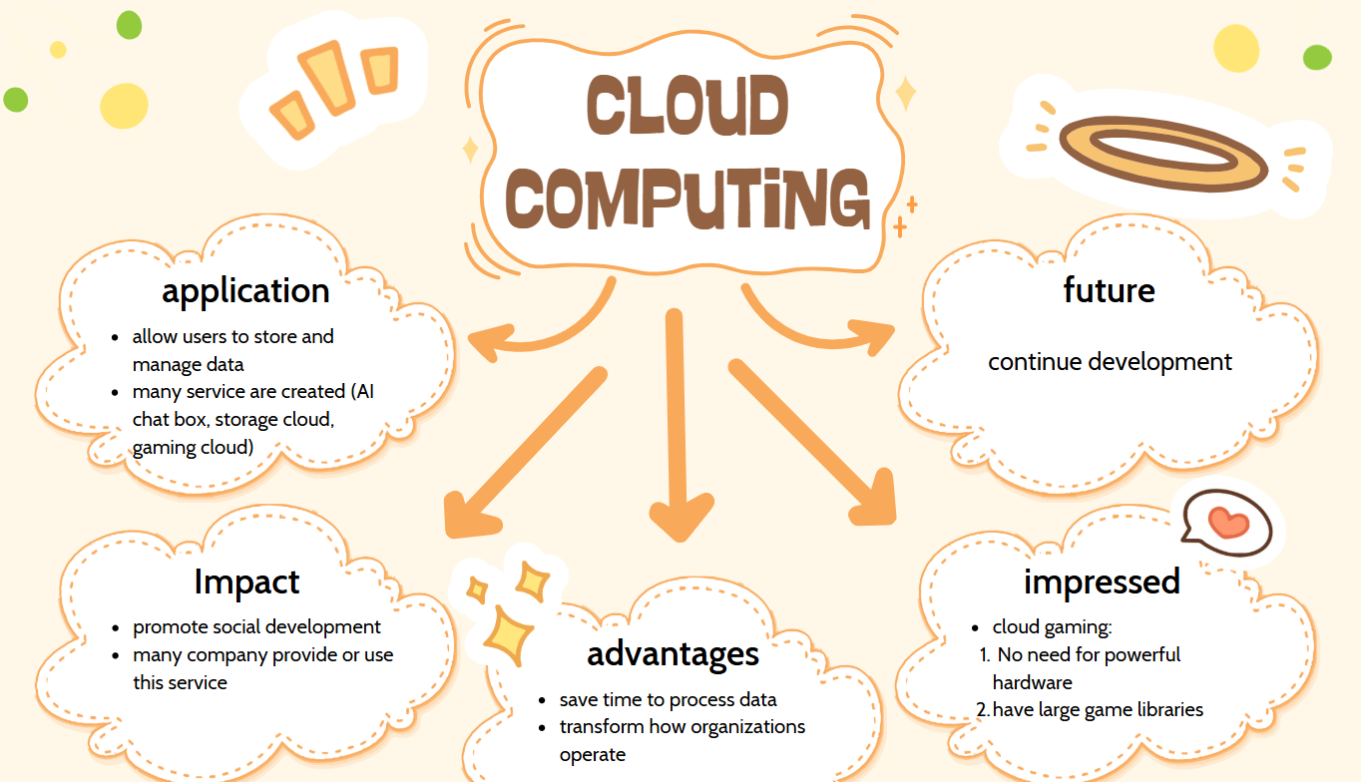
One of the most impressive developments in Information Technology in recent years is cloud computing. This technology allows users to store and manage data via device connecting with internet. It has transformed how organizations operate by using comfortable, saving time to process data. Cloud computing supports remote work, real-time collaboration.

Nowsaday, technology is becoming more and more development, many cloud service are created, they include cloud gaming, cloud storage service, AI chat box… I am impressed by cloud gaming service such as Xbox Game Pass, NVIDIA GeForce NOW, PlayStation Plus.

It helps me playing video games no need for powerful hardware, they have large game libraries and I can play and no need downloading material of games. In the future it will continue development and create many cloud service useful for customer.

