

|  |
| --- |
| Check Tor address |
|  |
| **Filename:** Check Tor address.docx  **Version:** 1.00  **Created:** 22.12.2017 10:00:00  **Last changed:** 22.12.2017 18:05:00  **Pages:** 21 |

**Revision history**

History:

| Rev. | Date | Activity | Author |
| --- | --- | --- | --- |
| 1.0 | 25.04.2016 | Currency setup | Krzysztof Nielepkowicz |
|  |  |  |  |
|  |  |  |  |
|  |  |  |  |
|  |  |  |  |
|  |  |  |  |
|  |  |  |  |
|  |  |  |  |
|  |  |  |  |
|  |  |  |  |

Table of contents

1 How to use 4

2 How to obtain code and run 5

2.1 Prepare to run 6

2.2 Running 7

# How to use

* First enter application deployed on heroku cloud : <https://gentle-depths-50473.herokuapp.com/>
* You can use tool in your web browser providing ip as the part of the address :

<https://gentle-depths-50473.herokuapp.com/185.100.85.61> - if IP is one of the TOR’s entrance nodes, application will return simple text message :  


But if IP is incorrect – Page not found will be returned :

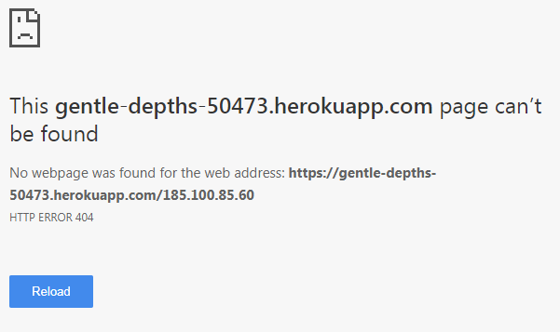

* Either you can use tool like [Postman](https://www.getpostman.com/). Simply open new tab and enter application address with desired IP, next choose operation type – at this moment only GET and HEAD is supported :  
    
  If you choose HEAD, then no message is returned – only status. So if IP is TOR exit node, then code 200 will be returned :  
    
  But if IP is invalid, code 404 will be returned :  
  

# How to obtain code and run

Code for application is stored at GitHub : <https://github.com/kyniek/checkTorAddress>. The simplest way to obtain it to your IDE is use *import* in STS (Spring Tool Suite)

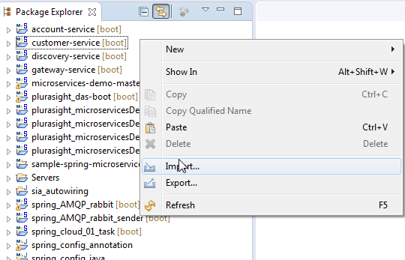

Next choose git

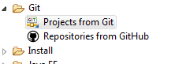

Then Clone URL

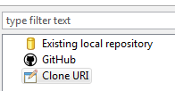

Enter repository URL :

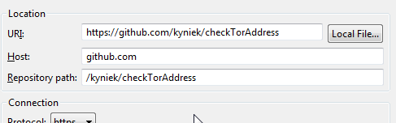

Choose branch – actually only one ☺

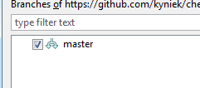

Select destination

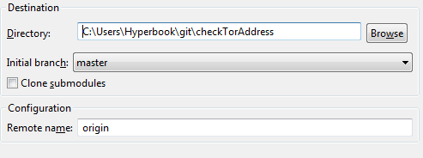

You can import as general project and finish process

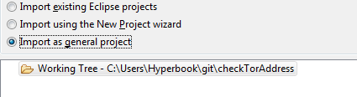

The last step is to configure project as maven project

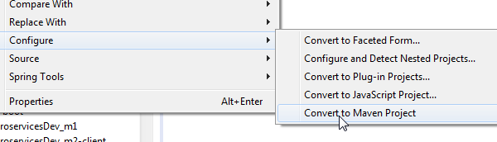

## Prepare to run

Use maven->update project :

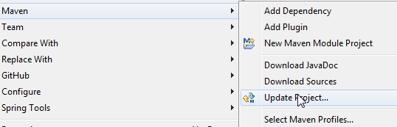

Maven will download all libs and will build project.

## Running

To run project use Boot Dashboard, of course you can use other ways – but this one is the simplest one :

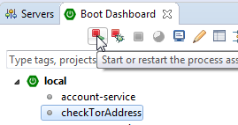

After few seconds you will be able to perform requests in Postman or simply with web browser :

