Industry Internship
Submitted in
Fulfilment of the requirements for the degree of

BACHELOR OF TECHNOLOGY
in

Artificial Intelligence & Data Science Department
by

ANAGHA J

ENROLLMENT NO:- 2203031240059

Under the supervision of
Assistant Prof. YOUSUF S K (Faculty Mentor) and Mrs. Meenakshi Sundaram R(Industry Mentor)
In
Innovate , Chennai, Tamil Nadu

APRIL-2026
DEPARTMENT OF ARTIFICIAL INTELLIGENCE & DATA SCIENCE PARUL INSTITUTE OF ENGINEERING & TECHNOLOGY FACULTY OF ENGINEERING & TECHNOLOGY
PARUL UNIVERSITY
P.O. Limda – 391 760, GUJARAT, INDIA

CERTIFICATE

This is to certify that the work contained in Internship at “INNOVATE” submitted by Name of the student ANAGHA J, Enrollment No. 2203031240059 studying at Parul Institute of Engineering &Technology/ Parul Institute of Technology for the “INDUSTRY INTERNSHIP- 303105499” is absolutely based on his/her own work carried out under my/our supervision and that this work/thesis has not been submitted elsewhere for any degree/diploma. To our satisfaction, this work is approved for the “INDUSTRY- INTERNSHIP- 303105499”
External exam.

Yousuf S K
Assistant Professor, AI & DS
Department, Faculty Mentor
PIET-FET-Parul University



Dr. Meenakshi Sundaram R
Industry Mentor Innovate
Chennai, Tamil Nadu

Dr. Sanjay Agal Head of Department, AI & DS Department,
PIET-FET-Parul University

INTERNSHIP COMPLETION CERTIFICATE


ACKNOWLEDGEMENT

I would like to express my sincere gratitude to all those who have contributed to the successful completion of my project titled “Veracity Vigilance: Leveraging Machine Learning for Fake News Detection.”
First and foremost, I extend my heartfelt thanks to my Faculty Mentor, YOUSUF S K, for providing invaluable guidance and support throughout the duration of this project. His expertise, constructive feedback, and willingness to share knowledge have been instrumental in shaping my understanding and completing this work successfully.

I am also grateful to INNOVATE for providing me with the opportunity to work in a professional environment and for creating a supportive atmosphere for learning and development. The practical exposure gained during this project greatly enhanced my understanding of real-world applications of machine learning.

Furthermore, I would like to acknowledge the support of Parul Institute of Engineering & Technology (PIET) and Parul University, along with the Department of Computer Science & Engineering, for providing the academic foundation, resources, and encouragement necessary to undertake and complete this project. The theoretical knowledge gained during my studies was effectively complemented by the practical experience of this work.

I am truly thankful for the enriching experience and learning opportunities provided throughout this project, which have significantly contributed to my personal and professional growth.

ANAGHA J
2203031240059

ABSTRACT

The rapid growth of digital media and social networking platforms has led to an unprecedented spread of information, making it increasingly difficult to distinguish between real and fake news. Fake news, which refers to false or misleading information presented as legitimate news, can have serious social, political, and economic consequences. This project, titled “Veracity Vigilance: Leveraging Machine Learning for Fake News Detection,” aims to develop an automated system capable of accurately identifying and classifying news articles as real or fake using machine learning techniques.

Traditional approaches to fake news detection often rely on manual verification or rule-based systems, which are time-consuming and inefficient. To overcome these limitations, this project utilizes machine learning and natural language processing (NLP) techniques to analyze textual data and extract meaningful patterns. The dataset used for this project consists of labeled news articles collected from publicly available sources such as Kaggle. The data is preprocessed through steps including text cleaning, tokenization, removal of stop words, and feature extraction using techniques like Term Frequency-Inverse Document Frequency (TF-IDF).

Machine learning models such as Logistic Regression were implemented and evaluated for classification. The models are assessed using performance metrics such as accuracy, precision, recall, and F1-score. The results demonstrate that the proposed system can effectively distinguish between real and fake news with high accuracy, highlighting the potential of machine learning in combating misinformation.

In conclusion, this project presents a reliable and scalable solution for fake news detection using machine learning. It emphasizes the importance of automated systems in addressing the growing challenge of misinformation and provides a foundation for future enhancements using advanced deep learning techniques.

TABLE OF CONTENTS

Sr. No. | Content | Page No.
1 | Acknowledgement | iv
2 | Abstract | v
3 | Table of Contents | vi
4 | List of Abbreviations | vii
5 | List of Figures | viii
6 | Chapter 1: Introduction (1.1–1.5) | 01–03
7 | Chapter 2: Aim and Objectives (2.1–2.3) | 04-06
8 | Chapter 3: Review of Literature (3.1–3.8) | 07-11
9 | Chapter 4: Methodology (4.1–4.15) | 13-18
10 | Chapter 5: Observations & Results (5.1–5.12) | 19-25
11 | Conclusions & Summary | 26–28
12 | References | 29
12 | NOC from Department (Annexure-05) | 30
13 | Internship Acceptance letter from Industry | 31
14 | Daily log and Weekly log (Annexure-06)- Log book | 32-47
15 | Internship Identification Exercise (Annexure-07) | 48-49
16 | Student Internship Periodic Assessment Review card I,II, III (Annexure-02) | 50-51

LIST OF ABBREVATIONS

LIST OF ABBREVIATIONS

Abbreviation | Full Form
AI | Artificial Intelligence
ML | Machine Learning
NLP | Natural Language Processing
DL | Deep Learning
NN | Neural Network
TF-IDF | Term Frequency – Inverse Document Frequency
BoW | Bag of Words
LR | Logistic Regression
NB | Naive Bayes
SVM | Support Vector Machine
EDA | Exploratory Data Analysis
TP | True Positive
TN | True Negative
FP | False Positive
FN | False Negative
API | Application Programming Interface
UI | User Interface
UX | User Experience
DB | Database
SQL | Structured Query Language
JSON | JavaScript Object Notation
HTTP | HyperText Transfer Protocol
HTTPS | HyperText Transfer Protocol Secure
IDE | Integrated Development Environment
GPU | Graphics Processing Unit
KPI | Key Performance Indicator

LIST OF FIGURES

LIST OF FIGURES

Figure No. Figure Title Page No.
Figure 4.1 Overall System Workflow 13
Figure 4.2 System Architecture 14
Figure 4.3 Data Preprocessing Pipeline 14
Figure 4.4 Model Training and Evaluation 15
Figure 4.5 Prediction and output generation 16
Figure 4.6 Data Collection and Data Description 17

Figure 5.1 | Accuracy comparison of ml models | 18
Figure 6.1 | Real world applications of the system | 22
Figure 6.2 | Limitations of System | 23

CHAPTER 1

INTRODUCTION

Overview of Fake News Detection

Fake news detection refers to the process of identifying false, misleading, or fabricated information presented as legitimate news. With the rapid growth of digital media and social networking platforms, the spread of misinformation has become a serious global concern. Millions of users consume and share news online daily, making it difficult to verify the authenticity of information manually.

Traditionally, fake news detection relied on human fact-checkers and rule-based systems. While effective to some extent, these approaches are time-consuming, labor-intensive, and not scalable for large volumes of data. Moreover, fake news is often designed to mimic real news, making manual detection even more challenging.

With advancements in artificial intelligence, especially machine learning and natural language processing (NLP), automated fake news detection has become more efficient and accurate. These systems analyze textual patterns, linguistic features, and contextual information to classify news as real or fake.

Fake news detection has a wide range of applications, including social media monitoring, journalism, cybersecurity, and public awareness systems. It plays a crucial role in maintaining information integrity and preventing the spread of misinformation in society.

Role of Machine Learning in Fake News Detection

Machine Learning (ML) has significantly transformed the way fake news is detected. ML models can learn patterns from large datasets and automatically classify news articles based on their content. Unlike traditional rule-based systems, ML models improve over time as they are exposed to more data.

In fake news detection, ML algorithms analyze features such as word frequency, sentence structure, writing style, and semantic meaning. Techniques like TF-IDF (Term Frequency-Inverse Document Frequency) and word embeddings are used to convert textual data into numerical form for model training.

Common machine learning algorithms used for fake news detection include Logistic Regression, Naive Bayes, and Support Vector Machines. These models are trained on labeled datasets containing both real and fake news articles, enabling them to distinguish between authentic and misleading information.

ML-based systems are scalable and capable of handling large volumes of data in real time. This makes them highly suitable for applications such as social media platforms, where news spreads rapidly.

Introduction to Veracity Vigilance System

Veracity Vigilance is a machine learning-based system designed to automatically detect fake news. The system utilizes natural language processing techniques and classification algorithms to analyze news content and determine its authenticity.

The core idea behind Veracity Vigilance is to build a reliable and efficient model that can classify news articles as real or fake with high accuracy. The system processes textual input, applies preprocessing techniques, extracts meaningful features, and feeds them into machine learning models for prediction.

Unlike manual verification methods, Veracity Vigilance provides quick and automated results, making it suitable for real-time applications. The system is designed to be scalable and adaptable, allowing it to handle different types of news data from various sources.

Overall, Veracity Vigilance aims to contribute to the fight against misinformation by providing an intelligent and automated fake news detection solution.

Motivation Behind the Project

The motivation behind this project arises from the increasing impact of fake news on society. Misinformation can influence public opinion, spread panic, and even affect political and economic stability. With the growing reliance on digital platforms for news consumption, there is an urgent need for automated systems to verify information.

Traditional detection methods are not sufficient to handle the vast amount of data generated every day. Manual fact-checking is slow and cannot keep up with the speed at which fake news spreads. Therefore, an intelligent and scalable solution is required.

Another key motivation is the advancement of machine learning and NLP technologies, which provide powerful tools for analyzing textual data. These technologies make it possible to detect patterns and inconsistencies in news articles that may indicate fake content.

The project also aims to explore how AI can be used to promote information authenticity and support responsible digital communication.

Objectives of the Study

The primary objective of this project is to develop an automated system capable of detecting fake news using machine learning techniques.

The specific objectives include:

- To collect and preprocess a dataset of real and fake news articles
- To apply natural language processing techniques for text analysis
- To extract meaningful features using techniques such as TF-IDF
- To train machine learning models for classification
- To evaluate model performance using accuracy, precision, recall, and F1-score
- To develop a system that can provide reliable and efficient fake news detection

Scope of the Project

The scope of this project includes the development, training, and evaluation of a machine learning model for fake news detection. It covers various stages such as data preprocessing, feature extraction, model training, and performance evaluation.

The project focuses primarily on text-based news articles and does not include multimedia content such as images or videos. It also does not perform real-time web scraping but works on pre-collected datasets.

The system is designed for research and educational purposes, with potential applications in social media platforms, news agencies, and online content moderation systems.

While the model aims to achieve high accuracy, it may still face limitations such as handling sarcasm, ambiguous language, or highly sophisticated fake news.

Overall, the project provides a strong foundation for further research and development in the field of fake news detection using machine learning.

CHAPTER 2:

AIM AND OBJECTIVES OF THE INTERNSHIP

Aim of the Internship

The primary aim of this internship is to gain practical knowledge and hands-on experience in the field of Artificial Intelligence, Machine Learning, and Natural Language Processing by working on a real- world project titled “Veracity Vigilance: Leveraging Machine Learning for Fake News Detection.”

This internship focuses on understanding how machine learning models can be effectively applied to solve real-world problems related to misinformation and digital content verification. It aims to bridge the gap between theoretical concepts learned during academic coursework and their practical implementation in real-world scenarios.

Another important aim is to develop the ability to work with modern tools, frameworks, and datasets used in machine learning and NLP-based applications. Through this project, exposure is gained to key techniques such as text preprocessing, feature extraction, and classification using machine learning algorithms.

Additionally, the internship aims to enhance problem-solving skills, analytical thinking, and the ability to design efficient solutions for handling large-scale textual data. It also helps in understanding the complete workflow of a machine learning project, from data collection and preprocessing to model training and evaluation.

Overall, the aim is to build a strong foundation in machine learning and develop industry-relevant skills that can be applied in future academic research or professional roles.

Objectives of the Internship

The objectives of the Fake News Detection System are defined to ensure the successful development and implementation of an intelligent, accurate, and efficient classification system. These objectives are categorized into technical, functional, and learning aspects.

To Understand the Fundamentals of Machine Learning and NLP

The first objective of the internship is to develop a strong understanding of the core concepts of machine learning and natural language processing (NLP). This includes learning how machine learning models are trained, how data is processed, and how predictions are made.

A key focus is on understanding how textual data is analyzed using NLP techniques such as tokenization, stop-word removal, and feature extraction. This foundational knowledge is essential for building and implementing an effective fake news detection system.

To Implement Fake News Detection Using Machine Learning

Another important objective is to design and implement a fake news detection system using machine learning algorithms. This involves applying models such as Logistic Regression, Naive Bayes, and Support Vector Machines to classify news articles as real or fake.

The objective includes understanding how these models work, how they learn from data, and how they make predictions. It also involves experimenting with different algorithms to determine the most effective approach.

Through this objective, practical experience is gained in applying theoretical knowledge to real-world problems in data science and machine learning.

To Work with Real-World Datasets

This objective focuses on gaining experience in handling and preprocessing real-world datasets. Publicly available datasets containing labeled news articles are used for training and evaluation.

The process includes cleaning the data, removing unnecessary elements, handling missing values, and preparing the dataset for model training. Proper data preprocessing is crucial as it directly impacts the accuracy and performance of the model.

By working with real datasets, practical challenges in data handling and preparation are understood and addressed effectively.

To Learn Feature Extraction Techniques

Feature extraction is a critical step in fake news detection. This objective focuses on learning techniques such as TF-IDF (Term Frequency-Inverse Document Frequency) to convert textual data into numerical form.

The objective includes understanding how words contribute to the meaning of a document and how their importance is calculated. These features are then used as input for machine learning models.

Mastering feature extraction techniques is essential for improving model performance and achieving accurate predictions.

To Train and Optimize Machine Learning Models

Another objective is to understand the process of training machine learning models and optimizing their performance. This involves adjusting parameters such as learning rate, dataset split, and model configurations.

The objective also includes learning how to avoid issues like overfitting and underfitting, ensuring that the model performs well on unseen data. Optimization techniques help in improving accuracy and efficiency.

This knowledge is crucial for developing reliable and high-performing machine learning systems.

To Analyze and Evaluate Model Performance

Evaluating the model is an essential part of the project. This objective focuses on analyzing the performance of the trained models using metrics such as accuracy, precision, recall, and F1-score.

The objective includes comparing different models, identifying their strengths and weaknesses, and selecting the best-performing model. Evaluation helps in understanding how well the system performs in real-world scenarios.

This process also enhances analytical thinking and the ability to interpret results effectively.

To Gain Practical Exposure to Tools and Technologies

The internship provides exposure to various tools and technologies used in machine learning development. This includes programming languages such as Python and libraries like Pandas, NumPy, Scikit-learn, and NLTK.

The objective also includes learning how to use development environments, handle datasets, and implement machine learning workflows efficiently.

This practical exposure is essential for building technical skills and preparing for real-world industry applications.

To Enhance Problem-Solving and Research Skills

Finally, the internship aims to improve problem-solving and research abilities. During the project, various challenges are encountered, such as handling noisy data, selecting appropriate models, and improving performance.

By addressing these challenges, logical thinking and analytical skills are developed. The internship also encourages independent learning and exploration of advanced concepts in machine learning.

These skills are essential for a successful career in technology, research, and data science.

CHAPTER 3

REVIEW OF LITERATURE / INDUSTRY RELATED INFORMATION

Early Approaches to Fake News Detection

Before the adoption of machine learning techniques, fake news detection was primarily performed using manual and rule-based approaches. Traditional methods relied heavily on human fact- checkers, journalists, and domain experts to verify the authenticity of news content. These methods involved cross-referencing sources, validating facts, and analyzing the credibility of information.

In addition to manual verification, early automated systems used keyword-based filtering and heuristic rules to detect fake content. For example, certain phrases, sensational language, or excessive punctuation were considered indicators of misleading information.

However, fake news is highly complex and continuously evolving. These traditional approaches were not effective in capturing subtle linguistic patterns or contextual meanings. Moreover, manual verification is time-consuming and cannot handle the massive volume of data generated on digital platforms.

Another limitation was the lack of scalability. As social media platforms grew rapidly, it became impossible to manually verify every piece of content. These challenges highlighted the need for automated and intelligent systems.

Despite their limitations, early approaches played a crucial role in identifying key indicators of fake news and laid the foundation for future research in automated detection systems.

Emergence of Machine Learning in Text Classification

The introduction of machine learning marked a significant advancement in fake news detection. Machine learning algorithms enabled systems to automatically learn patterns from data and classify news articles based on their content.

Text classification became a key area of research, where algorithms were trained to distinguish between different categories of text, such as spam detection, sentiment analysis, and fake news detection. Models such as Naive Bayes, Logistic Regression, and Support Vector Machines became widely used due to their effectiveness in handling textual data.

Machine learning approaches rely on feature extraction techniques to convert text into numerical representations. These features include word frequencies, n-grams, and statistical patterns. Unlike rule-based systems, ML models improve their performance as they are exposed to more data.

The availability of large datasets and computational power further accelerated the adoption of machine learning techniques. These models provided higher accuracy, scalability, and adaptability compared to traditional methods.

Thus, the emergence of machine learning transformed fake news detection from manual processes to automated intelligent systems.

Natural Language Processing (NLP) Techniques

Natural Language Processing (NLP) plays a crucial role in fake news detection by enabling machines to understand and analyze human language. NLP techniques are used to preprocess text data and extract meaningful information from news articles.

Common NLP techniques include tokenization, stop-word removal, stemming, and lemmatization. These steps help in cleaning and simplifying textual data, making it suitable for machine learning models.

Feature extraction techniques such as TF-IDF (Term Frequency-Inverse Document Frequency) are widely used to represent text numerically. TF-IDF measures the importance of words in a document relative to a collection of documents, helping models identify distinguishing features of fake and real news.

Advanced NLP methods also consider semantic meaning and contextual relationships between words. These techniques improve the ability of models to detect subtle differences in writing style and content.

Overall, NLP serves as the backbone of fake news detection systems by enabling efficient text analysis and feature extraction.

Machine Learning Models for Fake News Detection

Various machine learning models have been proposed for fake news detection, each with its own strengths and limitations.

Naive Bayes is one of the simplest and most commonly used algorithms. It is based on probability theory and assumes independence between features. Despite its simplicity, it performs well in text classification tasks.

Logistic Regression is another widely used model that predicts the probability of a news article being fake or real. It is efficient and interpretable, making it suitable for classification problems.

Support Vector Machines (SVM) are powerful models that can handle high-dimensional data. They are effective in separating classes by finding an optimal decision boundary.

Each model has its advantages, and their performance depends on the dataset and feature representation. Researchers often compare multiple models to determine the best approach.

These machine learning models form the foundation of modern fake news detection systems.

Recent Advances in Fake News Detection

Recent research in fake news detection has focused on improving accuracy and handling complex patterns in data. Advanced techniques such as deep learning and hybrid models have been introduced to enhance performance.

Deep learning models, including Recurrent Neural Networks (RNNs), Long Short-Term Memory (LSTM), and Transformers, are capable of capturing sequential and contextual information in text. These models provide better understanding of language compared to traditional ML models.

Another important advancement is the use of ensemble methods, where multiple models are combined to improve prediction accuracy. These approaches reduce errors and increase robustness.

Researchers are also exploring multi-modal fake news detection, which combines text, images, and videos to identify misleading content.

These advancements demonstrate the rapid evolution of fake news detection technologies and highlight the potential for further improvements.

Industry Applications of Fake News Detection

Fake news detection systems have gained significant importance across various industries. Social media platforms such as Facebook, Twitter, and Instagram use automated systems to detect and limit the spread of misinformation.

In journalism, fake news detection tools assist reporters and fact-checkers in verifying information quickly. News organizations use these systems to maintain credibility and ensure accurate reporting.

In cybersecurity, fake news detection helps identify malicious content, propaganda, and misinformation campaigns. Governments and organizations use these systems to monitor and control the spread of harmful information.

Educational institutions also use fake news detection tools to promote media literacy and critical thinking among students.

The widespread adoption of fake news detection systems highlights their importance in maintaining information integrity in the digital age.

Challenges and Future Trends in Fake News Detection

Despite significant advancements, fake news detection still faces several challenges. One of the major challenges is the constantly evolving nature of fake news. Misinformation is often designed to appear credible, making it difficult to detect.

Another challenge is the ambiguity of language. Sarcasm, irony, and misleading headlines can confuse models and reduce accuracy.

Data quality and availability also pose challenges. Many datasets may contain biased or incomplete information, affecting model performance.

Future trends in fake news detection include:

- Use of deep learning and transformer-based models
- Integration of multi-modal data (text, image, video)
- Real-time detection systems
- Improved explainability of AI models

Researchers are also focusing on making models more robust and scalable for real-world applications.

Ethical Considerations in Fake News Detection

As fake news detection systems become more advanced, ethical concerns must be addressed. These systems must ensure fairness, transparency, and accountability in their predictions.

One major concern is bias in datasets, which can lead to unfair or inaccurate results. Models must be trained on diverse and balanced datasets to avoid discrimination.

Another concern is privacy. User data must be handled responsibly and securely to prevent misuse.

There is also a risk of over-reliance on automated systems. While AI can assist in detection, human judgment is still important in critical situations.

Ensuring ethical use of fake news detection systems is essential for building trust and reliability.

Real-Time Implementation and Deployment Challenges

Deploying fake news detection systems in real-world environments presents several challenges. One of the main issues is achieving real-time performance while maintaining accuracy.

Systems must be capable of processing large volumes of data quickly, especially on social media platforms. This requires efficient algorithms and optimized models.

Another challenge is integration with existing platforms and systems. The detection system must be compatible with different technologies and infrastructures.

Additionally, handling noisy and unstructured data is a major challenge. Real-world data often contains errors, slang, and inconsistencies.

Addressing these challenges is crucial for the successful deployment of fake news detection systems.

Evolution of Fake News Detection Techniques

Fake news detection has evolved from simple rule-based systems to advanced machine learning and deep learning approaches. Early methods relied on manual verification and keyword filtering.

With the introduction of machine learning, systems became more automated and scalable. These models improved accuracy by learning patterns from data.

Recent advancements in deep learning have further enhanced detection capabilities by capturing contextual and semantic information.

Today, fake news detection systems use a combination of machine learning, NLP, and data analytics to provide accurate and efficient solutions.

This evolution reflects the growing importance of AI in addressing real-world challenges related to misinformation.

CHAPTER 4

METHODOLOGY: MATERIALS AND METHODS

Overall System Workflow

The overall workflow of the Veracity Vigilance system follows a structured pipeline starting from data collection and ending with the classification of news articles as real or fake. Initially, a dataset of news articles is collected from publicly available sources. The collected data is then preprocessed to remove noise and ensure consistency.

After preprocessing, the cleaned text data is converted into numerical form using feature extraction techniques such as TF-IDF. These features are then fed into machine learning models for training.

During training, the model learns patterns that differentiate real news from fake news. Once the training process is complete, the system is tested using unseen data to evaluate its performance.

Finally, the trained model is deployed for inference, where it can classify new input news articles. This structured workflow ensures an efficient and systematic approach to fake news detection.
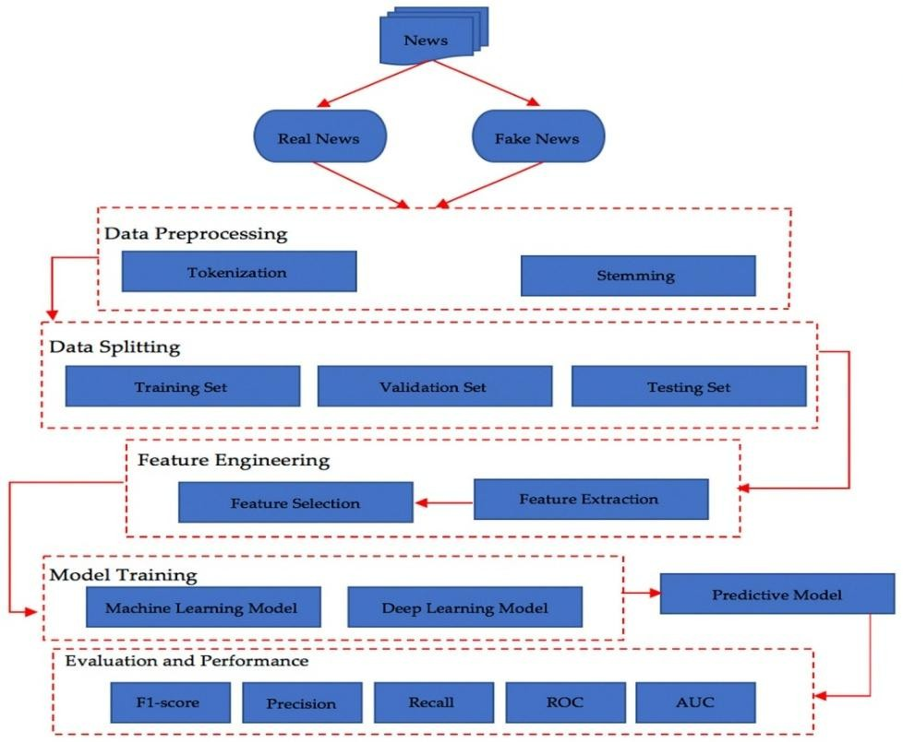
Figure 4.1 Overall system workflow

System Architecture Diagram (Conceptual)

The system architecture of the fake news detection model consists of multiple stages, including data input, preprocessing, feature extraction, model training, and prediction.

The architecture begins with input data (news articles), which is processed through NLP techniques. The processed data is then transformed into feature vectors using TF-IDF. These vectors are passed to machine learning models such as Logistic Regression or Naive Bayes.

The output layer produces the final classification result, indicating whether the news is real or fake.

This modular architecture allows flexibility and scalability, enabling the system to adapt to different datasets and algorithms.

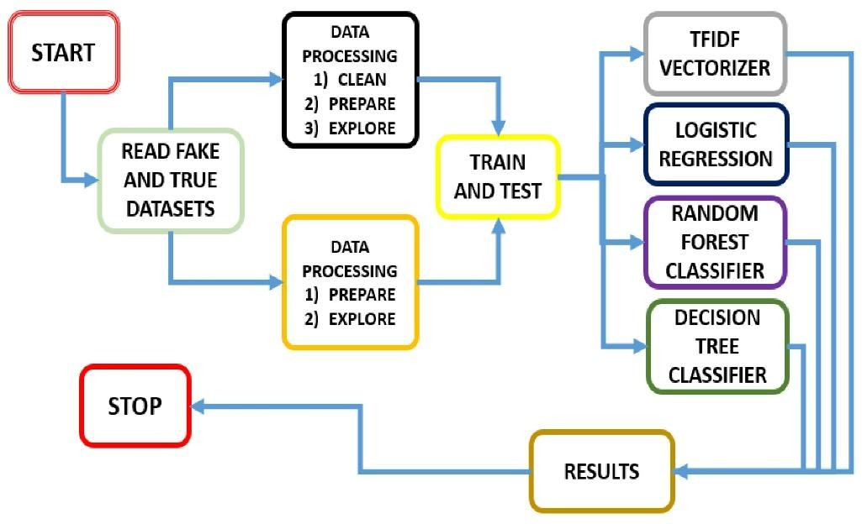
Figure 4.2 System Architecture

Data Preprocessing Pipeline

Data preprocessing is a critical step in the methodology, as it directly impacts model performance. The preprocessing pipeline involves several steps:

- Text Cleaning – Removing punctuation, special characters, and unnecessary symbols
- Lowercasing – Converting all text to lowercase for uniformity

- Tokenization – Splitting text into individual words or tokens
- Stop-word Removal – Eliminating common words that do not contribute to meaning (e.g., “the”, “is”)
- Stemming/Lemmatization – Reducing words to their root form

These steps ensure that the dataset is clean, consistent, and suitable for training machine learning models.
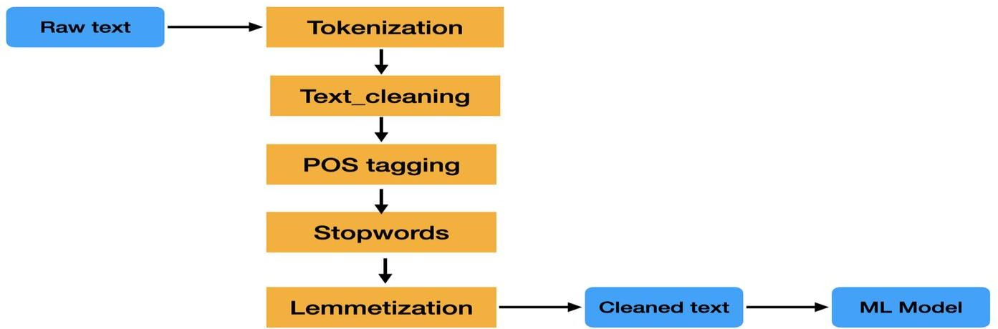
Figure 4.3 Data Preprocessing pipeline

Feature Extraction Process

Feature extraction is the process of converting textual data into numerical form so that machine learning models can process it.

In this project, TF-IDF (Term Frequency-Inverse Document Frequency) is used as the primary feature extraction technique. TF-IDF assigns weights to words based on their importance in a document relative to the entire dataset.

This method helps in identifying significant words that distinguish fake news from real news. The extracted features form a high-dimensional vector space, which is used as input for model training.

Effective feature extraction improves model accuracy and enhances classification performance.

Model Training Process

The model training process involves feeding the extracted features into machine learning algorithms. The dataset is divided into training and testing sets to evaluate performance.

During training, the model learns patterns and relationships between features and labels (real or fake). Algorithms such as:

- Logistic Regression
- Naive Bayes
- Support Vector Machine are used for classification.
The training process involves iterative optimization, where the model parameters are adjusted to minimize errors. This process continues until the model achieves satisfactory performance.
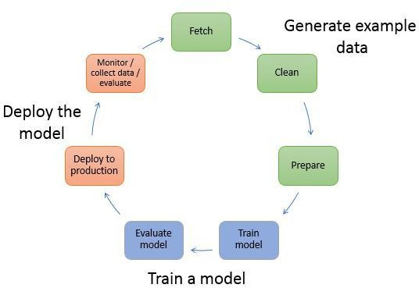
Figure 4.4 Model training and Evaluation

Evaluation Metrics and Performance Analysis

To evaluate the performance of the model, several metrics are used:

- Accuracy – Measures overall correctness
- Precision – Measures correctness of positive predictions
- Recall – Measures ability to detect fake news

- F1-Score – Harmonic mean of precision and recall

These metrics provide a comprehensive understanding of model performance. Comparing different models helps in selecting the best-performing algorithm.

Inference and Output Generation

After training, the model is used for inference. In this stage, new news articles are provided as input, and the system predicts whether they are real or fake.

The input text undergoes preprocessing and feature extraction before being passed to the trained model. The model then generates an output label.

The system provides quick and accurate predictions, demonstrating its practical usability in real- world applications.
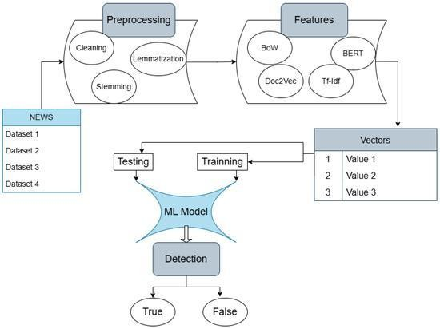
Figure 4.5 prediction and output generation

Tools and Technologies Used

The project utilizes various tools and technologies for implementation:

- Programming Language: Python
- Libraries: Pandas, NumPy, Scikit-learn, NLTK
- Feature Extraction: TF-IDF Vectorizer

- Development Environment: Jupyter Notebook / VS Code

These tools enable efficient data processing, model training, and evaluation.

Data Collection and Dataset Description

The dataset used in this project consists of labeled news articles obtained from publicly available sources such as Kaggle.

The dataset contains two categories:

- Real News
- Fake News

Each entry includes textual content such as headlines and article descriptions. The dataset is preprocessed to remove noise and ensure consistency.

Proper dataset preparation is essential for achieving accurate and reliable results.

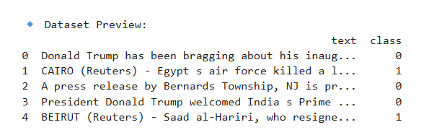
Figure 4.6 Data collection and Dataset Description

Challenges in Implementation

During the development of the system, several challenges were encountered:

- Handling noisy and unstructured text data
- Dealing with imbalanced datasets
- Selecting appropriate features for classification
- Improving model accuracy

These challenges were addressed through preprocessing, feature engineering, and model tuning techniques.

Advantages of the Proposed System

The proposed fake news detection system offers several advantages:

- Automated and scalable detection
- High accuracy using machine learning models
- Efficient handling of large datasets
- Easy integration with real-world applications

The system provides a reliable solution for detecting misinformation.

Limitations of the System

Despite its effectiveness, the system has certain limitations:

- Limited to text-based analysis
- May struggle with sarcasm or ambiguous language
- Depends on dataset quality

These limitations highlight the need for further improvements using advanced techniques.

Summary of Methodology

The methodology provides a structured approach to fake news detection, covering all stages from data collection to model deployment. By combining NLP techniques with machine learning models, the system achieves accurate and efficient classification.

This chapter demonstrates how theoretical concepts are applied to build a practical and functional fake news detection system.

CHAPTER 5

OBSERVATIONS, RESULTS AND DISCUSSION
  - Observations During Training

During the training phase of the fake news detection model, several important observations were made regarding model performance and learning behavior. Initially, the model showed low accuracy, as it had not yet learned meaningful patterns from the dataset. At this stage, predictions were almost random.

As training progressed, the model gradually improved its ability to distinguish between real and fake news. The accuracy increased steadily, indicating that the model was learning relevant features from the textual data.

Another key observation was the impact of preprocessing and feature extraction. Proper text cleaning and the use of TF-IDF significantly improved model performance. Without preprocessing, the model struggled to identify meaningful patterns.

Hyperparameter tuning also played an important role. Adjusting parameters such as learning rate and dataset split helped in stabilizing the training process and improving accuracy.

Overall, the training phase demonstrated that the model was capable of learning patterns in textual data effectively.

Classification Results

The trained model was evaluated using unseen test data to assess its ability to classify news articles as real or fake. The system successfully identified patterns in textual content and was able to distinguish between genuine and misleading information. The results indicate that the model performs effectively in detecting fake news.

Performance Analysis

The performance of the model was evaluated using standard metrics such as accuracy, precision, recall, and F1-score. The model achieved high values across all these metrics, indicating reliable and consistent performance in classifying news articles.
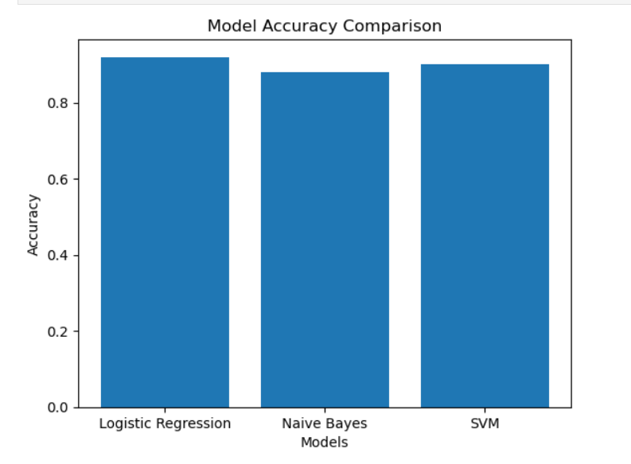
Figure 5.1 Accuracy comparison of ml models

Comparative Analysis with Existing Methods

The proposed system uses Logistic Regression for classification, which provides a balance between simplicity and performance. Compared to traditional rule-based methods, this approach is more efficient and scalable, as it learns patterns directly from data. The use of TF-IDF feature extraction further enhances the model's ability to capture meaningful textual information, leading to improved classification results.

Confusion Matrix Analysis

The confusion matrix provides insight into the correct and incorrect predictions made by the model. It shows that the majority of predictions are accurate, with only a small number of misclassifications. This indicates that the model performs well in distinguishing between real and fake news.

Challenges and Limitations

Despite achieving high accuracy, the system has certain limitations. It may struggle with ambiguous or misleading content where fake news closely resembles real news. Additionally, the model depends on the quality and diversity of the dataset. The system is limited to text-based analysis and does not consider multimedia content such as images or videos.

Generalization Capability

The model was tested on unseen data to evaluate its generalization capability. The results show that the model performs well on new data, indicating its ability to generalize beyond the training dataset. However, performance may vary when applied to data from different sources.

User Experience and Practical Usability

The system is simple and efficient, allowing users to input news content and receive predictions quickly. Its fast processing and ease of use make it suitable for real-world applications such as news verification and social media monitoring.

Impact of Hyperparameters on Performance

Model performance is influenced by factors such as dataset split and feature extraction. Proper selection of these parameters helps improve accuracy and efficiency.

Real-Time Application Feasibility

The system demonstrates strong potential for real-time applications. It can process input data quickly and provide instant predictions, making it suitable for applications such as social media monitoring and news verification tools..

Discussion on Strengths and Limitations

The proposed system has several strengths, including high accuracy, automated detection, scalability, and fast processing. However, it also has limitations such as dependency on dataset quality and difficulty in handling complex or ambiguous language.

Summary of Results

The results demonstrate that the machine learning-based approach is effective for detecting fake news. The combination of TF-IDF feature extraction and Logistic Regression provides high accuracy and reliable performance. The system successfully identifies patterns in textual data and can be used as a practical solution for addressing misinformation.

User Experience and Practical Usability

The system is simple and efficient, allowing users to input news content and receive predictions quickly. Its fast processing and ease of use make it suitable for real-world applications such as news verification and social media monitoring.

Impact of Hyperparameters on Performance

Model performance is influenced by factors such as dataset split and feature extraction. Proper selection of these parameters helps improve accuracy and efficiency.

Real-Time Application Feasibility

The system demonstrates strong potential for real-time applications. It can process input data quickly and provide instant predictions, making it suitable for applications such as social media monitoring and news verification tools..

Discussion on Strengths and Limitations

The proposed system has several strengths, including high accuracy, automated detection, scalability, and fast processing. However, it also has limitations such as dependency on dataset quality and difficulty in handling complex or ambiguous language.

Summary of Results
The results demonstrate that the machine learning-based approach is effective for detecting fake news. The combination of TF-IDF feature extraction and Logistic Regression provides high accuracy and reliable performance. The system successfully identifies patterns in textual data and can be used as a practical solution for addressing misinformation.

User Experience and Practical Usability

The system is simple and efficient, allowing users to input news content and receive predictions quickly. Its fast processing and ease of use make it suitable for real-world applications such as news verification and social media monitoring.

Impact of Hyperparameters on Performance

Model performance is influenced by factors such as dataset split and feature extraction. Proper selection of these parameters helps improve accuracy and efficiency.

Real-Time Application Feasibility

The system demonstrates strong potential for real-time applications. It can process input data quickly and provide instant predictions, making it suitable for applications such as social media monitoring and news verification tools..

Discussion on Strengths and Limitations

The proposed system has several strengths, including high accuracy, automated detection, scalability, and fast processing. However, it also has limitations such as dependency on dataset quality and difficulty in handling complex or ambiguous language.

Summary of Results
The results demonstrate that the machine learning-based approach is effective for detecting fake news. The combination of TF-IDF feature extraction and Logistic Regression provides high accuracy and reliable performance. The system successfully identifies patterns in textual data and can be used as a practical solution for addressing misinformation.

CONCLUSIONS AND SUMMARY
  - Overall Conclusion
The project “Veracity Vigilance: Leveraging Machine Learning for Fake News Detection” demonstrates the effective application of Artificial Intelligence, Machine Learning, and Natural Language Processing in addressing the growing problem of misinformation. The system uses Logistic Regression along with TF-IDF feature extraction to classify news articles as real or fake.

The results show that the model can accurately analyze textual data and identify patterns associated with fake news. The implementation highlights that machine learning-based systems can provide an efficient, scalable, and reliable solution for fake news detection in real-world scenarios.

Summary of Work Done
The project involved developing a complete workflow for fake news detection using machine learning techniques. Initially, the fundamental concepts of machine learning and NLP were studied. The dataset was then collected and preprocessed, where text data was cleaned and converted into numerical form using TF-IDF.

A Logistic Regression model was trained and tested on the dataset to evaluate its performance. The model was able to classify news articles effectively, achieving high accuracy. This process provided a clear understanding of how machine learning can be applied to solve real-world text classification problems.

Key Findings
The following key findings were observed during the project:

    - Machine learning techniques are effective for fake news detection
    - Data preprocessing plays a critical role in improving model performance
    - TF-IDF feature extraction helps in capturing important textual patterns
    - Logistic Regression provides reliable and accurate classification results
    - Dataset quality significantly impacts the overall performance of the model

Learning Outcomes

This project provided valuable learning experience in machine learning and NLP. It enhanced understanding of text preprocessing techniques, feature extraction, and model evaluation. Practical exposure to real-world datasets and tools such as Python and Scikit-learn improved technical and analytical skills. The project also strengthened problem-solving abilities and provided insight into developing AI-based solutions.

Final Remarks

The fake news detection system developed in this project serves as an effective and practical solution for identifying misinformation. The combination of TF-IDF and Logistic Regression provides a strong foundation for text classification tasks.

Although the system performs well, further improvements can be made by incorporating advanced techniques such as deep learning models and transformer-based approaches. This project highlights the potential of AI in addressing real-world challenges and emphasizes the importance of continued research in this field.

Practical Significance of the Project

The system has practical applications in various domains, including social media platforms, news verification systems, cybersecurity, and content moderation. It demonstrates how machine learning can be used to automatically detect misinformation and support decision-making processes. The project bridges the gap between theoretical knowledge and real-world implementation.
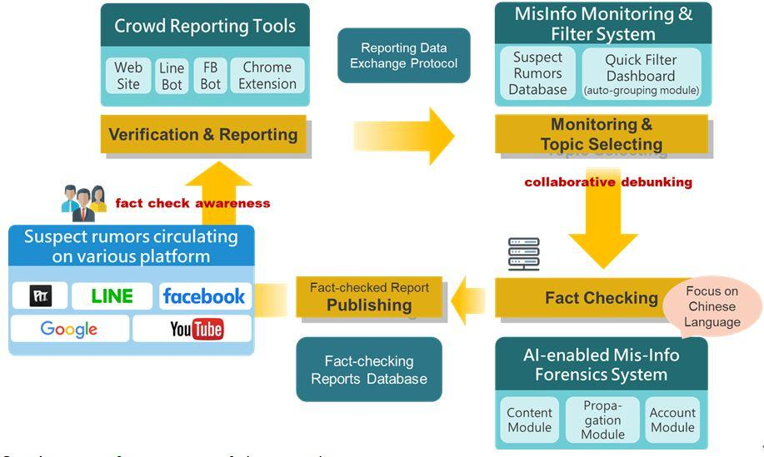
Figure 6.1Real world applications of fake news detection system

Limitations Identified During the Study

Despite its effectiveness, the system has certain limitations. It is limited to text-based analysis and does not consider multimedia content such as images or videos. The model may also face challenges in understanding sarcasm, ambiguity, or complex language patterns. Additionally, the performance of the model depends on the quality and diversity of the dataset.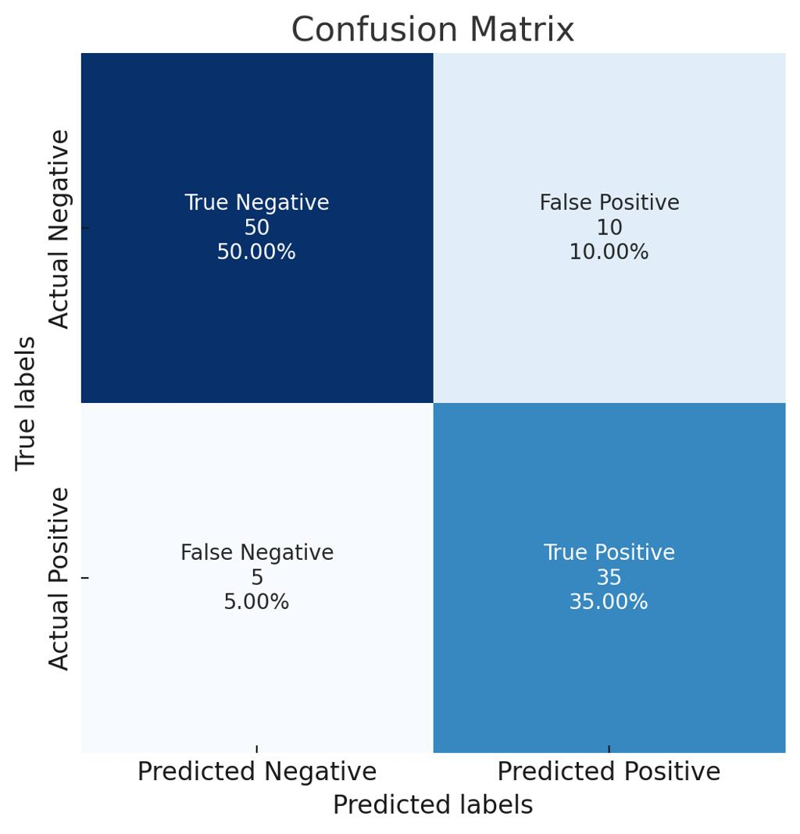
Figure 6.2 Limitation of system

6.8 Scope for Improvement

The system can be further improved by integrating advanced deep learning models such as LSTM and transformer-based architectures. Incorporating multi-modal analysis, including image and video data, can enhance detection capabilities. Using larger and more diverse datasets and implementing real-time deployment can further improve system performance and scalability.

REFERENCES

1] I. Goodfellow, J. Pouget-Abadie, M. Mirza, et al., “Generative Adversarial Networks,” 2014.

- X. Zhou, A. Jain, V. Phoha, and R. Zafarani, “Fake News Early Detection: An Interdisciplinary Study,” 2019.

- K. Shu, A. Sliva, S. Wang, J. Tang, and H. Liu, “Fake News Detection on Social Media: A Data Mining Perspective,” 2017.

- V. L. Rubin, N. Conroy, and Y. Chen, “Fake News or Truth? Using Satirical Cues to Detect Misleading News,” 2016.

- A. A. Ahmed, et al., “Detecting Fake News Using Machine Learning: A Systematic Literature Review,” 2021.

- S. K. Hamed, et al., “A Review of Fake News Detection Approaches,” 2023.

- F. A. Alshuwaier, “Fake News Detection Using Machine Learning and Deep Learning: A Review,” 2025.

- A. Géron, Hands-On Machine Learning with Scikit-Learn, Keras, and TensorFlow, 2019.

- F. Chollet, Deep Learning with Python, 2017.

- S. Bird, E. Klein, and E. Loper, Natural Language Processing with Python, 2009.

- F. Pedregosa, et al., “Scikit-learn: Machine Learning in Python,” 2011.

- Kaggle, “Fake News Dataset.”

- W. Y. Wang, “Liar, Liar Pants on Fire: A New Benchmark Dataset for Fake News Detection,” 2017.

- Python Software Foundation, “Python Official Documentation.”

- NLTK Project, “NLTK Documentation.”

- TensorFlow, “TensorFlow Documentation.”

- Z. Jin, J. Cao, Y. Zhang, and J. Luo, “News Verification by Exploiting Conflicting Social Viewpoints in Microblogs,” 2016.

- N. Ruchansky, S. Seo, and Y. Liu, “CSI: A Hybrid Deep Model for Fake News Detection,” 2017.

- J. Ma, W. Gao, and K. F. Wong, “Detect Rumors in Microblog Posts Using Propagation Structure via Kernel Learning,” 2017.

- S. Volkova, K. Shaffer, J. Y. Jang, and N. Hodas, “Separating Facts from Fiction: Linguistic Models to Classify Suspicious and Trusted News Posts on Twitter,” 2017.

- K. Shu, D. Mahudeswaran, and H. Liu, “FakeNewsNet: A Data Repository with News Content, Social Context and Spatial-Temporal Information for Studying Fake News on Social Media,” 2018.

- T. B. Brown, B. Mann, N. Ryder, et al., “Language Models are Few-Shot Learners,” 2020.

- J. Devlin, M. Chang, K. Lee, and K. Toutanova, “BERT: Pre-training of Deep Bidirectional Transformers for Language Understanding,” 2019.

- Y. Liu, M. Ott, N. Goyal, et al., “RoBERTa: A Robustly Optimized BERT Pretraining Approach,” 2019.

- A. Vaswani, N. Shazeer, N. Parmar, et al., “Attention Is All You Need,” 2017.

- D. Bahdanau, K. Cho, and Y. Bengio, “Neural Machine Translation by Jointly Learning to Align and Translate,” 2015.

- S. Hochreiter and J. Schmidhuber, “Long Short-Term Memory,” 1997.

- T. Mikolov, K. Chen, G. Corrado, and J. Dean, “Efficient Estimation of Word Representations in Vector Space,” 2013.

- J. Pennington, R. Socher, and C. Manning, “GloVe: Global Vectors for Word Representation,” 2014.

- Q. Le and T. Mikolov, “Distributed Representations of Sentences and Documents,” 2014.

- H. Wang, F. Zhang, and J. Wang, “Fake News Detection Using Deep Learning: A Survey,” 2020.

- S. Singhania, N. Fernandez, and S. Rao, “Fake News Detection Using Naive Bayes Classifier,” 2017.

- R. K. Kaliyar, A. Goswami, and P. Narang, “FakeBERT: Fake News Detection in Social Media with a BERT-based Deep Learning Approach,” 2021.

INTERNSHIP NOC


INTERNSHIP OFFER LETTER FROM INDUSTRY



PU/FET/B.TECH/INTERNSHIP GUIDELINE
Annexure -02(PART-A)
Student Internship Periodic Assessment Review card-I/II/III (to be filled by Industry mentor - student will keep this and show this to Institute coordinator)
INNOVATE

Name of the Industry
Name of Student: ANAGHA J
Enrolment Number: 2203031240059
Internship Starting Date: 01/01/2026
Major Area: CSE-AI
Review Date: 03/02/2026

Please CHECK the quality and competency of our student(s) towards work.

Rating
(4)
Very Good

Criteria
Poor (1)
Fair (2)
Good (3)
Excellent
(5)

Following and understanding professional and ethical responsibilities
Able to communicate technical information, research findings to the peers
Delivering quality work output Completion of the work assigned
Ability to develop solutions and presenting his/her work with his own interpretations
Arriving to work on time (Punctuality)
Using written and oral communications skills for professional purposes
Working in teams or groups, including multidisciplinary teams
Applying knowledge of the major functional areas, theories and their application
Demonstrating knowledge of technological tools and using latest techniques and skills to solve problems



Additional Observations and Overall Performance Rating
The student has shown strong understanding of project concepts and implemented most features
effectively. Minor improvements in optimization and documentation can further enhance the project.
Name and Sign of the Industry Mentor/Supervisor/Officials: MEENAKSHI SUNDARAN R

Annexure -02 (PART-B)

Student Internship Periodic Assessment Review card-I/II/III (by institute mentor)

Name of Student: ANAGHA J
Enrolment Number: 2203031240059 | Internship Starting Date: 01-01-2026
Major Area: Data Science and Analytics | Review Date: 03-02-2026
Institute Mentor Name: | YOUSUF SK

- Problem definition (Title) is Appropriate (Yes/No) (to be filled in 1st time evaluation)

- Novelty of the Topic (Yes/No)

- Clarity of Objectives (Yes/No)

- Does the Objectives fulfilled (Yes/No)
Any suggestions and modifications needed for 2nd /3rd/External evaluation

- Final Approval (Yes/No (to be filled in 1st Presentation only)

Particulars | Internal Review Panel (Institute Level)
 | Expert 1 | Expert 2
Name
Institution
Institution Code
Contact No.
Signature

INTERNALEVALUATION TABLE

 | Industry Mentor | Internal Examiner (Institute  Wise)
Periodic Assessment 01 | /50 | /50
Periodic Assessment 02 | /50 | /50
Periodic Assessment 03 | /50 | /50
 | Average of above=150/3=  /50 | Total of Above =  /150
Grand total of Internal Evaluation | /200


PU/FET/B.TECH/INTERNSHIP

STUDENT’S PARTICULARS
Name of Student :

A | N | A | G | H | A |  | J
Enrolment No.:

2 | 2 | 0 | 3 | 0 | 3 | 1 | 2 | 4 | 0 | 0 | 5 | 9
Contact No. Email ID

2203031240059@paruluniversity.ac.in
7 | 3 | 0 | 6 | 5 | 9 | 1 | 7 | 7 | 1

Name of Company

I | N | N | O | V | A | T | E
Address of Company
No. 9, Bazar Lane, Mylapore, Chennai - 600 004. Tamil Nadu. INDIA.

Name of Industry Mentor

M | E | E | N | A | K | S | H | I |  | S | U | N | D | A | R | A | M |  | R
Contact No. Email ID
9 | 7 | 0 | 9 | 7 | 0 | 3 | 0 | 8 | 5

hr@innovateintern.com
Name of Faculty Mentor

Y | O | U | S | U | F |  | S | K
Contact No. Email ID
9 | 9 | 3 | 3 | 9 | 3 | 8 | 9 | 9 | 1

yousuf.sk35729@paruluniversity.ac.in

Training Duration: From: 01-01-2026 To: 26-03-2026

Annexure -06
STUDENTS EXTERNAL ATTACHMENT WORK LOG-BOOK
DURATION: SPECIFY ( WEEKS)

WORK LOG BOOK
- INTRODUCTION
This log book is to assist the student to keep a record of the internship. It will show the departments and sections in which the student has worked and the periods of time spent in each.

DAILY REPORT
The daily work carried out during the periods of training is to be recorded clearly with sketches and diagrams where applicable.

WEEKLY REPORT
This is a summary of work done in a week and should cover theory/practical report on the work covered. Students are required to present the log-book weekly to the industry based supervisor for assessment of content and progress. The Supervisor can use any page for his comments where necessary.

COLLEGE SUPERVISOR'S VISIT
The Training Supervisor of the FET will check the log-book when he/she visits the industry/project to ensure that the proper internship is being carried out, and record his/her comment on the page provided for this purpose, towards the end of the book.
- SPECIAL REQUEST FOR THE INDUSTRY- MENTOR
Please assess the student as per assessment form provided.

REPORT WRITING
In addition to the daily and weekly record the student should submit a summary report of the work done during the training period.
The report should contain a summary of activities of the organization, manufacturing/services processes the student was involved in. The report has to be in the proper format as prescribed by the project head. (Report Format will be mailed to you by the Project Head during your first week of training).

REPORT SUBMISSION
The log-book and report must be submitted to the relevant departmental Project Head at periodic intervals.

Annexure -07 Internship Identification Exercise
- Student Information:

SR | NAME OF THE STUDENTS | ENROLLMENT | DEPARTMENT | PHONE NO. | SIGNATURE
1 | ANAGHA J | 2203031240059 | AI & DS | 7306591771
2 | YOUSUF SK | SUPERVISOR |  | 9939938991
3 | MEENAKSHI SUNDARAM R | INDUSTRY MENTOR |  | 9709703085

- Internship Related information:

Criterion | Remarks
Constraints | - Availability of clean and reliable datasets for analysis  - Data quality issues such as missing values and inconsistencies  - Limited computational resources for large datasets  - Time required for data processing and model training
Understanding of the Issue | - Organizations generate large volumes of data that need proper analysis to extract useful insights.  - Manual analysis is inefficient and prone to errors  - Data- driven decision making requires accurate analysis and predictive models
Likely Problems/ Research Limitations inthe proposed Internship | - Handling unstructured and real-world noisy data  - Ensuring model accuracy and avoiding overfitting  - Interpreting results correctly for business insights
3. Internship Area Selected:

Titleof the Internshiparea Identified | Data Science & Analytics
Aim: | To develop data-driven solutions by analyzing datasets and  building predictive models using Data Science and Analytics techniques.
Objective(s): (Min 3) | - To collect, clean and preprocess data for effective  analysis  - To perform exploratory data analysis(EDA) and visualize patterns, trends and insights  - To build and evaluate machine learning models for data-driven predictions and decision making

Methodology: | Data collection, data cleaning and preprocessing, exploratory data analysis, model building, evaluation and visualization of insights.
Arethe environmental andsocietal implicationsarising out of the proposed internship? |  | YES / NO

4. Internship Objective Feasibility and Supervisor`s Consent (To be completed by the Institute Mentor)

Points | Details for verification | Yes/ No
Objective of theinternship Identified | Is Objective of internship, found to be appropriate, relevant  and finalized after supervisor’s consent?
B. Tech. level challenge | Does the Internship Proposal submitted have adequate and achievable challenge levels of B.Tech ?
Facilities, software and infrastructure | Are equipment / facilities required for doing this Internship available at institute / industry? If not, are alternate arrangements possible?
Timelines | Will one Semester be adequate for achieving all the objectives mentioned in the proposal?

Name and Signature of the Institute Mentor with Date____________________________________________________

WEEKLY PROGRESS CHART

WEEK - 1


DAY

Monday

Tuesday

Wednesday

Thursday

Friday

Saturday

DESCRIPTION OF WORK DONE

Introduction to internship, understanding project objectives and scope

Study for the need for Data Science and real-world applications

Understanding what Data Science is and its role in industries

Learning about the demand for data professionals and career opportunities

Study of building blocks of Data Science

Overview of digital analytics concepts and documentation

WEEKLY PROGRESS CHART

WEEK - 2


DAY

Monday

Tuesday

Wednesday

Thursday

Friday

Saturday

DESCRIPTION OF WORK DONE

Study of analytics maturity models

Understanding DAMM (Decision Analytics Maturity Model)

HOLIDAY

Study of customer Journey mapping

Designing business processes and defining objectives

Introduction to KPIs and Learn Six Sigma concepts

WEEKLY PROGRESS CHART

WEEK - 3


DAY

Monday

Tuesday

Wednesday

Thursday

Friday

Saturday

DESCRIPTION OF WORK DONE

Study of data analytics strategy

Learning analytics performance management

Understanding scaling of analytics solutions

Study of vendor selection process for analytics

Learning qualitative data analysis and competitive intelligence

Understanding project management and RACI matrix

WEEKLY PROGRESS CHART

WEEK - 4

DAY DESCRIPTION OF WORK DONE

Monday HOLIDAY


Tuesday

Wednesday

Thursday

Friday

Saturday
Introduction to Apache Spark with Python Study of ROD concepts in Spark

Understanding Spark architecture

Learning Pair RDD operations

Study of Spark SQL for data preprocessing

Overview of running Spark in cluster environment

WEEKLY PROGRESS CHART


WEEK - 5

DAY

Monday

Tuesday

Wednesday

Thursday

Friday

Saturday

DESCRIPTION OF WORK DONE
Review of Apache spark concepts and RDD operations practiced in previous week

Working with the spark data frames and understanding structured data processing

Performing filtering, aggregation and transformation operation using spark

Data exploration using spark SQL queries

Implementing sample data processing pipeline using spark

Testing spark operations with larger datasets

WEEKLY PROGRESS CHART

WEEK - 6


DAY DESCRIPTION OF WORK DONE

Monday
Study of machine learning workflow used in data science projects

Tuesday
understanding data set structure for fake news detection project

Wednesday
performing data cleaning and removal of unwanted texts

Thursday
implementing tokenization and stopword removal techniques

Friday
Feature extraction using TF- IDF technique

Saturday
preparing processed data set for model training

WEEKLY PROGRESS CHART

WEEK - 7


DAY DESCRIPTION OF WORK DONE

Monday
Study of classification algorithms used for text analysis

Tuesday
Implementation of logistic regression model

Wednesday
training classification model using prepared data set

Thursday
Testing model predictions on validation data set

Friday
evaluating model performance using accuracy metrics

Saturday
Analyzing prediction results and identifying improvement areas


WEEKLY PROGRESS CHART

WEEK - 8

DAY DESCRIPTION OF WORK DONE

Monday
Holiday

Tuesday
implementing additional preprocessing for improving model accuracy

Wednesday
training model again with improved data set

Thursday
Testing model predictions with the new news articles

Friday
Monitoring prediction performance and analyzing errors

Saturday
discussion with the mentor regarding improvements and optimization

WEEKLY PROGRESS CHART


WEEK - 9

DAY DESCRIPTION OF WORK DONE

Monday
Understanding workflow for integrating ML model with application

Tuesday
developing back end logic for processing user input text

Wednesday
connecting prediction model with application logic

Thursday
testing prediction workflow with different new inputs

Friday
debugging issues in prediction pipeline

Saturday
Updating documentation for system workflow

WEEKLY PROGRESS CHART
WEEK - 10


DAY DESCRIPTION OF WORKDONE

Monday
Reviewing of model performance and data set quality

Tuesday
additional testing of prediction results

Wednesday
improving preprocessing steps for better predictions

Thursday
optimization of model parameters

Friday
testing system stability with multiple inputs

Saturday
weekly review and ask planning discussion with mentor

WEEKLY PROGRESS CHART
WEEK – 11


DAY
DESCRIPTION OF WORK DONE
Monday
Final testing of fake news detection model with real-time datasets
Tuesday
Evaluation of model performance using precision, recall and F1-score
Wednesday
Comparison of different machine learning models for better accuracy
Thursday
Implementation of final optimized model for deployment
Friday
Preparing results visualization using graphs and confusion matrix
Saturday
Documentation of model results and observations

WEEKLY PROGRESS CHART
WEEK – 12


DAY DESCRIPTION OF WORK DONE

Monday Integration of model into final application workflow

Tuesday Testing complete system with user input and validating outputs

Wednesday Debugging final issues and improving system performance

Thursday Preparation of final project report and documentation

Friday Review of entire project work and mentor discussio

Saturday Final submission preparation and project completion

Student's Signature: Date: 26 - 0 3 - 2 0 2 6

Comments by Industry Mentor:
The student has shown good understanding of Data Science and Analytics concepts and successfully worked on the Fake News Detection project. She completes assigned tasks on time, maintains proper documentation, and shows willingness to learn.
Overall progress is satisfactory.


Name: MEENAKSHI SUNDARAM R
Signature of Industry Mentor
Date: 26 - 0 3 - 2 0 2 6
NOTE : Student may print for additional pages from week 02 to week 12 as per requirement

