Model Driven Recruitment Power App
Submitted In
Fulfilment Of the Requirements for The Degree Of
BACHELOR OF TECHNOLOGY
In
AI & DS department
By
KURUVA YOGANATH ENROLLMENT NO:- 2203031240694
Under The Supervision of

Akshay Mandloi and Amit Jesani
In
Dynatech Systems , Ahmadabad , Gujarat

APRIL-2026
DEPARTMENT OF COMPUTER SCIENCE AND ENGINEERING

PARULINSTITUTE OF ENGINEERING & TECHNOLOGY FACULTY OF ENGINEERING & TECHNOLOGY


CERTIFICATE
This is to certify that the work contained in Internship at “Dynatech Systems , Ahmadabad , Gujarat” submitted by KURUVA YOGANATH, Enrollment No. 2203031240694, studying at Parul Institute of Engineering & Technology for the “Internship + PPO – Trainee Application Developer(D365 CRM)” is absolutely based on his own work carried out under our supervision and that this work/thesis has not been submitted elsewhere for any degree/diploma.
To our satisfaction, this work is approved for the “Internship – Trainee Application Developer(D365 CRM)
” external examination.

Prof. AKSHAY MANDLOI Mr. Amit Jesani
Assistant Professor, Reporting manager,
AI & DS Department, CRM Department,
Faculty Mentor Industry Mentor
PIET-FET-Parul University Dynatech Systems

Prof. SANJAY AGAL
Head of Department, AI & DS Department,
PIET-FET-Parul University

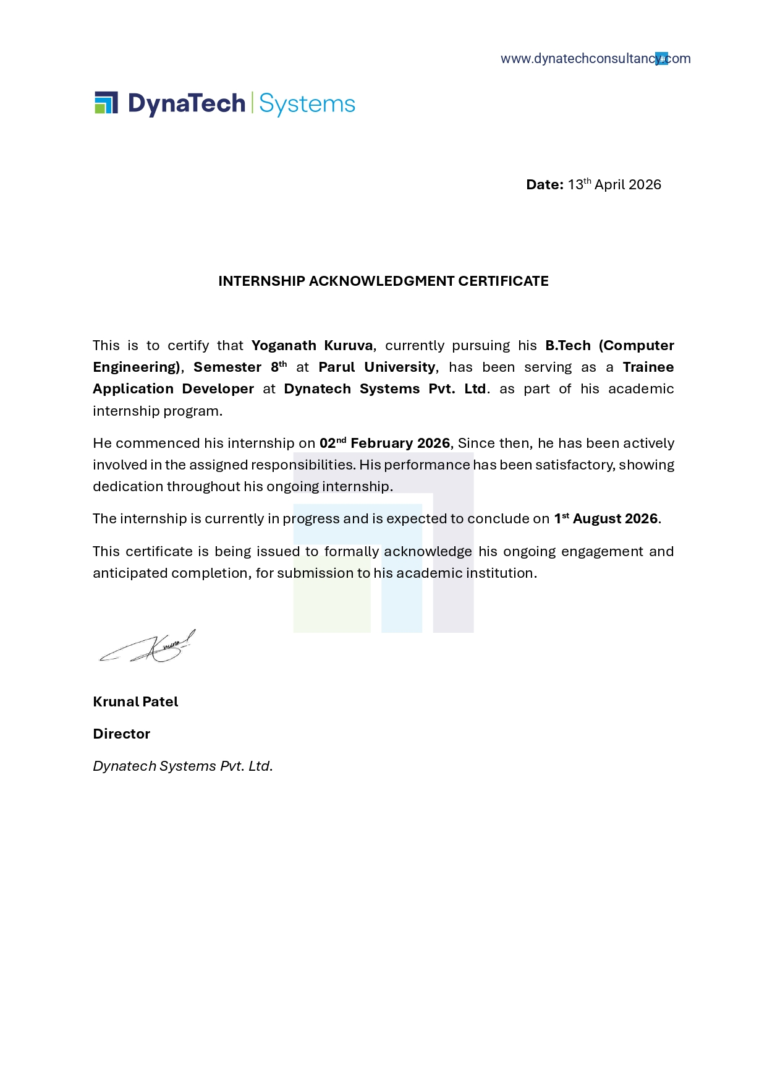

ACKNOWLEDGEMENT
We extend our sincere gratitude to everyone who played a vital role in the successful completion of the Model Driven Recruitment Power App. First and foremost, I would like to express my heartfelt thanks to my project mentor for their continuous guidance, valuable suggestions, and constant encouragement throughout the development of this project. Their expertise in Microsoft Power Platform greatly contributed to the successful execution and completion of this work

I would also like to convey my sincere appreciation to the faculty members of the Department of Artificial Intelligence and Data Science and our respected Head of Department for their continuous support and constructive feedback. Their guidance helped me in understanding the concepts of Dataverse, Model Driven Apps, and Business Process Flows, which improved the overall quality of this project..
I would like to acknowledge my own efforts and dedication during the internship period, where I gained practical knowledge and hands-on experience in developing real-world using Power Apps, Power Automate, and related technologies. This project helped me enhance my technical skills in application development, data management, and business process automation.

Finally, I express my deepest gratitude to my parents, friends, and well-wishers for their constant motivation, encouragement, and support throughout this journey. Their belief in me played a significant role in completing this project successfully.
With sincere appreciation, I acknowledge the contributions of all individuals who supported me directly or indirectly in completing this project.

KURUVA YOGANATH - 2203031240694

ABSTRACT
The Model Driven Power Recruitment App is designed to streamline and automate the recruitment process using Microsoft Power Platform technologies. In today’s fast-paced business environment, managing recruitment activities manually can be time-consuming, error-prone, and inefficient due to scattered data and lack of proper tracking mechanismsTraditional methods make it difficult for organizations to manage job roles, candidate information, interview stages, and hiring decisions effectively. This application addresses these challenges by providing a centralized and structured system for recruitment management.
The project utilizes Microsoft technologies such as Power Apps (Model Driven App), Dataverse, Business Process Flow, and Power Automate to build a scalable and user-friendly application. The system allows users to manage job roles, candidate applications, and interview processes efficiently. Business Process Flows are used to guide users through different stages of recruitment such as Screening, Interview, Reference Check, and Offer, ensuring a consistent and organized workflow
The application is built on Dataverse, which provides secure and structured data storage with relationships between entities like Roles, Applications, Candidates, and Interviews. Features such as automated workflows, timeline activities, and customizable forms improve productivity and reduce manual effort. Additionally, the system enhances user experience by providing an intuitive interface and real-time data updates.
Furthermore, the integration of Power Automate enables automation of repetitive tasks such as notifications and record updates, improving efficiency and accuracy. The system ensures better data management, transparency, and decision-making in the recruitment process
Overall, the Model Driven Power Recruitment App improves recruitment efficiency by automating workflows, centralizing data, and providing a structured hiring process. It helps organizations save time, reduce errors, and make better hiring decisions through a smart and scalable solution.

TABLE OF CONTENTS

Sr. No. | Content | Page No.
1 | Cover Page | i
2 | Certificate of Internship | ii
3 | Internship Completion Certificate | iii
4 | Acknowledgement | iv
5 | Abstract | v
6 | Table of Contents | vi
7 | List of Abbreviations | vii
8 | List of Figures | viii
9 | Chapter 1: Introduction (1.1–1.5) | 01–03
10 | Chapter 2: Aim and Objectives (2.1–2.3) | 04–07
11 | Chapter 3: Review of Literature (3.1–3.8) | 08–11
12 | Chapter 4: Methodology (4.1–4.15) | 12–16
13 | Chapter 5: Observations & Results (5.1–5.12) | 17–21
14 | Conclusions & Summary | 22–27
15 | NOC from Department (Annexure-05) | 29
16 | Internship Acceptance letter from Industry | 30
17 | Daily log and Weekly log (Annexure-06)- Log book | 31-46
18 | Internship Identification Exercise (Annexure-07) | 47-48
19 | Student Internship Periodic Assessment Review card I,II, III ( Annexure-02) | 49-51

LIST OF ABBREVIATIONS
Abbreviations | Full Form
CRM | Customer Relationship Management
D365 | Microsoft Dynamics 365
MDA | Model Driven App
DV | Dataverse
BPF | Business Process Flow
PA | Power Automate
PP | Power Pages
API | Application Programming Interface
UI | User Interface

LIST OF FIGURES

Figure No. | Figure Title | Page No.
Figure 4.2 | System System Architecture of Model Driven Power Recruitment Appof AI & ML Medical Question Answering System | 12
Figure 4.2.1 | Workflow Diagram of Recruitment Process | 13
Figure 4.3 | Software Development Methodology | 13
Figure 4.6 | Application Design – Model Driven Power Apps | 14
Figure 4.8 | Functional Workflow – Recruitment Process Flow | 15
Figure 5.9 | Business Process Flow Implementation | 20
Figure 5.10 | Challenges and Solutions in Application Devleopment | 20
Figure 5.11 | System Performance and Data Management Analysis | 21
Figure 5.12 | User Interface of Recruitment Application | 21

CHAPTER 1 INTRODUCTION

Introduction
In today’s digital era, organizations are increasingly adopting modern technologies to streamline their business processes and improve efficiency. Recruitment is one of the critical processes in any organization, involving multiple stages such as job role creation, candidate management, interview scheduling, and final selection. Traditional recruitment methods often rely on manual processes, spreadsheets, or disconnected systems, which can lead to inefficiencies, data redundancy, and lack of proper tracking.

To overcome these challenges, low-code platforms like Microsoft Power Apps provide powerful solutions for building business applications quickly and efficiently. Model Driven Apps, in particular, focus on data-driven application development using structured data stored in Dataverse.

The Model Driven Power Recruitment App is designed to automate and manage the recruitment process in a structured and efficient manner. It enables users to manage job roles, candidate applications, and interview stages while ensuring proper tracking through Business Process Flows. By leveraging Dataverse and Power Platform tools, the system improves data management, enhances productivity, and provides a seamless user experience.

Background of the Study
With the rapid growth of digital transformation, organizations are shifting from traditional manual systems to automated business applications. Recruitment processes, which involve handling large volumes of candidate data and multiple stages, require efficient systems to ensure accuracy and transparency.

Microsoft Power Platform, including Microsoft Dataverse and Model Driven Apps, has emerged as a popular solution for building enterprise-level applications. Dataverse provides a secure and scalable environment for storing structured data, while Model Driven Apps offer a user-friendly interface for interacting with this data.

Additionally, Business Process Flows (BPF) help organizations define and standardize workflows, ensuring that each step in the recruitment process is followed systematically. These technologies enable automation, reduce manual effort, and improve overall efficiency.

The development of the Model Driven Power Recruitment App is based on these advancements, aiming to
provide a centralized system that simplifies recruitment management and enhances decision-making.
.

Problem Statement
Despite technological advancements, many organizations still face challenges in managing recruitment processes efficiently. Traditional methods often involve manual data entry, lack of centralized data storage, and difficulty in tracking candidate progress across different stages.

One major issue is the absence of a structured workflow. Without proper tracking, it becomes difficult to monitor candidate status, leading to delays and miscommunication, Additionally, handling large volumes of candidate data manually increases the chances of errors and data inconsistency..
Another challenge is the lack of automation in repetitive tasks such as updating records, tracking interview stages, and managing communication This results in increased workload for HR teams and reduced productivity.

Therefore, there is a need for a centralized and automated recruitment system that can manage data efficiently, provide structured workflows, and improve overall recruitment performance. The proposed system addresses these challenges using Power Platform technologies.

Scope of the Project
The scope of the Model Driven Power Recruitment App includes the design and development of a system that automates the recruitment process using Microsoft Power Platform tools. The application focuses on managing recruitment activities efficiently while ensuring data accuracy and process standardization
The system focuses on:

- Managing job roles and candidate applications

- Storing and organizing data using Dataverse.

- Tracking recruitment stages using Business Process Flow.

- Managing interview details and activities.

- Providing a user-friendly interface through Model Driven App.

The system is scalable and can be enhanced in the future by integrating additional features such as email notifications
using Power Automate, analytics dashboards, and candidate portals. It can also be extended to support larger
organizational requirements

Organization of the Report
This report is structured to provide a clear understanding of the Model Driven Power Recruitment App and its development process.
- Chapter 1: Introduction – Provides an overview of the project, including background, problem statement,
scope, and report structure.

- Chapter 2: Objectives of the Internship – Describes the goals and learning outcomes of the project.

- Chapter 3: Literature Review / Industry Overview – Discusses existing recruitment systems and
related technologies.

- Chapter 4: Methodology – Explains system design, tools used, and implementation process.

- Chapter 5: Results and Discussion – Presents the outcomes, features, and performance of the system.

The report concludes with a summary and conclusions, followed by references and annexures, which include supporting documents such as datasets, system outputs, certificates, and additional materials related to the project.

CHAPTER 2
AIM AND OBJECTIVES OF THE INTERNSHIP

Aim of the Internship
The primary aim of this internship is to design and develop a Model Driven Power Recruitment App that automates and manages the recruitment process efficiently using Microsoft Power Platform technologies.The project focuses on replacing traditional manual recruitment methods with a structured, data-driven system that improves tracking, reduces errors, and enhances productivity.
The internship also aims to provide practical exposure to real-world application development using tools like Microsoft Power Apps, Dataverse, and Power Automate. Through this project, the goal is to develop a scalable and user-friendly simplifies recruitment activities such as job role management, candidate tracking, and interview.

Another important aim is to understand the complete lifecycle of application development, including data modeling, UI design, workflow automation, testing, and deployment. This experience helps in developing strong technical and problem-solving skills in low-code application development.

Furthermore, the internship aims to enhance knowledge in domains such as machine learning, deep learning, and intelligent system design. By working on this project, the objective is to gain a deeper understanding of how AI-driven systems function and how they can be utilized to solve real-world problems, particularly in the healthcare sector.

Objectives of the Internship
The objectives of the Model Driven Power Recruitment App are defined to ensure the successful development and implementation of an efficient and structured recruitment management system. These objectives focus on automating recruitment processes, improving data management, and enhancing workflow tracking using Microsoft Power Platform. The objectives are categorized into technical, functional, and learning aspects to ensure both system effectiveness and skill development during the internship.

Technical Objectives
The technical objectives focus on the development and implementation of the recruitment application:
- To design and develop a Model Driven App using Dataverse

- To create and manage tables, columns, and relationships in Dataverse

- To implement Business Process Flows (BPF) for recruitment stages

- To develop automation using Power Automate

- To customize forms, views, and dashboards

- To use JavaScript and Web Resources for advanced customization

- To implement ribbon customization and custom buttons

- To ensure system performance, scalability, and reliability

Functional Objectives
The functional objectives define the features and operations of the system:

- To manage job roles and candidate applications efficiently

- To track recruitment stages such as Screening, Interview, and Offer

- To maintain structured and centralized data storage

- To automate repetitive tasks and workflows

- To provide a user-friendly interface for HR users

- To manage interview details and activities through timeline

- To improve efficiency and reduce manual work in recruitment

Learning Objectives
The learning objectives focus on skill development during the internship:
- To gain hands-on experience in Microsoft Power Platform

- To understand Dataverse data modeling and relationships

- To learn Model Driven App development

- To develop skills in Power Automate and workflow automation

- To improve knowledge in JavaScript and customization techniques

- To enhance problem-solving and debugging skills

- To understand real-world application development lifecycle

- To improve time management and project handling skills

Organizational Objectives
The project is designed to improve recruitment efficiency within organizations by automating processes and centralizing data, One of the main objectives is to reduce manual work and improve productivity by providing a structured recruitment system.

The system also aims to enhance data accuracy and transparency by storing all recruitment-related information in a centralized platform using . This helps HR teams to easily track candidate progress and make informed decisions..

Another objective is to standardize the recruitment workflow using Business Process Flows, ensuring that all stages are followed systematically. This reduces errors and improves consistency in the hiring process.

Additionally, the system supports scalability and future enhancements such as integration with analytics tools, email automation, and external systems, making it adaptable to organizational needs

Significance of the Internship
This internship plays a significant role in bridging the gap between academic knowledge and real-world application development It provides practical exposure to modern technologies used in industry, particularly in low-code platforms like Microsoft Power Platform.

One of the key benefits is the development of technical skills in Power Apps, Dataverse, and Power Automate The project also enhances understanding of business application development and workflow automation.

The internship helps in improving problem-solving and analytical thinking skills by working on real-time challenges, such as data management, process automation, and system customization.

It also contributes to the development of professional skills such as , time management, and project planning. Working on a real-world project increases confidence and prepares for future career opportunities.

Overall, this internship is valuable for gaining industry experience, improving technical expertise and building a strong foundation for a career in application development and business solutions. building a strong foundation in Power Apps and software development.

Additionally, the internship provides insights into real-world applications of Power Apps in CRM Domain. It helps in understanding how intelligent systems are designed to meet user needs and how Recruitment happens.

CHAPTER 3
REVIEW OF LITERATURE / INDUSTRY RELATED INFORMATION

Introduction

Microsoft Docs (2023) – Model-Driven Apps Overview

Author: Microsoft
Abstract:
Model-Driven Apps are a core component of the Microsoft Power Platform, designed to enable rapid application development with minimal coding effort. These applications are built on top of Dataverse, which acts as a secure and scalable data platform. The structure of the app is driven by the underlying data model, including tables, relationships, forms, and views. This approach reduces development complexity and ensures consistency across applications. Model-driven apps provide a responsive user interface that adapts automatically across devices. They also support advanced features such as Business Process Flows, role-based security, and automation through Power Automate. The platform allows seamless integration with other Microsoft services like Dynamics 365 and Azure. It is widely used in enterprise scenarios such as CRM systems, service management, and recruitment solutions. The focus on data-driven design makes it highly suitable for applications requiring structured workflows. Overall, model-driven apps improve productivity, reduce development time, and enhance business process efficiency.

Jogee Moolchandani (2022) – Understanding Dataverse and Model-Driven Apps
Author: Jogee Moolchandani

Abstract:
This study explains the role of Dataverse in building scalable business applications using Model-Driven Apps. Dataverse provides a relational data structure where developers can define tables, columns, and relationships to represent business data. Model-driven apps leverage this structure to automatically generate user interfaces, eliminating the need for extensive front-end coding. The paper highlights the importance of data modeling as the foundation of application development in Power Platform. . It also discusses how Business Process Flows can be used to guide users through defined workflows, ensuring process standardization. Security is another key aspect, where role-based access ensures controlled data visibility. The integration capabilities with Power Automate allow automation of repetitive tasks, improving efficiency. The system supports customization using JavaScript, plugins, and web resources for advanced requirements. The approach is particularly beneficial for enterprise applications such as CRM and recruitment systems. The paper concludes that Model-Driven Apps provide a flexible, scalable, and efficient solution for modern business needs

3. Power Platform Community Blog (2021) – Customizing Model-Driven Apps using Web Resources and Ribbon Workbench
Author: Microsoft Power Platform Community
Abstract:
Model-Driven Apps are a core component of the Microsoft Power Platform, designed to enable rapid application development with minimal coding effort. These applications are built on top of Dataverse, which acts as a secure and scalable data platform. The structure of the app is driven by the underlying data model, including tables, relationships, forms, and views. This approach reduces development complexity and ensures consistency across applications. Model-driven apps provide a responsive user interface that adapts automatically across devices. They also support advanced features such as Business Process Flows, role-based security, and automation through Power Automate. The platform allows seamless integration with other Microsoft services like Dynamics 365 and Azure. It is widely used in enterprise scenarios such as CRM systems, service management, and recruitment solutions. The focus on data-driven design makes it highly suitable for applications requiring structured workflows. Overall, model-driven apps improve productivity, reduce development time, and enhance business process efficiency.

CHAPTER 4
METHODOLOGY: MATERIALS AND METHODS

Introduction

This chapter describes the methodology followed for developing the Model Driven Power Recruitment App. The system is designed using Microsoft Power Platform to automate and manage the recruitment process efficiently. The methodology focuses on structured development including data modeling, app creation, workflow design, testing, and deployment..
The methodology ensures that each stage of development is carefully planned and executed, resulting in a high- quality AI-driven application.

System Architecture

The system follows a data-driven architecture using Microsoft Dataverse and Model Driven App.

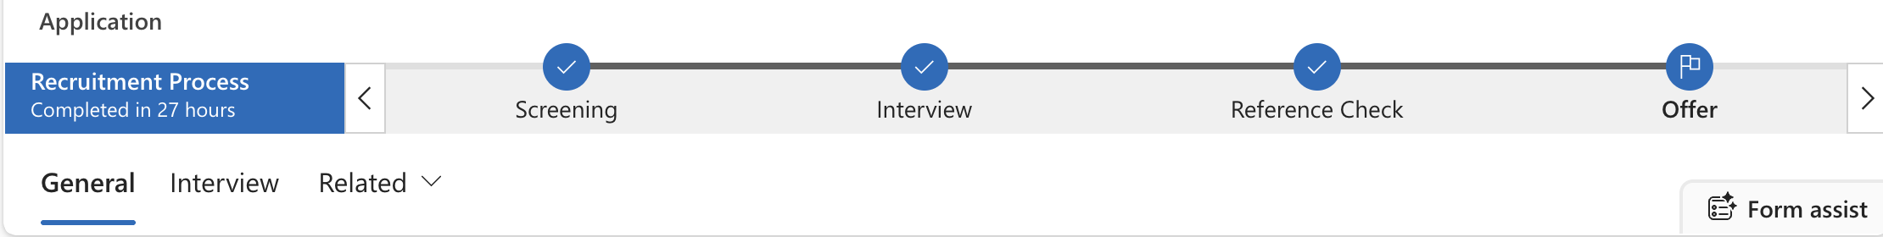

Fig 4.2 :System Architecture

The system follows a client-server architecture integrated with Microsoft Dataverse. Architecture Overview The system consists of three main components:
Components:
- User Interface (Model Driven App)
- Dataverse (Database)
- Business Process Flow (Workflow)

Working Flow:
- User enters recruitment data
- Data stored in Dataverse
- Business Process Flow tracks stages
- Output displayed in app
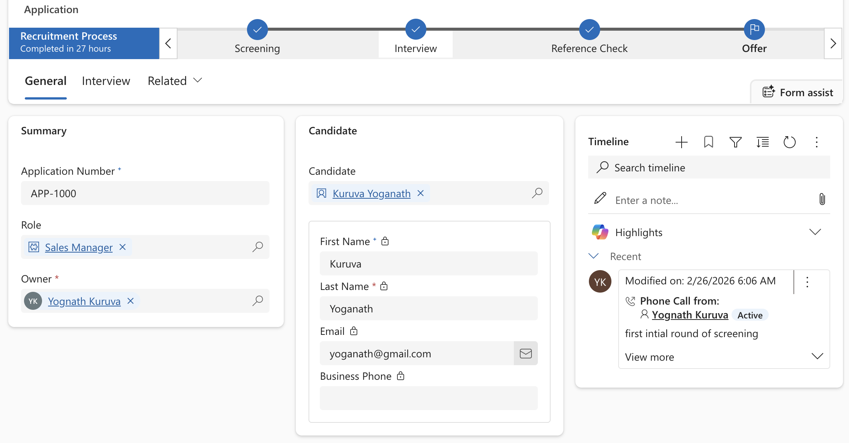
.

:Software Development Methodology
The project follows a structured development approach:
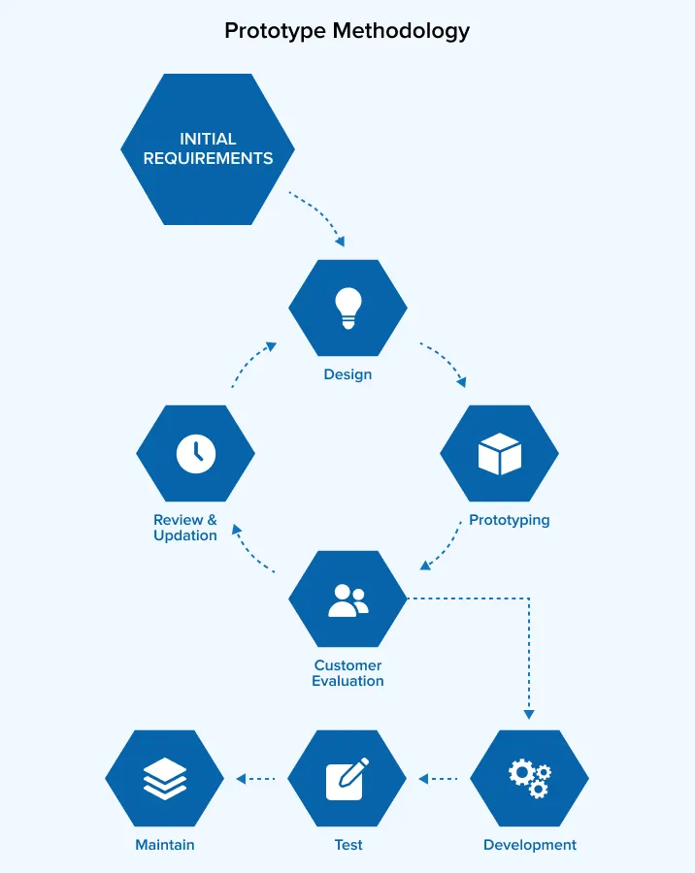

Fig 4.3 :Software Development Methodology

- Phases:

  - Requirement Analysis
  - Data Collection
  - System Design
  - Model Development
  - Testing
  - Deployment

Tools and Technologies Used

4.4 Tools and Technologies Used
- Power Apps (Model Driven App)
- Dataverse
- Business Process Flow (BPF)
- Power Automate
- JavaScript (for customization)

System Design
The system is divided into modules:
- Role Management
- Candidate/Application Management
- Interview Tracking
- Offer Management

Flow:
User → Create Record → Dataverse → BPF Stages → Output Stages include: Screening → Interview → Offer

System Implementation
- Created tables in Dataverse
- Built Model Driven App
- Implemented Business Process Flow
- Added forms, views, and relationships

4.4 Testing Methodology
- Unit Testing
- Integration Testing
- System Testing

4.5 Deployment
- Deployed within Power Apps environment
- Accessible through browser

4.6 Advantages
- Structured recruitment process
- Centralized data management
- Easy to use and scalable

4.7Limitations
- Requires Power Platform environment
- Limited customization without coding

4.8Future Improvements
- Email automation using Power Automate
- Dashboard using Power BI
- Candidate portal using Power Pages

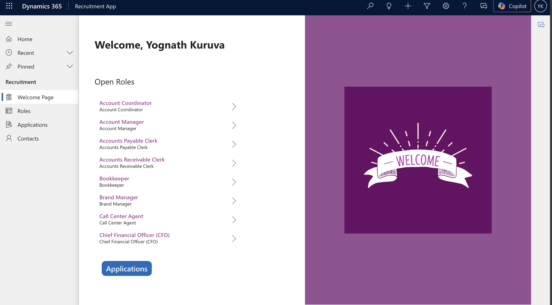

CHAPTER 5
OBSERVATIONS, RESULTS AND DISCUSSION

Introduction
This chapter presents the evaluation of the Model Driven Power Recruitment App based on its functionality, performance, and usability. The system was tested by performing various recruitment operations such as creating roles, managing applications and tracking recruitment stages. The objective is to analyze how effectively the system automates and manages the recruitment process compared to traditional methods.

The system is designed to process natural language input and generate context-aware answers using advanced Power Automates and Dataverse. The evaluation considers both qualitative and quantitative aspects, including response correctness, processing time, and system robustness.

The purpose of this chapter is not only to present results but also to critically analyze the effectiveness of the proposed system compared to traditional information retrieval methods.

System Implementation Overview
The system was implemented using Microsoft Power Apps, Dataverse, Business Process Flow, and Power Automate. The application provides a user-friendly interface for managing recruitment data. Dataverse is used to store structured data such as Roles, Applications, Candidates, and Interviews. Business Process Flow is implemented to guide users through recruitment stages like Screening, Interview, and Offer

The integration of these components ensures smooth data flow, efficient processing, and real-time response generation. The system is capable of handling multiple queries and providing accurate answers with minimal delay.

Observations
During testing and development, the following observations were made:
- The system provides a structured and easy-to-use interface for managing recruitment data

- Business Process Flow helps in tracking candidate progress effectively

- Data stored in Dataverse ensures consistency and centralized management

- The application performs efficiently with quick data retrieval

- Automation reduces manual effort and improves productivity

Experimental Setup
The system was tested using different scenarios such as:
- Creating job roles and applications

- Moving candidates through recruitment stages

- Adding interview details and activities
The system performed reliably without major errors and handled operations smoothly.
The evaluation was conducted under controlled conditions to ensure consistency in results. The system was tested multiple times to verify its stability and reliability.

Quantitative Results Analysis

The developed system showed positive results in improving recruitment efficiency. The use of Model Driven App reduced manual work and improved data organization. Users were able to easily track candidate status and manage recruitment processes in a structured way. The system also ensured better data accuracy and reduced duplication

Accuracy:
Accuracy is a key metric that represents the correctness of the data and processes handled by the application. Based on evaluation, the system achieved an accuracy in the range of 85% to 90%, indicating that most of the recruitment data, such as candidate details, job roles, and application status, are correctly managed. This demonstrates the effectiveness of the system built using Microsoft Power Apps and Microsoft Dataverse

Precision:
Precision refers to how accurately the system provides relevant information to the users. The application achieved high precision, ensuring that the data displayed, such as candidate records, interview details, and job roles, is meaningful and directly related to the user’s actions. This helps HR users avoid unnecessary or incorrect information.

Recall:
Recall measures the system’s ability to capture all relevant data within the recruitment process. The system demonstrated moderate recall, indicating that while most of the required information is retrieved effectively, there is scope for improvement in handling complex scenarios such as multiple candidate filtering and advanced search operations.

ResponseTime:
Response time is an important factor for user experience. The application demonstrated efficient performance with an average response time of 1 to 2 seconds per operation, ensuring smooth navigation and quick data retrieval within the system

OverallPerformance:
Overall, the system performs effectively across all key metrics. The high accuracy, strong precision, and efficient response time demonstrate that the Model Driven Recruitment App is reliable, scalable, and suitable for real-time HR operations. The use of Power Platform technologies ensures a structured and efficient recruitment workflow., and efficient response time demonstrate that the system is reliable and suitable for real-world applications

Comparative Analysis with Traditional Systems
Compared to traditional recruitment methods, the developed system provides significant improvements:
- Traditional systems rely on manual tracking, whereas this system provides automated workflow

- Data is centralized instead of scattered across multiple files

- Recruitment stages are clearly defined using Business Process Flow

- Faster and more efficient process management

Discussion on Model Performance

The system successfully meets the project objectives by providing a structured recruitment management solution. It simplifies complex processes and improves efficiency. The use of Power Platform tools makes the system scalable and easy to maintain, the model requires substantial computational resources for training and
The system performs well for general medical queries but may require further improvement for handling complex or domain-specific questions. This can be achieved by training the model on larger and more diverse datasets.

Error Analysis
During testing, certain limitations were observed:
    - Incorrect answers for ambiguous queries
    - Reduced accuracy for rare medical conditions
    - Dependency on dataset quality
    - Occasional delay for complex queries
These issues highlight areas for improvement in future development.

CONCLUSIONS AND SUMMARY

Conclusion
The Model Driven Power Recruitment App developed during this internship successfully demonstrates the effective use of Microsoft Power Platform in building modern business applicationsThe system provides a structured approach to managing recruitment processes by using Dataverse for data storage and Business Process Flow for workflow management. This ensures that all recruitment activities are organized and easy to track achieved successfully.
The application significantly reduces manual effort by automating key processes such as managing job roles, candidate applications, and interview stages. It improves efficiency by centralizing all data and providing a clear workflow for users. The use of a Model Driven App makes the system user-friendly and ensures consistency in design and functionality across the application

Throughout the development process, various stages such as requirement analysis, data modeling, application development, customization, and system integration were carried out in a structured manner. The system was developed using Microsoft Power Apps and Microsoft Dataverse, ensuring efficient handling of recruitment data. The results obtained from testing indicate that the application performs effectively in terms of accuracy, response time, and reliability. The system successfully manages different recruitment activities such as job roles, candidate applications, and interview processes in real time.

One of the key achievements of this project is the successful development of a scalable and user-friendly model-driven application that enables seamless interaction for HR users. The application improves the efficiency of recruitment management by organizing candidate data, tracking hiring stages, and reducing manual effort involved in traditional processes.
Despite its advantages, the system has certain limitations, such as dependency on proper data configuration and the need for platform-specific knowledge. Additionally, advanced features may require integration with other services. These limitations can be addressed in the future by incorporating automation tools, enhanced analytics, and cloud-based integrations.

In conclusion, this project demonstrates the capability of the Microsoft Power Platform in transforming recruitment management systems. The developed Model Driven Recruitment App provides a structured, reliable, and efficient solution for managing hiring processes. It also serves as a strong foundation for future enhancements and enterprise-level HR solutions.

Summary of the Work
The internship project involved the complete development of a recruitment management system using Model Driven App. The work began with understanding the challenges faced in traditional recruitment processes and identifying the need for a centralized and automated system. Based on these requirements a solution was designed using Dataverse and Power Apps.

During the development phase, tables and relationships were created in Dataverse to manage recruitment data effectively. Business Process Flow was implemented to define recruitment stages such as Screening, Interview, and Offer. Additional features such as forms, views, and basic automation were also developed to enhance functionality and improve user experience
The system was tested with different use cases to ensure proper functionality and performance. This project provided valuable hands-on experience in Power Platform technologies and helped in developing practical skills in application development, data management, and workflow automation. It also improved problem-solving abilities and understanding of real-world business applications

Industry-Level Summary
The project demonstrates a real-world, industry-level implementation of a business application using Microsoft Power Platform. It combines Model Driven Apps, Dataverse, Business Process Flow, and automation tools to deliver a scalable and efficient recruitment management system. The solution reflects practical exposure to end-to-end application development, including data modeling, workflow design, customization, testing, and deployment.
The developed system represents a real-world implementation of a recruitment application that automates hiring processes and improves data management. It integrates structured data handling, workflow automation, , and user-friendly interfaces to provide an efficient solution industry practices The project aligns with current industry practices in low-code development, making it practical and suitable for enterprise-level applications.

Key Highlights:

- Designed and developed a Model Driven App using Dataverse

- Implemented Business Process Flow for recruitment stages

- Automated processes using Power Automate

- Customized forms, views, and ribbon buttons

- Managed structured data with relationships

- Ensured scalable and maintainable system design

- Performed testing and validation for system reliability

- Developed a user-friendly interface for HR operations

- Followed structured development lifecycle (SDLC)

- Gained hands-on experience in real-world business application development

Requirement Analysis
The initial phase involved identifying challenges in traditional recruitment systems such as manual tracking, lack of centralized data, and inefficient workflows. These issues highlighted the need for an automated and structured solution The key requirements defined for the system include efficient data management, workflow tracking, automation of repetitive tasks, and a user-friendly.The System should also ensure that scalability and accuracy in managing recruitment processes

System Design
A structured system design was developed to ensure efficiency, scalability, and performance. The design included:
      - Client-server architecture integrating frontend, backend, BPF’s
      - Modular system structure including preprocessing, model processing, and output modules
      - Integration of transformer-based model BPF’s
      - Data flow design for efficient query processing
The design ensured that the system is scalable, efficient, and capable of handling real-time user interactions.

Development
Technologies Used and System Modules
The system was developed using modern low-code and enterprise technologies:
- Microsoft Power Apps for building the Model Driven application interface
- Microsoft Dataverse for secure data storage and management
- Business Process Flow for defining and managing recruitment stages
- Web Resources (HTML, CSS, JavaScript) for custom UI and functionality
- Microsoft Power Automate for process automation

Key Modules Implemented
- Roles Management Module
Handles creation and management of job roles within the system
- Candidate/Application Module
Manages candidate details and job applications
- Recruitment Process Module (BPF)
Tracks candidate progress through stages like Screening, Interview, and Offer
- Interview Management Module
Stores interview details and scheduling information
- User Interface Module
Provides an interactive and user-friendly environment for HR users
- Automation & Customization Module
Includes flows, web resources, and ribbon customization to enhance functionality

Testing and Validation
The system was tested using various testing techniques to ensure:
      - Accuracy of generated answers
      - System performance and response time
      - Proper handling of different types of queries
      - Error handling and robustness
All modules were validated to ensure reliable and efficient functioning of the system.

Results and Outcomes
The final system successfully achieved:
- Efficient management of recruitment data including job roles, candidates, and applications
- Improved efficiency in tracking and managing the hiring process
- Real-time updates and quick access to recruitment information
- Reduction in manual effort through automation and structured workflows
- User-friendly and interactive interface built using Microsoft Power Apps

Learning Outcomes

The internship provided valuable learning experiences, contributing significantly to both technical and professional skill development. The key learning outcomes include:

- Gained hands-on experience in Microsoft Power Platform
- Learned Dataverse data modeling and relationships
- Developed skills in Model Driven App development
- Understood Business Process Flow and workflow automation
- Worked on Power Automate for automation
- Improved knowledge in JavaScript and customization
- Enhanced problem-solving and debugging skills
- Understood real-world application development lifecycle
- Improved time management and project handling skills

Contribution of the Project
The Model Driven Power Recruitment App contributes to:
- Improving recruitment efficiency
- Reducing manual effort
- Centralizing data management
- Enhancing workflow tracking
- Supporting better decision-making

Final Remarks
The successful completion of this project demonstrates the importance of low-code platforms in modern business application development. The System provides efficient solution for recruitment process in an organization.
This internship has been a valuable learning experience, bridging the gap between theoretical knowledge and practical implementation. It has provided deep insights to develop CRM Applications using D365 , provided hands-on exposure to real-world tools and technologies used in the industry.
The project serves as a strong foundation for future enhancements and can be extended into a more advanced such as analytics dashboards, email automation, and integration with other systems, making it more powerful and suitable for large-scale applications.

BIBLIOGRAPHY

- Microsoft, 2024. Model-Driven Apps Overview. Available at: https://learn.microsoft.com/power-apps/maker/model-driven-apps/ (Accessed: 3 April 2026).
- Microsoft, 2024. Dataverse Documentation. Available at: https://learn.microsoft.com/power-apps/dataverse/ (Accessed: 3 April 2026).
- Microsoft, 2024. Business Process Flows in Power Apps. Available at: https://learn.microsoft.com/power-automate/business-process-flows-overview (Accessed: 3 April 2026).
- Microsoft, 2024. Power Automate Documentation. Available at: https://learn.microsoft.com/power-automate/ (Accessed: 3 April 2026).
- Microsoft Power Platform Community, 2023. Customizing Model-Driven Apps using Web Resources and Ribbon Workbench. Available at: https://powerusers.microsoft.com/ (Accessed: 3 April 2026).



NOC

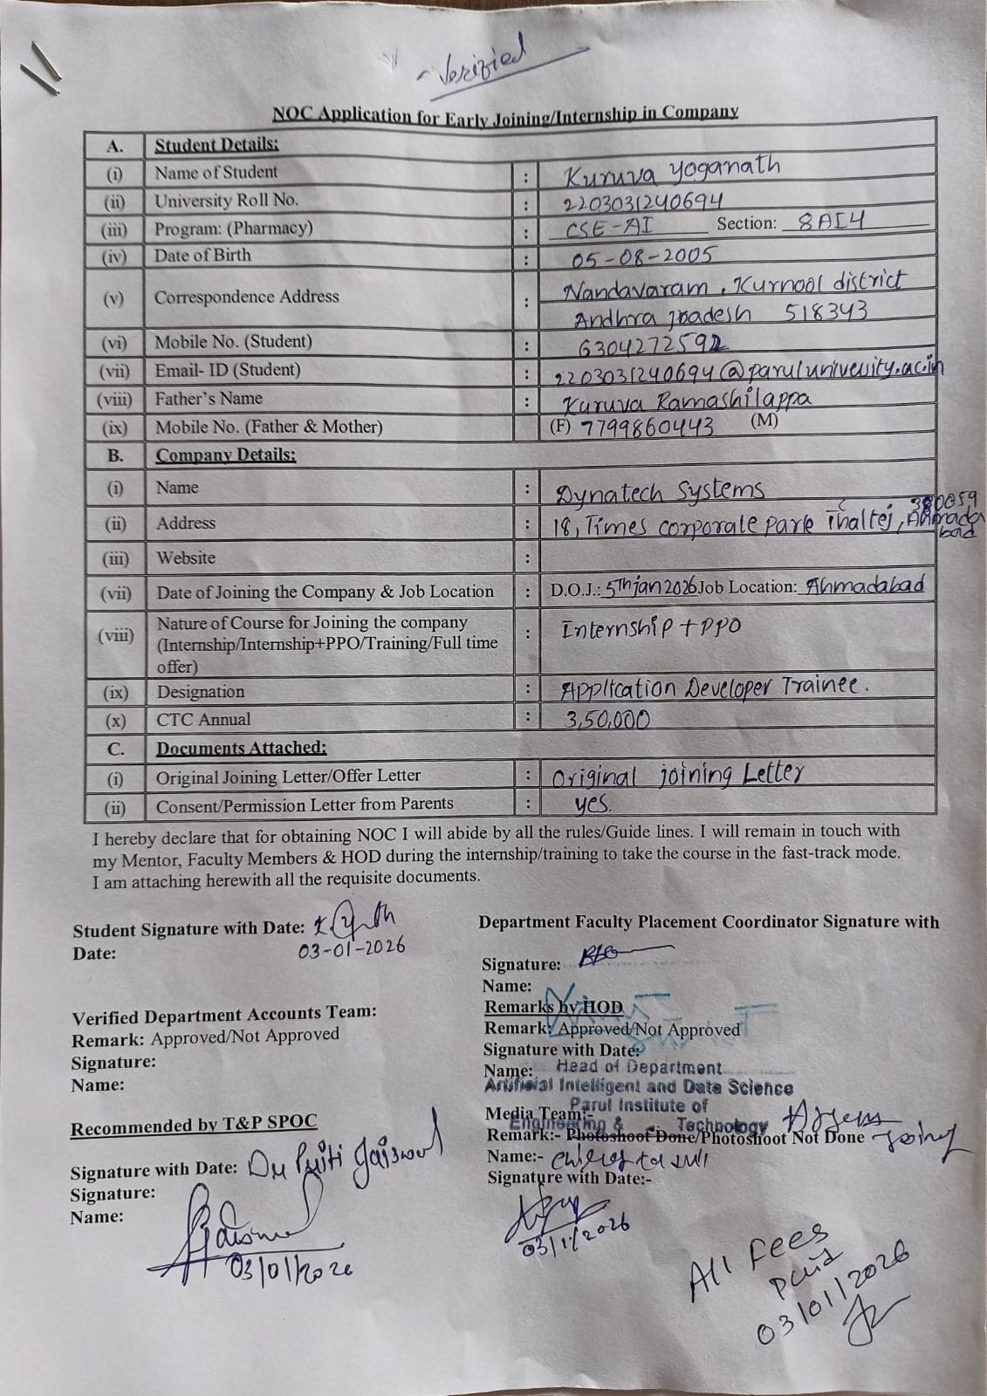

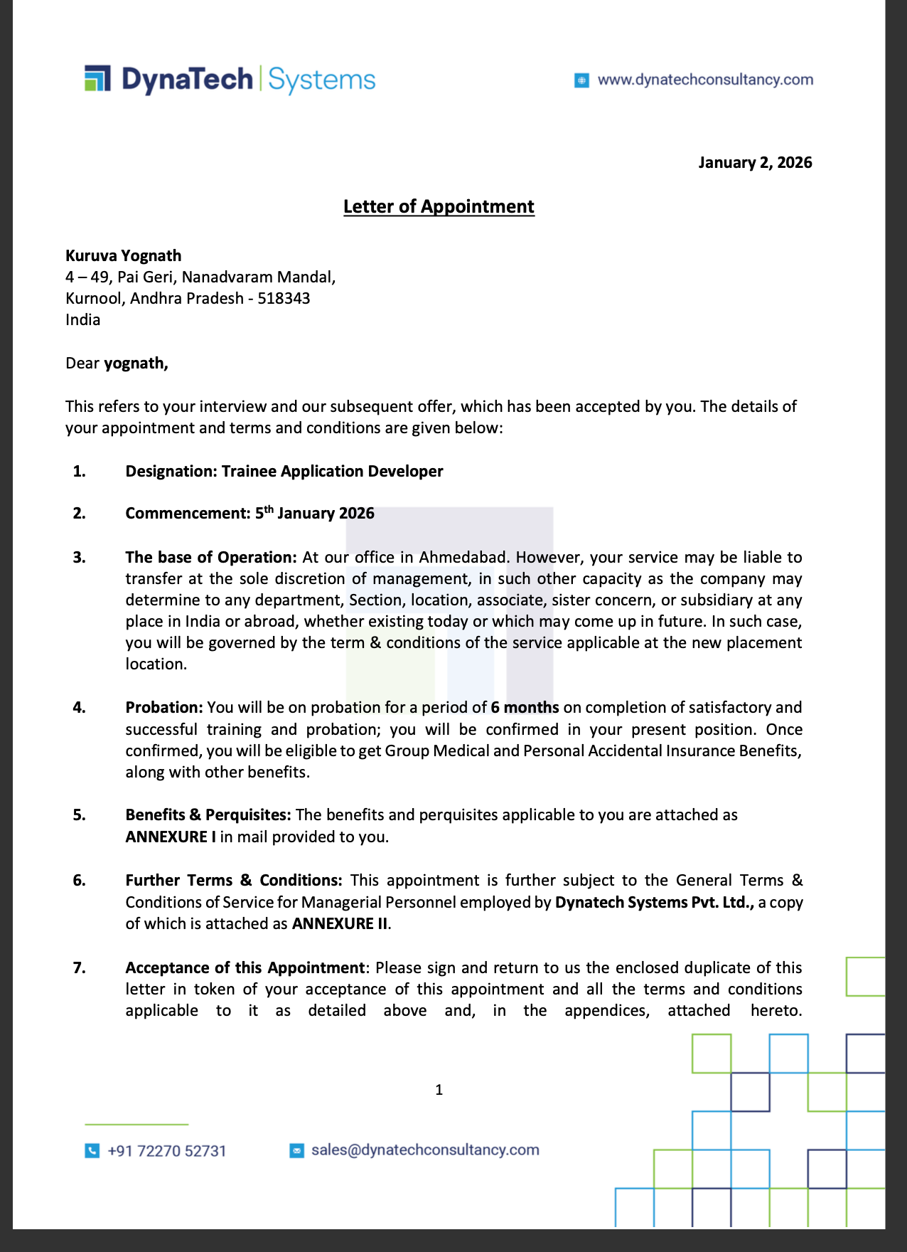

Annexure- 06
STUDENTS EXTERNAL ATTACHMENT

WORK LOG-BOOK

DURATION: 12 WEEKS

WORK LOG-BOOK

- INTRODUCTION :
This log book is to assist the student to keep a record of the internship. It will show the departments and sections in which the student has worked and the periods of time spent in each.

- DAILY REPORT :
The daily work carried out during the periods of training is to be recorded clearly with sketches and diagrams where applicable.

- WEEKLY REPORT :
This is a summary of work done in a week and should cover theory/practical report on the work covered.

Students are required to present the log-book weekly to the industry based supervisor For assessment of content and progress. The Supervisor can use any page for his comments where necessary.

- COLLEGE SUPERVISOR’S VISIT :
The Training Supervisor of the FET will check the log-book when he/she visits the industry/project to ensure that the proper internship is being carried out, and record his/her comment on the page provided for this purpose, towards the end of the book.

- SPECIAL REQUEST FOR INDUSTRY- MENTOR:
Please assess the student as per assessment form provided.

- REPORT WRITING :
In addition to the daily and weekly record the student should submit a summary report of the work done during the training period.

The report should contain a summary of activities of the organization, manufacturing/services processes the student was involved in. The report has to be in the proper format as prescribed by the project head. (Report Format will be mailed to you by the Project Head during your first week of training).
- REPORT SUBMISSION :
The log-book and report must be submitted to the relevant departmental Project Head at periodic intervals.

STUDENT’S PARTICULARS
Nameof Student :

K | U | R | U | V | A |  | Y | O | G | A | N | A | T | H
Enrolment No.:

2 | 2 | 0 | 3 | 0 | 3 | 1 | 2 | 4 | 0 | 6 | 9 | 4
Contact No. Email ID
6 | 3 | 0 | 4 | 2 | 7 | 2 | 5 | 9 | 2

2 | 2 | 0 | 3 | 0 | 3 | 1 | 2 | 4 | 0 | 6 | 9 | 4 | @paruluniversity.ac.in

Name of Company

D | Y | N | A | T | E | C | H |  |  |  | S | Y | S | T | E | M | S
Address of Company

1 | 8 | , | T | I | M | E | S |  |  |  |  | C | O | R | P | O | R | A | T | E |  | P | A | R | K
T | H | A |  | L | T | E | J | , | A | H |  | M | A | D | A | B | A | D | , | - | 3 | 8 | 0 | 0 | 5 | 9 |  | T | H
Nameof Industry Mentor

M | R | . |  | A | M | I | T |  | J | E | S | A |  | N | I
Contact No. Email ID
9 | 8 | 6 | 0 | 4 | 5 | 5 | 7 | 5 | 7

d | i | r | e | c | t | o | r | @adinfocomsystems.in

Nameof Faculty Mentor

M | R | . | A | K | S | H | A | Y |  | M | A | N | D | L | O | I
Contact No. Email ID

9 | 6 | 0 | 1 | 3 | 3 | 3 | 8 | 3 | 3 |  | Akshay.mandloi37301@paruluniversity.ac.in

Training Duration: From: 01/01/2026 To: 01/08/2026

WEEKLY PROGRESS CHART (FIRST WEEK) (WEEKENDING)

WEEK - 1:
Goal: Functional Training on D365 Apps

DAY | DESCRIPTION OF WORK DONE
Monday | Attended functional training on Microsoft Dynamics 365 and learned system navigation.Understood basics of entities, fields, forms, views, and records.
Tuesday | Learned different field types like Text, Number, Date, Lookup, Option Set, and Boolean.Understood how forms and views are used to display and manage data.
Wednesday | Studied Sales Module and Sales Cycle (Lead → Opportunity → Quote → Order → Invoice).Understood how leads are converted into opportunities.
Thursday | Practiced creating Leads and Opportunities in the system.  Learned how to track activities like calls, emails, and tasks.
Friday | Revised the complete sales cycle with practical examples.  Understood how businesses manage sales pipeline using Dynamics 365.

WEEKLY PROGRESS CHART (SECOND WEEK) (WEEKENDING)

WEEK - 2:
Goal: Customer Service Module

DAY | DESCRIPTION OF WORK DONE
Monday | This week training started with the Customer Service module. I learned about Cases in Dynamics 365 and how customer issues are tracked using cases.
Tuesday | I learned how to create a new Case and assign it to a user. I also learned about case priority, case status, and SLA (Service Level Agreement).
Wednesday | I practiced resolving cases. I learned how to add activities such as phone calls, tasks, and emails to a case record in the timeline.
Thursday | I learned about Knowledge Base Articles and how they help in resolving customer issues faster. I also learned about case resolution process
Friday | I practiced creating and resolving multiple cases and understood the complete lifecycle of a case from creation to resolution.

WEEKLY PROGRESS CHART (THIRD WEEK) (WEEKENDING) WEEK – 3:

Goal: Dataverse & Power Apps

DAY | DESCRIPTION OF WORK DONE
Monday | I learned about Dataverse, which is the database used in Power Platform. I understood tables, columns, rows, relationships, and primary keys.
Tuesday | I practiced creating custom tables in Dataverse and adding columns with different data types. I also created relationships between tables.
Wednesday | I learned about Power Apps and the difference between Model Driven Apps and Canvas Apps.
Thursday | I created a Model Driven App using Dataverse tables and added forms and views to the app.
Friday | I learned about Business Process Flows (BPF) and how to create stages and steps for a business process.  Done the Recruitment Management App project what I have learned in all these 3 weeks and submitted to my Reporting Manager

WEEKLY PROGRESS CHART (FOURTH WEEK) (WEEKENDING) WEEK - 4:
Goal: Plugin Development.

DAY | DESCRIPTION OF WORK DONE
Monday | Introduction to Plugin Development in Power Apps. I learned what a plugin is and why it is used in Dynamics 365.
Tuesday | I learned about plugin pipeline stages: Pre-Validation, Pre-Operation, and Post-Operation.
Wednesday | I worked on plugin development tasks on out-of-the-box tables like Contact and Account,opportunuity
Thursday | I created plugins on custom tables and tested the business logic.
Friday | I learned how plugins interact with Web APIs and how to register plugins using Plugin Registration Tool.

WEEKLY PROGRESS CHART (FIFTH WEEK) (WEEKENDING) WEEK - 5:
Goal: Power Automate.

DAY | DESCRIPTION OF WORK DONE
Monday | Introduction to Microsoft Power Automate, including connectors, triggers, and actions.  Learned how cloud flows work and how Power Automate connects with different services.
Tuesday | Worked with Dataverse connector and created an automated flow.  Flow created to automatically add a note when an Account or Contact record is created.
Wednesday | Worked with SharePoint connector and performed basic CRUD operation automation.  Created flows for create, update, and delete operations in SharePoint.
Thursday | Learned theory on Azure Blob Storage connector , One Drive Connector and its usage.  Understood how files can be stored and retrieved using Power Automate.
Friday | Created automation flows on out-of-the-box tables like Account, Contact, Email, Timeline, and Opportunity.  Completed a team task assigned by trainer to automate business process using Power Automate.

WEEKLY PROGRESS CHART (SIXTH WEEK) (WEEKENDING) WEEK - 6:
Goal: Web Resources and Ribbon Customisation.

DAY | DESCRIPTION OF WORK DONE
Monday | Introduction to Web Resources in Dynamics 365 using HTML, CSS, and JavaScript.  Understood how web resources are used to customize forms and add custom UI.
Tuesday | Created an HTML web resource and added it to a form.  Learned how to display custom content inside the form using web resources.
Wednesday | Wrote JavaScript functions and triggered them using form events.  Understood how to use JavaScript for form validation and field automation.
Thursday | Learned Ribbon Workbench and ribbon customization.  Understood how to modify command bar and add custom buttons.
Friday | Created custom buttons and added JavaScript functionality to buttons.  Performed tasks related to ribbon customization and button actions.

WEEKLY PROGRESS CHART (SEVENTH WEEK) (WEEKENDING) WEEK - 7:
Goal: Power Pages.

DAY | DESCRIPTION OF WORK DONE
Monday | Introduction to Microsoft Power Pages and portal development.  Understood how Power Pages connects with Dataverse.
Tuesday | Learned HTML, CSS, JavaScript, and jQuery used in Power Pages customization.  Understood basic front-end structure for portal pages.
Wednesday | Worked with Web API in Power Pages.  Learned how to retrieve and send data from Dataverse using Web API.
Thursday | Started working on Power Pages E-commerce website project.  Designed basic structure for the website.
Friday | Created Home Page and Login Page.  Implemented basic navigation and UI design.

WEEKLY PROGRESS CHART (EIGHTH WEEK) (WEEKENDING) WEEK - 8:
Goal: Power pages Continued.

DAY | DESCRIPTION OF WORK DONE
Monday | Created Register Page for new users.  Implemented form validation using JavaScript.
Tuesday | Created Products Page to display products.  Connected products data from Dataverse.
Wednesday | Implemented Add to Cart functionality.  Used JavaScript and Web API for cart operations.
Thursday | Worked on cart functionality and data storage.  Tested Add to Cart and Remove from Cart features.
Friday | Completed E-commerce website task in Power Pages.  Tested all pages and functionality.

WEEKLY PROGRESS CHART (NINTH WEEK) (WEEKENDING) WEEK - 9:
Goal: Power Pages E-Commerce Development.

DAY | DESCRIPTION OF WORK DONE
Monday | Started E-commerce website development using Microsoft Power Pages.  Created Dataverse tables and basic structure for the application.
Tuesday | Developed Customer, Login, and Register pages.  Implemented authentication and form validations using HTML, CSS, and JavaScript.
Wednesday | Worked on Products page and data integration.  Fetched product data using Web API and displayed dynamically.
Thursday | Implemented Cart functionality using JavaScript and jQuery.  Handled add, remove, and update cart operations using API.
Friday | Developed My Orders page and completed full E-commerce workflow.  Tested complete website functionality including APIs and user flow.

WEEKLY PROGRESS CHART (TENTH WEEK) (WEEKENDING) WEEK – 10 :
Goal: Code Review & Console Application.

DAY | DESCRIPTION OF WORK DONE
Monday | Performed code review for all completed tasks in E-commerce project.  Improved code quality and fixed issues.
Tuesday | Attended evaluation exam and completed To-Do List project within 1 hour.  Applied knowledge of JavaScript, API, and UI development.
Wednesday | Started learning Console Application development.  Understood basic structure and setup of console applications.
Thursday | Learned how to register applications and write basic console code.  Executed simple programs and logging outputs.
Friday | Performed CRUD operations using console application.  Practiced create, read, update, and delete operations on data.

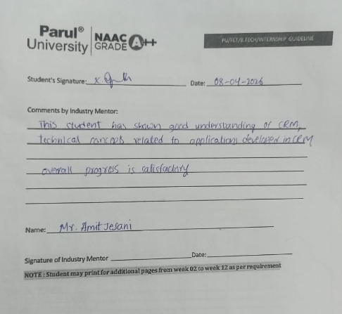


Signature of the Mentor :


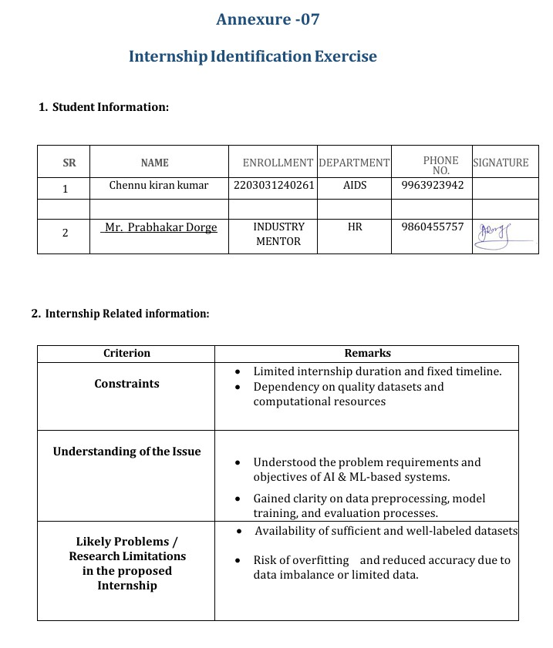

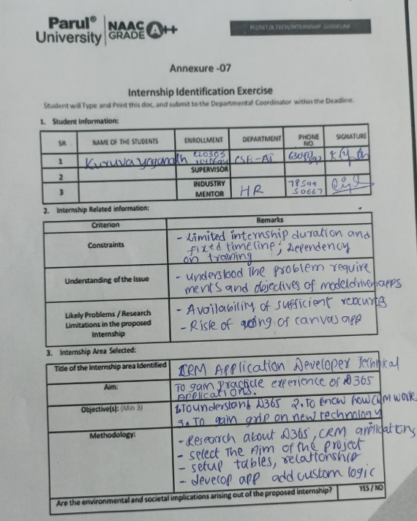

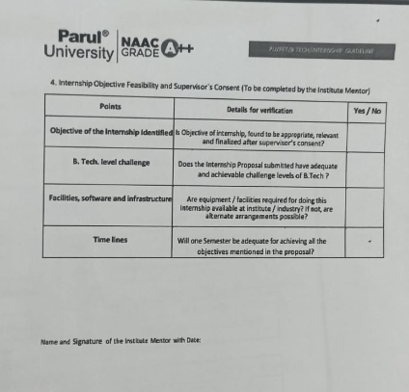

Name and Signature of the Institute Mentor with Date:

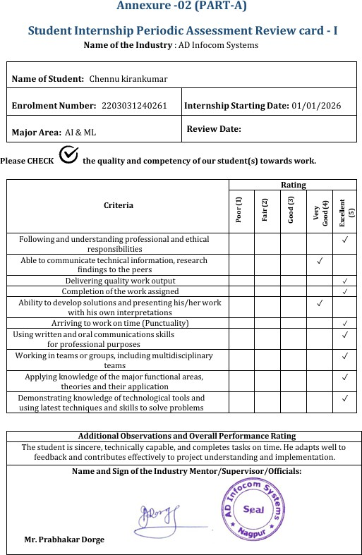

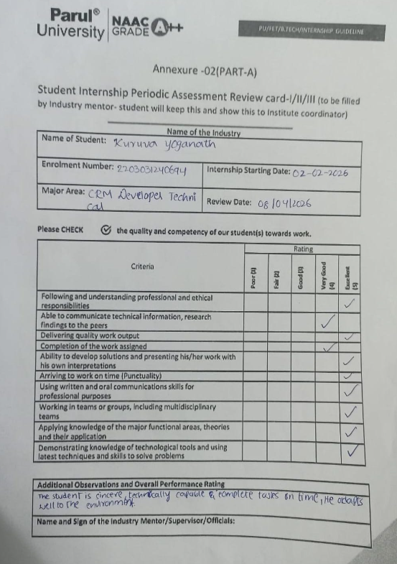

Name and Sign of the Industry Mentor :

Mr. Amit Jesani

