**Finite temperature first principles calculation**

**of Al <100> twist boundary energy**

J.Amakawaa, K.Horikawaa, S.R.Nishitania

a Departement of Computer Science,

Kwansei Gakuin University, Sanda, Japan -a

Kyohei Horikawa

A short CV may be inserted here, summarizing the academic education and current position. The research topics and scientific interests may also be indicated in this frame. Text should be written using Arial 10 pts.

Please insert your photo in the left frame. It will be printed in black and white.

If you do not want, leave it blank.

1. Introduction

Last year, Nishitani published the finite temperature first principles calculations on Al <100> symmetric tilt boundary energy[1]. In finite temperature calculations, we performed Einstein-model calculaties of harmonic oscillators and Frenkel method to include anharmonic effects. We will report the applications of his method on Al <100> twist boundary.

1. Method

We use Einstein model for the finite temperature free energy calculated by the first principles calculations of VASP, to calculate energies as to lock atoms on each sites and vibrate thermally. And, Grain boundary energy is calculated from energy difference the model contains grain boundary.

1. Conclusion

Fig.1 shows following things:

* The temperature dependency is smaller than that of tilt boundary.
* The boundary energy at 500K is smaller than that of tilt boundary.
* The value at θ=36.87 degs is slightly smaller than that at 22.62 degs.
* 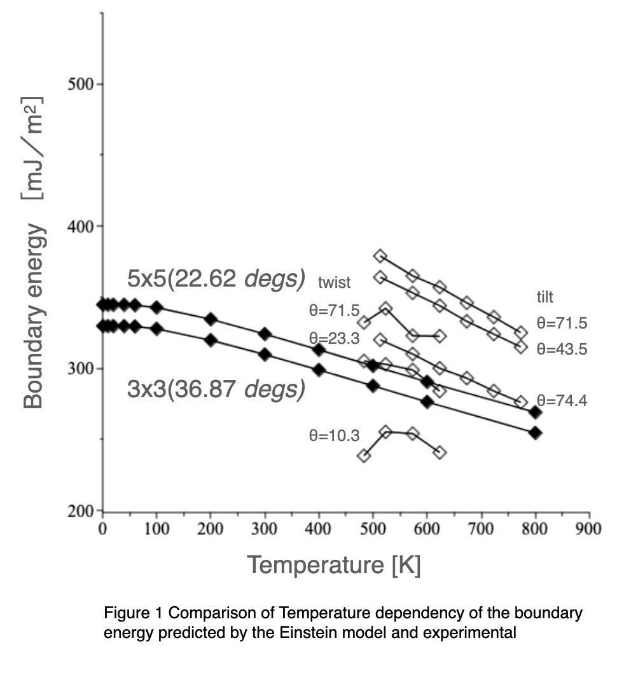

[1] S. R. Nishitani (2020) Finite-temperature first-principles calculations of Al ⟨100⟩ symmetric tilt grain-boundary energy, Philosophical Magazine, DOI: 10.1080/14786435 .2020.1855371.

[2] A. Otsuki, *Research on boundary energy of Al*, Ph.D. diss., Kyoto Univ., 1990, in Japanese.