# Report No. 3 Software Requirement Specification

## User Requirement Specification

### Unauthorized User Requirement

Unauthorized is user does not login to this system. Unauthorized only has two functions.

* Sign up.
* Login.

### Authorized User Requirement

Authorized User is user who has logged into system. Authorized User only has two functions.

* Edit profile.
* Logout.

### Borrower Requirement

Borrower can use some following functions:

* + Check in
  + Check out
* Add wish list book
* View borrowed list

### Librarian Requirement

Librarian is the user who interacts directly to borrower, they can use some following functions:

* Search borrower
* Edit borrowed books of a borrower
* Search book

### Admin Requirement

Admin is the user who responsible for managing accounts for the whole system, they can use some following functions:

* Manage accounts

### Emulator Requirement

Emulator is the device which can interact with mobile phone, it can use some following functions:

* Read & write RFID tags
* Verify user by NFC/QR code

### Auto Handler Requirement

Auto Handler can use some following functions:

* + Suggest promotions
  + Auto extend subscription
  + Crawl bus routes
  + Auto generate server token

## System Requirement Specification



### External Interface Requirement

#### User Interface

* The user interface uses English language in both web admin and mobile application.
* The user interface displays best on 1366x768 resolutions on desktop, and 1080x1920 on mobile.

#### Hardware Interface (RFID, beacon, emulator)

#### Software Interface(API, thu vien support)

#### Communication Protocol

* Use HTTP 1.1 to communicate between the web browser and the web server.
* Use HTTP 1.1 to communicate between the mobile application and the web service.

### System Overview Use Case

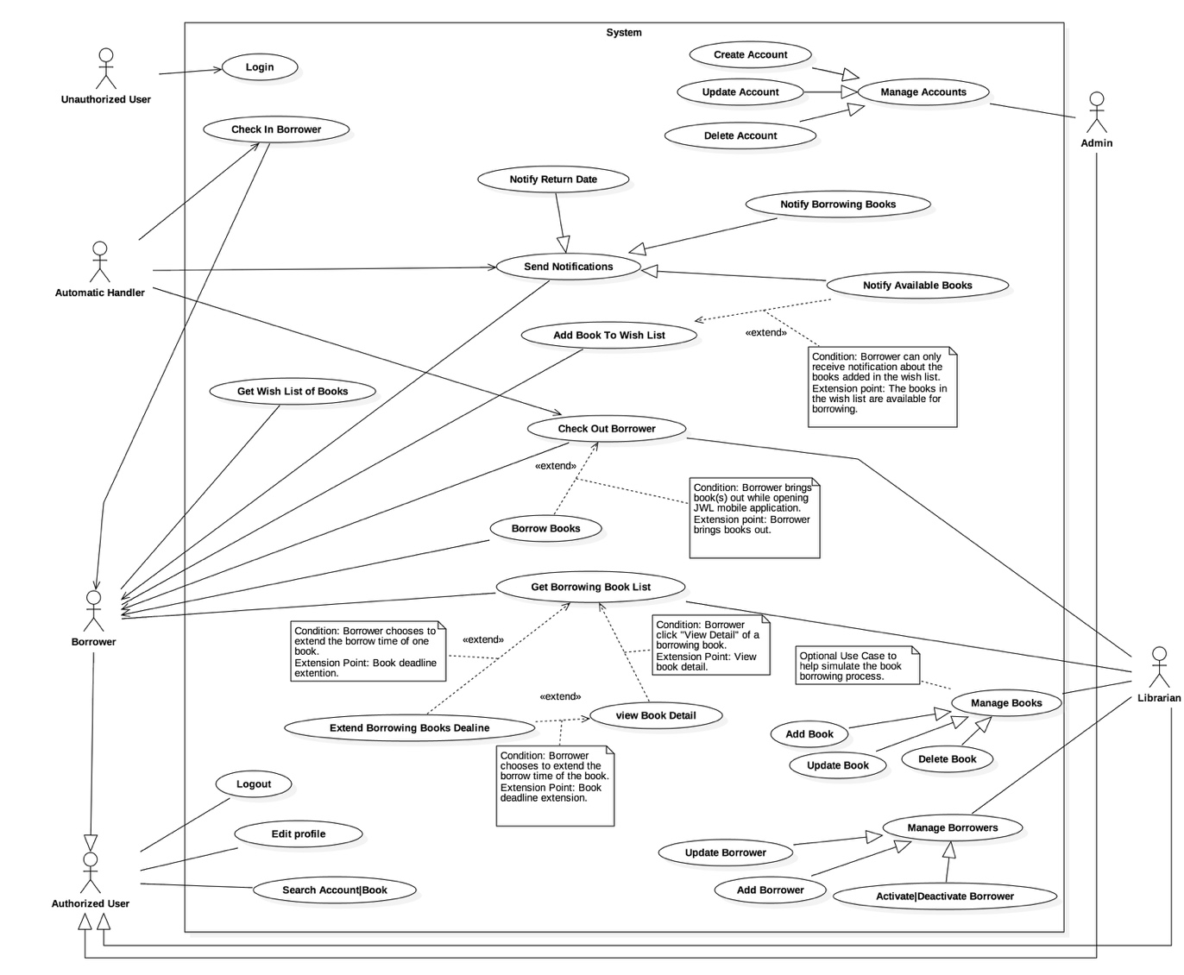

Figure 1 : <Use case> System overview



#### Web Application

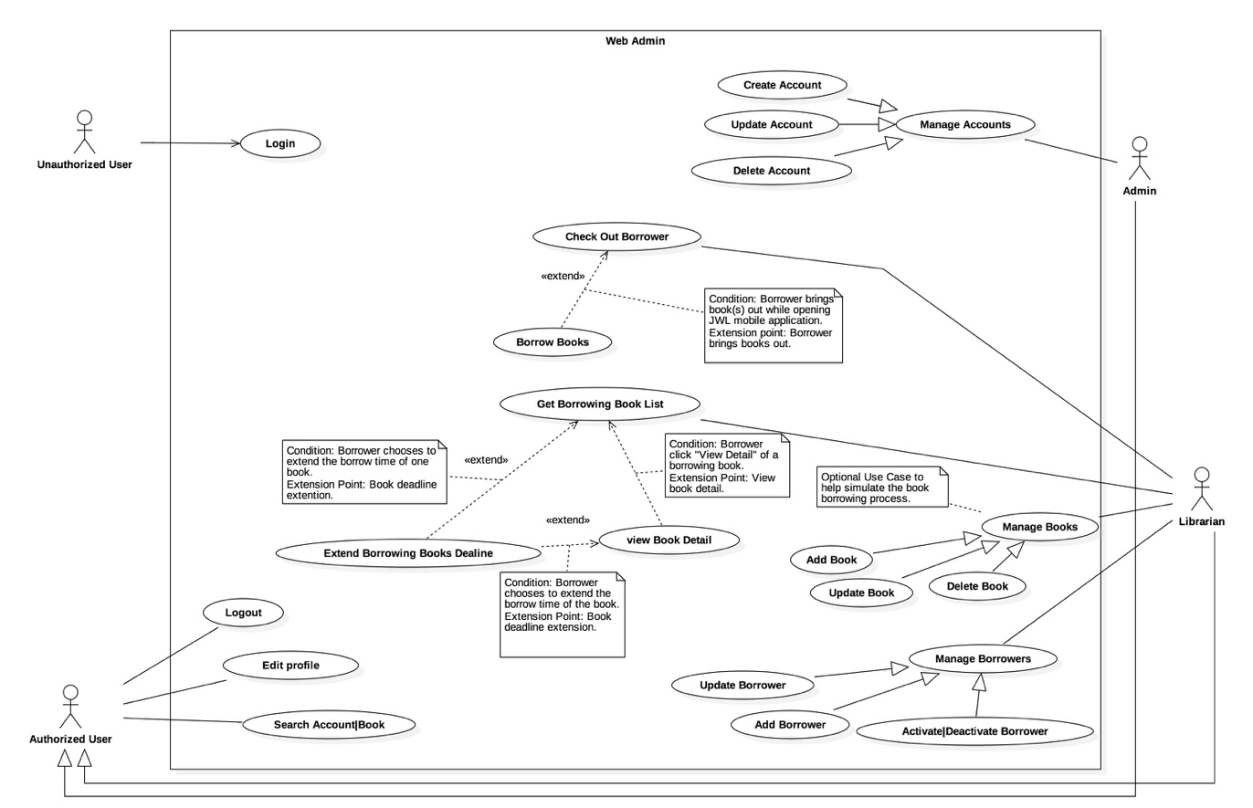

Figure 2 : <Use case> Web application overview

#### Mobile Application

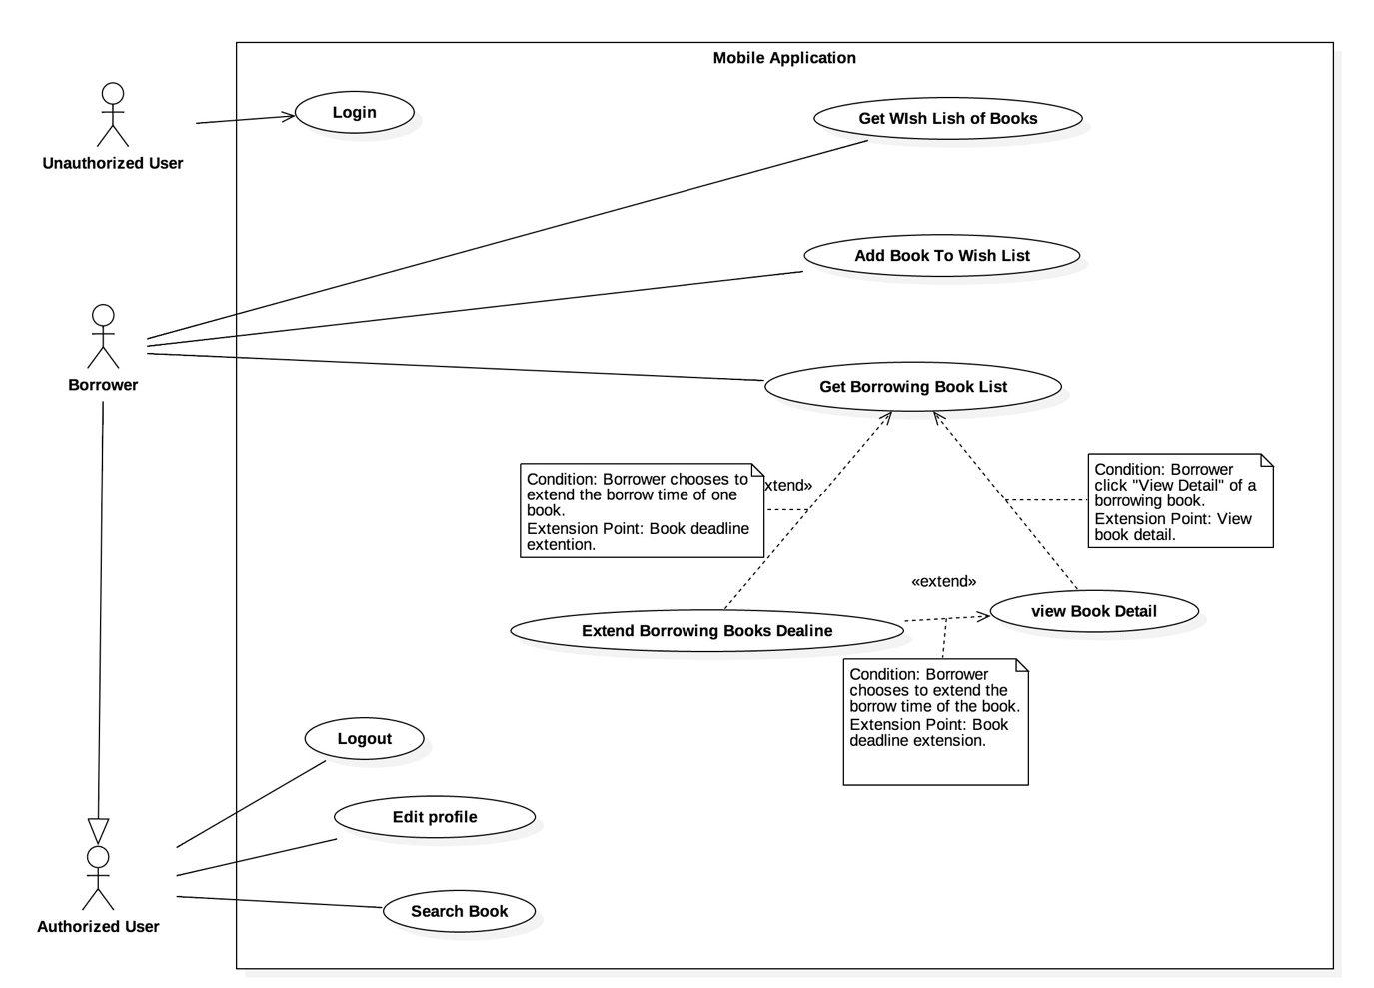

Figure 3: <Use case> Mobile application overview



### List of Use Case

#### Common Use Case

##### Unauthorized User

###### <Unauthorized User> Overview use case

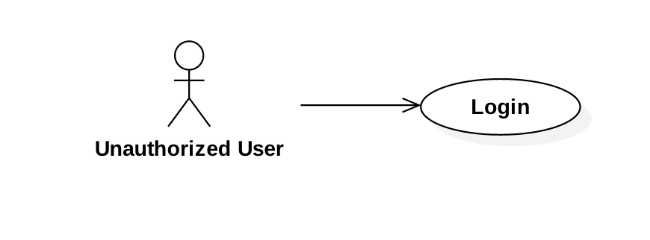

Figure 4: <Unauthorized User> Overview Use Case

###### <Unauthorized User> Login



Figure 5: <Unauthorized User> Login

|  |  |  |  |
| --- | --- | --- | --- |
| **USE CASE – JWL01** | | | |
| **Use Case No.** | JWL01 | **Use Case Version** | 1.0 |
| **Use Case Name** | Login | | |
| **Author** | Nguyen Tuan Anh | | |
| **Date** | January 16, 2017 | **Priority** | High |
| **Actor:**   * Unauthorized User.   **Summary:**   * This use case allows Unauthorized User to log into the system with a specific role.   **Goal:**   * Authenticate user, redirect user to a specific view based on the role.   **Triggers:**   * Unauthorized User sends Login command.   **Preconditions:**   * Valid username and password are input.   **Post Conditions:**   * **Success:** Unauthorized User is logged into the system as Authorized User. * **Fail:** N/A   **Main Success Scenario:**   |  |  |  | | --- | --- | --- | | Step | Actor Action | System Response | | 2 | Unauthorized User inputs username and password, then sends Login command.  [Exception 1] | Unauthorized User will be logged into System with their specified role.  The system redirects to the role’s view.  [Alternative 1] |   **Alternative Scenario:**  [Alternative 1]   |  |  |  | | --- | --- | --- | | Step | Cause | System Response | | 1 | Unauthorized user leaves the username and password field empty. | System displays an error message. |   **Exception:**  [Exception 1]   |  |  |  | | --- | --- | --- | | Step | Actor Action | System Response | | 1 | Unauthorized User inputs wrong username and password. | System displays an error message. |   **Relationships: N/A**  **Business Rules:**   * System authenticates user by checking the username and password. * Unauthorized User enters password in a hidden text field and the password must be encrypted before sending to server. * After logged in to the system, Unauthorized User will be redirected to a specific view: * If the role is “Admin”, the system will display Admin view. * If the role is “Librarian”, the system will display Librarian view. * If the role is “Borrower”, the system will display Borrower view. | | | |

##### Authorized User

###### <Authorized User> Overview Use Case

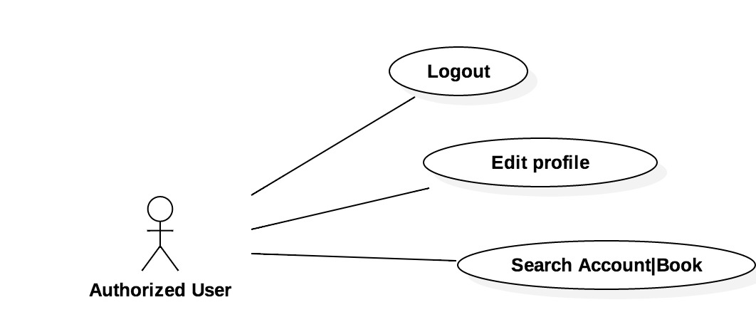

Figure 6: <Authorized User> Overview Use Case

###### <Authorized User> Logout

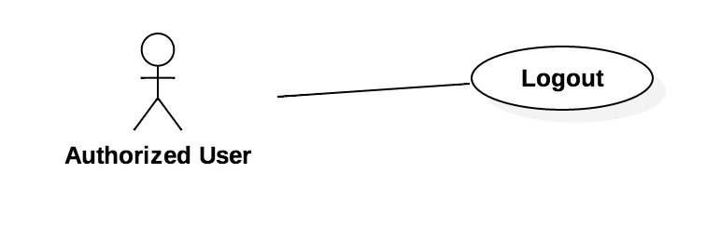

Figure 7: <Authorized User> Logout

|  |  |  |  |
| --- | --- | --- | --- |
| **USE CASE – JWL02** | | | |
| **Use Case No.** | JWL02 | **Use Case Version** | 1.0 |
| **Use Case Name** | Logout | | |
| **Author** | Nguyen Tuan Anh | | |
| **Date** | January 16, 2017 | **Priority** | Normal |
| **Actor:**   * Authorized User   **Summary:**   * This use case allows Authorized User to logout.   **Goal:**   * Authorized User can logout of the system.   **Triggers:**   * Authorized User sends Logout command.   **Preconditions:**   * Actor logged in system with role Authorized User.   **Post Conditions:**   * **Success:** Authorized User is logged out. * **Fail:** N/A   **Main Success Scenario:**   |  |  |  | | --- | --- | --- | | Step | Actor Action | System Response | | 1 | Authorized User sends Logout command. | System clears the current session of the user then redirects to login screen. |   **Alternative Scenario:** N/A  **Exceptions:** N/A  **Relationships:** N/A  **Business Rules:**   * After logged out of the system, user no longer has permission to access any authorized functions of the system. | | | |

###### <Authorized User> Edit Profile

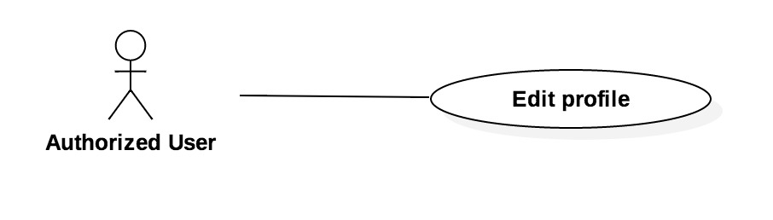

Figure 8: <Authorized User> Edit Profile

|  |  |  |  |
| --- | --- | --- | --- |
| **USE CASE – JWL03** | | | |
| **Use Case No.** | JWL03 | **Use Case Version** | 1.0 |
| **Use Case Name** | Edit Profile | | |
| **Author** | Nguyen Tuan Anh | | |
| **Date** | January 16, 2017 | **Priority** | Low |
| **Actor:**   * Authorized User   **Summary:**   * This use case allows Authorized User to edit his/her personal information.   **Goal:**   * Authorized User’s personal information is updated as he/she sends Update command.   **Triggers:**   * Authorized User sends Edit Profile command.   **Preconditions:**   * The Actor must be logged in the System.   **Post Conditions:**   * **Success:** Authorized User’s personal information is updated in the database. * **Fail:** Error message is displayed.   **Main Success Scenario:**   |  |  |  | | --- | --- | --- | | Step | Actor Action | System Response | | 1 | Authorized User sends Edit Profile command. | System lists out the information of the account:   * “Username”: label, not editable * “Full name”: text input, length 6-100 * “Password”: password input, length 6-50 * “Confirm Password”: password input, length 6-50 * “Date of Birth”: datetime picker * “Email”: email input * “Address”: text input, length 6-100 * “Phone number”: text input, length 8-12 * “Place of Work”: text input: length 6-50 * “Account Type”: label Student, Teacher, Officer, …; not editable * “Subscription End Date”: date label, not editable * Update command. | | 2 | Authorized User updates information. |  | | 3 | Authorized User sends Update command. | * System validates the input then updates the account’s profile. * System displays a successful message: “Update Successful”   [Exception 1, 2, 3, 4, 5, 6, 7] |   **Alternative Scenario: N/A**  **Exception:**   |  |  |  | | --- | --- | --- | | No | Cause | System Response | | 1 | Authorized User inputs Full Name field with wrong format. | System displays error message: “Full name length is 6-100 characters.” | | 2 | Authorized User inputs Password field with wrong format. | System displays error message: “Password length is 6-100 characters.” | | 3 | Authorized User inputs wrong Confirm Password field. | System displays error message: “Confirm Password must match Password.” | | 4 | Authorized User inputs Email field with wrong format. | System displays error message: “Wrong Email format. Please input something like abc@somemail.com” | | 5 | Authorized User inputs Address field with wrong format. | System displays error message: “Address length is 6-100 characters.” | | 6 | Authorized User inputs Phone Number field with wrong format. | System displays error message: “Phone Number should be all numbers at 8-12 length.” | | 7 | Authorized User inputs Place of Work field with wrong format. | System displays error message: “Place of Work length is 6-100 characters.” |   **Relationships: N/A**  **Business Rules:**   * User updates account profile in case of changing their personal information. * Password must be encrypted before saving to the system. * User cannot update Username, Account Type, and Subscription End Date. | | | |

###### <Authorized User> Search Account/Book

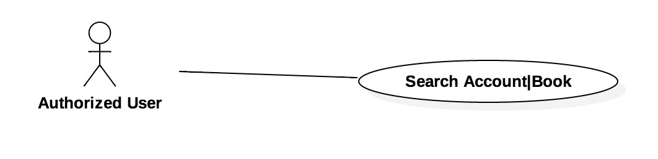

Figure 9: <Authorized User> Search Account/Book

|  |  |  |  |
| --- | --- | --- | --- |
| **USE CASE – JWL04** | | | |
| **Use Case No.** | JWL04 | **Use Case Version** | 1.0 |
| **Use Case Name** | Search | | |
| **Author** | Nguyen Tuan Anh | | |
| **Date** | February 11, 2017 | **Priority** | Low |
| **Actor:**   * Authorized User   **Summary:**   * This use case allows Authorized User to search Account/Book.   **Goal:**   * Authorized User’s can get list of Account/Book that match his/her input.   **Triggers:**   * Authorized User sends Search command.   **Preconditions:**   * The Actor must be logged in the System. * The Actor can only search Account with role Admin or Librarian. * The Actor can search Book with all authorized roles.   **Post Conditions:**   * **Success:** List of Account/Book is showed based on the Actor’s search criteria. * **Fail:** N/A.   **Main Success Scenario:**   |  |  |  | | --- | --- | --- | | Step | Actor Action | System Response | | 1 | Authorized User finds the search input above the Account table or the Book table (depends on the Actor’s current view). |  | | 2 | Authorized User changes text in search input and sends Search command. | System loads the search results with their information:  Account:   * UserId * Fullname * Email * Address * Date of Birth * Phone Number * Place of Work * Role * Is in library * Is activated   Book:   * Title * Publisher * Published year * Number of Pages * Number of Copies   [Alternative 1] |   **Alternative Scenario:**  [Alternative 1]   |  |  |  | | --- | --- | --- | | Step | Cause | System Response | | 1 | There is no Book/Account matches search criteria. | System shows message: “Cannot find searched Book/Account.” |   **Exception: N/A**  **Relationships: N/A**  **Business Rules:**   * Each Account has a unique userId. * Account is searched by userId, and Book is searched by title. * Only Admin and Librarian can search for Account. * Book can be search by all Authorized User. | | | |

#### Web Application

##### Admin

###### <Admin> Overview Use Case

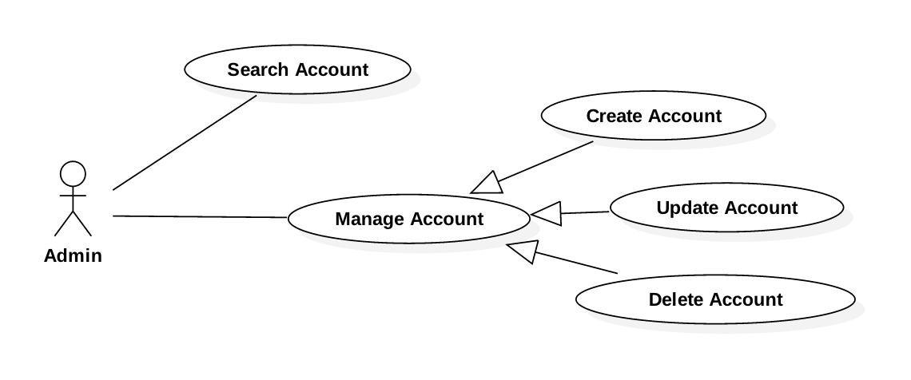

Figure 9: <Admin> Overview Use Case

###### <Admin> Search Account

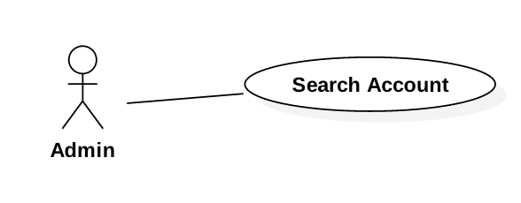

Figure 10: <Admin> Search Account

|  |  |  |  |
| --- | --- | --- | --- |
| **USE CASE – JWL04** | | | |
| **Use Case No.** | JWL04 | **Use Case Version** | 1.0 |
| **Use Case Name** | Search Account | | |
| **Author** | Nguyen Tuan Anh | | |
| **Date** | January 16, 2017 | **Priority** | Normal |
| **Actor:**   * Admin   **Summary:**   * This use case allows Admin to search for an account.   **Goal:**   * Admin can get a list accounts that match input username or full name.   **Triggers:**   * Admin changes the content of the search field.   **Preconditions:**   * Actor logged in system with role Admin.   **Post Conditions:**   * **Success:** List of matching accounts based on search term is showed. * **Fail:** N/A   **Main Success Scenario:**   |  |  |  | | --- | --- | --- | | Step | Actor Action | System Response | | 1 | Admin inputs wanted username or full name. | System loads the result each time the input search field changes. Information for each account:   * Username * Full name * Date of Birth * Phone No. * Status (active/deactivated)   [Alternative 1] |   **Alternative Scenario:**   |  |  |  | | --- | --- | --- | | Step | Cause | System Response | | 1 | There is no account that matches the search term. | System shows message: “No account found.” |   **Exceptions:** N/A  **Relationships:** N/A  **Business Rules:**   * Each account has a unique username, such as student ID, or identity ID. | | | |

###### <Admin> Create Account

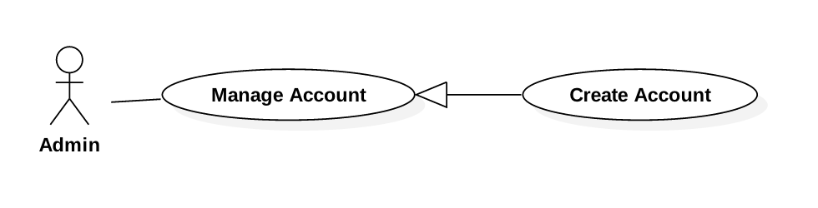

Figure 11: <Admin> Create Account

|  |  |  |  |
| --- | --- | --- | --- |
| **USE CASE – JWL05** | | | |
| **Use Case No.** | JWL05 | **Use Case Version** | 1.0 |
| **Use Case Name** | Create Account | | |
| **Author** | Nguyen Tuan Anh | | |
| **Date** | January 16, 2017 | **Priority** | Normal |
| **Actor:**   * Admin   **Summary:**   * This use case allows Admin to create an account.   **Goal:**   * Admin can create a new account for another user (Borrower/Librarian).   **Triggers:**   * Admin sends Create Account command.   **Preconditions:**   * Actor logged in system with role Admin.   **Post Conditions:**   * **Success:** A new account with input information is added to the System database. * **Fail:** N/A   **Main Success Scenario:**   |  |  |  | | --- | --- | --- | | Step | Actor Action | System Response | | 1 | Admin sends Create Account command. | System lists out the information of the new account:   * “Username”: text input, length 6-50 * “Full name”: text input, length 6-100 * “Password”: password input, length 6-50 * “Confirm Password”: password input, length 6-50 * “Date of Birth”: datetime picker * “Email”: email input * “Address”: text input, length 6-100 * “Phone number”: text input, length 8-12 * “Place of Work”: text input: length 6-50 * “Account Type”: dropdown box: Student, Teacher, Officer, Retired Officer, Business Person * Commit command. | | 2 | Authorized User input the information. |  | | 3 | Authorized User sends Submit command. | * System validates the input then create a new account. * System displays a successful message: “New Account for [username] is added.”   [Exception 1, 2, 3, 4, 5, 6, 7] |   **Alternative Scenario:** N/A  **Exceptions:**   |  |  |  | | --- | --- | --- | | No | Cause | System Response | | 1 | Admin inputs Username field with wrong format. | System displays error message: “Full name length is 6-50 characters.” | | 2 | Admin inputs Full Name field with wrong format. | System displays error message: “Full name length is 6-100 characters.” | | 3 | Admin inputs Password field with wrong format. | System displays error message: “Password length is 6-50 characters.” | | 4 | Admin inputs wrong Confirm Password field. | System displays error message: “Confirm Password must match Password.” | | 5 | Admin inputs Email field with wrong format. | System displays error message: “Wrong Email format. Please input something like abc@somemail.com” | | 6 | Admin inputs Address field with wrong format. | System displays error message: “Address length is 6-100 characters.” | | 7 | Admin inputs Phone Number field with wrong format. | System displays error message: “Phone Number should be all numbers at 8-12 length.” | | 8 | Admin inputs Place of Work field with wrong format. | System displays error message: “Place of Work length is 6-100 characters.” |   **Relationships:** N/A  **Business Rules:**   * Each account has a unique username, such as student ID, or identity ID. * Password must be encrypted before saving to the system. | | | |

###### <Admin> Update Account

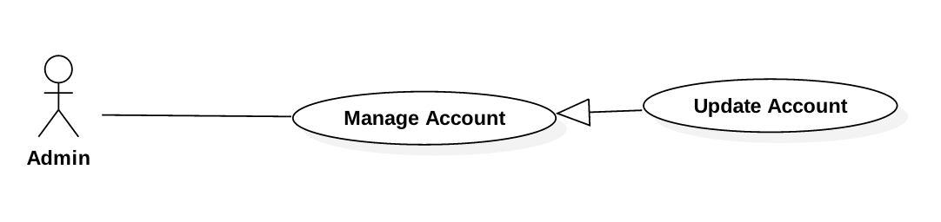

Figure 12: <Admin>Update Account

|  |  |  |  |
| --- | --- | --- | --- |
| **USE CASE – JWL06** | | | |
| **Use Case No.** | JWL06 | **Use Case Version** | 1.0 |
| **Use Case Name** | Update Account | | |
| **Author** | Nguyen Tuan Anh | | |
| **Date** | January 16, 2017 | **Priority** | Low |
| **Actor:**   * Admin   **Summary:**   * This use case allows Admin to update another account information.   **Goal:**   * Admin can update another Actor’s personal information as he/she sends Submit command.   **Triggers:**   * Admin sends Update command.   **Preconditions:**   * Actor logged in system with role Admin.   **Post Conditions:**   * **Success:** The account’s personal information is updated in the database. * **Fail:** Error message is displayed.   **Main Success Scenario:**   |  |  |  | | --- | --- | --- | | Step | Actor Action | System Response | | 1 | Admin sends Update Account command on a specific account. | System lists out the information of the account:   * “Username”: text input, length 6-50 * “Full name”: text input, length 6-100 * “Password”: password input, length 6-50 * “Confirm Password”: password input, length 6-50 * “Date of Birth”: datetime picker * “Email”: email input * “Address”: text input, length 6-100 * “Phone number”: text input, length 8-12 * “Place of Work”: text input: length 6-50 * “Account Type”: dropdown box: Student, Teacher, Officer, Retired Officer, Business Person * Update command. | | 2 | Admin updates information. |  | | 3 | Admin sends Submit command. | * System validates the input then updates the account’s profile. * System displays a successful message: “Update Successful”   [Exception 1, 2, 3, 4, 5, 6, 7] |   **Alternative Scenario: N/A**  **Exception:**   |  |  |  | | --- | --- | --- | | No | Cause | System Response | | 1 | Admin inputs Username field with wrong format. | System displays error message: “Full name length is 6-50 characters.” | | 2 | Admin inputs Full Name field with wrong format. | System displays error message: “Full name length is 6-100 characters.” | | 3 | Admin inputs Password field with wrong format. | System displays error message: “Password length is 6-50 characters.” | | 4 | Admin inputs wrong Confirm Password field. | System displays error message: “Confirm Password must match Password.” | | 5 | Admin inputs Email field with wrong format. | System displays error message: “Wrong Email format. Please input something like abc@somemail.com” | | 6 | Admin inputs Address field with wrong format. | System displays error message: “Address length is 6-100 characters.” | | 7 | Admin inputs Phone Number field with wrong format. | System displays error message: “Phone Number should be all numbers at 8-12 length.” | | 8 | Admin inputs Place of Work field with wrong format. | System displays error message: “Place of Work length is 6-100 characters.” |   **Relationships: N/A**  **Business Rules:**   * Password must be encrypted before saving to the system. * Each account has a unique username, such as student ID, or identity ID. | | | |

###### <Admin> Delete Account

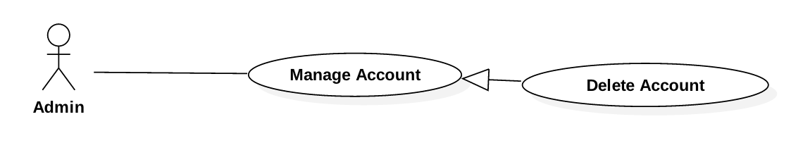

Figure 13: <Admin> Delete Account

|  |  |  |  |
| --- | --- | --- | --- |
| **USE CASE – JWL07** | | | |
| **Use Case No.** | JWL07 | **Use Case Version** | 1.0 |
| **Use Case Name** | Delete Account | | |
| **Author** | Nguyen Tuan Anh | | |
| **Date** | January 16, 2017 | **Priority** | Low |
| **Actor:**   * Admin   **Summary:**   * This use case allows Admin to delete another account.   **Goal:**   * Admin can delete any other account.   **Triggers:**   * Admin sends Update command.   **Preconditions:**   * Actor logged in system with role Admin.   **Post Conditions:**   * **Success:**   + The account’s delete date is updated in the database.  + The account can no longer be viewed or do any functions of the System.   * **Fail:** Error message is displayed.   **Main Success Scenario:**   |  |  |  | | --- | --- | --- | | Step | Actor Action | System Response | | 1 | Admin sends Delete Account command on a specific account. | System shows Delete Account pop up which includes:   * “Username”: label * “Full name”: label * “Date of Birth”: label * “Phone number”: label * “Account Type”: label * System asks for confirmation. | | 2 | Admin sends Confirm command.  [Alternative 1] | * System update the account’s delete date in the database. * System displays a successful message: “the Account [username] is Successfully deleted” |   **Alternative Scenario:**   |  |  |  | | --- | --- | --- | | No | Cause | System Response | | 1 | Admin sends Cancel command. | System closes the Delete Account pop up. |   **Exception: N/A**  **Relationships: N/A**  **Business Rules:**   * Deleted account’s record is still kept in the database, only the delete date is updated. * Deleted account cannot be viewed or do anything function of the System. | | | |

##### Librarian

###### <Librarian> Overview Use Case

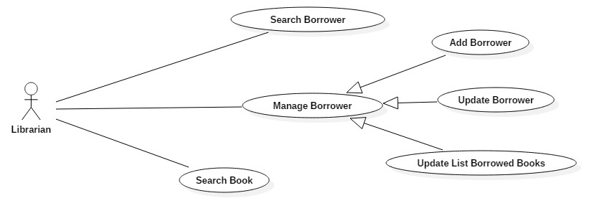

Figure 14: <Librarian> Overview Use Case

###### <Librarian> Search Book

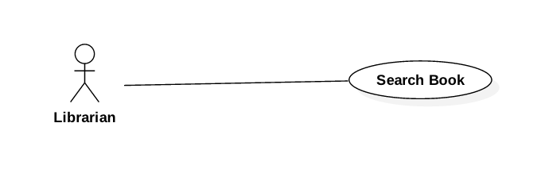

Figure 15: <Librarian> Search Book

|  |  |  |  |
| --- | --- | --- | --- |
| **USE CASE – JWL08** | | | |
| **Use Case No.** | JWL08 | **Use Case Version** | 1.0 |
| **Use Case Name** | Search Book | | |
| **Author** | Dang Nhat Thien | | |
| **Date** | February 12, 2017 | **Priority** | Normal |
| **Actor:**   * Librarian   **Summary:**   * This use case allows Librarian to search book.   **Goal:**   * Librarian can get a list book that match input book’s id, book’s name or book’s author.   **Triggers:**   * Librarian changes the content of the search field.   **Preconditions:**   * Actor logged in system with role Librarian.   **Post Conditions:**   * **Success:** List of matching books based on search term is showed. * **Fail:** N/A   **Main Success Scenario:**   |  |  |  | | --- | --- | --- | | Step | Actor Action | System Response | | 1 | Librarian inputs wanted book’s id, book’s name or book’s author. | System loads the result each time the Librarian click on “Search” button. Information for each account:   * Book Title * Publisher * Description * Publish year * Number of pages * Number of copies * Book type * Position * ISBN   [Alternative 1] |   **Alternative Scenario:**   |  |  |  | | --- | --- | --- | | Step | Cause | System Response | | 1 | There is no book that matches the search term. | System shows message: “No book found.” |   **Exceptions:** N/A  **Relationships:** N/A  **Business Rules:**   * Each book has a unique id. | | | |

###### <Librarian> Add Borrower

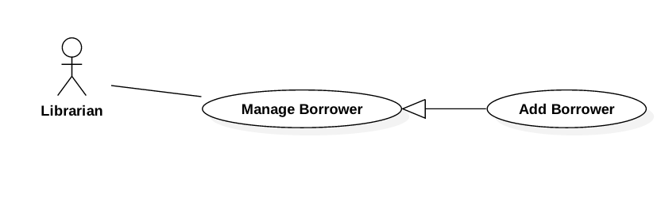

Figure 19: <Librarian> Add Borrower

|  |  |  |  |
| --- | --- | --- | --- |
| **USE CASE – JWL09** | | | |
| **Use Case No.** | JWL09 | **Use Case Version** | 1.0 |
| **Use Case Name** | Add Borrower | | |
| **Author** | Dang Nhat Thien | | |
| **Date** | February 13, 2017 | **Priority** | Normal |
| **Actor:**   * Librarian   **Summary:**   * This use case allows Librarian to create an account for Borrower   **Goal:**   * Librarian can create a new account for Borrower.   **Triggers:**   * Librarian sends Create Borrower command.   **Preconditions:**   * Actor logged in system with role Librarian.   **Post Conditions:**   * **Success:** A new Borrower with input information is added to the System database. * **Fail:** N/A   **Main Success Scenario:**   |  |  |  | | --- | --- | --- | | Step | Actor Action | System Response | | 1 | Librarian sends Create Borrower command. | System lists out the information of the new account:   * “Username”: text input, length 6-50 * “Full name”: text input, length 6-100 * “Password”: password input, length 6-50 * “Confirm Password”: password input, length 6-50 * “Date of Birth”: datetime picker * “Email”: email input * “Address”: text input, length 6-100 * “Phone number”: text input, length 8-12 * “Place of Work”: text input: length 6-50 * “Account Type”: dropdown box: Student, Teacher, Officer, Retired Officer, Business Person * Commit command. | | 2 | Librarian input the information. |  | | 3 | Librarian sends Submit command. | * System validates the input then create a new borrower. * System displays a successful message: “New Borrower: [username] is added.”   [Exception 1, 2, 3, 4, 5, 6, 7] |   **Alternative Scenario:** N/A  **Exceptions:**   |  |  |  | | --- | --- | --- | | No | Cause | System Response | | 1 | Librarian inputs Username field with wrong format. | System displays error message: “Full name length is 6-50 characters.” | | 2 | Librarian inputs Full Name field with wrong format. | System displays error message: “Full name length is 6-100 characters.” | | 3 | Librarian inputs Password field with wrong format. | System displays error message: “Password length is 6-50 characters.” | | 4 | Librarian inputs wrong Confirm Password field. | System displays error message: “Confirm Password must match Password.” | | 5 | Librarian inputs Email field with wrong format. | System displays error message: “Wrong Email format. Please input something like abc@somemail.com” | | 6 | Librarian inputs Address field with wrong format. | System displays error message: “Address length is 6-100 characters.” | | 7 | Librarian inputs Phone Number field with wrong format. | System displays error message: “Phone Number should be all numbers at 8-12 length.” | | 8 | Librarian inputs Place of Work field with wrong format. | System displays error message: “Place of Work length is 6-100 characters.” |   **Relationships:** N/A  **Business Rules:**   * Each borrower has a unique username, such as student ID, or identity ID. * Password must be encrypted before saving to the system. | | | |

###### <Librarian> Search Borrower

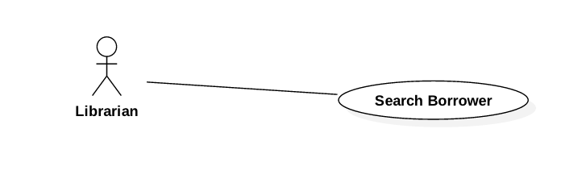

Figure 22: <Librarian> Search Borrower

|  |  |  |  |
| --- | --- | --- | --- |
| **USE CASE – JWL10** | | | |
| **Use Case No.** | JWL10 | **Use Case Version** | 1.0 |
| **Use Case Name** | Search Borrower | | |
| **Author** | Dang Nhat Thien | | |
| **Date** | February 13, 2017 | **Priority** | Normal |
| **Actor:**   * Librarian   **Summary:**   * This use case allows Librarian to search for a borrower.   **Goal:**   * Librarian can get a list borrower that match input username or full name.   **Triggers:**   * Librarian changes the content of the search field.   **Preconditions:**   * Actor logged in system with role Librarian.   **Post Conditions:**   * **Success:** List of matching borrowers based on search term is showed. * **Fail:** N/A   **Main Success Scenario:**   |  |  |  | | --- | --- | --- | | Step | Actor Action | System Response | | 1 | Librarian inputs wanted username or full name. | System loads the result each time the input search field changes. Information for each Borrower:   * Username * Full name * Date of Birth * Phone No. * Status (active/deactivated)   [Alternative 1] |   **Alternative Scenario:**   |  |  |  | | --- | --- | --- | | Step | Cause | System Response | | 1 | There is no borrower that matches the search term. | System shows message: “No borrower found.” |   **Exceptions:** N/A  **Relationships:** N/A  **Business Rules:**   * Each borrower has a unique username, such as student ID, or identity ID. | | | |

###### <Librarian> Update Borrower

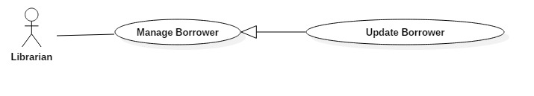

|  |  |  |  |
| --- | --- | --- | --- |
| **USE CASE – JWL11** | | | |
| **Use Case No.** | JWL11 | **Use Case Version** | 1.0 |
| **Use Case Name** | Update Borrower Information | | |
| **Author** | Dang Nhat Thien | | |
| **Date** | February 13, 2017 | **Priority** | Low |
| **Actor:**   * Librarian   **Summary:**   * This use case allows Librarian to update borrower’s information.   **Goal:**   * Librarian can update borrower’s information as he/she sends Submit command.   **Triggers:**   * Librarian sends Update command.   **Preconditions:**   * Actor logged in system with role Librarian.   **Post Conditions:**   * **Success:** The account’s personal information is updated in the database. * **Fail:** N/A.   **Main Success Scenario:**   |  |  |  | | --- | --- | --- | | Step | Actor Action | System Response | | 1 | Librarian sends Update Account command on a specific account. | System lists out the information of the account:   * “Username”: text input, length 6-50 * “Full name”: text input, length 6-100 * “Password”: password input, length 6-50 * “Confirm Password”: password input, length 6-50 * “Date of Birth”: datetime picker * “Email”: email input * “Address”: text input, length 6-100 * “Phone number”: text input, length 8-12 * “Place of Work”: text input: length 6-50 * “Account Type”: dropdown box: Student, Teacher, Officer, Retired Officer, Business Person * “Status”: dropdown box: Activate, Deactivate * Update command. | | 2 | Librarian updates information.  [Alternative 1]: Librarian change state of dropdown box |  | | 3 | Librarian sends Submit command. | * System validates the input then updates the account’s profile. * System displays a successful message: “Update Successful”   [Exception 1, 2, 3, 4, 5, 6, 7] |   **Alternative Scenario:**   |  |  |  | | --- | --- | --- | | No | Cause | System Response | | 1 | Librarian change state of dropdown box:   * From Activate to Deactivate * From Deactivate to Activate | * System show text input below the dropdown box, so Librarian can enter the reason. * System show the fee the Borrower must pay for late returning book before. |   **Exception:**   |  |  |  | | --- | --- | --- | | No | Cause | System Response | | 1 | Librarian inputs Username field with wrong format. | System displays error message: “Full name length is 6-50 characters.” | | 2 | Librarian inputs Full Name field with wrong format. | System displays error message: “Full name length is 6-100 characters.” | | 3 | Librarian inputs Password field with wrong format. | System displays error message: “Password length is 6-50 characters.” | | 4 | Librarian inputs wrong Confirm Password field. | System displays error message: “Confirm Password must match Password.” | | 5 | Librarian inputs Email field with wrong format. | System displays error message: “Wrong Email format. Please input something like abc@somemail.com” | | 6 | Librarian inputs Address field with wrong format. | System displays error message: “Address length is 6-100 characters.” | | 7 | Librarian inputs Phone Number field with wrong format. | System displays error message: “Phone Number should be all numbers at 8-12 length.” | | 8 | Librarian inputs Place of Work field with wrong format. | System displays error message: “Place of Work length is 6-100 characters.” |   **Relationships: N/A**  **Business Rules:**   * Password must be encrypted before saving to the system. * Each account has a unique username, such as student ID, or identity ID. | | | |

###### <Librarian> Update List Borrowed Books

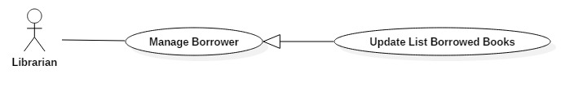

Figure 20: <Librarian> Update Borrower

|  |  |  |  |
| --- | --- | --- | --- |
| **USE CASE – JWL12** | | | |
| **Use Case No.** | JWL12 | **Use Case Version** | 1.0 |
| **Use Case Name** | Update Borrowed Books List | | |
| **Author** | Dang Nhat Thien | | |
| **Date** | February 13, 2017 | **Priority** | Low |
| **Actor:**   * Librarian   **Summary:**   * This use case allows Librarian to update list borrowed books of a borrower.   **Goal:**   * Librarian can update list borrowed books of a borrower as he/she sends Submit command.   **Triggers:**   * Librarian Click “Remove” button beside a specific book. * Click “Add” button below the list. * Librarian sends Update command.   **Preconditions:**   * Actor logged in system with role Librarian. * Librarian find out specific Borrower.   **Post Conditions:**   * **Success:** The borrowed books of a user is updated in the database. * **Fail:** N/A   **Main Success Scenario:**   |  |  |  | | --- | --- | --- | | Step | Actor Action | System Response | | 1 | Librarian sends Update Borrowed Books command on a specific Borrower. | System shows list of borrowed books of this Borrower.  Update command. | | 2 | Librarian updates list of borrowed books by:  A. Click “Remove” button beside a specific book to remove this book from list.    B.1. Click “Add” button below the list to Add book to list.  B.2. Librarian enter RFID and click on “Add” button on the pop-up. | A. System hide that book from the list.  B.1 A pop-up is displayed with Text Input for librarian can input RFID of specific book.  B.2 The system find the book by RFID and display on the list.  [Alternative 1]: Can’t find out the book by RFID. | | 3 | Admin sends Submit command. | System displays a successful message: “Borrowed books of Borrower [username] is update successfully” |   **Alternative Scenario:**   |  |  |  | | --- | --- | --- | | No | Cause | System Response | | 1 | Can’t find out the book by RFID. | Show message: “Book has [RFID] not found!” |   **Exception:** N/A  **Relationships:** N/A  **Business Rules:** N/A | | | |

#### Mobile Application

##### Borrower

###### <Borrower> Overview Use Case

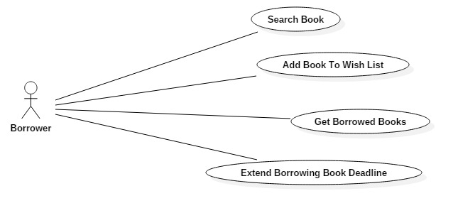

Figure 24: <Borrower> Overview Use Case

###### <Borrower> Search Book

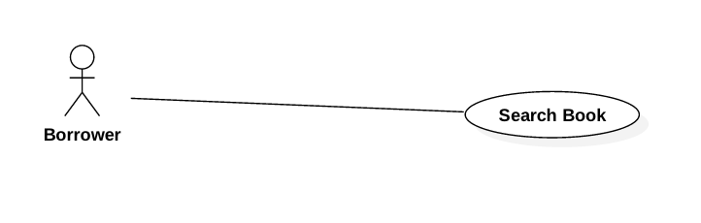

Figure 25: <Borrower> Search Book

|  |  |  |  |
| --- | --- | --- | --- |
| **USE CASE – JWL13** | | | |
| **Use Case No.** | JWL13 | **Use Case Version** | 1.0 |
| **Use Case Name** | Search Book | | |
| **Author** | Dang Nhat Thien | | |
| **Date** | February 12, 2017 | **Priority** | Normal |
| **Actor:**   * Borrower   **Summary:**   * This use case allows Borrower to search book.   **Goal:**   * Borrower can get a list book that match input book’s name or book’s author.   **Triggers:** N/A  **Preconditions:**   * Actor logged in system with role Borrower.   **Post Conditions:**   * **Success:** List of matching books based on search term is showed. * **Fail:** A Dialog will be showed and display message: “Search fail. Please check your internet connection”.   **Main Success Scenario:**   |  |  |  | | --- | --- | --- | | Step | Actor Action | System Response | | 1 | Borrower inputs wanted book’s id, book’s name or book’s author.  Then click “Search” button. | System loads the result each time the Librarian click on “Search” button. Information for each account:   * Book Title * Publisher * Description * Publish year * Number of pages * Number of copies * Book type * Position * ISBN   [Alternative 1]: There is no book that matches the search term.  [Exception 1]: Internet connection is lost. |   **Alternative Scenario:**   |  |  |  | | --- | --- | --- | | Step | Cause | System Response | | 1 | There is no book that matches the search term. | System shows message: “No book found.” |   **Exceptions:**   |  |  |  | | --- | --- | --- | | No | Cause | System Response | | 1 | Internet connection is lost. | System show error message via Dialog. |   **Relationships:** N/A  **Business Rules:**   * Each book has a unique id. | | | |

###### <Borrower> Add Book To Wish List

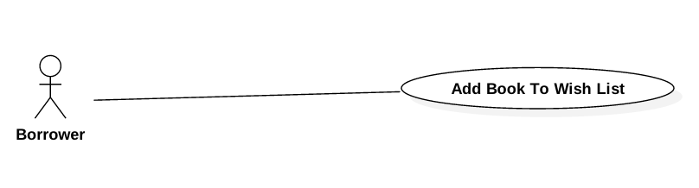

Figure 26: <Borrower> Add Book To Wish List

|  |  |  |  |
| --- | --- | --- | --- |
| **USE CASE – JWL14** | | | |
| **Use Case No.** | JWL14 | **Use Case Version** | 1.0 |
| **Use Case Name** | Add Book To Wish List | | |
| **Author** | Dang Nhat Thien | | |
| **Date** | February 12, 2017 | **Priority** | Normal |
| **Actor:**   * Borrower   **Summary:**   * This use case allows Borrower Add Book To Wish List.   **Goal:**   * The book is saved as wish book of specific Borrower.   **Triggers:** After find out a book, Borrower click on “Add to wish list” button in Book detail.  **Preconditions:**   * Actor logged in system with role Borrower. * Borrower find out the book. <Borrower> Search Book   **Post Conditions:**   * **Success:** A dialog will be showed and display message: “Book [title] has been add to your wish list!”. * **Fail:** A dialog will be showed and display message: “Add fail. Please check your internet connection”.   **Main Success Scenario:**   |  |  |  | | --- | --- | --- | | Step | Actor Action | System Response | | 1 | After find out a book, Borrower click on “Add to wish list” button in Book detail. | * System save to database and display success message.   [Exception 1] Lost Internet Connection |   **Alternative Scenario:** N/A  **Exceptions:**   |  |  |  | | --- | --- | --- | | No | Cause | System Response | | 1 | Lost Internet Connection | System show error message via Dialog. |   **Relationships:** <Borrower> Search Book  **Business Rules:** N/A | | | |

###### <Borrower> Get Borrowed Books

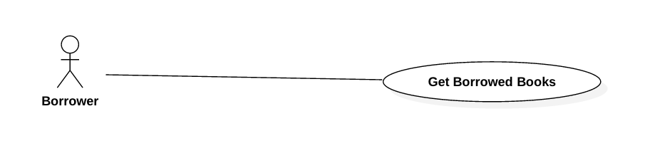

Figure 27: <Borrower> Get Borrowed Books

|  |  |  |  |
| --- | --- | --- | --- |
| **USE CASE – JWL15** | | | |
| **Use Case No.** | JWL15 | **Use Case Version** | 1.0 |
| **Use Case Name** | Get Borrowed Books | | |
| **Author** | Dang Nhat Thien | | |
| **Date** | February 12, 2017 | **Priority** | Normal |
| **Actor:**   * Borrower.   **Summary:**   * This use case allows Borrower Get Borrowed Books.   **Goal:**   * Borrower can get a list borrowed books.   **Triggers:** Borrower click on “Show borrowed books” item on Left Slide Menu.  **Preconditions:**   * Actor logged in system with role Borrower.   **Post Conditions:**   * **Success:** List borrowed books is displayed. * **Fail:** A dialog will be showed and display message: “Loading fail. Please check your internet connection”.   **Main Success Scenario:**   |  |  |  | | --- | --- | --- | | Step | Actor Action | System Response | | 1 | Borrower click on “Show borrowed books” item on Left Slide Menu. | System show list borrowed books.  [Exception 1] Lost Internet Connection. |   **Alternative Scenario:** N/A  **Exceptions:**   |  |  |  | | --- | --- | --- | | No | Cause | System Response | | 1 | Lost Internet Connection | System show error message via Dialog. |   **Relationships:** N/A  **Business Rules:** N/A | | | |

###### <Borrower> Extend Borrowed Book Deadline

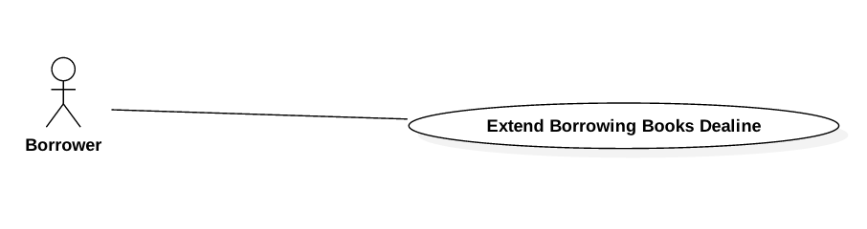

Figure 28: <Borrower> Extend Borrowed Book Deadline

|  |  |  |  |
| --- | --- | --- | --- |
| **USE CASE – JWL16** | | | |
| **Use Case No.** | JWL16 | **Use Case Version** | 1.0 |
| **Use Case Name** | Extend Borrowed Book Deadline | | |
| **Author** | Dang Nhat Thien | | |
| **Date** | February 12, 2017 | **Priority** | Normal |
| **Actor:**   * Borrower   **Summary:**   * This use case allows Borrower Extend Borrowed Book Deadline   **Goal:**   * Borrower can Extend Borrowed Book Deadline.   **Triggers:** N/A  **Preconditions:**   * Actor logged in system with role Borrower.   **Post Conditions:**   * **Success:** A dialog will be showed and display message: “Book [title] has been extends to [deadline]!” * **Fail:** A dialog will be showed and display message: “Loading fail. Please check your internet connection!”.   **Main Success Scenario:**   |  |  |  | | --- | --- | --- | | Step | Actor Action | System Response | | 1 | After get list borrowed books, Borrower click on “Extends” button in Book detail. | System return new deadline and show success message.  [Exception 1] Lost Internet Connection. |   **Alternative Scenario:** N/A  **Exceptions:**   |  |  |  | | --- | --- | --- | | No | Cause | System Response | | 1 | Lost Internet Connection | System display error message. |   **Relationships:** <Borrower> Get Borrowed Books  **Business Rules:** N/A | | | |

##### Automatic Handler

###### <Automatic Handler> Overview Use Case

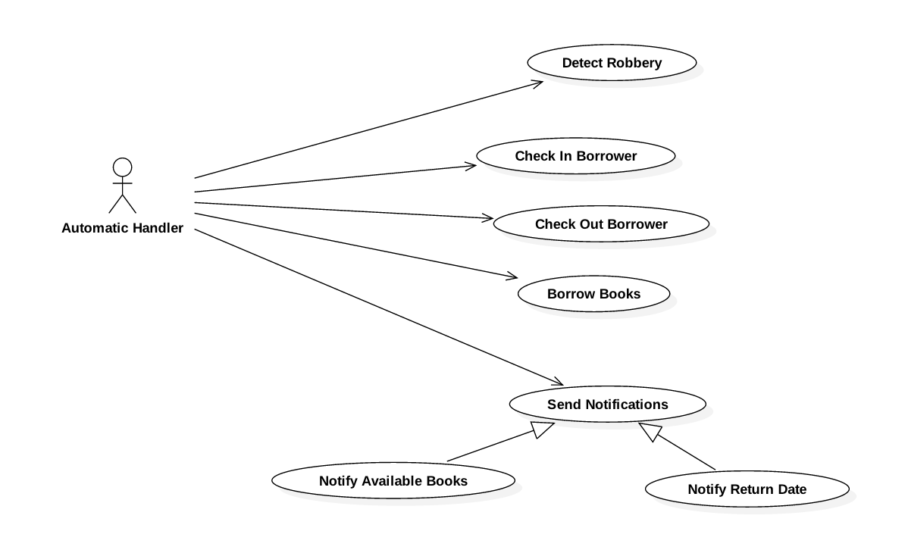

Figure 29: <Automatic Handler> Overview Use Case

###### <Automatic Handler> Detect Robbery

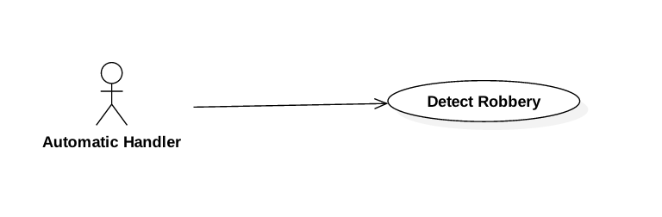

Figure 30: <Automatic Handler> Detect Robbery

###### <Automatic Handler> Check In Borrower

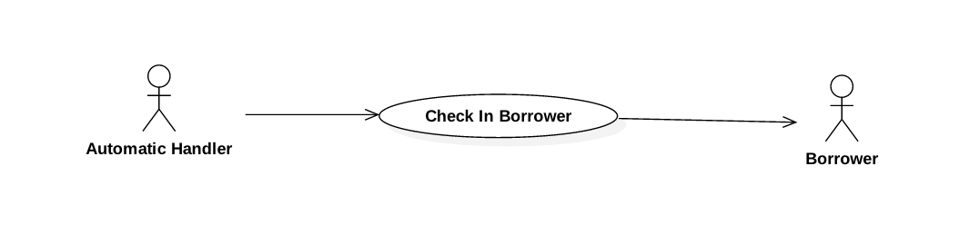

Figure 31: <Automatic Handler> Check In Borrower

###### <Automatic Handler> Check Out Borrower

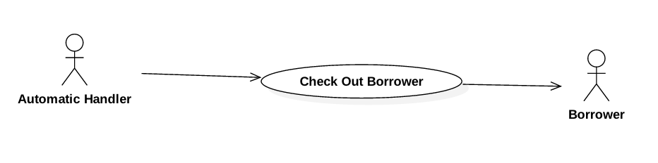

Figure 32: <Automatic Handler> Check Out Borrower

###### <Automatic Handler> Borrow Books

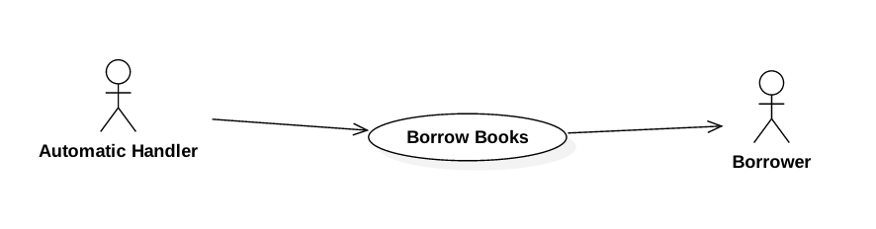

Figure 33: <Automatic Handler> Borrow Books

###### <Automatic Handler> Notify Available Books

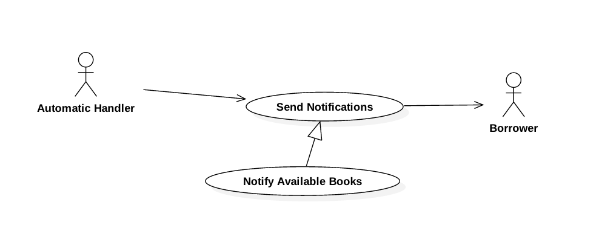

Figure 34: <Automatic Handler> Notify Available Books

###### <Automatic Handler> Notify Return Date

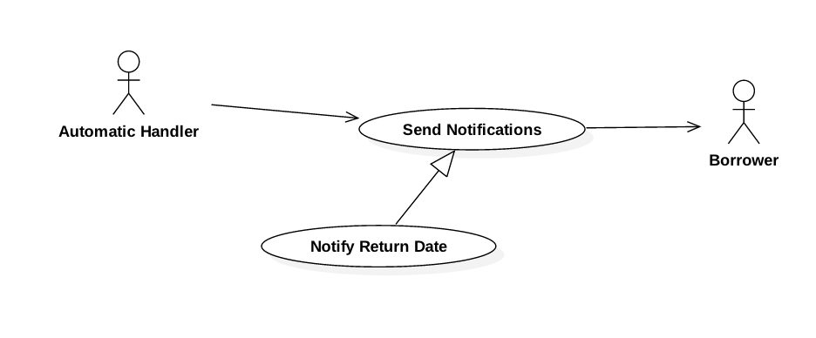

Figure 35: <Automatic Handler> Notify Return Date

## Software System Attribute



### Usability

* The Android application for emulator requires 10 minutes training for staff.
* The Android application for passenger will take 10-30 minutes to get used to the mobile system completely

### Reliability

* The number of sending notification failure is 1 time per 1000 notifications.
* Timer tasks run at configured time with 100% execution rate.

### Availability

* System is available 24 hours per day and 7 days per week.
* System should take at most 5 hours per month for backup or repairing.

### Security

* Privacy: Each role of user has a specific permission to interact with system.
* System requires SMS verification for all users.
* System always checks authorization and authenticated before doing anything.
* Only admin can grant permission to other roles.

### Maintenanability

* The system is divided into separated modules.
* The code is easy to maintain and upgrade.

### Portability

* The web application is running on Windows Server 2008 or above.
* Mobile application for passenger and emulator runs on Android API greater than 4.1.
* Providing easy installation.

### Performance

* Web appication handles the task within 10 seconds.
* System response time of SMS message depend on telecomunications infrastructurs and server.
* Emulator reads data from NFC card in less than 5 second within the distance between 0 centimeter and 1 centimeter in the condition with no obstacle.

## Conceptual Diagram

1. 

Figure 45: Conceptual Diagram

**Data Dictionary:**

|  |  |
| --- | --- |
| Entity Name | Description |
| User | Contains all properties about user. |
| Passenger | Contains all properties about passenger info. |
| Admin | Contains all properties about admin info. |
| Staff | Contains all properties about staff info. |
| Manager | Contains all properties about manager info. |
| Card | Contains all properties about NFC card. |
| Ticket Type | Contains all properties about ticket type for based on bus route, each ticket type has diffirent price. |
| Bus Route | Contains all properties about bus route in Ho Chi Minh City. |
| Ticket | Contains all properties about ticket to specify which card buy ticket belongs to which ticket type on which bus route. |
| Credit Plan | Contains all info about credit plan which will be chosen while adding credit to card. |
| Payment Transaction | Contains all info about transaction when adding credit to card via cash, credit plan or scratch card. |
| Promotion | Contains all info about promotion. |
| Scratch Card | Contains all info about scratch card. |
| Offer Subscription | Contains all info about offer subscription. |
| User Subscription | Contains all info about user subscription to specify who subscribe which offer subscription. |

Table 35: Conceptual Diagram Data Dictionary