Canadian Virtual Exchange

Bitcoin Payment Processing Module

for the Übercart E-Commerce Platform

Developed by Kipp Grose , November 2013

<http://www.linkedin.com/in/kippgrose>

kippgrose@live.ca

This module adds Bitcoin payment processing support for Übercart 3. Using your Canadian Virtual Exchange Merchant Account, you can now receive payments in Bitcoin. First you must have a registered merchant account with VirtEx. Upon checkout with this payment option, users will be sent to VirtEx servers and CDN will be converted to BTC value at the current exchange rate. Users follow the Bitcoin payment instructions provided by VirtEx and when the payment has been received, Übercart updates the transaction as paid automatically.

Installation

1. Ensure you are running the latest Drupal Core and Übercart files and have all the prerequisite modules they want installed before hand. All required modules should be (enabled).
2. Copy all the files contained in this package to ../modules/ubercart/uc_cavirtex



Setup Guide

Configuring the VirtEx Bitcoin payment gateway to work with Übercart is simple. Just follow this step by step guide to configuring and using this module and begin accepting Bitcoin payments on your website directly into your VirtEx merchant account. No programming knowledge is required but these instructions do assume a familiarity with Drupal and Übercart administration and that you already have a merchant account with the Canadian Virtual Exchange and are familiar with the merchant tools available on their website and have already setup your merchant account for accepting payments.

Configuration

1. After copying the files into your Drupal installation’s Übercart modules directory, go to the modules section of the Drupal administration site and check for updates (you will see “Failed to get update data for one project”. Sorry about that, I aim to incorporate the update system in a future release). You will see a new entry in your Übercart:

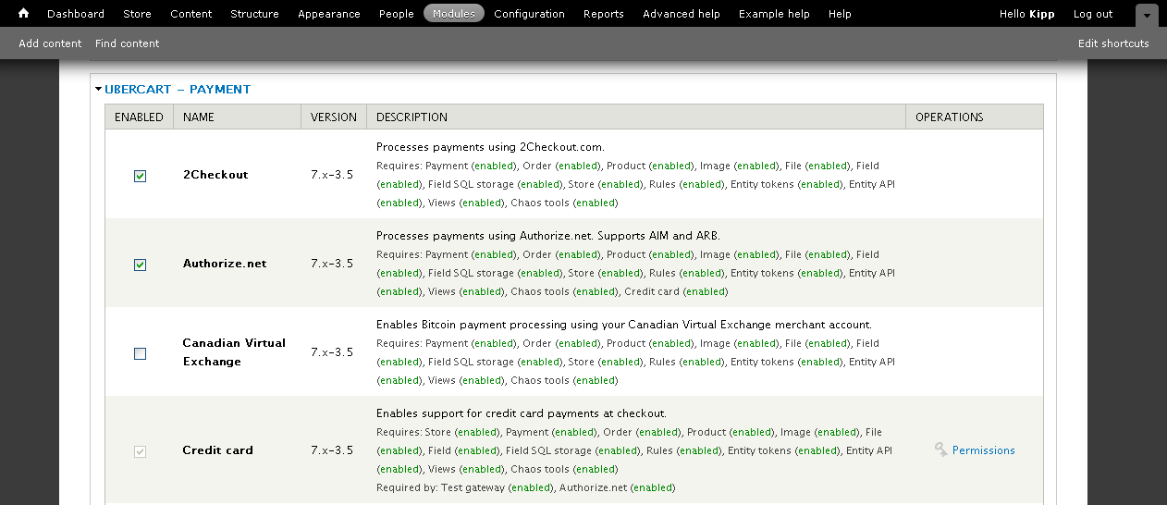

1. Enable the module and then head over to Store administration and then Payment Methods:

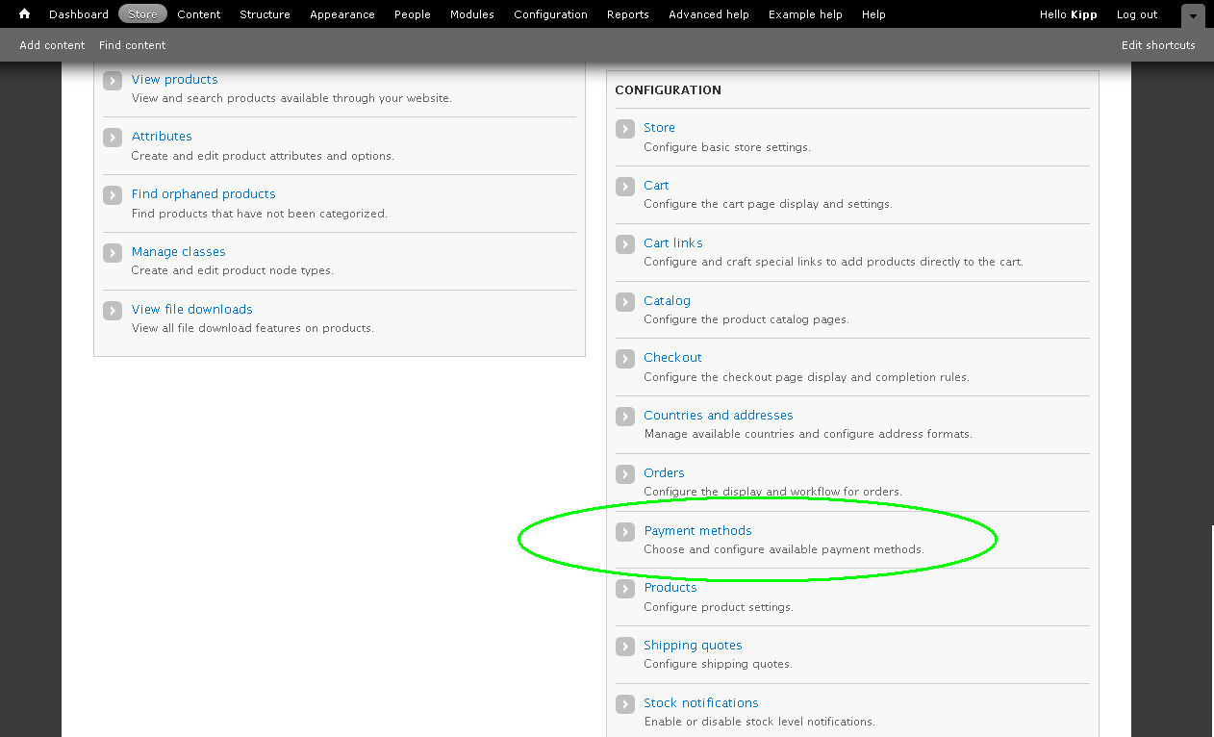

1. Enable Canadian Virtual Exchange and select Settings:

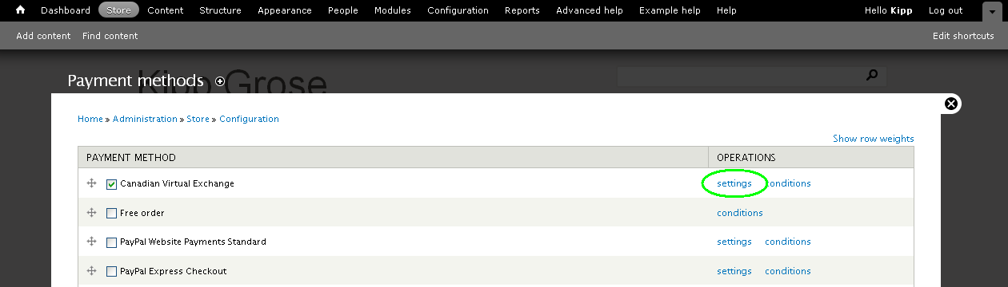

1. Last step, all you need to do is enter your Canadian Virtual Exchange Merchant Key:

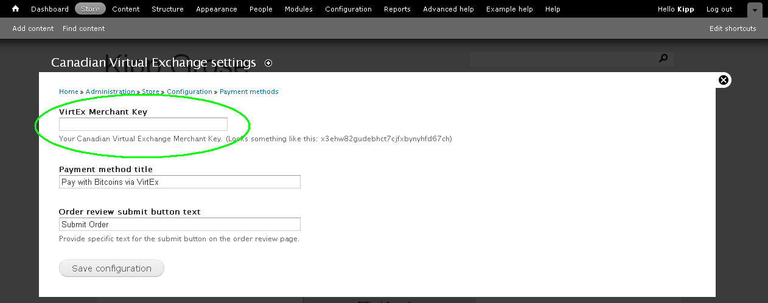

Your VirtEx Merchant Key can be found on your VirtEx Merchant Profile Page:

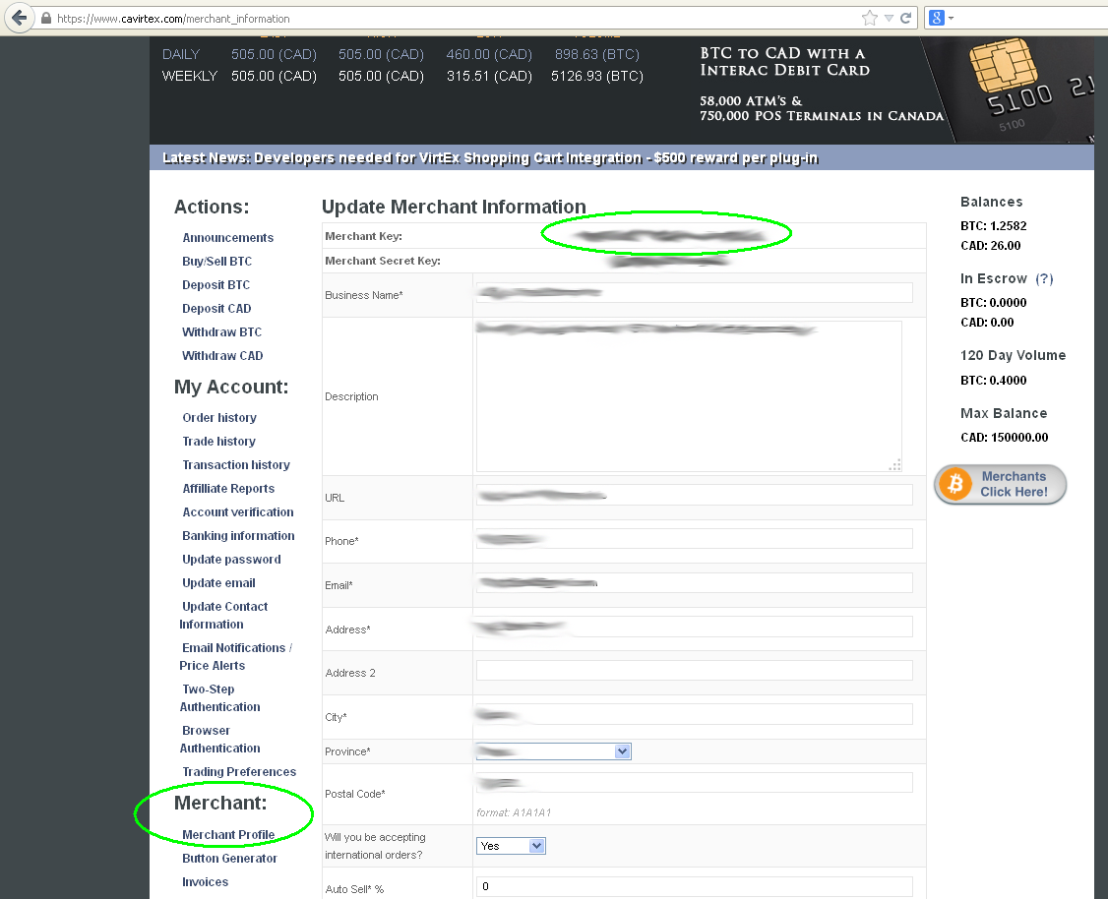

The User Experience

After filling up their shopping basket on your website, your shopper will enter the checkout process. As they complete the process and get to the payment method screen, they will now be able to select an option to pay with Bitcoin. You can modify what text is displayed for this payment option by going to Store, then Payment Methods and then in settings for Canadian Virtual Exchange.

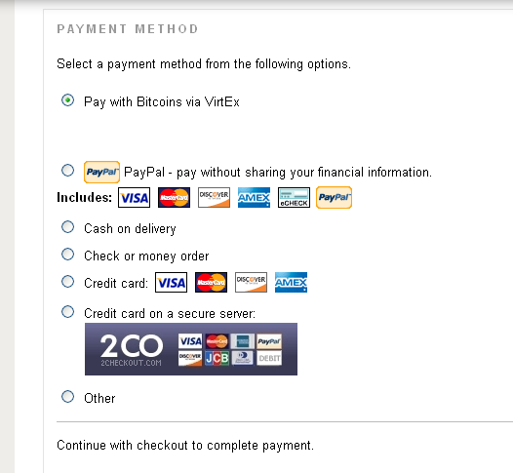

When the user gets to the Review Order screen, they review the details of their order and then proceed by clicking the Submit Order button. You can modify the text of the button by going to Store, then Payment Methods and then in settings for Canadian Virtual Exchange.

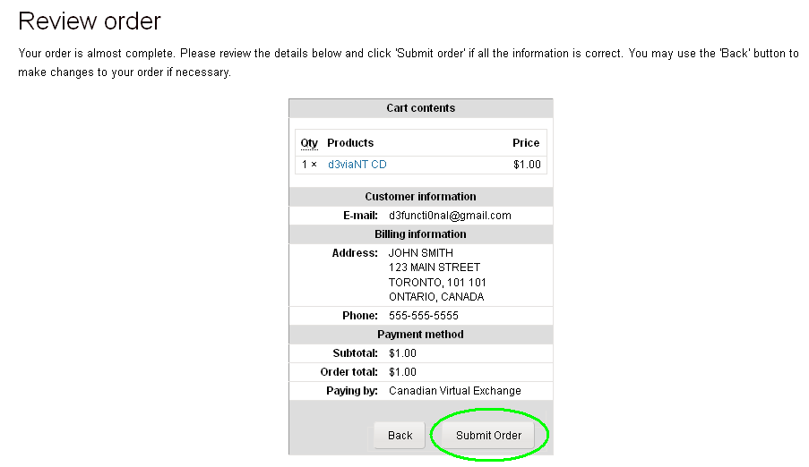

The user is then sent to VirtEx’s server to receive instructions on how to fulfill the Bitcoin payment. The user is presented with a 15 minute time window to send the requested amount of BTC through the Bitcoin network to the specified Bitcoin address. The transaction is usually detected within seconds by VirtEx’s servers and is instantly approved, no waiting around for confirmations is required. When the Bitcoin payment is received, the screen is updated to inform the user that the payment has been received and a link back to originating website is provided. When the user follows the link to return to the originating website, Übercart updates the order database with the payment information.

You can see this process illustrated on the following pages.

VirtEx Bitcoin Payment Gateway

Awaiting Payment

After providing an email address, the user is presented with an amount in BTC and a bitcoin address to send it to. The user has 15 minutes to complete the transaction.

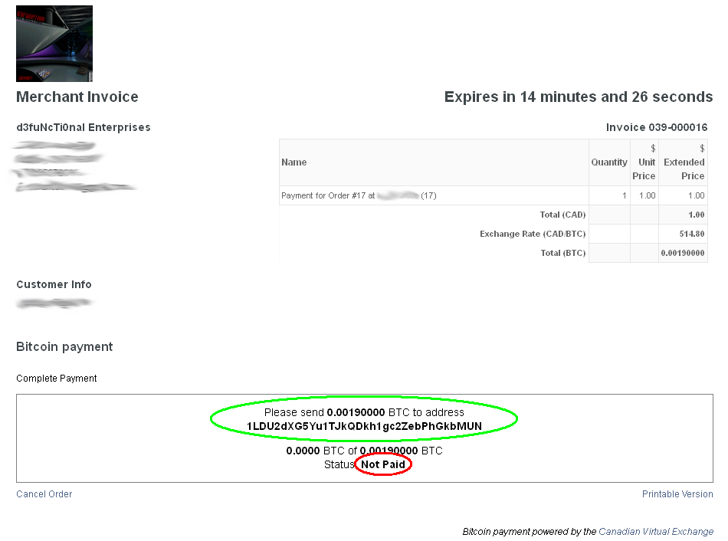

VirtEx Bitcoin Payment Gateway

Payment Received

When the payment is received by VirtEx’s server, the screen is updated and a link back to the originating website is provided.

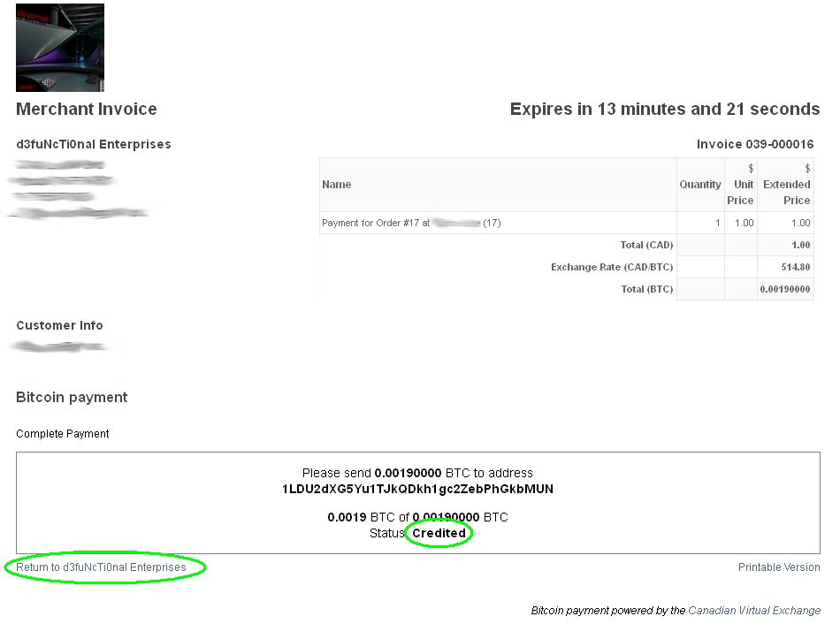

Returning to Your Website

Finally, the user sees a confirmation screen on your website and all is well in the world.

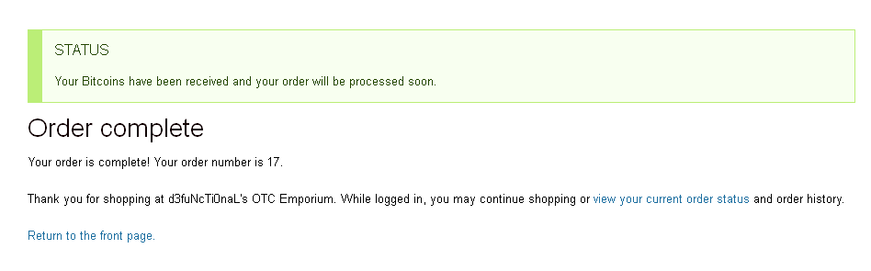

Viewing the Transaction in Übercart

Übercart will show the payment in the original CAD dollars. The Bitcoin conversation is handled by VirtEx. The current currency conversion rate of CAD/BTC is not fed back to your website, just the fact that the transaction was paid and that the method of payment was the Canadian Virtual Exchange. The conversation rate at the time of the transaction can be found on VirtEx’s website, under Invoices.

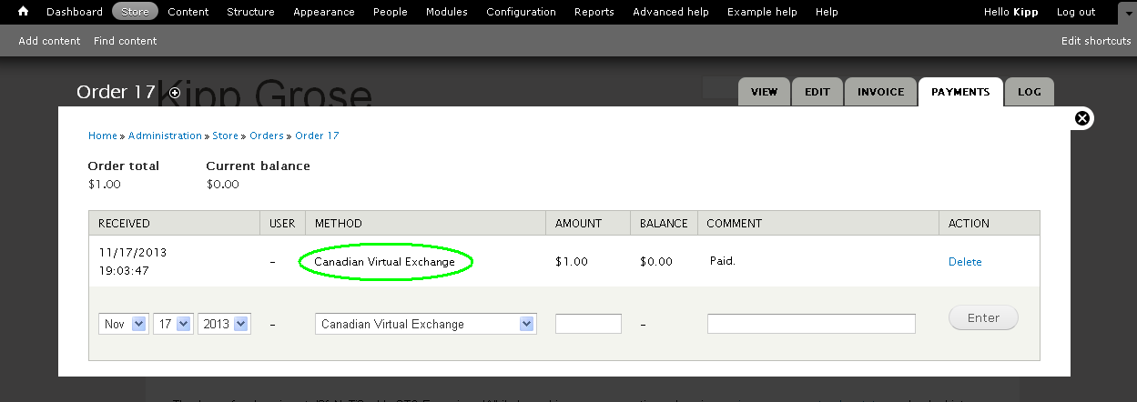

Viewing the Transaction (Invoice) in VirtEx

Note that the Transaction ID’s of your website and your VirtEx merchant account will not necessarily be in sync. To see what order from your website each invoice is for, you must click on the invoice. The Übercart based order number from your website will be provided in the description.

