Stock Price Analysis Report
2014.09 ~ 2018.04
19 Stocks | 896 Trading Days

1. Overview
This report analyzes the stock price data of 19 companies over approximately 3 years and 7 months, from September 2014 to April 2018. The analysis covers price trends, total returns, volatility, and inter-stock correlations.

1.1 Dataset Summary
Item | Details
Analysis Period | September 19, 2014 ~ April 11, 2018 (approx. 3 years 7 months)
Number of Stocks | 19 stocks (AAAA, FF, BBBB, ZZZZ, GG, DDD, WWW, CCC, GGMM, TTT, UUU, SSSS, XXX, RRR, YYY, MM, PPP, JJJ, SSXX)
Trading Days | 896 days
Data Source | stock_prices.csv

2. Stock Price Trend Analysis
The chart below shows the normalized price trends of all 19 stocks (base = 100 at start date), total return rankings, and a comparison of the top 5 vs. bottom 5 performers.

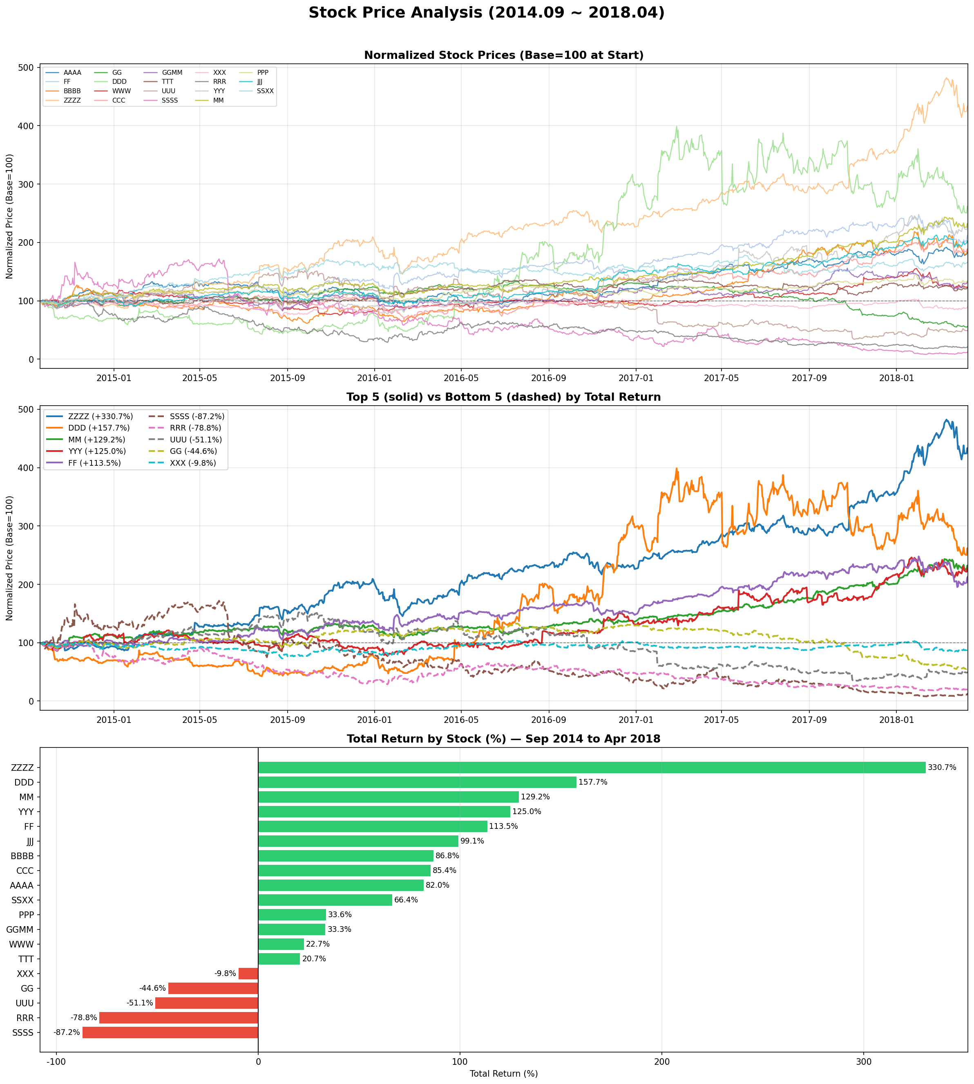
[Figure 1] Normalized Stock Price Trends & Total Return Rankings

2.1 Top 5 Performers (by Total Return)
Rank | Ticker | Total Return | Remarks
1 | ZZZZ | +330.7% | Best performer — over 4x return in 3.5 years
2 | DDD | +157.7% | High volatility (64.4%) but strong returns
3 | MM | +129.2% | Steady upward trend
4 | YYY | +125.0% | Consistent growth with moderate volatility
5 | FF | +113.5% | Doubled in value over the period

2.2 Bottom 5 Performers (by Total Return)
Rank | Ticker | Total Return | Remarks
15 | XXX | -9.8% | Slight decline, relatively stable
16 | GG | -44.6% | Significant downtrend throughout the period
17 | UUU | -51.1% | Lost more than half its value
18 | RRR | -78.8% | Severe decline with high volatility (50.0%)
19 | SSSS | -87.2% | Worst performer — highest volatility (70.0%) + worst return

2.3 Full Return Rankings
Rank | Ticker | Return | Rank | Ticker | Return | Rank | Ticker | Return
1 | ZZZZ | +330.7% | 8 | CCC | +85.4% | 15 | XXX | -9.8%
2 | DDD | +157.7% | 9 | AAAA | +82.0% | 16 | GG | -44.6%
3 | MM | +129.2% | 10 | SSXX | +66.4% | 17 | UUU | -51.1%
4 | YYY | +125.0% | 11 | PPP | +33.6% | 18 | RRR | -78.8%
5 | FF | +113.5% | 12 | GGMM | +33.3% | 19 | SSSS | -87.2%
6 | JJJ | +99.1% | 13 | WWW | +22.7%
7 | BBBB | +86.8% | 14 | TTT | +20.7%

3. Volatility & Correlation Analysis
The chart below presents the annualized volatility of each stock and the return correlation heatmap between all 19 stocks.

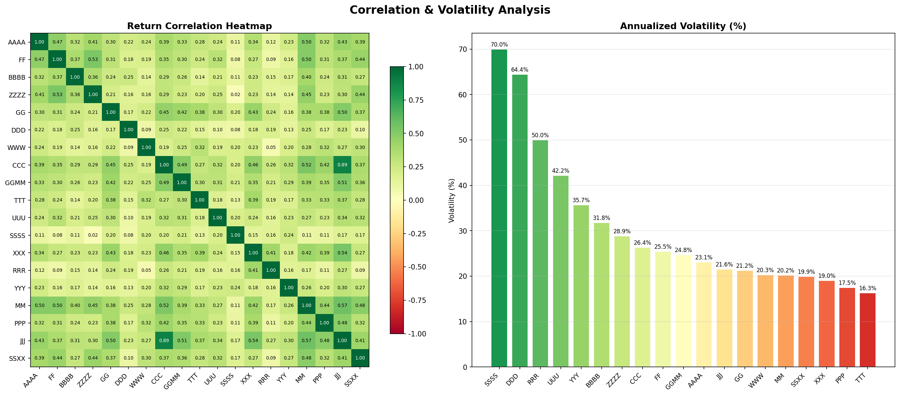
[Figure 2] Correlation Heatmap & Annualized Volatility

3.1 Annualized Volatility Rankings
Rank | Ticker | Volatility | Rank | Ticker | Volatility | Rank | Ticker | Volatility
1 | SSSS | 70.0% | 8 | GGMM | 24.8% | 15 | MM | 20.2%
2 | DDD | 64.4% | 9 | FF | 25.5% | 16 | SSXX | 19.9%
3 | RRR | 50.0% | 10 | AAAA | 23.1% | 17 | XXX | 19.0%
4 | UUU | 42.2% | 11 | JJJ | 21.6% | 18 | PPP | 17.5%
5 | YYY | 35.7% | 12 | GG | 21.2% | 19 | TTT | 16.3%
6 | BBBB | 31.8% | 13 | WWW | 20.3%
7 | ZZZZ | 28.9% | 14 | CCC | 26.4%

3.2 Correlation Analysis
Key findings from the return correlation heatmap:
- Most stocks show positive correlation, indicating they tend to move together with the broader market.
- SSSS, DDD, and RRR exhibit lower correlations with other stocks, suggesting more independent price movements.
- Stocks with similar business characteristics tend to cluster with higher mutual correlations.
- Diversification benefits are limited when most stocks are positively correlated.

4. Key Insights

4.1 High Return Stocks
- ZZZZ achieved the highest return of +330.7%, growing more than 4x in approximately 3.5 years.
- DDD delivered +157.7% return despite high volatility (64.4%), demonstrating a high-risk, high-reward profile.
- MM, YYY, and FF all more than doubled in value, showing consistent upward trends.

4.2 High Risk Stocks
- SSSS recorded the worst performance: highest volatility (70.0%) combined with the worst return (-87.2%).
- RRR and UUU also showed severe declines (-78.8%, -51.1%) with high volatility.
- These stocks represent the classic high-risk, low-reward scenario.

4.3 Stable Low-Volatility Stocks
- TTT (16.3%), PPP (17.5%), and XXX (19.0%) showed the lowest volatility.
- While their returns were modest, they provided stability and capital preservation.
- These stocks are suitable for risk-averse investors seeking steady, predictable performance.

4.4 Overall Market Trend
- Most stocks showed an upward trend from 2016 onward, suggesting a broad market recovery.
- The period from late 2014 to early 2016 was relatively volatile with mixed performance.
- The divergence between winners and losers widened significantly after 2016.

5. Conclusion
This analysis of 19 stocks over approximately 3.5 years (September 2014 to April 2018) reveals significant performance divergence across the portfolio. The key takeaways are:

- ZZZZ was the standout winner with +330.7% total return, while SSSS was the worst performer at -87.2%.
- High volatility does not always translate to high returns — DDD succeeded while SSSS and RRR failed.
- Low-volatility stocks (TTT, PPP) provided stability but limited upside.
- Most stocks are positively correlated, limiting diversification benefits within this portfolio.
- The post-2016 period saw broad market gains, benefiting most stocks except the structural underperformers.

Generated by AI Analysis Agent

