Smart Campus Classroom Monitoring
  - Technical Report for the Midterm Project
Real-Time Data Analysis and Decision Making
Daniyar Sharipov, Zhanashev Aibyn | BDA-2404 | 28 September 2026

1 Project overview
This project implements a Python system that receives classroom observations one at a time, cleans each record and updates current indicators. I use a reproducible generator to represent temperature, carbon dioxide concentration and occupancy in three fictional classrooms. The system displays progress in the console, detects configured events and saves the input and results for replay.
The reference run received 541 records, accepted 536 and rejected 5. It filled missing sensor values in 3 records and flagged 60 observations. Nine automated checks passed, and replaying the saved source produced the same calculated results. These results demonstrate the processing pipeline on synthetic data; they do not measure conditions in real classrooms.

Problem and intended decision
A campus operator needs to notice when classroom conditions change during a teaching session. Reviewing a complete dataset only after the session would delay that decision. The proposed system updates a short history for each room and highlights observations that may require attention. A sustained CO2 increase suggests checking ventilation and occupancy. A temperature event suggests inspecting cooling, while a sudden CO2 jump suggests checking the sensor or a rapid change in the room.

Project objectives
The objectives are to acquire timestamped records incrementally, handle common data-quality problems, calculate at least three current indicators with Pandas and NumPy, and apply understandable event rules. The implementation also needs a continuously updated output and persistent results so that another person can reproduce and inspect the analysis.

Scope and submitted materials
The project covers the Weeks 1–4 topics: Python functions and state, streaming acquisition, data cleaning, transformation and aggregation. The submission includes modular Python code, a raw JSONL dataset, a seeded generator, an executed notebook, installation instructions, test evidence, result tables and two figures. The application runs locally after dependency installation and requires no external API or sensor connection.
The thresholds and room capacity are explicit project assumptions. The program records suggested events for a human operator and does not control ventilation equipment. The design is a finite teaching demonstration rather than a production monitoring service.

2 Data source and schema
The source represents three rooms named C101, C102 and C103. Each room produces one observation every 10 seconds of event time. The reference dataset uses 180 steps, starting at 04:00:00 UTC on 28 September 2026 and ending at 04:29:50 UTC. This corresponds to 09:00:00–09:29:50 at UTC+5. The simulated interval covers about 30 minutes.
Table 1 Incoming record schema and validation ranges
Field | Clean type | Meaning and accepted values
event_id | String | Room plus sample index; used to identify duplicate records
timestamp | UTC time | ISO 8601 event time; must increase within each room
room | String | One of C101, C102 or C103
temperature_c | Float | Temperature in degrees Celsius; range 0 to 50
co2_ppm | Float | CO2 concentration in parts per million; range 250 to 5000
occupancy | Integer | Number of people; range 0 to 60

Reproducible generation
The function generate_stream uses NumPy default_rng with seed 42 [3]. Occupancy follows a changing pattern with small random variation. CO2 depends on occupancy plus noise, and temperature follows a small drift plus noise. The function yields each observation as a dictionary, so the consumer does not need to create the complete dataset before processing it. The supplied JSONL stores one incoming record per line.

Controlled events and errors
C102 receives an additional 850 ppm of CO2 and 3 C at steps 60–109. This represents a sustained ventilation problem. C103 receives an additional 6 C at steps 130–138. C101 receives a one-record CO2 increase of 1000 ppm at step 145. These controlled patterns make the different rules visible in the results without claiming real environmental measurements.
The generator also inserts three missing or nonnumeric sensor values, one decimal comma, four invalid records and one duplicate. The invalid records contain missing occupancy, a temperature of 99 C, an invalid timestamp and negative occupancy. The duplicate raises the received count from 540 to 541. Each issue is intentional and reproducible.

Event time and demonstration speed
Event timestamps determine all windows. The command-line delay only pauses delivery between records. Running with zero delay therefore changes the playback speed while preserving the analytical results. A paced run makes the incremental behavior visible; it is not a measurement of network latency or real sensor throughput.

3 Incremental processing and storage
The main loop requests one record, writes the raw input, validates it, updates the corresponding room and saves the result before requesting the next record. The Python generator uses yield to pause between observations [4]. The alternative replay source reads one JSONL line at a time and follows the same processing path.
Table 2 Responsibilities of the implementation modules
Module | Responsibility
source.py | Generate observations, replay JSONL and apply delivery pacing
processing.py | Validate input, fill eligible sensor values, maintain windows and detect events
storage.py | Write raw, rejected, cleaned, metric and alert records incrementally
visuals.py | Create the final grouped summary and charts from stored results
main.py | Connect the stages, display progress and record run settings

Validation and causal cleaning
Pandas converts timestamps to UTC and converts numeric strings with errors set to coerce, which turns an unsuccessful numeric conversion into a missing value [1]. A decimal comma is replaced with a decimal point. NumPy checks that all resulting numbers are finite. The cleaner then checks room membership, field ranges, integer occupancy, duplicate accepted IDs and increasing timestamps within each room.
Missing temperature or CO2 can use the last actually observed value from the same room when it is at most 60 seconds old. An imputed value does not reset that age, so a chain of missing observations cannot extend the source value indefinitely. Missing occupancy is rejected. No future observation is used, and rejected records do not update the accepted history. The cleaned row records which fields were filled.

Window state
Each room has a separate deque. Before adding a new accepted reading, the processor removes readings at or before the current timestamp minus 60 seconds. The resulting window is open on the left and closed on the right. With complete 10-second sampling it contains six readings. A small DataFrame created from this window supports Pandas rolling calculations. The complete input is not loaded for online analysis.

Persistent results
The system flushes CSV and JSONL files after every received record. It stores all raw input, rejected input with reasons, cleaned records, metrics and flagged observations. The final manifest records settings, package versions and counts. Final summary tables and figures are built from the completed metrics file. Existing nonempty output folders are protected from overwriting. The duplicate-ID set grows with the run, so only the analytical window is bounded by time.

4 Indicators and event detection
The processor recalculates the indicators after each accepted record. All window calculations use the event-time interval (t minus 60 seconds, t], including the new observation. During startup, the calculation uses the readings already available. This provides early output while the window is still filling.
Table 3 Indicators updated for every accepted record
Indicator | Method and interpretation
CO2 mean over 60 seconds | Pandas rolling mean; describes the recent CO2 level
CO2 standard deviation | NumPy std with ddof=0; describes variation inside the current window
Maximum temperature | NumPy maximum over the current window; retains a recent peak
Event count over 60 seconds | Number of accepted observations in the current window
Occupancy percentage | Current people divided by a configured capacity of 40, multiplied by 100
Total room events | Cumulative count of accepted records for this room

A time-based rolling mean uses timestamp boundaries rather than a fixed number of rows [2]. This matters when invalid observations are rejected: a minute can contain fewer than six accepted readings. The standard deviation uses the population definition for the values in that window. With one reading it is zero. Occupancy percentage is not clipped, so values above the configured capacity would remain visible.

Detection rules and operator response
Rule | Condition | Suggested response
CO2_HIGH | Mean CO2 > 1200 ppm and at least 3 accepted readings in the window | Check ventilation and occupancy
TEMP_HIGH | Current temperature > 28 C | Inspect the room and cooling
CO2_JUMP | Positive CO2 change > 400 ppm from the previous accepted reading still in the window | Check the sensor or a sudden change

The jump rule skips comparisons when either CO2 value was imputed. The sustained CO2 rule waits for at least three accepted observations, while the temperature and jump rules can respond earlier. All inequalities are strict. The thresholds are demonstration choices and have not been calibrated as official environmental standards.

How to interpret an alert
Each matched rule is attached to the current record. One record can match several rules, and a long event can produce many consecutive flagged observations. Therefore, the number of flagged rows is not the number of separate incidents. The program keeps these rows for analysis; merging them into incident intervals is outside the present scope.

5 Results and interpretation
The reference run used seed 42 and the pinned package versions. It received 541 records, accepted 536 and rejected 5. Three accepted records required sensor-value filling, and one needed decimal normalization. The table below summarizes the accepted observations; averages therefore include the three causally filled values.
Table 4 Summary of the reference run
Room | Accepted | Mean CO2  ppm | Max CO2  ppm | Max temp  C | Flagged  rows
C101 | 178 | 813.66 | 1741.5 | 23.74 | 1
C102 | 180 | 1051.65 | 1648.7 | 26.72 | 50
C103 | 178 | 797.95 | 1036.2 | 30.62 | 9

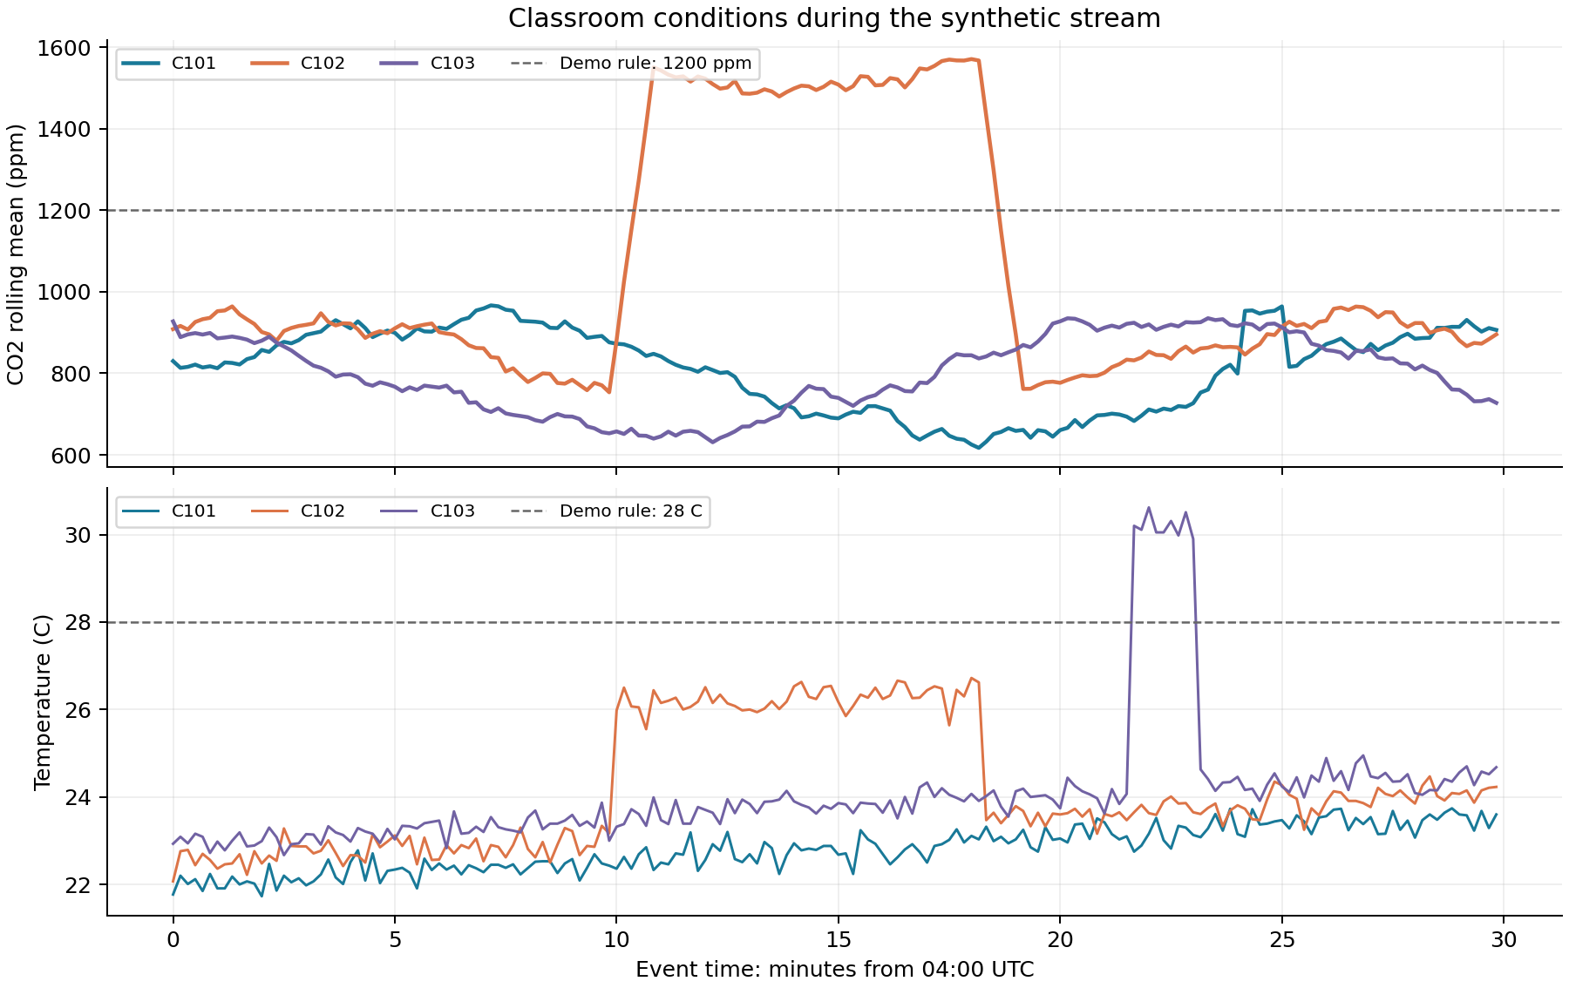
Figure 1 Rolling CO2 means and current temperatures for the synthetic stream
C102 has the highest mean CO2 at 1051.65 ppm because of its sustained event. CO2_JUMP first triggers at 04:10:00 UTC. CO2_HIGH begins at 04:10:30 UTC and remains active briefly after the elevated input ends. This delay is expected because the mean still contains older readings.
C103 reaches 30.62 C and produces nine temperature flags. The isolated C101 spike reaches 1741.5 ppm and triggers CO2_JUMP, while its minute mean remains below 1200 ppm. Combining a smoothed indicator with a change rule detects different patterns. These observations describe the generated examples, not measured detection accuracy on real data.

6 Demonstration and verification
The console displays received, accepted and rejected counts together with the event time, room, rolling mean, standard deviation, maximum temperature and window count. Normal progress appears at the configured interval; event and rejection messages appear as they occur. Setting print-every to 1 displays every accepted record.
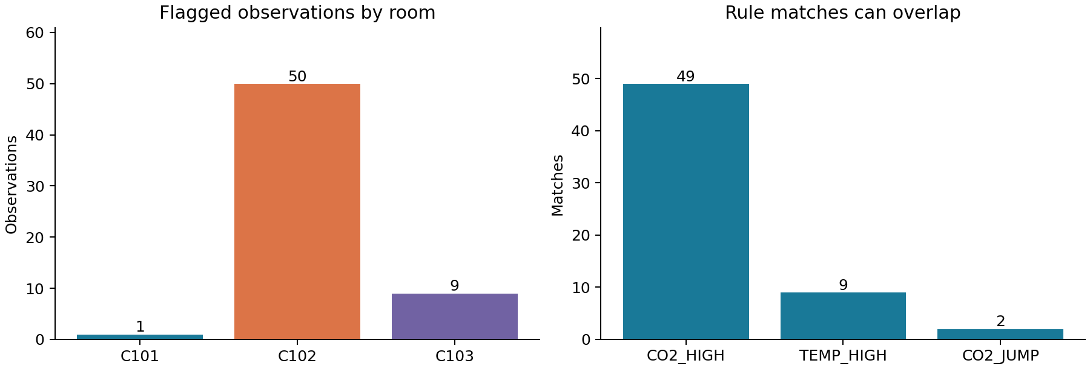
Figure 2 Flagged observations by room and matches by rule
The run contains 49 CO2_HIGH matches, 9 TEMP_HIGH matches and 2 CO2_JUMP matches. No rules overlap on the same record in this reference run, giving 60 flagged observations in total. The C102 count of 50 consists of its initial jump and 49 subsequent mean-threshold matches.

Evidence of incremental output
A separate 12-step run used a delay of 0.08 seconds per record. During execution, a monitor inspected the metrics file. Rows were already present while the process was running and before the final manifest existed. The completed run contained 36 accepted records. Observed wall times below depend on the computer and are not performance guarantees.
Table 5 Observed file growth before stream completion
Elapsed wall time | Saved metric rows | Process running | Final manifest
0.529 s | 1 | Yes | Not yet created
1.295 s | 10 | Yes | Not yet created
2.548 s | 25 | Yes | Not yet created

Verification results
All nine automated tests passed. They cover seeded generation, invalid JSON, causal filling and expiration, room isolation, duplicates, timestamp order, window boundaries, standard deviation and event rules. The integration check compares cleaned data, every metric, alerts and room summaries after replay.
An independent batch calculation matches every online rolling CO2 mean. All ten notebook code cells ran successfully in Python and produced the saved tables and figures. Test logs and file-growth evidence are included in the outputs folder.

7 Reproducibility and conclusion

Installation and execution
The project was tested with Python 3.12.14, Pandas 2.2.3, NumPy 2.3.5 and Matplotlib 3.10.8. Requirements are pinned for repeatable results; Python 3.11 or newer is needed. After creating a virtual environment, run these commands from the extracted project folder. Each output directory must be new or empty.
python -m pip install -r requirements.txt
python main.py --delay 0.05 --output outputs/my_demo
python main.py --delay 0 --output outputs/reproduced
python main.py --input data/classroom_stream.jsonl --delay 0 --output outputs/replayed
python -m unittest discover -s tests -v
README.md and START_HERE_RU.md provide full installation commands for Windows, macOS and Linux. The notebook must remain beside main.py and the campus folder. Its fresh runs use a temporary output directory and preserve the submitted reference files.

Limitations and possible improvements
The source is synthetic, so the results do not establish performance on real sensors. Filling a missing value can hide a short change. The system rejects late records instead of reordering them, and it has no network reconnection or durable checkpoint recovery. Duplicate IDs remain in memory throughout the run, and final plotting loads the full completed CSV. A longer-running service would need bounded deduplication, retention rules and restart support.
A next version could replace the generator with a real sensor source, calibrate rules against observed classroom conditions, group repeated flags into incidents and add a dashboard. These additions should preserve the separation between event time, processing time and data-quality information.

Conclusion
The implemented project meets the required workflow: timestamped acquisition, incremental cleaning, Pandas and NumPy analysis, six current indicators, three event rules, continuous console output and persistent results. The reproducible example shows why a rolling mean and a sudden-change rule provide different signals. Replaying the stored source reproduces the calculated tables and supports inspection of every accepted and rejected record.

References
[1] Pandas. pandas.to_numeric. https://pandas.pydata.org/docs/reference/api/pandas.to_numeric.html
[2] Pandas. pandas.DataFrame.rolling. https://pandas.pydata.org/docs/reference/api/pandas.DataFrame.rolling.html
[3] NumPy. Random Generator. https://numpy.org/doc/stable/reference/random/generator.html
[4] Python Software Foundation. Generators. https://docs.python.org/3/tutorial/classes.html#generators
Documentation accessed 28 September 2026. Online documentation may describe newer versions than the tested environment.

