**Features:**

* 加簽(先會、後會)可以增加備註
* Workflow service提供 線上表單、線上簽核及簽核代理人 服務

**更新方式:**

project請調整為JDK8

更新tcc-bpm-model.jar

<http://tcci-svn/svn/src/tcc-fc/tcc-fc-view/branches/pf5.1/bpmadmin/lib/tcc-bpm-model.jar> (version: 49483)

簽核流程管理>待簽核查詢

修改BpmTodoList.java (package com.tcci.fc.controller.bpmadmin)

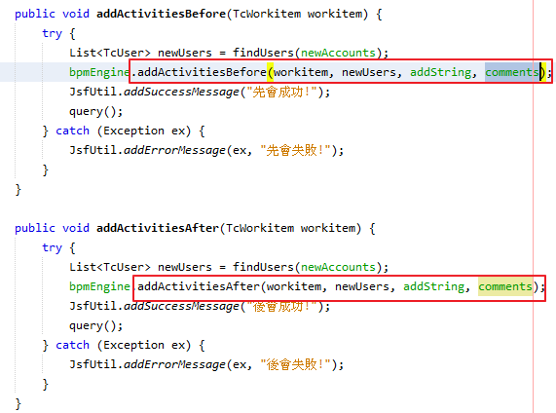

修改其它簽核頁面可先(後)會controller中的bpmEngine.addActivitiesBefore, bpmEngine.addActivitiesAfter

先(後)會UI調整:

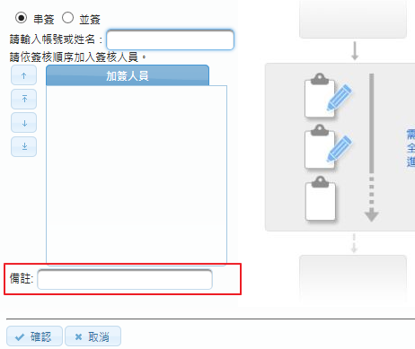

更新WorkflowService.java (package com.tcci.fc.service.workflow)

(<http://tcci-svn/svn/src/tcc-fc/tcc-fc-view/branches/pf5.1/bpmadmin/src/java/com/tcci/fc/service/workflow/WorkflowService.java> version 49545)

新增WorkflowVO.java (package com.tcci.fc.service.workflow)

([http://tcci-svn/svn/src/tcc-fc/tcc-fc-view/branches/pf5.1/bpmadmin/src/java/com/tcci/fc/service/workflow/WorkflowVO.java version 49545](http://tcci-svn/svn/src/tcc-fc/tcc-fc-view/branches/pf5.1/bpmadmin/src/java/com/tcci/fc/service/workflow/WorkflowVO.java%20version%2049545))

刪除ReassignConfVO (package com.tcci.fc.service.workflow)

修改jndi name

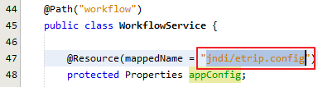

確認有appURL property (ex: <http://etrip.taiwancement.com/etrip>)

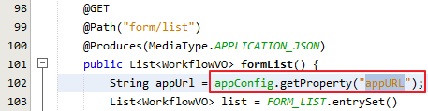

修改線上表單(名稱,連結)

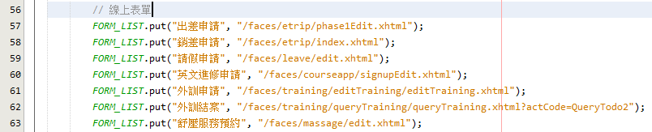

修改線上簽核(名稱,連結,表單classname，若待簽數量不是by表單classname，請自行修改todoCount/list裡的code)

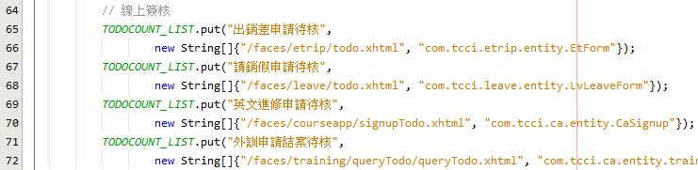

簽核代理人(流程名稱,代碼,processname，目前僅開放預設)

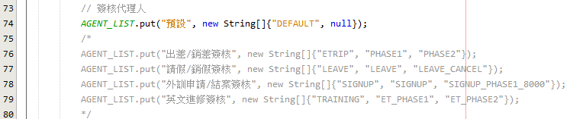

確認系統管理員的role是ADMINISTRATORS



Workflow service測試

線上表單(form/list)

[{"name":"出差申請","link":"http://192.168.203.81/etrip/faces/etrip/phase1Edit.xhtml"},

{"name":"銷差申請","link":"http://192.168.203.81/etrip/faces/etrip/index.xhtml"},

{"name":"請假申請","link":"http://192.168.203.81/etrip/faces/leave/edit.xhtml"},

…

}]

線上簽核(todoCount/list)

[{"name":"出銷差申請待核","link":"http://192.168.203.81/etrip/faces/etrip/todo.xhtml","todoCount":12},

{"name":"請銷假申請待核","link":"http://192.168.203.81/etrip/faces/leave/todo.xhtml","todoCount":0},

{"name":"英文進修申請待核","link":"http://192.168.203.81/etrip/faces/courseapp/signupTodo.xhtml","todoCount":2},

{"name":"外訓申請結案待核","link":"http://192.168.203.81/etrip/faces/training/queryTodo/queryTodo.xhtml","todoCount":0}]

簽核代理人(agent/list)

[{"code":"DEFAULT","name":"預設","agentName":"陳昇賢","agentAccount":"oliver.chen","agentStart":"2018-08-09T00:00:00.000+08:00","agentEnd":"2018-08-16T00:00:00.000+08:00","agentNote":"take a rest","modifytime":"2018-08-13T16:35:18.000+08:00"}]