Topic: Database performance tuning for foundation

1. 如何打開SQL Developer的Explain Plan

Step.1: 執行SQL.

Step.2: 按下工具列上的Explain Plan(F10)按鈕 (如下圖).

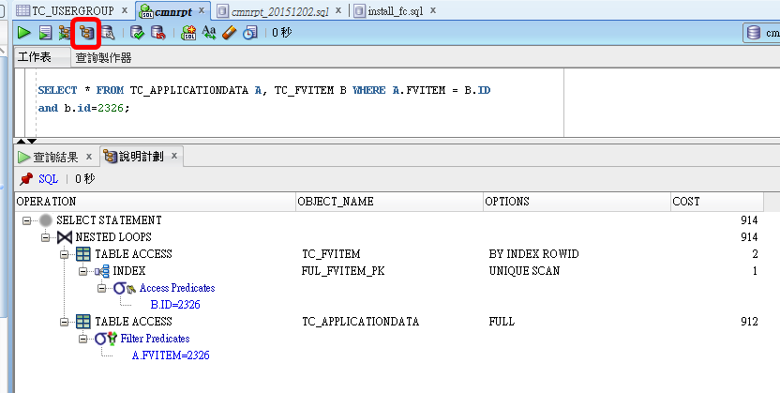

1. 如何打開SQL Server Management Studio的Explain Plan

Step.1: 按下工具列上的Explain Plan按鈕.

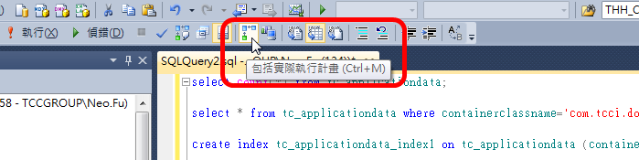

Step.2: 執行SQL.

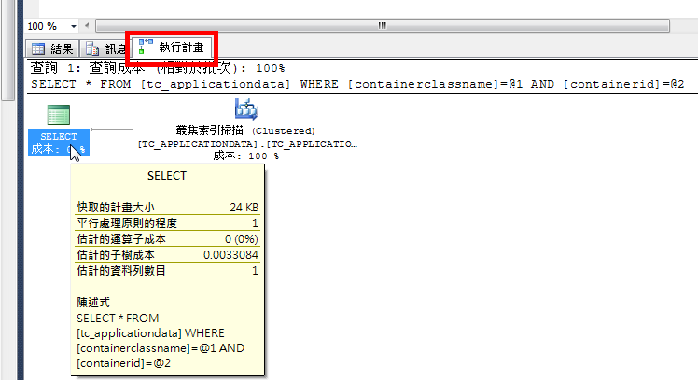

Case 1: class name + id to simulate interface in Java

Target table: TC_APPLICATIONDATA

Target column: containerclassname, containerid

Records: 239,627

Explain plan (以SQL Developer為例):

Before:

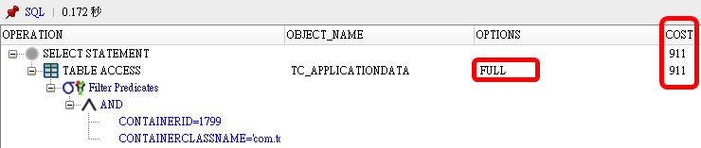

After:

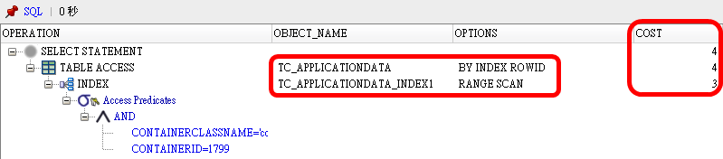

Case 2: foreign key need index or not? **YES.**

Target table: TC_APPLICATIONDATA, TC_FVITEM

Target column: fvitem

SQL 1: select * from tc_applicationdata where fvitem = xxx

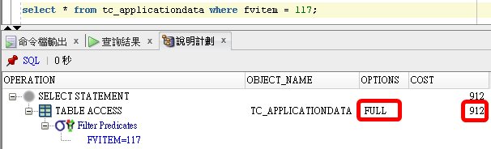

SQL 2: select a.* from tc_applicationdata a, tc_fvitem b where a.fvitem = b.id and b.id = xxx

Before:

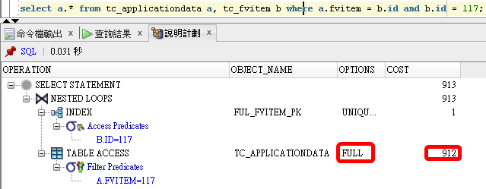

After: 