Glassfish 4 RESTful service with Jackson JSON lib

New Web Project: restdemo

New RESTful Web Services from Pattern

Simple Root Resource

Resource Package: com.tcci.restdemo.service

Path: sample

Class Name: SampleService

MIME Type: application/json

Representation Class: java.lang.String

Netbeans自動產生2個檔案

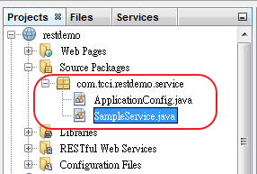

修改ApplicationConfig，將ApplicationPath("webresources") 改成 ApplicationPath("service") (純粹個人習慣)

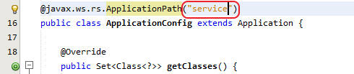

New Java Class (POJO java for JSON mapping)

Class Name: Sample

Package: com.tcci.restdemo.model

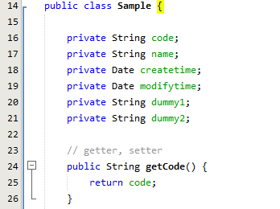

修改SampleService，return Sample as JSON object

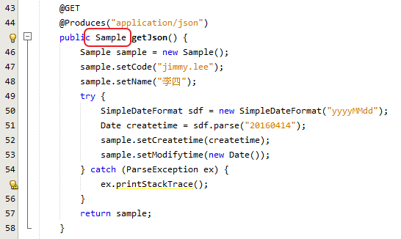

測試: <http://localhost:8080/restdemo/service/sample>

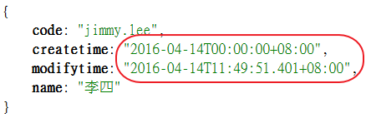

日期格式有一點點不一樣! 改用 Jackson JSON lib

參考: <https://jersey.java.net/documentation/latest/media.html#json.jackson>

*“In order to use Jackson as your JSON (JAXB/POJO) provider you need to register JacksonFeature (Jackson1Feature) and a ContextResolver<T> for ObjectMapper, if needed, in your Configurable (client/server)*.”

將jackson-annotations.jar, jackson-core.jar, jackson-databind.jar, jersey-media-json-jackson.jar (在glassfish\modules目錄下) 加到 project libraries(不需勾package)

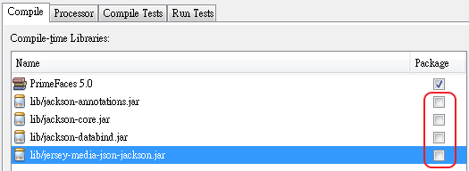

New Java Class (ContextResolver<T> for ObjectMapper，先用預設值)

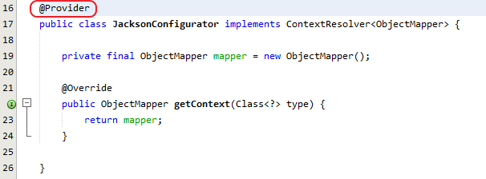

修改 ApplicationConfig (手動註冊JacksonFeature，JacksonConfigurator會自動加入)

JacksonFeature已包在jersey-media-json-jackson.jar裡了

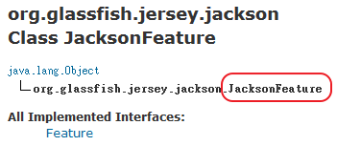

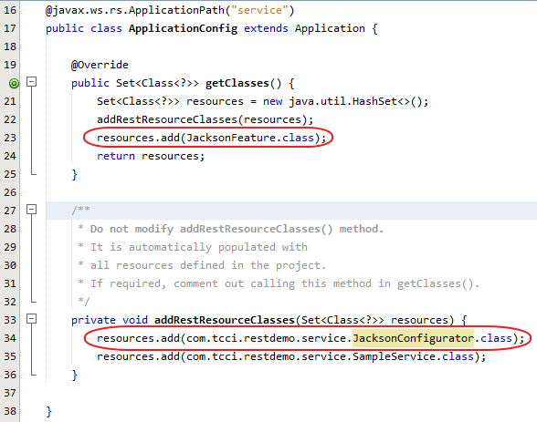

測試: <http://localhost:8080/restdemo/service/sample>

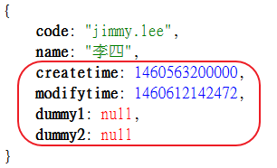

Date格式變成long，null欄位也出現 !!，調整ObjectMapper

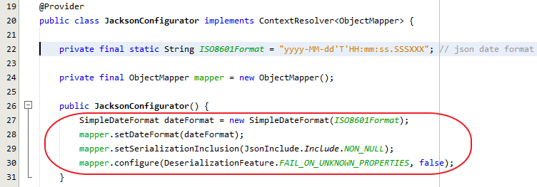

調整Date格式(ISO8601)，設定null值不顯示，有未定義的欄位時不會exception (json -> java)，再測看看: 正常了!

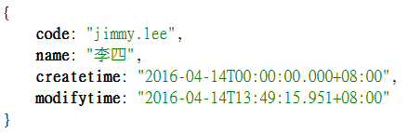

例外處理: (這是附帶一提，與Jackson無關)

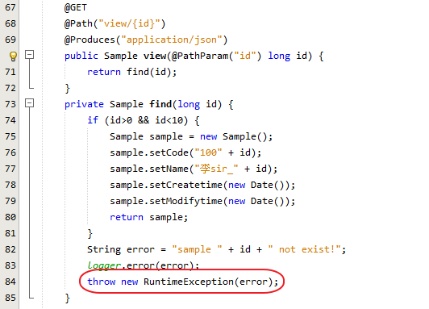

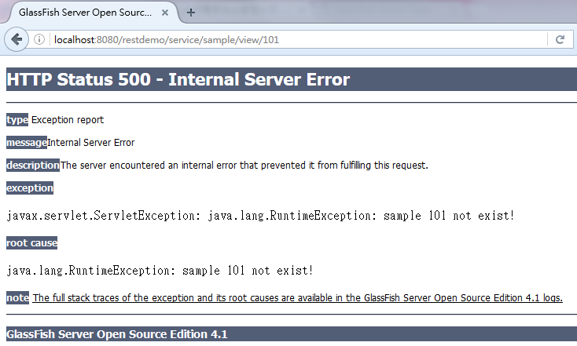

Issue 1: status 500感覺是程式的錯，但這個case似乎回status 400 (BadRequest)比較好

Issue 2: client端通常是其它AP (手機app或其它web ap)，建議回plain text比回整個html好。

修正如下:

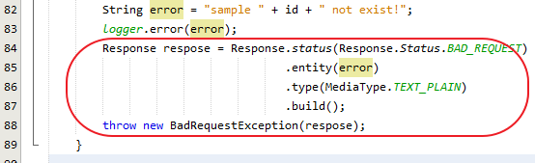

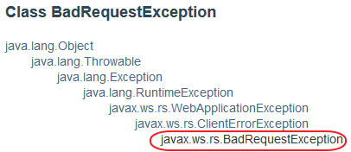

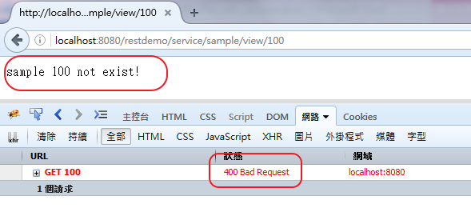

More refactoring: 自訂一個ServiceException，產生exception時順便印出stack trace。

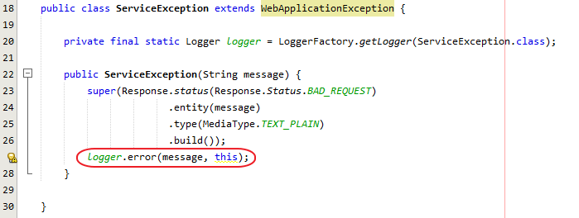

business logic變更簡潔



debug時也有比較快找到出問題的method

