elFinder: file manager for web

elFinder is an open-source file manager for web, written in JavaScript using jQuery UI. Creation is inspired by simplicity and convenience of Finder program used in Mac OS X operating system.

網址: <http://studio-42.github.io/elFinder>

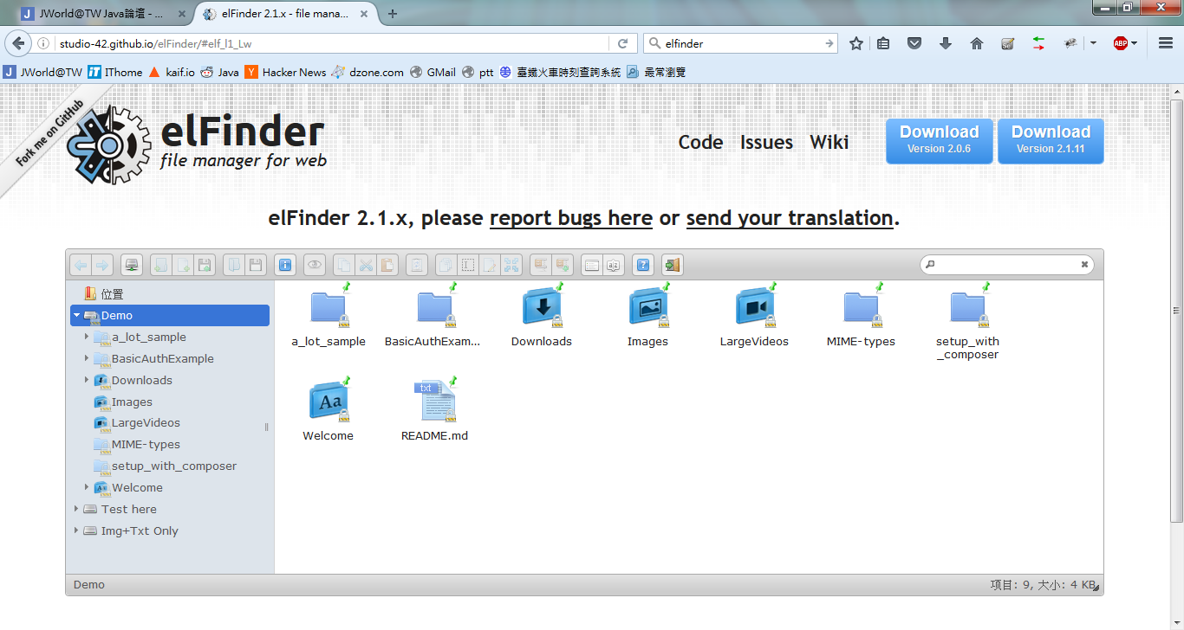

Features (2.0): (2.1版使用chunked file upload，目前java版的connector尚未支援)

* All operations with files and folders on a remote server (copy, move, upload, create folder/file, rename, etc.)
* High performance server backend and light client UI (該網站有5k_files, 7k_dirs, 10k_files檔案/目錄, 開啟10k_files目錄約19秒)
* Multi-root support
* Local file system, MySQL, FTP volume storage drivers
* Background file upload with Drag & Drop HTML5 support
* List and Icons view
* Keyboard shortcuts
* Standard methods of file/group selection using mouse or keyboard
* Move/Copy files with Drag & Drop
* Archives create/extract (zip, rar, 7z, tar, gzip, bzip2) (java版尚未支援)
* Rich context menu and toolbar
* Quicklook, preview for common file types
* Edit text files and images (image修改java版尚未支援)
* "Places" for your favorites
* Calculate directory sizes
* Thumbnails for image files
* Easy to integrate with web editors (elRTE, CKEditor, TinyMCE)
* Flexible configuration of access rights, upload file types, user interface and other
* Extensibility
* Simple client-server API based on JSON

3rd party connectors:

* ASP.NET
* Java Servlet
  + https://github.com/trustsystems/elfinder-java-connector (SevletContainerInitializer and NIO)
  + https://github.com/bluejoe2008/elfinder-2.x-servlet (選這個的原因是google到的第1個)
* Python
* Ruby/Rails
* Django
* Laravel

Integration with TinyMCE 4.x

* <https://github.com/Studio-42/elFinder/wiki/Integration-with-TinyMCE-4.x>

elfinder-connector: <http://tcci-svn/svn/src/elfinder-connector/trunk>

* source from elfinder-2.x-servlet
* 移掉springframework dependency
* Apache Commons Lang3 -> Commons Lang (commons-lang-2.6.jar)
* 打包成elfinder-connector.jar，方便各個專案使用

elfinder-demo: <http://tcci-svn/svn/src/elfinder-connector/demo>

自行修改volume的目錄



Demo: <http://192.168.204.45/elfinder-demo/>

NOTE: elfinder-connector一定要加上權限控管!