**Parental Consent**

Name of the Child: **Bogossian Hugo**

Name of the Parent or Guardian: **Bogossian Alan**

Use of computers and Internet:

As the parent or guardian, I understand that computer access is provided for educational purposes,

and that student use for any other purpose is inappropriate. I recognize it is impossible for KYOTO LESSON to restrict access to all inappropriate materials, and I shall not hold KYOTO LESSON responsible for materials acquired during the class. I hereby give permission for my child to use technology resources at KYOTO LESSON.

Sharing my personal data with other parents:

I authorize / I do not authorize**(1)** KYOTO LESSON to communicate to other parents of children enrolled in KYOTO LESSON my mobile number and / or my e-mail address (for example to facilitate documents sharing by e-mail or chat and allow the child to work on group projects).

Child photos and videos:

I authorize / I do not authorize**(1)** KYOTO LESSON to take photos and videos of my child during the lessons and to have full rights to use these photos and videos for exhibition, publicity and website of KYOTO LESSON as well as press releases.

Authorization to go back home alone:

I give permission / I do not give permission**(1)** to my child to go back home (or to another specified destination) on their own after the class. I have explained to my child the safety aspects of going home on their own. I understand that it is the responsibility of the parents, and not the school, once my child has left the school premises.

I, the undersigned, hereby certify that the information given above is true and correct.

I further certify that I am the parent / legal guardian of the Child.

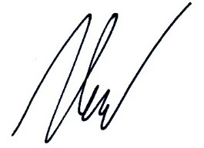

**30th November 2018 Bogossian Alan**

**Date Signed Printed Name & Signature of Parent/Guardian**

(1) Strikeout the part that does not apply.