문제 상황 : insWhiteListTable() 함수 호출 시
main.c → insWhiteListTable() 로 하면 아무 문제가 없지만,
main.c → PrintMenu() → insWhiteListTable() 로 하면 whitelist 입력을 건너 띔.
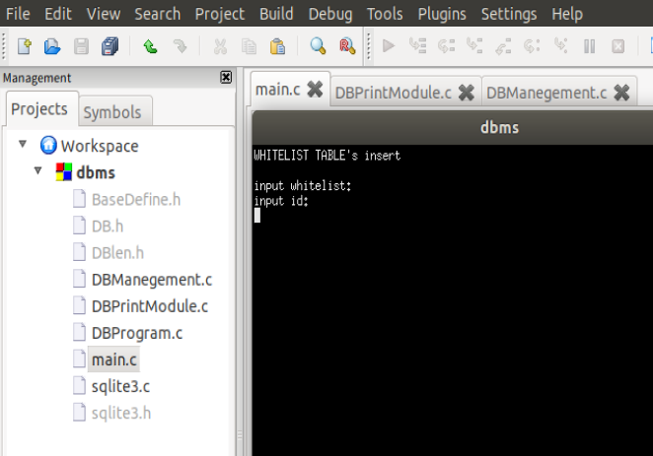
결과 화면 설명 : 입력 커서가 input whitelist: 로 가야하는데, 건너 띄고 input id: 로 감

<< main.c >>
#define _CTR_SECURE_NO_WARNINGS
#include <stdio.h>
#include <stdlib.h>
#include <string.h>
#include <sqlite3.h>
#include "BaseDefine.h"
#include "DBlen.h"

void printMenu();

static int callback(void *NotUsed, int argc, char **argv, char **azColName) {
int i;
for(i = 0; i < argc; i++) {
printf("%s = %s\n", azColName[i], argv[i] ? argv[i]:"NULL");
}
printf("\n");

return 0;
}

int main(int argc, char *argv[]) {

int menu;

printMenu();

system("clear");

return 0;
}

<< DBPrintModule.c >>
#include <stdio.h>
#include "DB.h"

void printMenu(int pr_menu) {
int tb = 0;
int func = 0;
int menu = 0;

printf("Select DB Table\n");
printf("1 : WHITELIST DB Table\n");
printf("2 : ADMINISTRATOR DB MAC Table\n");
printf("3 : ADMINISTRATOR DB ADMIN Table\n");
printf("4 : ADMINISTRATOR DB INFO Table\n");
printf("0 : EXIT\n");
printf("Table :");
scanf("%d", &tb);

printf("Select Number\n");
printf("6 : insert\n");
printf("7 : update\n");
printf("8 : delete\n");
printf("9 : search\n");
printf("0 : EXIT\n");
printf("menu : ");
scanf("%d", &func);
menu = tb*10 + func;

switch(menu) {
case 16:
insWhiteListTable();
break;

default :
break;
}

}

<< DBManagement.c >>
#include <stdio.h>
#include <sqlite3.h>
#include <string.h>
#include "BaseDefine.h"
#include "DBlen.h"

struct WhiteListTable {
char whitelist[WLlen];
char id[IDlen];
char date[DATElen];
};

enum Account {
Robot, CPS, Root
};

// print function
static int callback(void *NotUsed, int argc, char **argv, char **azColName) {
int i;
for(i = 0; i < argc; i++) {
printf("%s = %s\n", azColName[i], argv[i] ? argv[i]:"NULL");
}
printf("\n");

return 0;
}

int insWhiteListTable(struct WhiteListTable ins_wt) {
struct WhiteListTable wt;

sqlite3 *db;
char *errmsg;
sqlite3_stmt *res;
int rc;
char *sql;
char input_sql[512];
char whitelist[WLlen] = { 0, };
char id[IDlen] = { 0, };
char date[DATElen];

rc = sqlite3_open("WHITELIST.db", &db);
if(rc != SQLITE_OK) {
fprintf(stderr, "Can't open WHITELIST DB : %s\n", sqlite3_errmsg(db));
return 1;
}
else {
fprintf(stderr, "Opened database successfully\n");
}
sqlite3_busy_timeout(db, 500); //db open시 timeout 500ms로 설정

sql = "CREATE TABLE WHITELIST ("\
"whitelist TEXT(30) PRIMARY KEY NOT NULL,"\
"id TEXT(9) NOT NULL,"\
"date TEXT(12));";
rc = sqlite3_exec(db, sql, 0, 0, &errmsg);
if(rc != SQLITE_OK) {
fprintf(stderr, "Can't create WHITELIST table : %s\n", sqlite3_errmsg(db));
return 1;
}
else {
fprintf(stderr, "Created table successfully\n");
}

system("clear");

puts("WHITELIST TABLE's insert\n");
puts("input whitelist:");
gets(whitelist);
puts("input id:");
gets(id);
puts("input date:");
gets(date);

fflush(stdin);
strcpy(input_sql, "insert into WHITELIST values('");
strcat(input_sql, whitelist); //whitelist
strcat(input_sql, "','");
strcat(input_sql, id); //id
strcat(input_sql, "','");
//sql = "select datetimes(strftime('%s', 'now'), 'unixepoch', 'localtime'))";
strcat(input_sql, date); //date
strcat(input_sql, "');");
printf("%s\n", input_sql);
rc = sqlite3_exec(db, input_sql, callback, 0, &errmsg);
if(rc != SQLITE_OK) {
fprintf(stderr, "Can't input : %s\n", sqlite3_errmsg(db));
return 1;
}
else {
fprintf(stderr, "Print input successfully\n");
}

sqlite3_close(db);

return 0;
}

