**ASA Philippines Foundation Inc.**

November 15, 2021

To whom it may concern,

Greetings in Jesus Name!

I am Kim Darren F. Peralta, a 4th-year student pursuing a Bachelor of Science in Information Technology at Cagayan State University – Gonzaga Campus. I have been a recipient of your scholarship program since my 2nd year in college, and I am grateful to have been granted this chance, as it greatly helps my academics.

Unfortunately, last academic year, I was unable to get the financial support provided for the second semester due to the COVID-19 pandemic. As a response to the outbreak, my university has opted to close its doors to all students, professors, and personnel, for the time being, making it impossible to handle any requests, including scholarship purposes.

In line with that, I kindly ask that you consider a humble request for the disbursement of financial assistance that I was unable to receive for the second semester of the academic year 2020-2021, as well as for the first semester of the academic year 2021-2022. It will be beneficial to my studies, particularly in this time of the pandemic.

I am looking forward to hearing from you.

Thank you very much and God bless!

Sincerely,

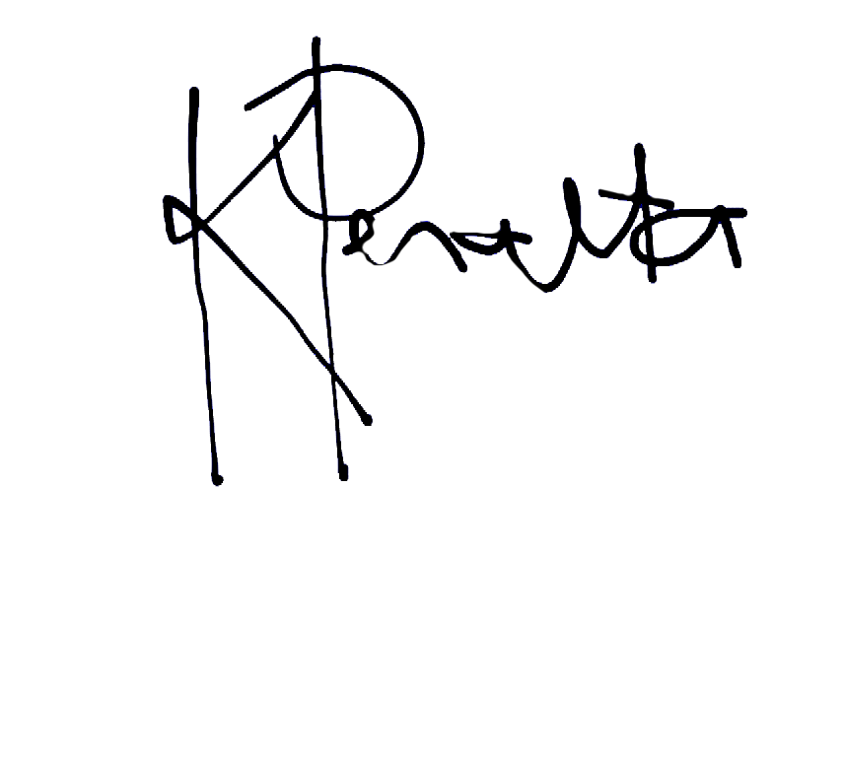

Kim Darren F. Peralta