Order:
Tablet simvastatin 10mg 1 Tablet EOD Everyday
in the google sheet tbl_medicationorder:
RxOrderID ResidentID Dosage Form Brand Name Active Ingredient Dose Unit Frequency Administration Times Dosing Days Indication Instruction Duration Type Start Date End Date Noted By Ordered By Supplied By Status PreviousRxOrderID
48e9e997 DEMO-0001 Tablet Zocor simvastatin 10mg 1 Tablet EOD 1000PM Everyday Hyperlipidaemia Take at bedtime Long Term 26/08/2026 DEMO-0002 Family Family Active

I expected what the tbl_medicationstock will be recording:
StockID ResidentID RxOrderID Balance Unit Daily Usage Days Remaining StockDate RegisteredBy EntryType
b12e9243 DEMO-0001 48e9e997 12 Tablet 0.5 18 19/09/2026 09:15:00 DEMO-0003 Stock Count
instead, it is showing:
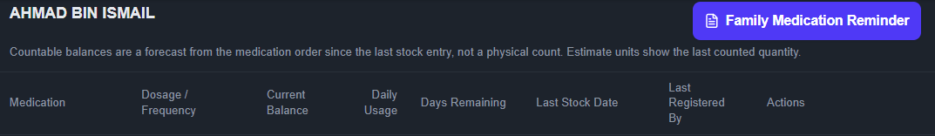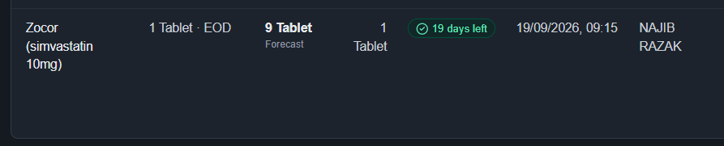
in the tbl_medicationstock:
StockID ResidentID RxOrderID Balance Unit Daily Usage Days Remaining StockDate RegisteredBy EntryType
b12e9243 DEMO-0001 48e9e997 12 Tablet 0 0 19/09/2026 09:15:00 DEMO-0003 Stock Count

few problems with this structure:
1. The daily usage is wrong. 1 tab EOD means daily usage = 0.5 tab
2. Unit and Daily Usage recorded in the sheet are both 0
3. The forecast balance shows 9 tablet. Even if it is true, if patient is taking 1 tablet EOD, “Days Remaining” should be 18 days (9 tablets divide by daily usage of 0.5 tab/day)
what I like:
1. The countable balances are a forecast from the order since the last stock entry.
2. Estimate units show the last counted quantity

ui optimization:
1. Remove text “Countable balances are a forecast from the medication order since the last stock entry, not a physical count. Estimate units show the last counted quantity.”
2. Instead of showing “18 days left”, also include the expected last date of stock. E.g. today is 25/9/2026, left 18 days means the last date of stock will be 12/10/2026. when a order is “1 Tablet ON Monday/Wednesday/Friday”, given the last stock count on 23/9 is 20 tablets, if user can know when will be the last dose, then this information will be more useful

