http://mscroggs.co.uk/

Dec 1:

Answer: 233

Explanation: For a given 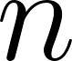 let 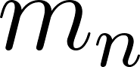 be the number of ways to express that end in a 1, and let 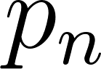 be the number of ways that end in a 2. Then the total number of ways for is 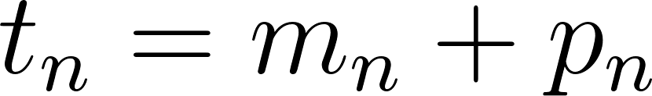. These then satisfy the recursive relations

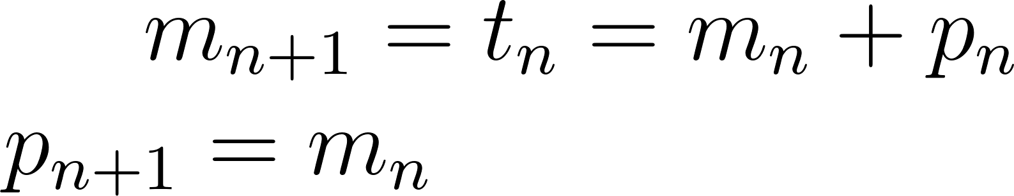

with 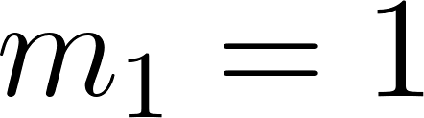 and 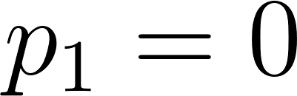.

These result in Fibonacci numbers offset depending on whether you are looking at , , or 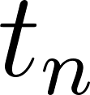. A Python script was written to calculate this recursion.

Dec 2:

Answer: 172

Explanation: A circle with that area has a square radius of 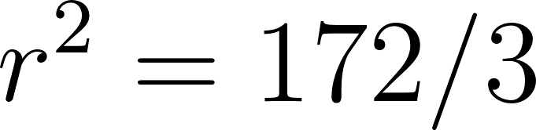. Then the area of a dodecagon in terms of its circumradius is 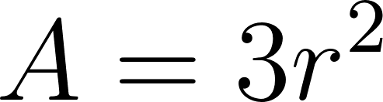. Hence the dodecagon area is 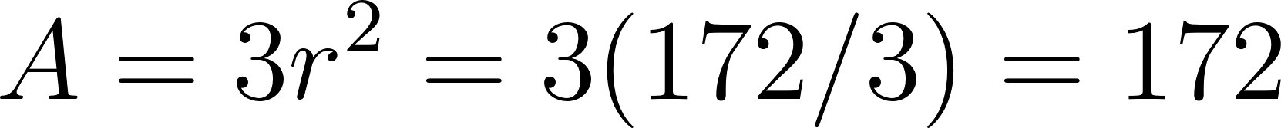.

Dec 3:

Answer: 108

Explanation: Wrote a brute-force Python script to solve these. Completed grid is:

4 | 5 | 2
8 | 9 | 6
7 | 3 | 1

Dec 4:

Answer: 150

Explanation: A python script was written to determine this by actually calculating the factorial, which is easy in Python due to handling arbitrarily large integers.

Dec 5:

Answer: 445

Explanation: Clearly the middle pages are on the top of the top sheet of paper. Since each half-sheet is two pages and there are 111 sheets, the last page number in the first half (i.e. the left side of the top of the top sheet) is 222. The right side of the top of the top sheet is page 223.

Dec 6:

Answer: 121

Explanation: Here are the factors. This was verified with Python.

Number | Factors | Largest Odd Factor
12 | 1,2,3,4,6,12 | 3
13 | 1,13 | 13
14 | 1,2,7,14 | 7
15 | 1,3,5,15 | 15
16 | 1,2,4,8,16 | 1
17 | 1,17 | 17
18 | 1,2,3,6,9,18 | 9
19 | 1,19 | 19
20 | 1,2,4,5,10,20 | 5
21 | 1,3,7,21 | 21
22 | 1,2,11,22 | 11

Dec 7:

Answer: 969

Explanation: This can be solved either using a direct simulation or by noticing that we can simply find the factors of each locker number, and noting that it will be closed at the end if the number of factors is even (since it started out closed), and open if the number is odd. These to methods were shown to be equivalent in Python.

Dec 8:

Answer: 691

Explanation: Through logical reasoning, the grid was determined to be:

6 | 3 | 5
9 | 8 | 7
1 | 2 | 4

Dec 9:

Answer: 252

Explanation: Between 0 and 10 there are 6 numbers meeting this criteria: 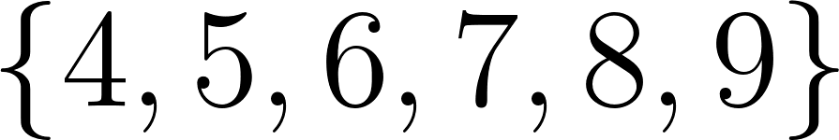. Considering double-digit numbers, if we assume that the first digit of single-digit numbers is 0, then there would be 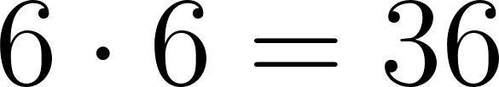 numbers in this range, which is also the case from 10 to 100 (since 100 is not included). Likewise the number of 3-digit numbers would be 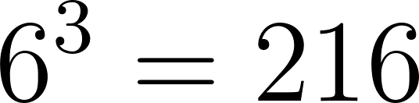. However, the two-digit numbers do not really have a leading 0 so we must add them, of which there are 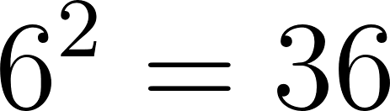. We don’t need to worry about single-digit numbers since we are starting at 10. Hence the total number is . This was confirmed with a Python simulation.

Dec 10:

Answer: 110

Explanation: This is a most interesting problem. Let 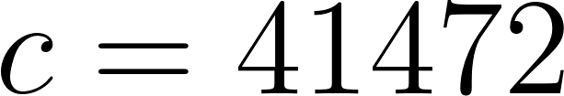 so that, for an integer solution with some 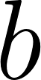, we have
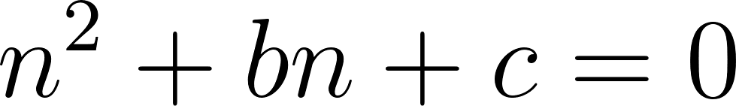
From this it follows that must be a divisor of . To determine the that generates this solution we have
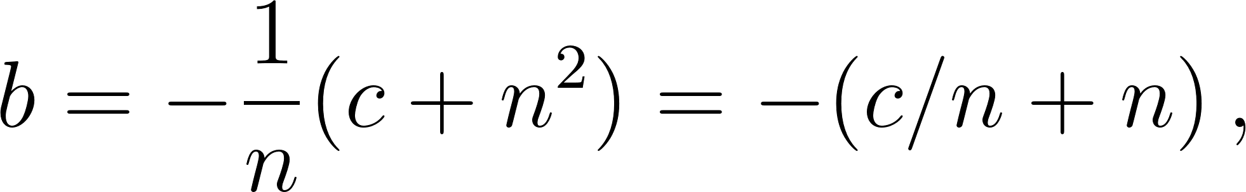
noting that 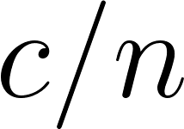 is an integer since is a divisor of .

Now, the same generates two solutions and we can show that they are both integers. For if 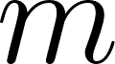 and are both solutions for the same then we have
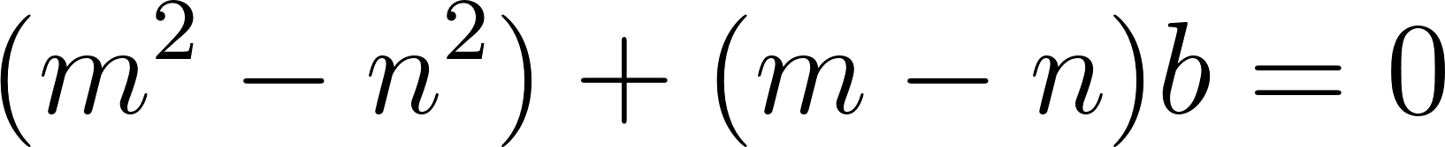
Now, if 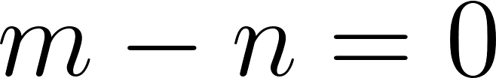 then clearly 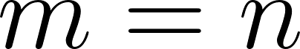 so that this is not the solution we care about. In the other case have
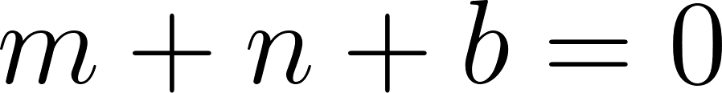
Thus the other solution is the corresponding divisor of , and they both generate the same , which we can then express as

Now, 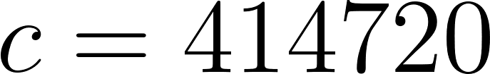 has 110 divisors, including 1 and itself, which are also valid solutions, but since a divisor and its counterpart generate the same and the question is about the number of values of there are only 55 values of for the positive divisors. However, if both divisors are negative, they still multiply to the positive and they also result the negative of the with positive divisors since 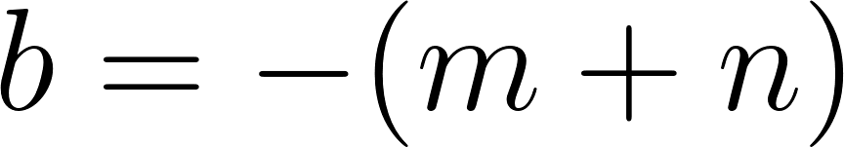 (hence these values of will actually be positive, whereas those from positive divisors are negative). Hence there are a total of 110 distinct values of that result in two integer solutions.

Dec 11:

Answer: 108

Explanation: First we note that, for an odd number 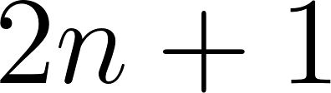 we have that the sum of all odd numbers up to and including it is
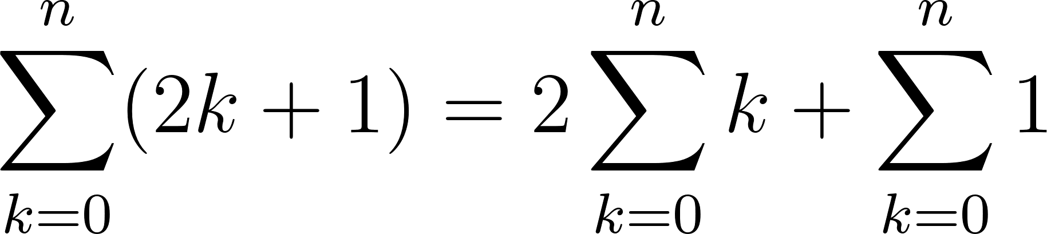
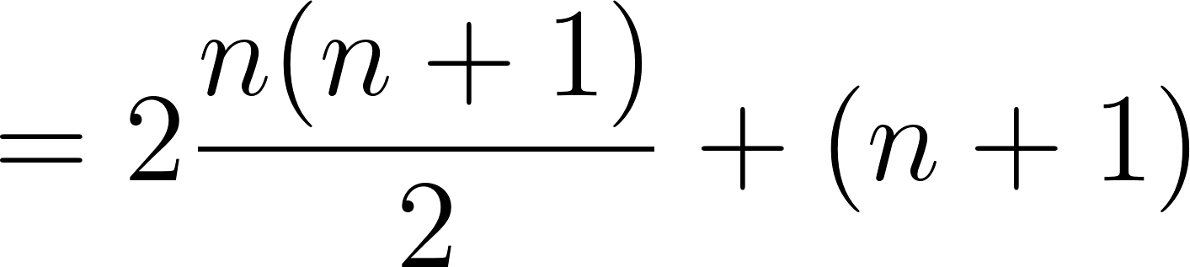
Then, for the actual problem we have that
Therefore, with
we have that
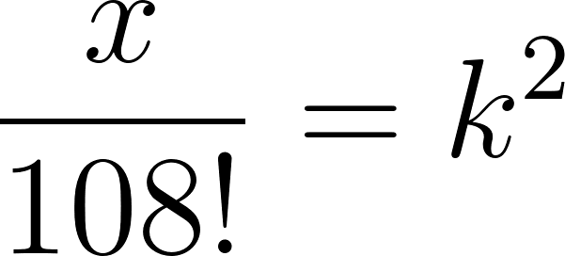
so that 108 is the solution. This was verified with huge integers in Python. Note that a link for a similar puzzle was given right on the puzzle page, which basically walks through how to solve it.

Dec 12:

Answer: 312

Explanation: This was done in a brute force way in Python by checking dot products between triangle sides to look for orthogonal sides.

Dec 13:

Answer: 608

Explanation: Simulated in Python

Dec 14:

Answer: 135

Explanation: Solved using the Python script written to solve these. The completed grid is:

8 | 7 | 9
4 | 2 | 1
5 | 6 | 3

Dec 15:

Answer: 323

Explanation: Wrote Python script to determine this, though really it could have been reasoned out fairly easy in retrospect.

Dec 16:

Answer: 845

Explanation: Determined by logical deduction. Solved grid is

3 | 7 | 8
6 | 2 | 4
1 | 9 | 5

Note that 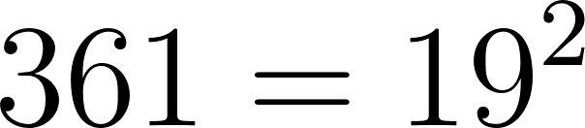 so that it is square, 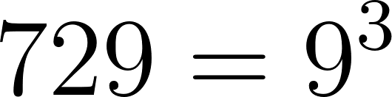 so that it is cubic, and 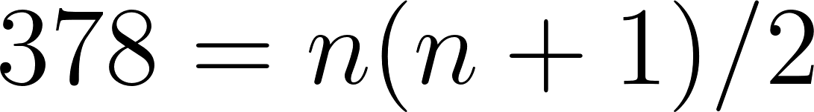 for 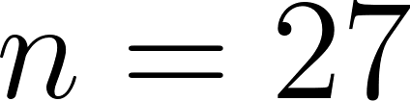 so that it is triangular.

Dec 17:

Answer: 285

Explanation: The diagram below shows the grid and values at each point:

x < y
1 | 2 | 3 | 4 | 5 | 6 | 7 | 8 | 9
1 | 2 | 3 | 4 | 5 | 6 | 7 | 8 | 8
1 | 2 | 3 | 4 | 5 | 6 | 7 | 7 | 7
1 | 2 | 3 | 4 | 5 | 6 | 6 | 6 | 6
1 | 2 | 3 | 4 | 5 | 5 | 5 | 5 | 5
1 | 2 | 3 | 4 | 4 | 4 | 4 | 4 | 4
1 | 2 | 3 | 3 | 3 | 3 | 3 | 3 | 3
1 | 2 | 2 | 2 | 2 | 2 | 2 | 2 | 2
1 | 1 | 1 | 1 | 1 | 1 | 1 | 1 | 1
x >= y

From this it is reasoned that the sum of these values is
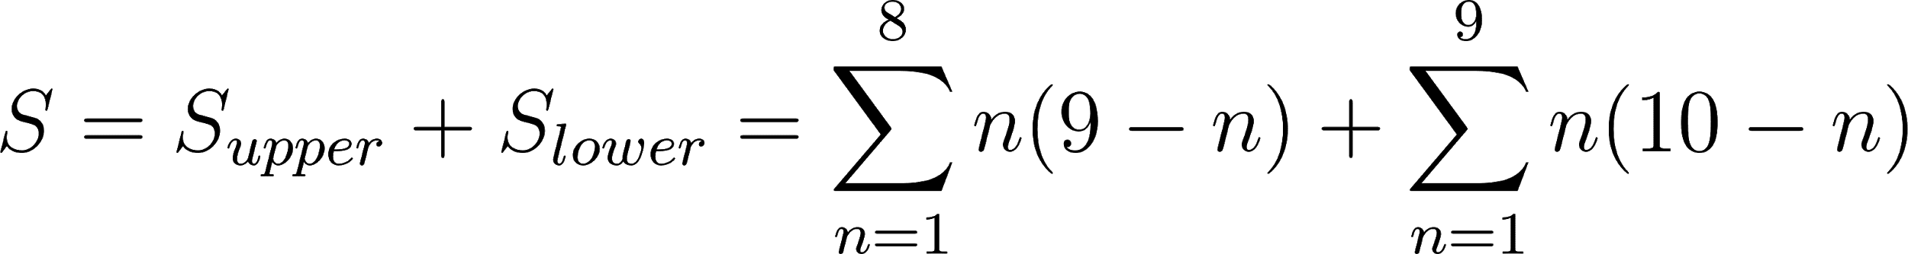
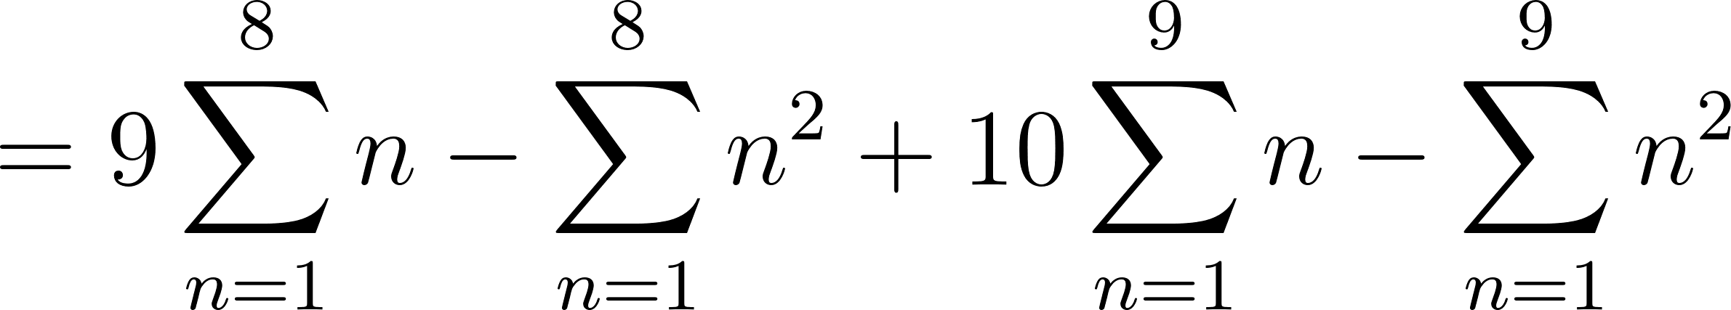
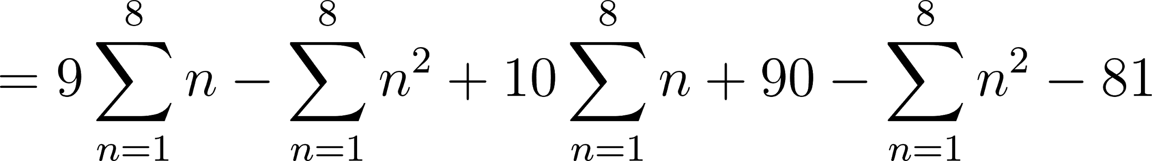
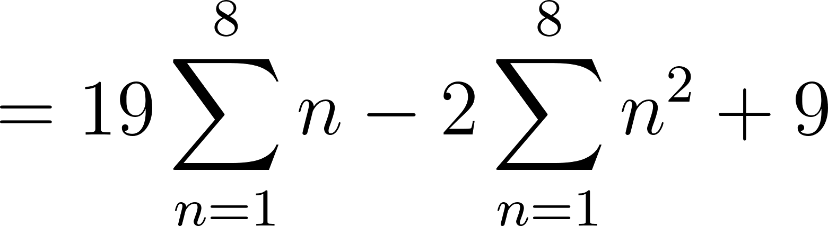
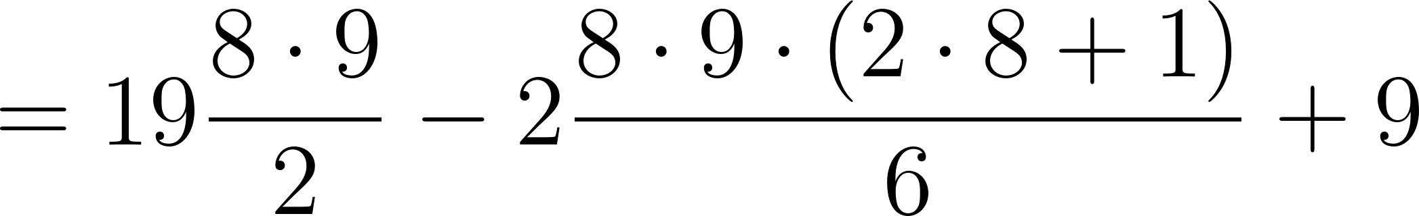
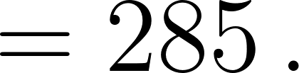

This sum was verified with a direct Python calculation over the grid.

Dec 18:

Answer: 153

Explanation: In the somewhat general case we can apply the binomial formula twice:
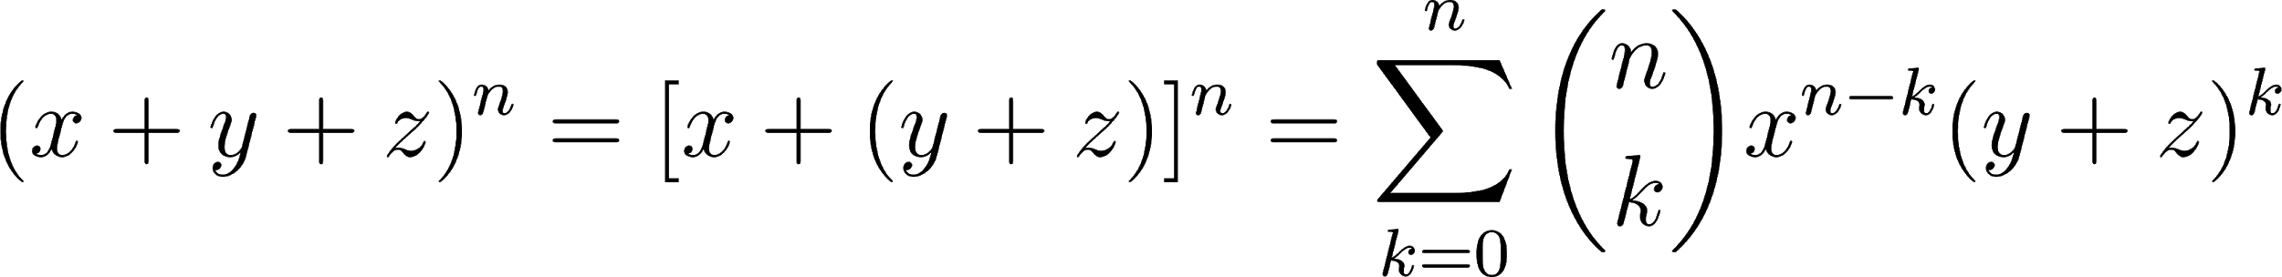
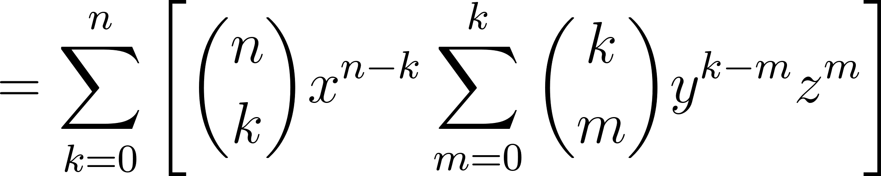
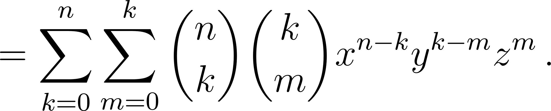
Now, since we do not care about the terms themselves and are only interested in counting the terms, we can just replace them with 1 and evaluate the sums
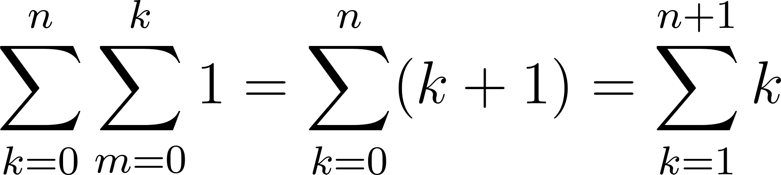
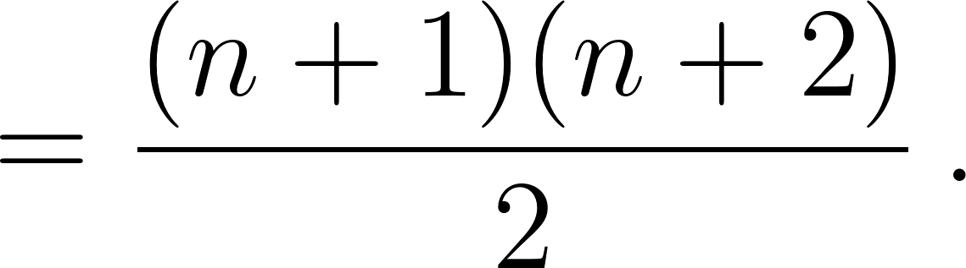
The problem asks the number of terms for 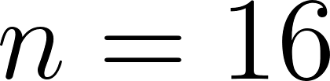, which is then 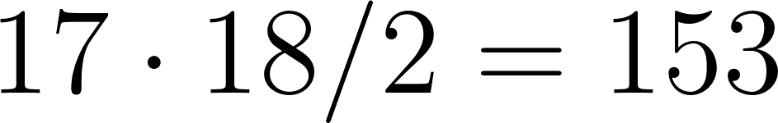.

Dec 19:

Answer: 112

Explanation: The points in a unit hypercube of dimension can be all the points in the set 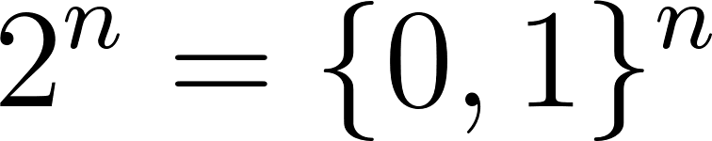, that is they are binary strings of length . A hyperside of dimension 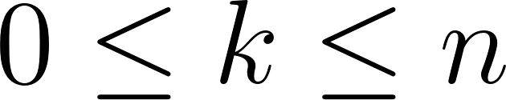 is made up of the 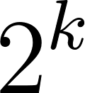 points where any 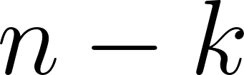 of the coordinates are held constant. Now, the number of ways we can choose coordinates to hold are
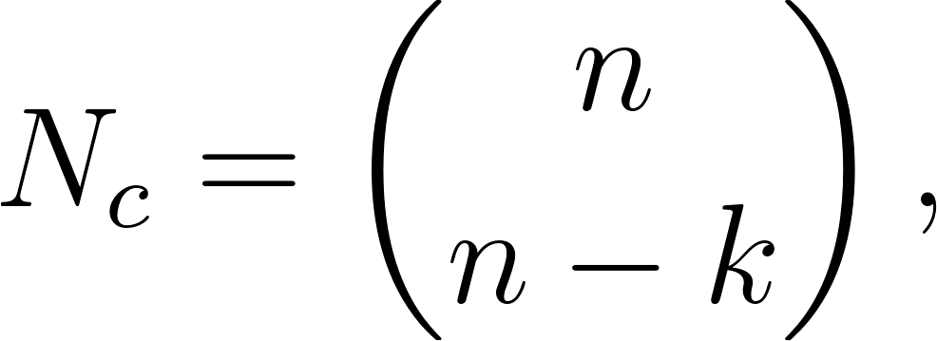
i.e. they are combinations. Then, after choosing the coordinates to hold there are 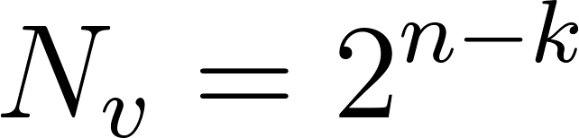 possible values of those held coordinates, each one resulting in a different hyperside. Therefore the total number of hypersides of dimension 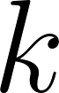 is
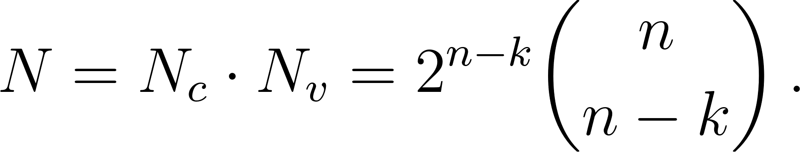
This quite general result was confirmed with Python for a number of low-dimensional examples. For the given problem of the number of 6-dimensional sides of an 8-dimensional hypercube,  was computed to be the answer above.

Dec 20:

Answer: 730

Explanation: This was a trivially easy problem that was calculated in Python.

Dec 21:

Answer: 269

Explanation: Solved in Python using a general solver for these digit problems. Completed grid:

7 | 3 | 5
4 | 8 | 1
9 | 2 | 6

Dec 22:

Answer: 330

Explanation: For any 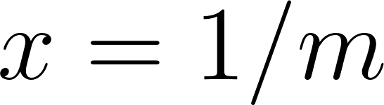 for positive integer we have that the finite expansion in base is
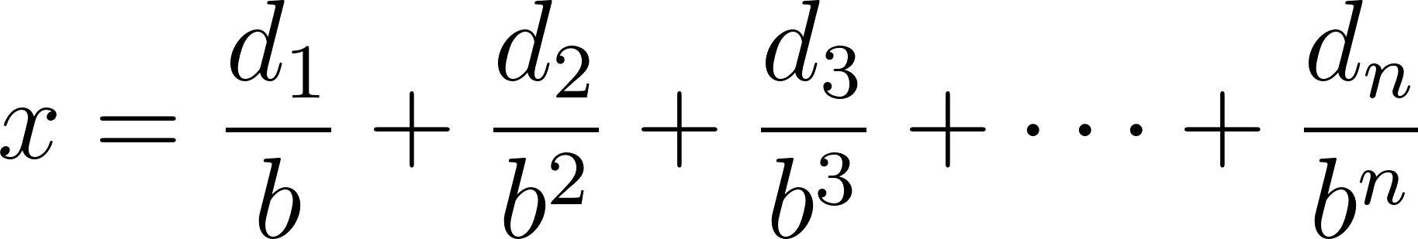
for some positive integer , and where of course each digit 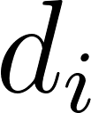 is an integer such that 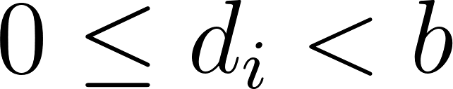. It then follows that
which is of course an integer. Conversely, 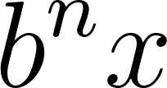 will not be an integer if the expansion is infinite. Thus the base expansion is finite if and only if there is a positive integer such that 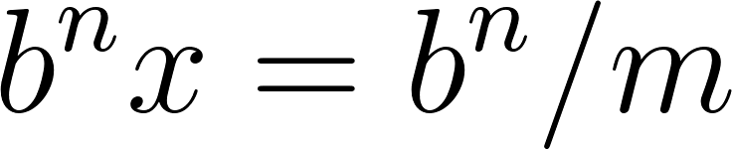 is an integer.

In our case we have that 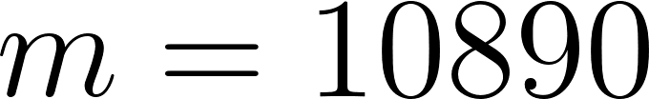. We can find the minimum base by looking at the prime factorization of , which is
Clearly then any integer 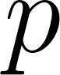 such that 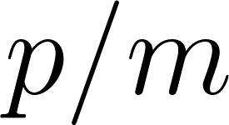 is an integer must contain these prime factors. In fact, the smallest we seek is clearly just the product of these prime factors:
since then we have that
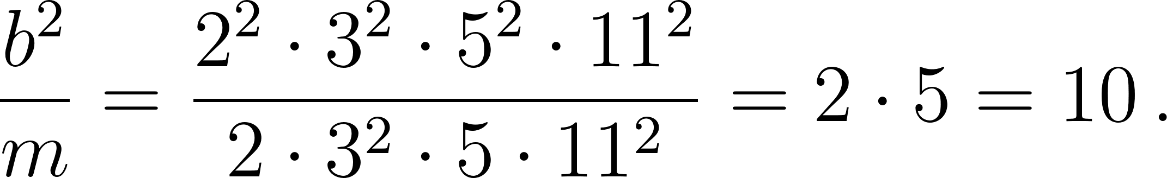

Also wrote a Python program to expand digits past decimal point in any base and detect if it is finite or infinite as extra verification.

Dec 23:

Answer: 132

Explanation: Suppose that the required parimeter is . Then, if the sides of the rectangle are  and , we have
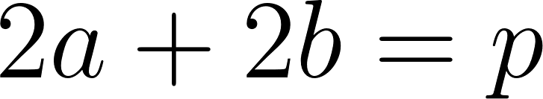
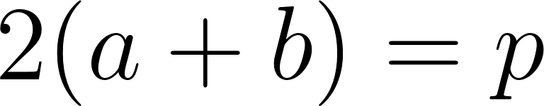
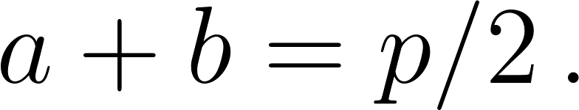
Then we have that the rectangle area is
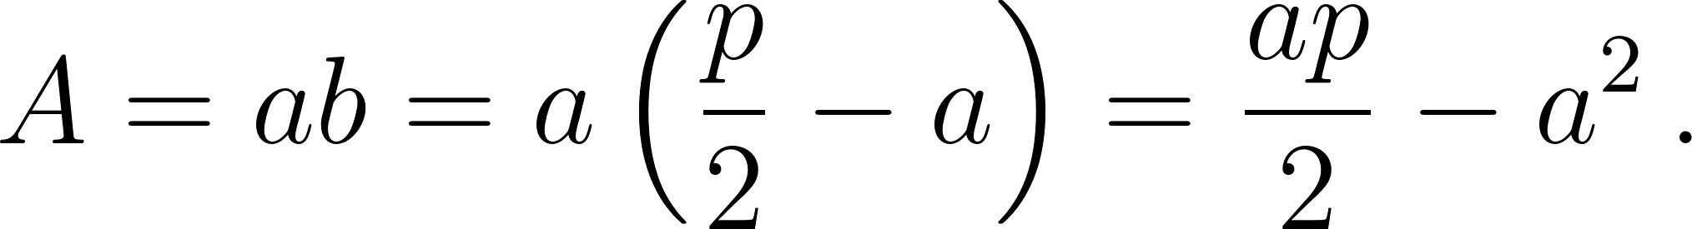
A plot of this for 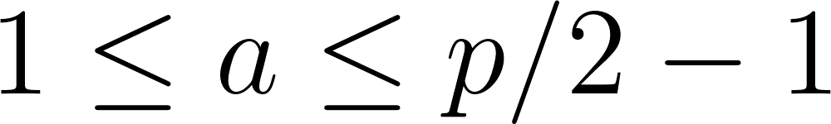 for our case in which 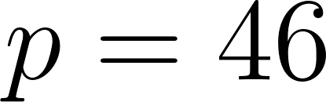 show that there is a local maximum. To find this maximum we of course solve
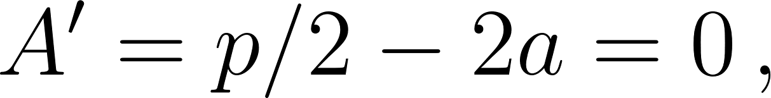
which results in 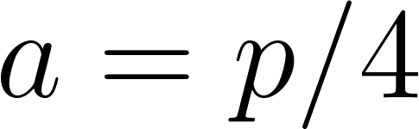. Now, in our case, 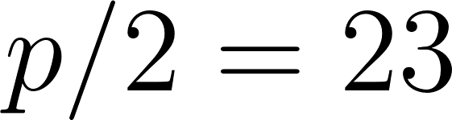 is odd so that 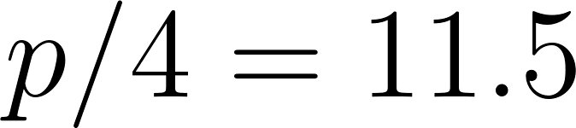 is not an integer. Therefore the closest we can get to the maximum is when 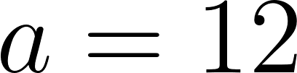 and 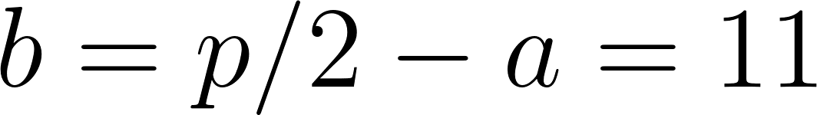 so that the maximum area is 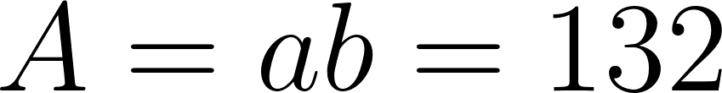.

This was also checked with a brute force Python program.

Dec 24:

Answer: 157

Explanation: Wrote Python program to check every sequence and count those with the desired property.

